Process Document

CRM – Student Advice & Wellbeing
Liverpool John Moores University

Student Advice Wellbeing:
Creating a Contact

Version 0.1, October 2015
Author: DS Business Support Team

Contents

- Creating a Contact

- Marking a Student Contact with a Disability

- Adding the ‘In Counselling’ flag to a students record.

- Adding an Alert to a Contact.

- Creating a Contact

All current students have already been set up as a Contact in CRM. However, you may still need to set up a Contact for a third party e.g. a parent.

  - To create a new contact, first ensure you are within the Student Services and select Contacts from the Customers menu.

  - Click on the New + button
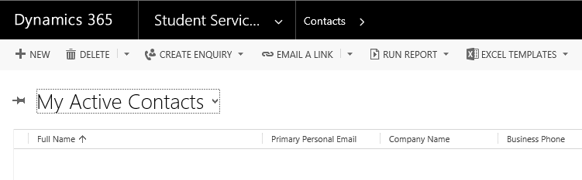
  - This will take you to the New Contact form.
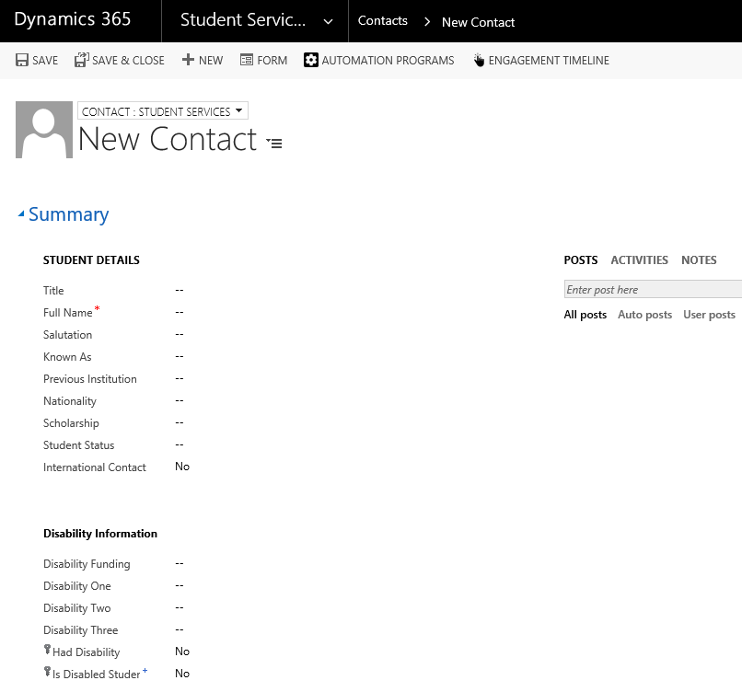

  - Note that you can change the type of Contact by clicking on the drop down above ‘New Contact’.

Note: All Current Students have been created as a Student Services Contact type.
  - Depending on the type of Contact, there will be different Mandatory fields, but you will always need to enter Name and Email address.

  - Click Save.

Note: Remember that Notes can be left against the Contact record, but for auditing purposes and that so a full picture can be given, all notes should be held against a Case.

- Marking a Student Contact with a Disability

  - Navigate to the Student’s Contact record.

  - Ensure that the form that appears is the Student Services form by changing the drop down.

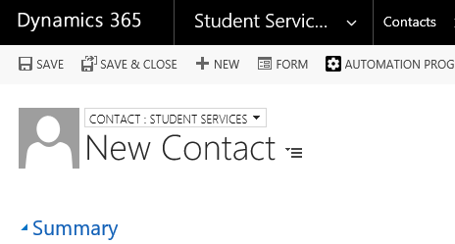

  - You can then add in Details of a students Disability, or mark them as in Counselling by filling out relevant fields.

  - Details can be added under Disability Information:

  - The Disability Details section:

- Adding the ‘In Counselling’ flag to a students record.

  - Ensure that the In Counselling flag is ticked in the Welfare section of the students Contact form.

- Adding an Alert to a Contact
You may wish to set an Alert to convey an important message regarding a Contact such as preferred Contact/Communication methods.
  - Navigate to Advanced Find.

  - Click into Look For and Select Alerts from the drop down menu.

  - Click on the Results button

  - Click on New Alert

  - Next, you need to add details of the Alert:
- The Type of Alert
- The Alert Period
- Description of the Alert
- Who Alert is regarding

  - Click on Save and Close.

  - Whenever you access this Contact the Alert will now display.

