# [Image result for liverpool john moores university logo](https://www.google.co.uk/url?sa=i&rct=j&q=&esrc=s&source=images&cd=&cad=rja&uact=8&ved=0ahUKEwjZuerSu4nXAhWGchQKHbT9CwIQjRwIBw&url=https://www.eventbrite.co.uk/o/liverpool-john-moores-university-roscoe-lectures-3233158788&psig=AOvVaw2rEDE_dQz3fMXV7J1A9n9g&ust=1508941556822069)

# Process Document

# 

**CRM – SAW Events**

Liverpool John Moores University

**SAW: Events**

Version 0.2 August 2019

Author: Debbie Smith Business Support Team

**Version Control**

|  |  |  |
| --- | --- | --- |
| **Version 0.1** | **July 2019** | **Original Version** |
| **Version 0.2** | **August 2019** | **Updates made following initial training session.** |
| **Version 0.3** | **March 19** | **Updated to add sending presentation slides to event attendees** |

**Contents:**

1. **SAW Events Dashboard**
2. **Creating an Event**
3. **Saving the Event**
4. **Adding an Event Venue and Room**
   1. Adding an Event Venue
   2. Adding an Event Room
   3. Adding a Room to an Existing Venue
5. **Managing Registration/Restrict Numbers/Waiting Lists**
   1. Manage Registration/Restrict Numbers
   2. Waiting Lists
6. **Open Registration & Publish Event to Website**
7. **Booking an Event**
   1. Via the SAW Events Website
8. **Reviewing Booking Registrations in CRM**
9. **Adding Students on to an Event Manually in CRM**
10. **Event Changes & Cancellation**
    1. Event Changes
    2. Cancelling a Students Event Booking
    3. Cancelling an Event
11. **Event Registration**
    1. Using a Device to scan Student Cards**.**
    2. Manual Register
12. **Completing an Event**
    1. Sending Presentation Slides to Event Attendees
13. **Workflow Emails/SMS**
14. **SAW Events Dashboards**

* Each Team have their own Dashboard in CRM, which acts as a sort of Home page.
* The SAW Events dashboard is ‘SAW Events Management’ and this is a System Dashboard.

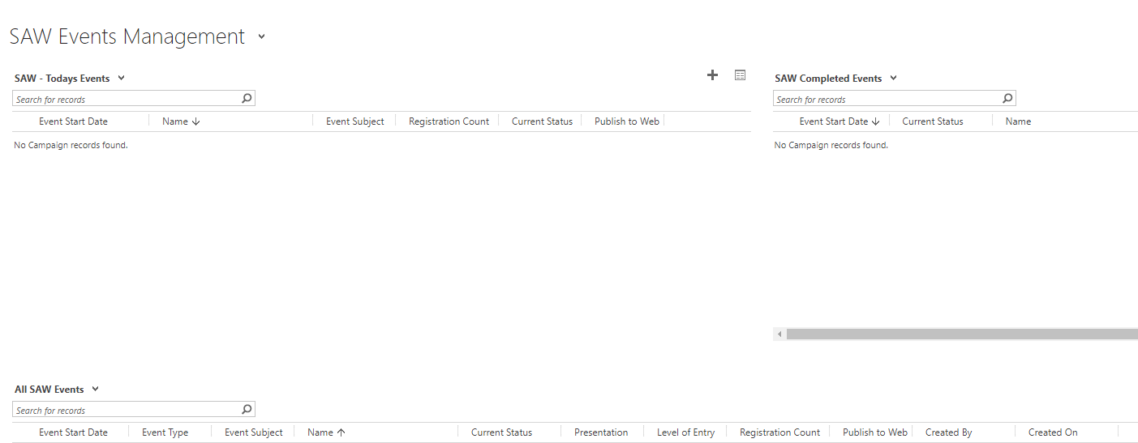

The SAW Events Management Dashboard has 4 views:

1. **SAW: Today’s Events**: Displays all SAW Events at a glance that are being held Today.
2. **SAW: Completed Events**: Displays all SAW Events that have been Completed.
3. **All SAW Events**: All SAW Events in CRM
4. **SAW Upcoming Events**: Displays all future SAW Events.

You can click into the Events from the dashboard, and can pop any view out by clicking on



* You can filter on any of the headings.

**\*Remember you can pin dashboards by clicking on Set as Default at the top of the page\***

1. **Creating an Event**
2. To create an Event, you first need to select the Events entity.
3. Next to Dynamics 365, there will be an Entity Name. e.g. Recruitment /My Work/ Student Services.
4. Click on the downward arrow next to the **Entity Name**.

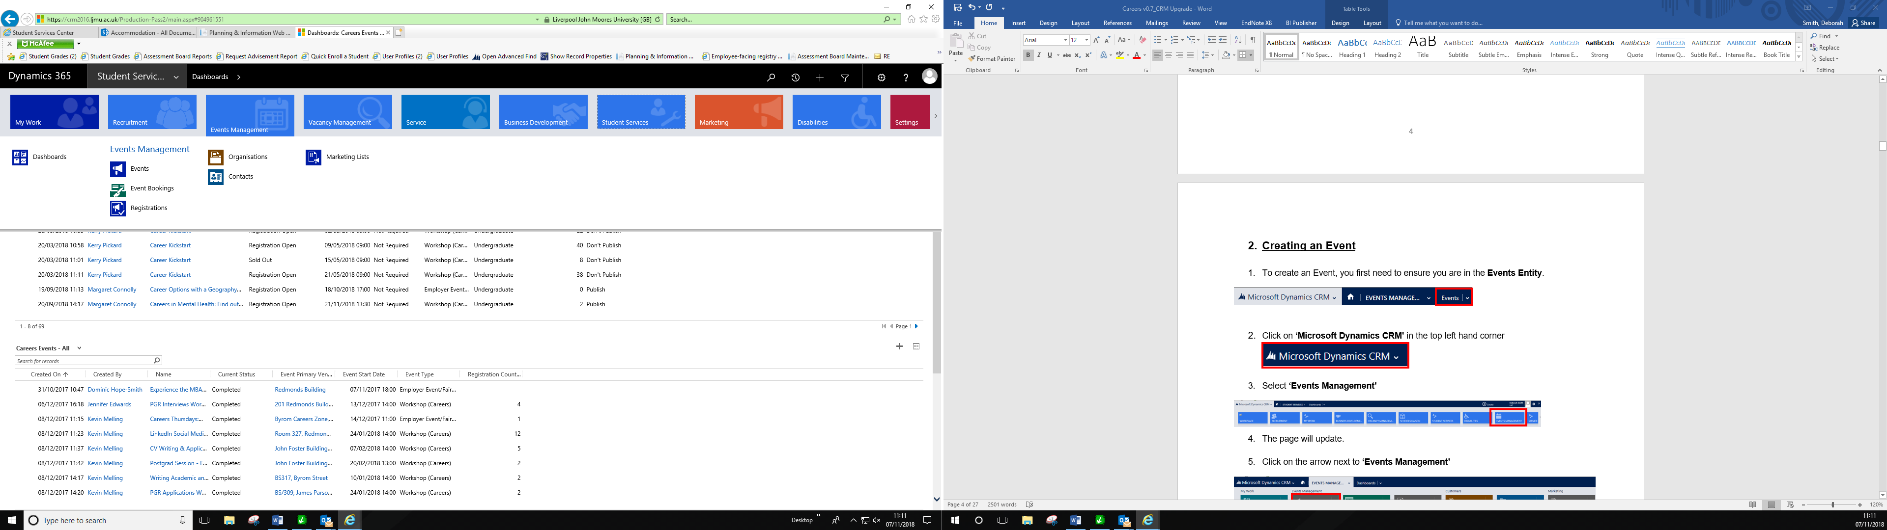

1. Search for **Events Management**
2. Select **Events**

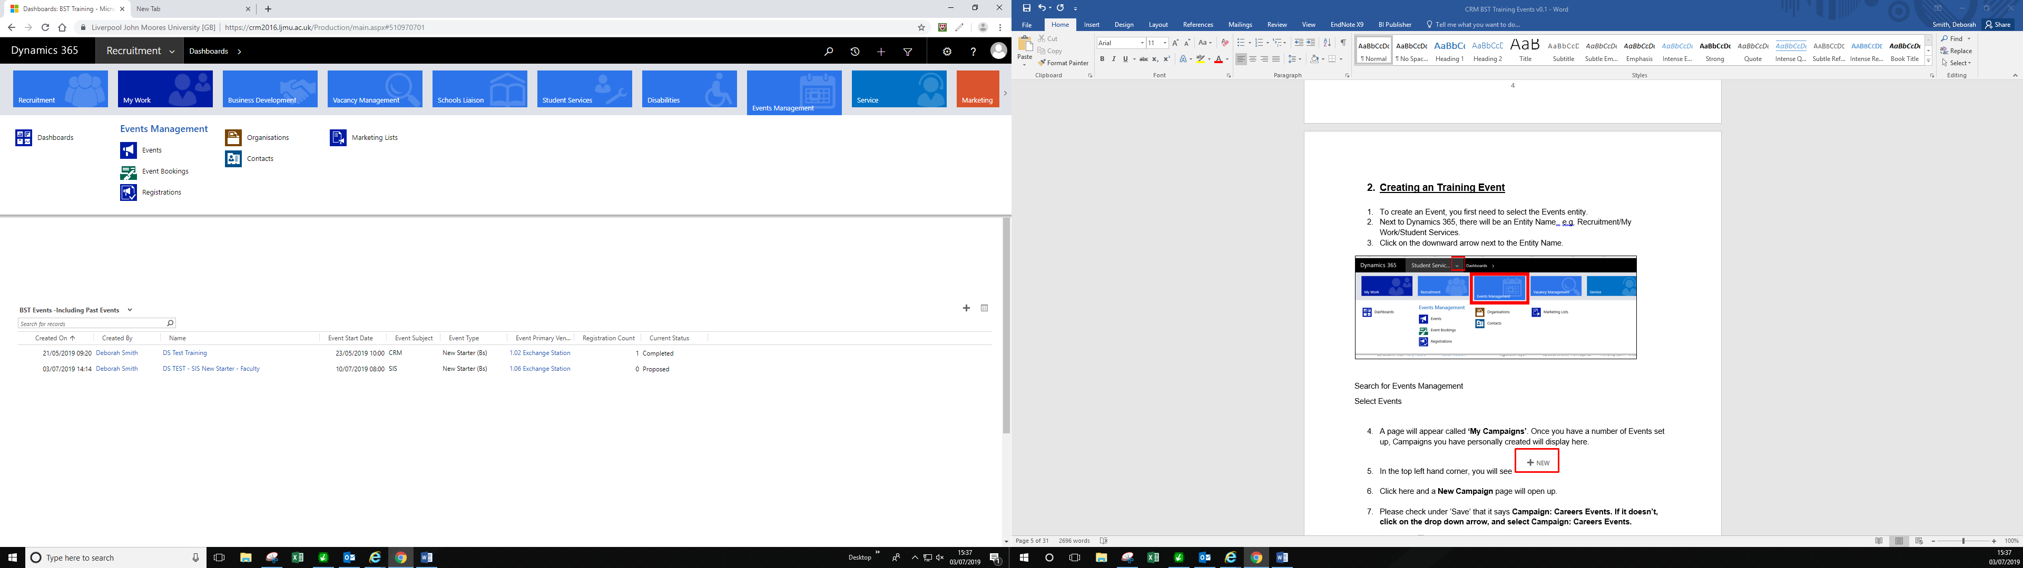

1. A page will appear called **‘My Campaigns’**. You can change this to a more meaningful view if you wish e.g SAW views mentioned above that also appear on the dashboard.
2. If you change the view, then you can pin it by clicking on **Set as Default.**
3. In the top left hand corner, you will see 
4. Click here and a **New Campaign** page will open up.

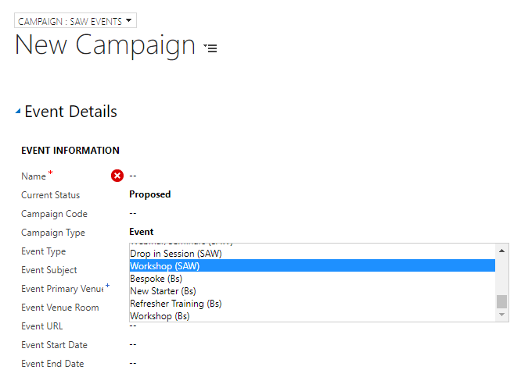

1. Under the Save Button at the top of the page it should state **‘Campaign: SAW Events’**
2. If it doesn’t, you can change this by clicking on the downward arrow.

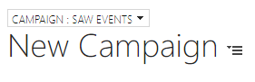

1. On this page, you will need to complete the following:

* **Name:** Enter the Name of the Event.
* **Current Status:** Change this to ‘**Registration Open’**
* **Campaign Type**: Select ‘**Event’**.
* **Event Type:** **Select Seminar/Webinar (SAW), Drop in Session (SAW), Workshop (SAW). Event (SAW)**

**(Drop In Sessions are purely for information, students won’t be able to book on to these Events)**

**The Event Type will NOT be visible to students on the website – just the Event Subject.**

* **Event Subject:** Select **Study Support, Health & Wellbeing, Student Opportunities, Money Advice**
* **Event Start Date:** Enter the Date of the Event and Start Time
* **Event End Date:** Enter the Date of the Event and End Time.
* **Event Primary Venue:** Select the Venue which the Event is taking place.

1. To Look Up the Venue: Click on the magnifying glass icon. 
2. A few venue options will pop up, but if you scroll down to ‘**Look up more records’** a more detailed pop up box will appear to select the correct venue.
3. If the Venue is not set up, then please see section below called : **Adding an Event Venue/Room** and follow the process through.

**\*\*Please be mindful here that you just add the Building the Event is being held into this field. The room is then added separately.\*\***

1. Select your **Event Venue** from the list, by ticking it on the left hand side.
2. Click **Add**

* **Event Venue Room** field underneath and select the **Room** the Event is taking place

1. **To Look up the Event Venue Room:** Click on the magnifying glass icon.



1. A few room options will pop up, but if you scroll down to ‘**Look up more records’** a more detailed pop up box will appear to select the correct venue.
2. If the Venue is not set up, then please see section below called : **Adding an Event Venue/Room** and follow the process through.

* **Event URL:** EnterWebinar URL if using Webinars only.

1. **Saving the Event**
2. Click on Save at the top of the screen  Or
3. Click on the **‘Save’** icon at the bottom right of the screen 
4. Once Saved, you will notice the Name of the Event will appear in the top left corner.

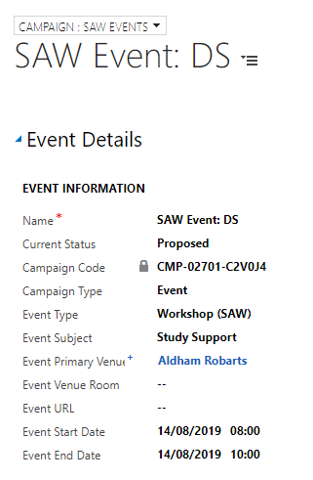

**\*\*PLEASE NOTE: At this point – the Event is NOT Live on the website just yet… We are only partway through setting the Event up.\*\***

1. **Adding an Event Venue and Room.**

If your Event Venue is not available in the list, then you can add this yourself.

* 1. **Adding an Event Venue**
* If the Venue you require is not in the drop down list, you can add a new Venue & Room
* Click on the **look up (magnifying glass icon)**
* Scroll down to the bottom of the list.
* Click on **Look Up New Records**

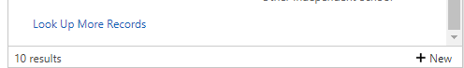

* Click on **New**

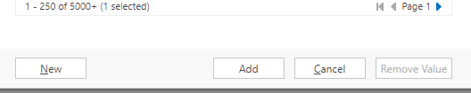

* A new window will pop up.
* Ensure that above the words ‘**New Organisation’** it says ‘**Organisation Venue’**.
* You can change this by clicking on the downward arrow.

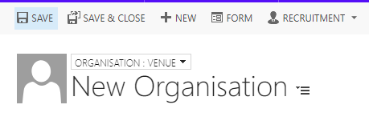

* You will need to complete the ‘Organisation Name’ and ‘Is a Venue’ initially.

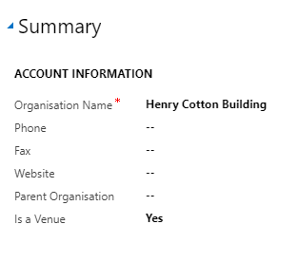

* Scroll down to Address field and enter the address.

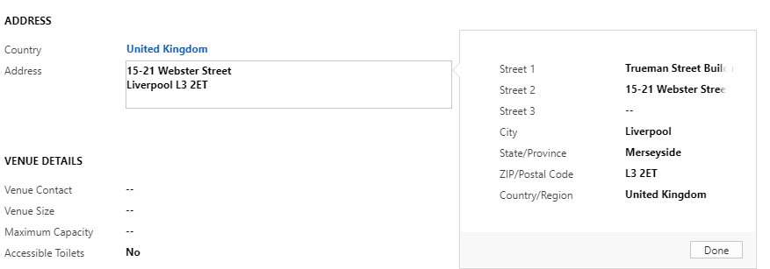

* You can add additional details into **Venue Details** if you wish. This is not compulsory.
* Click **Save.**
  1. **Adding a Room to an existing Event Venue**
* Once you have selected the **Event Primary Venue** on the Event page, click on it.
* You will be taken to the **Organisation:Venue** page

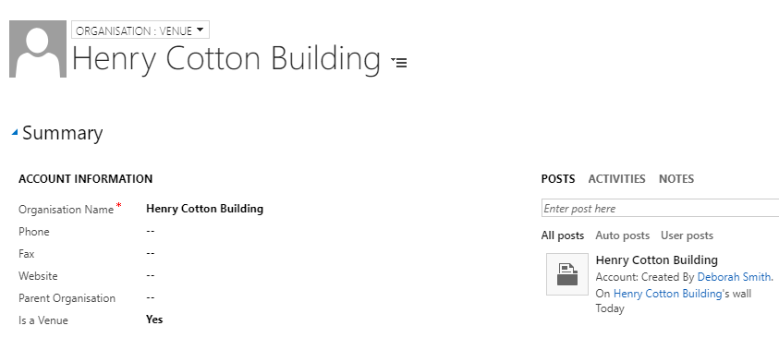

* Scroll down the page and to the right hand side you will see a section called ‘**Venue Rooms’.**

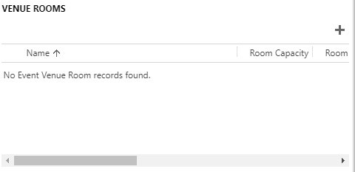

* Click on the **plus** icon.
* Complete the **Room Name**:

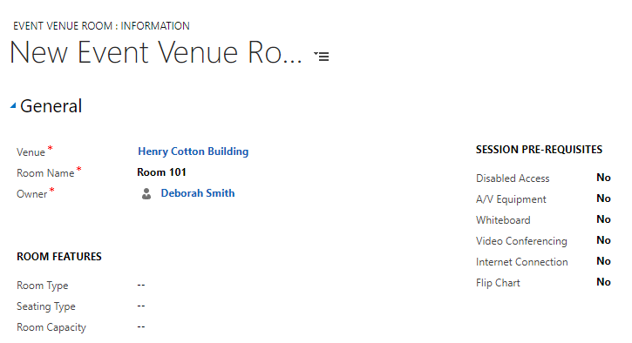

* Click **Save & Close**
* Navigate back to the Event and select the room you have created.

1. **Managing Registration/Restrict Numbers/Waiting Lists**
2. Navigate to the Event Page.
3. Scroll down the page to **‘Delegate Management’**.
   1. **Manage Registration/ restrict numbers**.

Here, you can restrict the numbers attending the Event, and set up a **Waiting List**.

1. To restrict the numbers attending the Event, ensure there is a **‘Yes’** in the **Manage Registration** checkbox
2. Then, enter an amount into the **Maximum Event Capacity** field.

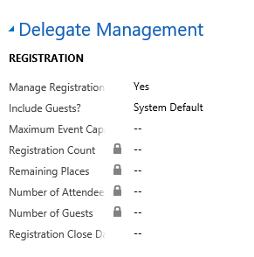

1. Click **Save** (small floppy disk icon in bottom right)
2. The amount entered into the the **Maximum Event Capacity** field will be used to calculate **‘Remaining Places’** at the top of the Event Page.

**\*\*You will need to refresh the page to be able to see this\*\***

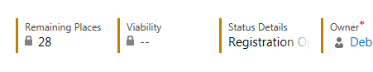

* 1. **Waiting Lists**

1. To add a Wait List to an Event, navigate to **‘Wait List’**.

2. Select **‘Yes’** in the **Waitlist this Event** field.

3. Next, click into **Waitlist Starting Point**, and add the number you wish the Waitlist to start at. This should be the **same** as the **Maximum Event Capacity**. E.g. If you have a capacity of 30, add 30 into the Wait List starting point.

4. **Save (bottom right – floppy disk icon)**

**If a Student is added to a Waiting List, then an Email will be sent to them via an automatic workflow. If a place does later come available, the ‘waiting list’ student will be emailed advising them that space has become available, and inviting them to book on to the Event (on a first come first served basis)**

* + 1. **Increasing Capacity of Event after it has gone to Wait List.**

1. If you wish to increase Capacity of the Event, navigate back to the Event and change both the **Maximum Event Capacity** field and the **Waitlist Starting Point.**
2. Next, change the status of the Event back to **Registration Open.**
3. Students on the Waiting List will then receive an email notifying them that they can now book on to the event via website – this will be **first come first served.**
4. **Publishing your Event to the Website**
5. Once all Registration Detail has been added to an Event, you are ready to make it Live & Publish to the Website.
6. Staying on the Event screen, scroll back up to **‘Event Details’**.
7. Navigate to the section called **‘Marketing’**

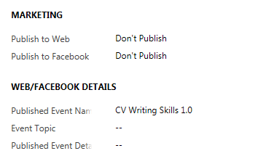

1. Change the **Publish to Web** field to **‘Publish’.**

**\*\*Changing from ‘Publish’ to ‘Don’t Publish’ will remove it from the Website**.**

1. Please ignore **‘Publish to Facebook’** as this is currently not supported.
2. Click into the **Web/Facebook Details** section.
3. Ignore **Published Event Name** and **Event Topic**
4. Navigate to **Published Event Details** field & enter a description/some detail about the Workshop/Webinar. **\*\*This detail will appear on the Website.\*\***

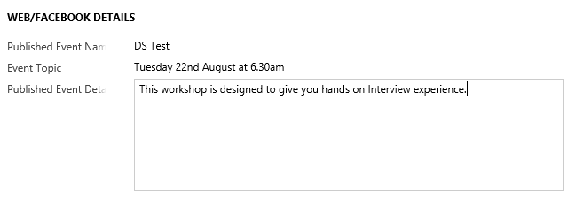

1. Click on the small Save icon (bottom right) 
2. This Event is now live for students to book on to on the Website.
3. **Booking on to an Event**
4. Students can book on to an Event in a number of ways:

* **Self Service: via the Website**
* **Booked on by Staff.**

1. When booked on to an Event an Email will be sent to the Student automatically. Please see details in **Appendix 1**.
2. A reminder of the Event will also be sent 24 hours before the date and time of the Event.
   1. **Via the Website**

The preferred option for booking on to an Event is for students to do it themselves via this web address:

[**https://saw.ljmu.ac.uk**](https://saw.ljmu.ac.uk)

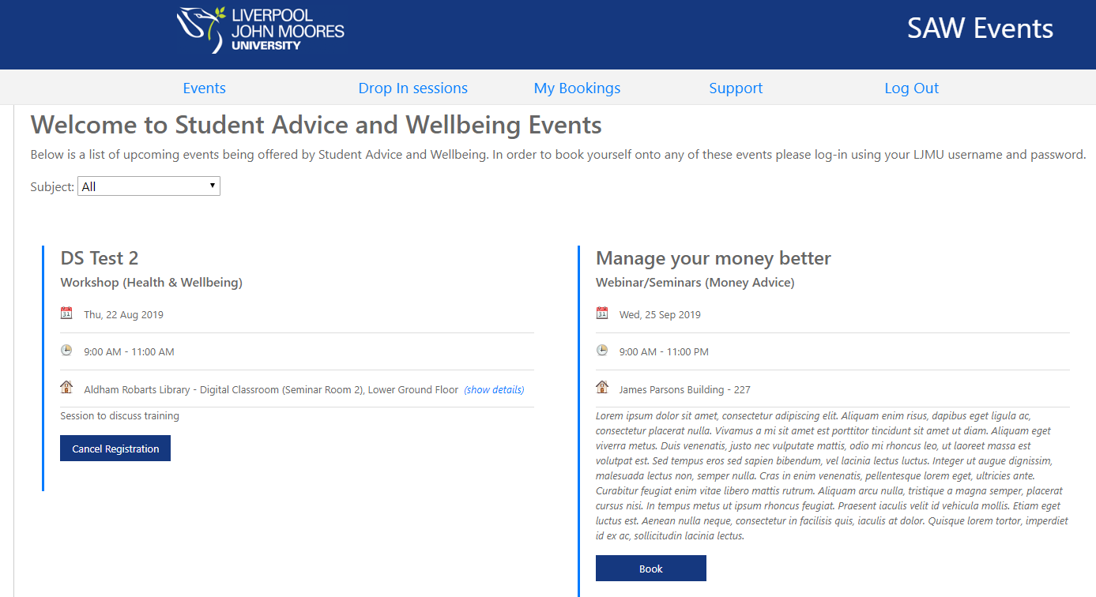

* Students will need to logon using their usual Credentials to gain access.
* They will be taken to a page where they can view all **SAW Events**
* Students can filter **Events by Subject:**
* **Study Support**
* **Health & Wellbeing**
* **Student Opportunities**
* **Money Advice**
* To book onto an Event, students will click the **‘Book**’ button.
* Students will have the option to tick **Receive SMS Reminder**, and add their mobile number if they so wish.
* They will also have the option to tick **‘Additional Support Required’** if necessary and enter details*. (These details will appear on the* ***Event Register*** *in CRM)*
* Then click on **‘Confirm Booking’**
* They will receive a pop up to tell them that their Booking was Successful. This Event will now also appear under **‘My Bookings’**
* **The student will receive an Email (which is sent from CRM) confirming that they have booked on to the event. Please see Appendix 1: Automatic Emails/SMS**
* **Cancelling:** Attendees can also cancel a booking on the website via **My Bookings**. This will remove them from the event in CRM – although you will still be able to see that they booked on the event originally.
  1. **Navigating the website**

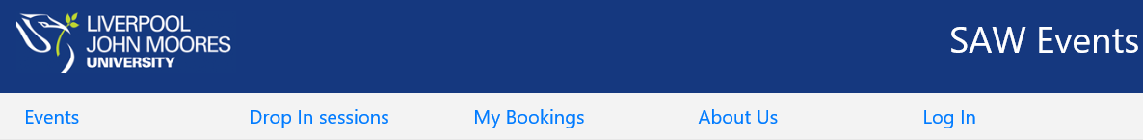

* **Drop In Sessions**

The Drop in Sessions section of the website is for information only. Students cannot book on to these sessions via the website.

* **My Bookings**

Here, students can view bookings previously made and cancel bookings for Events and Appointments if they need to.

* **Support**

This is some information about the support services SAW offer and contact details.

1. **Reviewing Booking Registration in CRM**
2. Back in **CRM**, on the **Event Page,** you are able to review who has booked on to an Event, within the ‘**Bookings’** section.

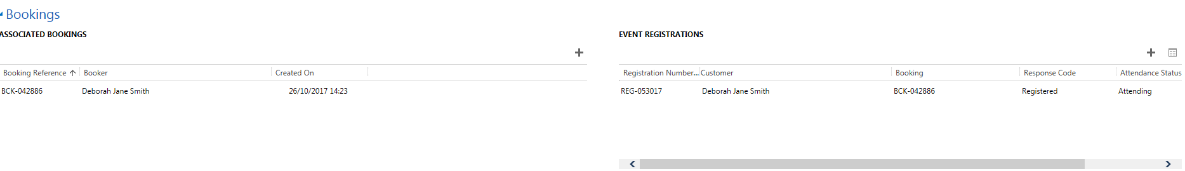

1. All Bookings will appear under ‘**Event Booking’**. This includes if any Bookings have been cancelled. **All Active Bookings will appear under Event Registrations.**
2. **Adding Students on to an Event Manually in CRM**

* Although preferable for students to book themselves via the Website, you may need to manually add a student on to an Event directly into CRM.
* You can do this via the Event page.
* **Once you have added the student, then an Email will be sent to the student automatically from CRM confirming the Booking.**
* **A reminder email will also be sent 24 hours prior to the date & time of the Event.**

1. Navigate to your Event Booking.
2. Scroll down to **‘Bookings’**

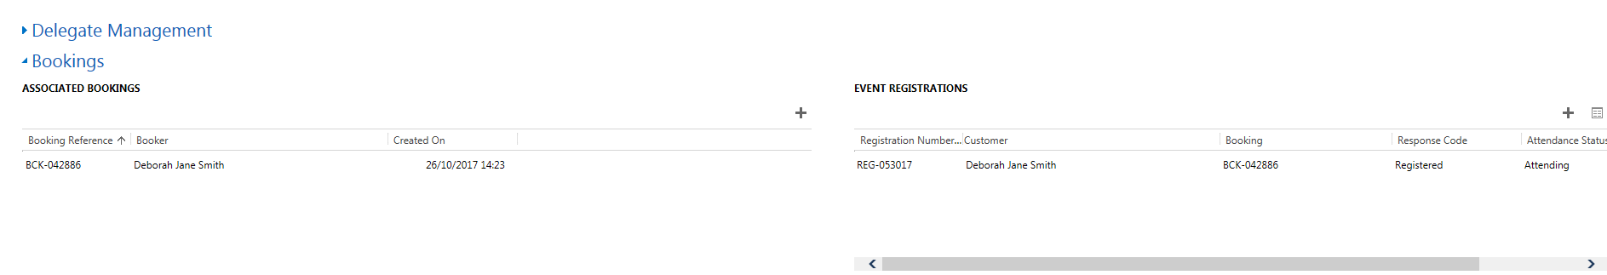

1. Where it says ‘**Event Registrations’** click on the ‘+’.

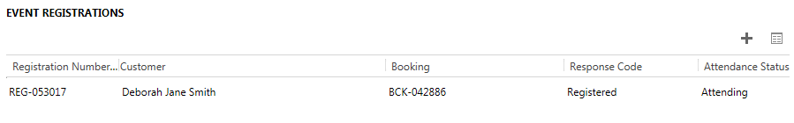

1. **‘New Campaign Response’** box will open
2. **Ensure that the header above ‘Campaign Response is set to Campaign Response: Attendee by clicking on the downward arrow.**

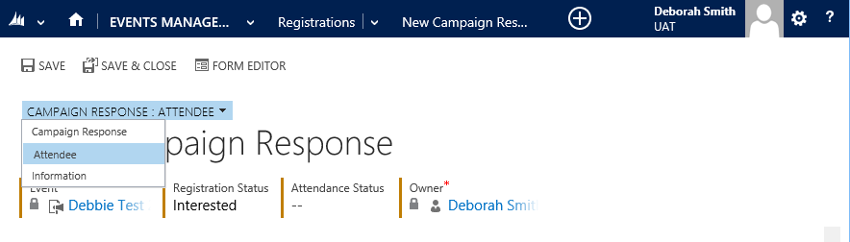

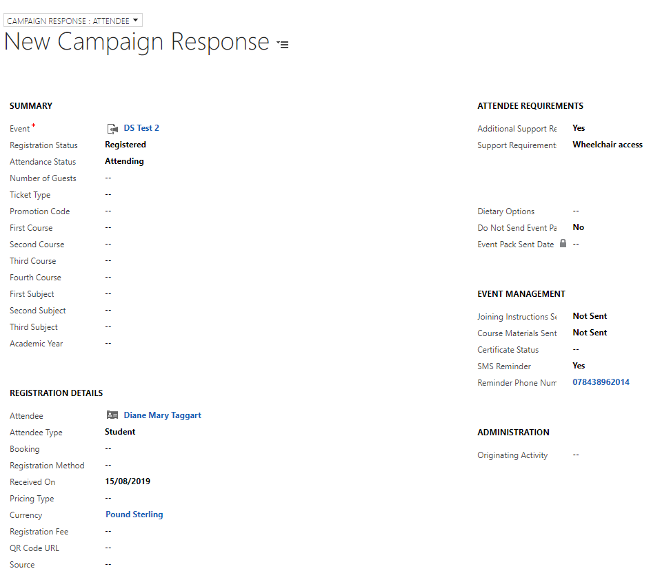

**4**

**3**

**2**

**1**

**4**

1. Click into the **Registration Status field**, andselect **Registered (1)**
2. Next, click into the **Attendance Status field** and select **Attending (or Attended if adding after the Event)**
3. Navigate to the **Registration Details section (2)**
4. Click into the **Attendee** field and search for the student.
5. You can search for the student by using the **wildcard * or by student ID number.**
6. **Once you find the student, click the ‘tick’ to the left of their name and then ‘Add’.**
7. Click into **Attendee Type** and select ‘**Student’**
8. **If the student has any Additional Support Requirements**, navigate to **Attendee Requirements** and complete relevant boxes. **(3)**
9. If the Student would like an **SMS reminder,** then navigate to **’Event Management’, SMS Reminder,** select **Yes** and enter students **Mobile Number. (4)**
10. Make sure you **Save**!
11. **Event Changes & Event Cancellation**
    1. **Event Changes**

If an Event has:

* A Date Change
* A Time Change
* Date & Time Change
* Location Change

You can do this by just updating the ‘Event Page’ and clicking Save.

**Once these changes have been updated in CRM by a member of staff, an Email will be automatically sent to all Attendees advising them of the changes.**

* 1. **Cancelling a Student’s Event Booking**

A student may cancel their booking via the Website, this is the easiest and preferred option! However, a member of Staff may cancel an Event on a student’s behalf.

You can cancel a student’s Event Booking by scrolling to **Bookings**.

1. Navigate to the right hand table ‘ **Event Registrations’**
2. Locate the Student from the list
3. Click on the **Registration Number, it will start with ‘REG –‘**
4. The Campaign Response screen will update.

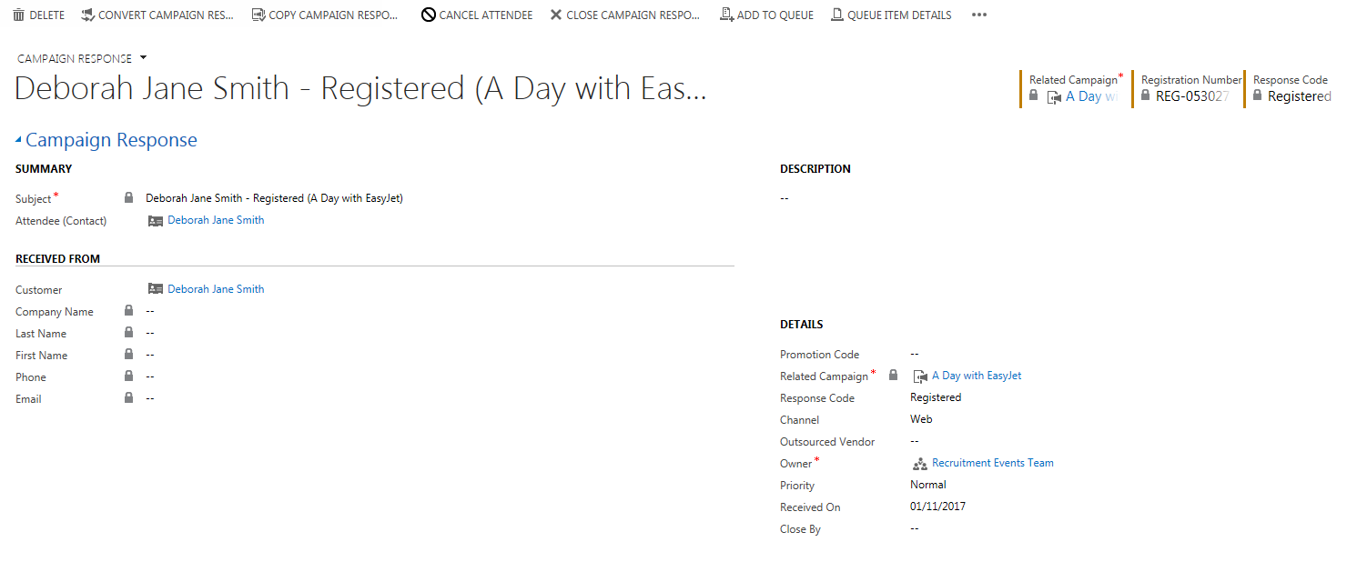

1. Along the top of the screen, you will see ‘Cancel Attendee’ button.



1. Click here, and a **‘Cancel Attendee’** window will open up.
2. Click ‘**Yes’**, as this to ‘**Refund Event Fee’s’**.
3. Click **‘Next’**

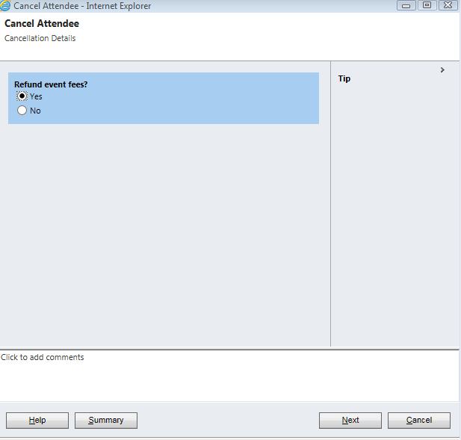

1. Click **‘Finish’**

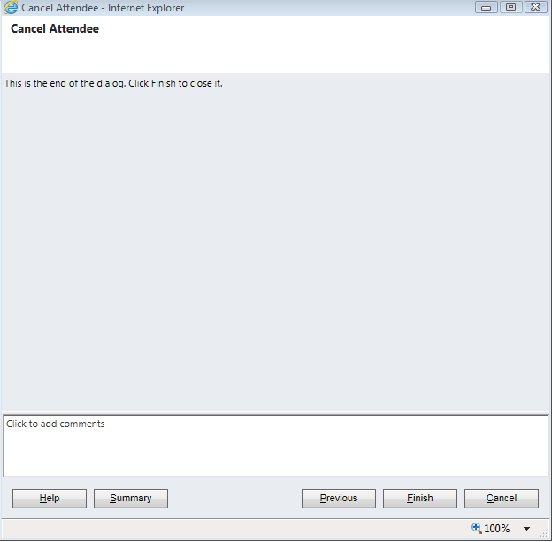

1. You will note that the status has now changed from **‘Registered’** to **‘Registration Cancelled’**.

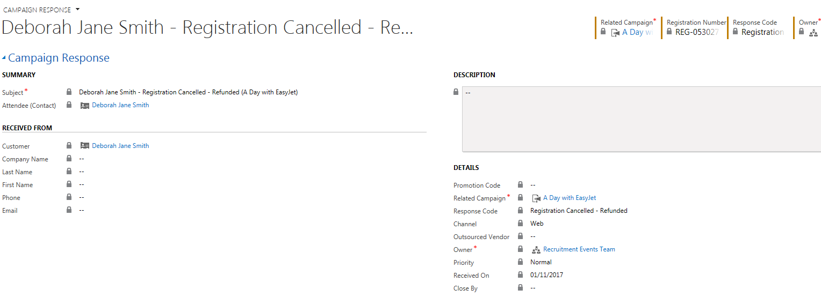

* If you head back to the Event Page
* Navigate to **Bookings** section
* You will note that the students name will no longer appears under Event Registrations. The students name will still appear under Associated Bookings if they booked via the Website.

**Once a student’s booking has been cancelled, then an email will be sent to the student automatically.**

* 1. **Cancelling an Event.**

1. Navigate to the Event Page
2. Click into **Current Status**
3. Update this to **‘Cancelled’**
4. Click **Save.**

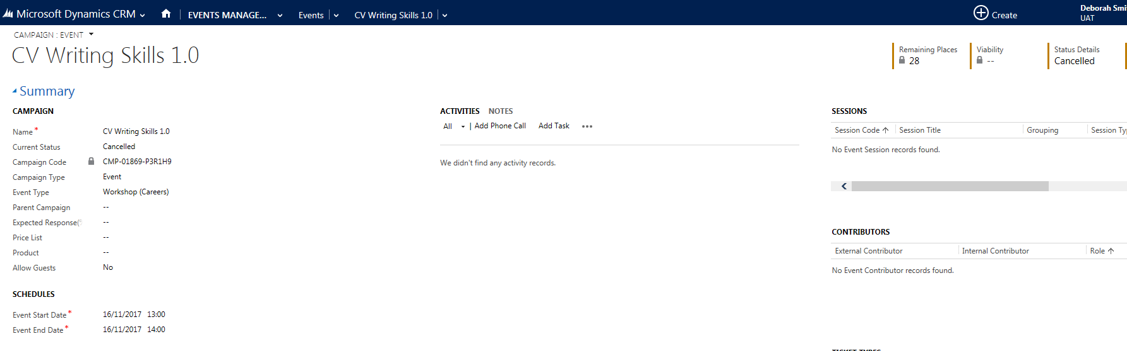

**An Email will be sent to those registered as attending, advising them of the Booking Cancellation**

1. **Event Registration**

**Registering Students Attendance at an Event**

* 1. **Using a Device to scan Student Cards.**
* Please refer to separate guide on how to set up and use the device to scan attendees.
* ‘Scanned’ attendees will update to CRM roughly every hour, and will update their Attendance Status to **Attended.**
* Anyone scanned using a device will be uploaded to CRM and marked as Attended.
* You will still need to go into CRM to mark attendees as No Shows, and add any students who were not captured using the Device.
* You will also still need to complete the Event in CRM (detailed at point 12.)
  1. **Manual Register**
     + 1. You can also export a list of Registered Students for each event on CRM to enable you to tick off who has actually attended. To do this you, must run a report.
       2. At the top of the screen, click on to **the button next to Dynamics 365 button.**
       3. Click on the downward arrow to the right.
       4. Ensure ‘**My Work’** is selected

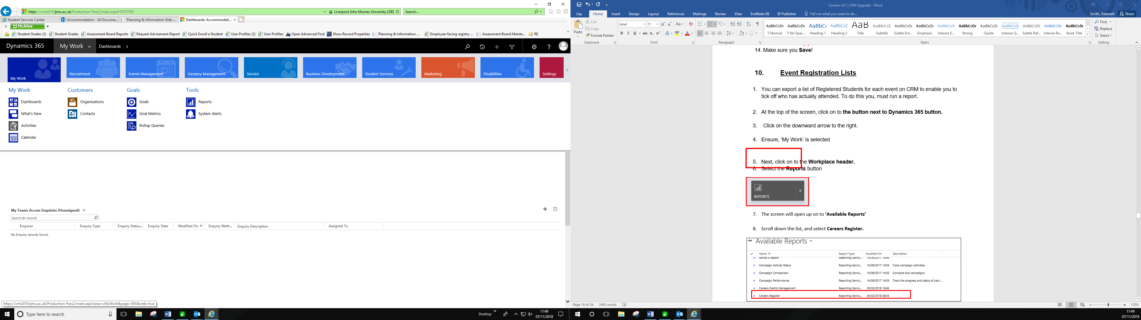

* + - 1. Select the **Reports** button under Tools

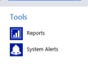

* + - 1. The screen will open up on to **‘Available Reports’**

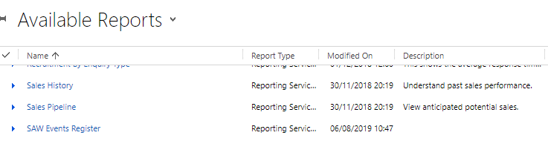

7. Scroll down to find **‘SAW Events Register’**

8. You will need to search for the Event which you wish to view the Registrations for at the top, under **‘Campaign Id’**

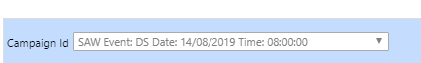

9**.** You can then **Save or Print** this information.

1. **Completing an Event**

Once an Event has been held, all attendees have been added either automatically or manually, the attendees need to have their Attendance Status Updated.

1. To do this, click into the Event & navigate to **Bookings** section.
2. Click into the **Event Registration’s** & ‘pop out’, by clicking on the small square. 



1. A larger window will open up giving a list of students registered to attend the event.

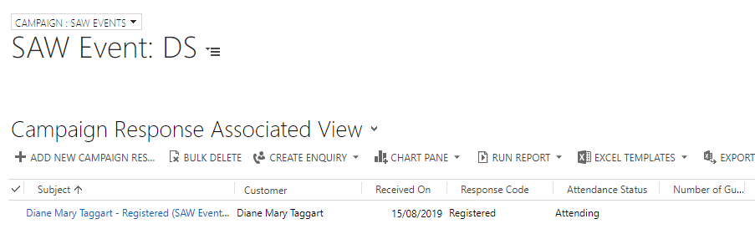

1. If you have used a device to capture attendees at the event then the **Attendance Status** should have updated students to **‘Attended’** automatically.

**\*Please note that this will update roughly every hour\***

1. If a Device was not used, or you need to manage those that have not shown up/scanned in then you can update the **Attendance Status** manually.
2. To the left of **‘Subject’** and the students name you will see a tick column.



1. Once you have ticked against the student, you will notice options appear along the top, Attended and No Show.
2. You will be able to select multiple students, and amend their Attendance Status.
3. Once you have done this, you need to navigate back to the Event so that you can ‘Complete’ it.
4. From the Event page, change the **‘Current Status’** to **Completed**.
5. Click on the ‘**Save’** Icon.

**12.1. Sending Presentation Slides to Event Attendees**

**\*Presentation slides will only send to attendees who have been marked as ‘Attended’ following an event\***

1. To upload the presentation slides navigate to the relevant SAW event.
2. Ensure the form view is set to **CAMPAIGN: SAW EVENTS**

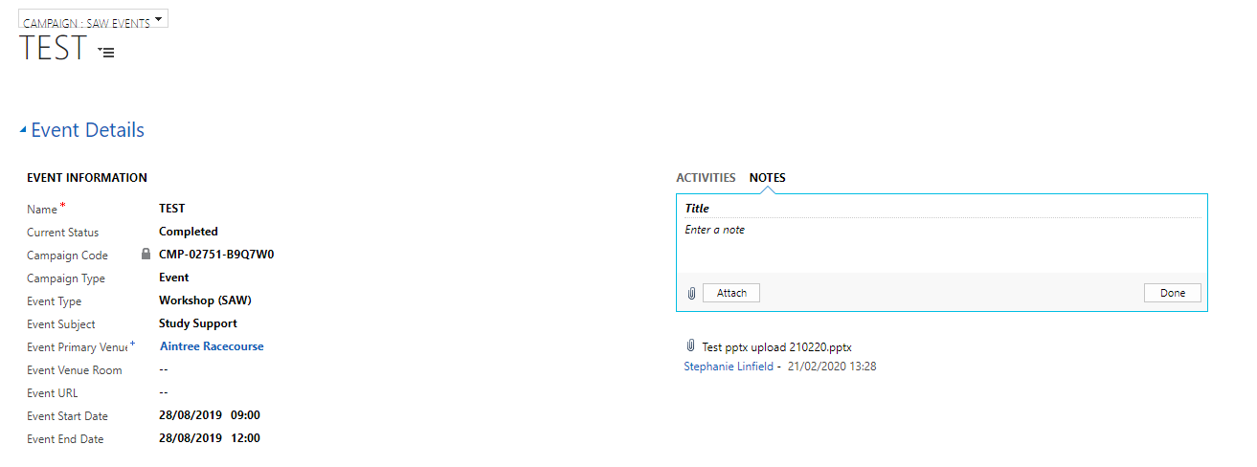

* Click on the **Notes** section header

1. Click in the box and select **Attach** and then **Choose File**

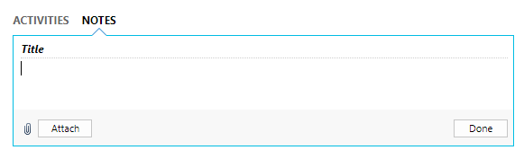

1. Search and Select the correct PowerPoint presentation slides from your PC to upload here. Please note only files in Powerpoint format will successfully send to attendees, no other file types such as Excel, Word will send, so please ensure you select the correct documents.
2. Click **Done**
3. Scroll to the bottom right of the form to **Presentation from Notes**

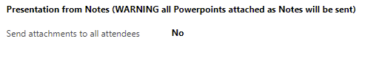

1. Select **Send attachments to all attendees** and set it to **Yes.**

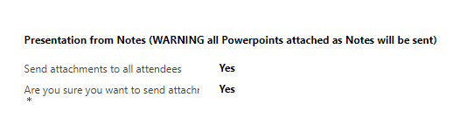

1. You will then be asked to confirm you are sure you want to do this, select **Yes** again
2. Click **Save** in the bottom right corner of the page – Upon saving, an email will then be sent to all the attendees of an event with details of the relevant presentation slides.
3. **Workflow Emails/SMS**

A number of Workflows have been created within CRM to send emails automatically at different stages of the Event process. Emails will be sent to LJMU Email Addresses only. More details on email content can be found in a separate document Appendix 1.

The workflows are:

1. **Booking onto an Event**
2. **Reminder of an Event**
3. **Event Change**
4. **Event Cancellation**
5. **Post Event Survey**
6. **Event full – on a waiting list**
7. **Event full – on a waiting list and place becomes available.**

Any changes to Workflows, need to be requested via Helpdesk.

SMS will be used in the following situations:

* **Reminder of Event** (If student opts for this and adds mobile number).
* **Event Cancellation** (by SAW)
* **Event Change** (Venue/Room/Time)