Process Document

CRM – Student Advice & Wellbeing
Liverpool John Moores University

Student Advice & Wellbeing
Dashboards

Version 0.2, November 2018
Author: DS Business Support Team
Contents
- Dashboards

  - Pinning a Dashboard

  - Views:
    - Pop Out
    - Sorting

- Default Dashboards:

  - Dashboard: SAW Disability Dashboard

  - Dashboard: SAW Finance Welfare Dashboard

  - Dashboard: SAW Counselling

  - Dashboard: Advice Welfare Dashboard

  - Dashboard: Student Engagement

- Dashboards
Each team with SAW has their own Default Dashboard.
Within CRM, the Dashboard acts as a sort of Home page.
You can also create your own personal Dashboards, and new Team Dashboards. If you want to amend/set up a new Dashboard to be shared with a team, we recommend you contact Helpdesk in the first instance.
Dashboards can display various information including charts and lists. To add information to a Dashboard, then a View must first exist.
A View is basically a Query which has been set up to bring back a list of information within the parameters selected. An example of a View is ‘Emails to be Processed’
  - Pinning a Dashboard
If you do use a number of Dashboards, then you can also pin a particular Dashboard so that it appears as a Default when you log in:

To do this, select the Dashboard, and select ‘Set as Default’.
  - Views

    - ‘Pop Out’ Function
You may find the Views within the Dashboard cut off information.
You can ‘pop out’ the view from the Dashboard by clicking on the button below:
    - Sorting
Remember that from within the pop out you can sort or arrange any information by clicking on the headers. You can sort (Ascending, Descending, numerical or alphabetical).
Additionally there is a Search box in the top right where you can search for a student.

- Default Dashboards

  - Dashboard: SAW Disability Dashboard

The Views are:
Emails to be Processed: Emails awaiting to be processed by the team
SAW Disability Emails relating to an existing record: Emails which have come in which relate to an existing Contact record.

  - Dashboard: SAW Finance Welfare Dashboard

The Views are:

- Emails to be Processed
- SAW Finance Teams Emails Related to existing record
- SAW Finance Enquiries
- Current Open Cases

  - Dashboard: SAW Counselling

Emails to be Processed: Emails awaiting to be processed by the team
SAW Counselling Emails relating to an existing record: Emails which have come in which relate to an existing Contact record.
Current Open Cases: All Current Open Cases.

  - Dashboard: Advice Welfare Dashboard
Emails to be Processed: Emails awaiting to be processed by the team
SAW Advice team emails relating to an existing record: Emails which have come in which relate to an existing Contact record.
Current Open Cases: All Current Open Cases.

  - Student Engagement Dashboard

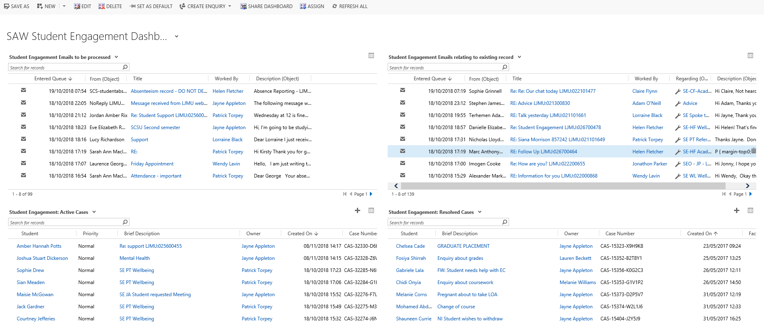
Student Engagement Emails to be processed: All new emails emailed to queue NOT set regarding a Case.
Student Engagement Emails relating to existing record: All emails emailed to queue set regarding a Case
Student Engagement: Active Cases: All Active Cases for Student Engagement Team
Student Engagement: Resolved Cases: All Resolved Cases owned by Student Engagement Team

Student Engagement Team also have Personal Dashboards which contain the following views:
- Student Engagement Emails: Worked by
- My Sent Emails
- My Active Cases
- My Resolved Cases

