Process Document

CRM – Student Advice & Wellbeing
Liverpool John Moores University

Student Advice Wellbeing: Disability Team
Processing a Case

Version 2.0, November 2018
Author: DS Business Support Team

Contents

- Contact: Disability Team

- Processing a Disability Case

- Activities

- Processing the Case: Initial Contact

- Processing the Case: Evidence

- Processing the Case: Application Stage – Assessment Report

- Processing the Case: Application Stage

- Processing the Case: Funding Approvals

- Processing the Case: Needs Assessment

- Processing the Case: Learning Plan

- Processing the Case: Resolve

- Automatic Emails

- Contact: Disability Team

Before creating a new case, it is important to check the students Contact record first. The reason for this is because certain pieces of information need to be recorded against the student’s record.
Information that can be completed here:

- Is Disabled Student:
- Disability One
- Disability Two
- Details of the Disability can also be added via the Disability Details section.
- Disclosure Entity
Refer to Create a Contact guide for more Information on the above.

- Processing a Disability Case

Once you have created a case (details available in separate guide: ‘Creating a Case’), you will notice the chevrons along the top of the screen. These chevrons effectively make up the Case Management Flow for the case you have created. This flow will take you through the life of the case from beginning to resolution. The Case Management Flow changes depending upon the Subject selected on Case creation. For Disability cases the correct Case Management Flow is the ‘Initial Contact to Learning Plan’ process.

For all Advice queries, the Subject selected will be ‘Disability’ or a sub –subject of Disability. This will ensure that the correct process is used.

The Initial Contact to Learning Plan Process is only used for all Disability cases and currently has six stages.

- Activities

There are separate guides for:

- Adding Phone Calls
- Adding an Appointment
- Uploading Documents
- Sending Emails
- Adding Notes

You can complete any of the above at any point throughout the life of the case.

- Processing the Case: Initial Contact

This is the first stage of the case, and is about ‘acknowledging’ the case.
You will need to complete:
- Find Customer- Mandatory Field - Will autofill from the Student Name once Case has been created.
- Contact Method- Mandatory Field - Select from Walk In, Phone, Email, Web, Facebook, Twitter, Appointment.
- Eligible – Yes/No
- Acknowledged- Yes/No. This is selected to indicate that the ‘New Case’ has been reviewed. This needs to be Yes to carry onto the next stage
- Acknowledgement – Date will autofill.

- Processing the Case: Evidence
No Fields are Mandatory.

  - Medical Evidence: Dropdown options including N/A, Not Provided, Provided, Requested, Questionnaire.
  - SPLD Evidence: Dropdown options including N/A, Not Provided, Provided, Requested, Questionnaire.
  - Other Evidence: Dropdown options including N/A, Not Provided, Provided, Requested, Questionnaire.
  - Questionnaire Given: Select Date
  - Questionnaire Received: Select Date

Automatic Email may trigger at this point:
Send Evidence Reminder Email: This triggers when the record is created and it is a Disability case. SPLD/Medical or Other Evidence is requested. The email will be sent 2 weeks after the case is created.

Notes: At this point, you may wish to upload any evidence received, or add Notes to record information. Please refer to relevant guides to do so.

- Processing the Case: Application Stage - Assessment Report
On completing the Evidence stage, and clicking Next, you will be prompted to add an Assessment Report.

Click on to the ‘Create’ plus symbol.

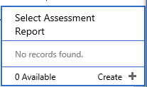

Once you have clicked on ‘Create’ you will be taken to the Assessment Report Form.
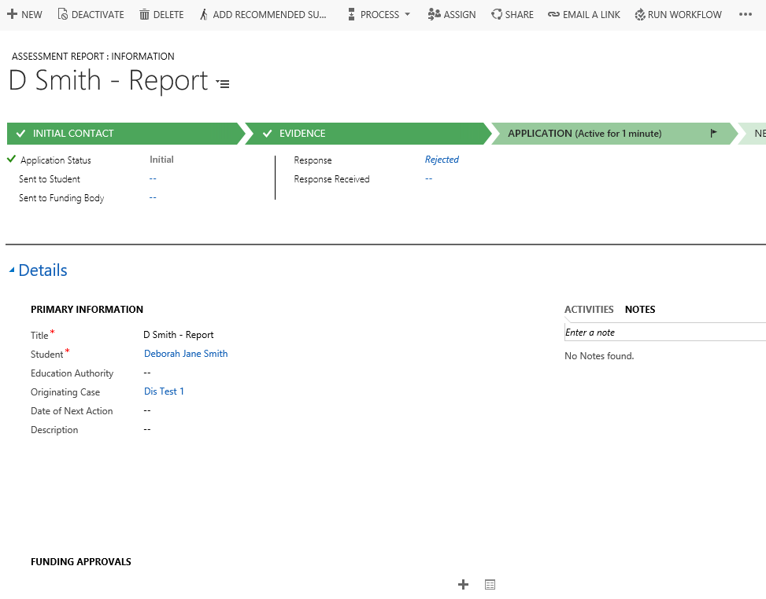

Title: This will be the title of the Report, e.g. Students Name/ Application
Students Name: This will Autofill with the Students Name.

Complete any other relevant fields.

Click Save

- Processing the Case: Application Stage

- Application Status: Initial – This will be auto selected.
- Sent to Student: Date the Application was sent to student
- Sent to Funding Body: Date the Application was sent to the Funding Body
- Response: Accepted/Rejected
- Response Received: Date Response was received.

Automatic Email may trigger at this point:

- Send Email on Send to Funding Body – This triggers when the record is created and Sent to Funding Body is populated with a date.
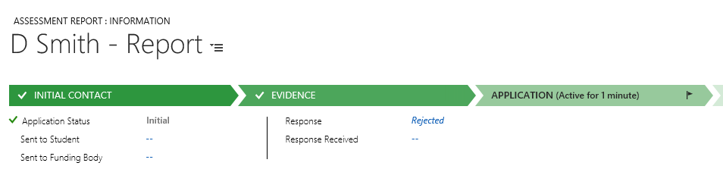

- Processing the Case: Funding Approvals

To add a Funding Approval, navigate to the Funding Approvals sub grid section in the main window, and click on the plus sign.

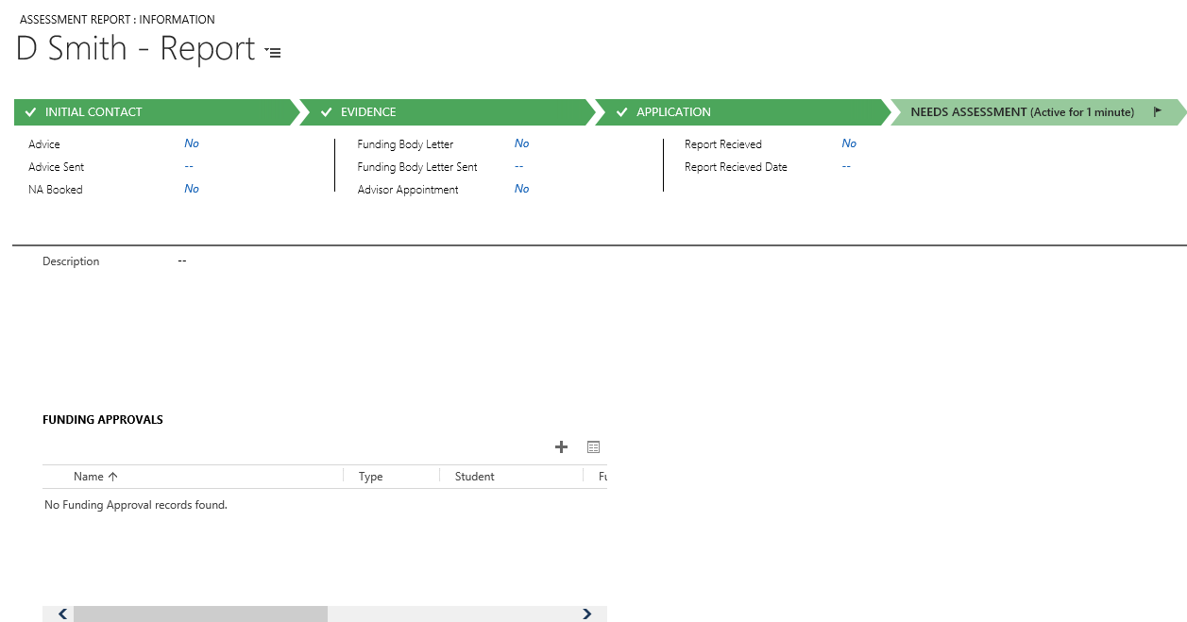

You will then be able to select the Approval you require from the list, or add a new Approval by clicking on the ‘+New’ button.

- Adding a New Funding Approval

Click on the + button.

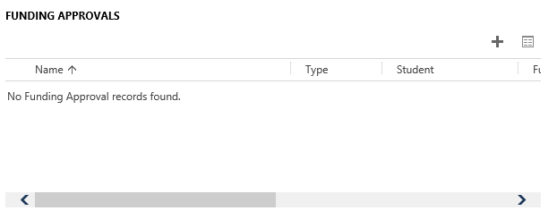

Click on Look Up
Click on ‘New’

The new Funding Approval Form will appear:

Mandatory fields include:

Name: Name of Funding Approval
Funding Source: Choose from Menu
Email: Students Email.

‘Student’ is not a Mandatory field, however, if a student is selected, then the students email will populate.

- Processing the Case: Needs Assessment

- Once Approval for Funding has been received, then the next stage would be the Need Assessment Appointment.
You will need to set up the appointment with the student via Outlook, and then also add the Appointment on to CRM using the Adding an Appointment guide. (Current issue regarding

Next, you would complete the process fields.

Please Note: All fields are Non Mandatory.

- Advice
- Advice Sent
- NA Booked
- Funding Body Letter
- Funding Body Letter
- Advisor Appointment
- Report Received
- Report Received Date
A number of Automatic Emails may be sent out at this stage of the process:

- Send Email on NA Advice Acknowledgment – This triggers when the advice is changed is set to ‘Yes’.

- Sending NA Reminder Email – This triggers when Advice is updated. The system will then wait for 7 days. If after 7 days, NA Booked does not equal Yes and Assessment Report received does not equal Yes – Email will be sent.

- Send Email NA Report Received – When Report received is set to ‘Yes’.

- Send Funding Body Email – When Funding Body Letter is updated and Funding Body Letter Sent field is completed.

- Send Email Reminder for Funding Body Letter – If Funding Body Letter is updated , and Advisor Appointment is not set to yes within 14 days.

- Processing the Case: Learning Plan

No Fields are Mandatory
- Support Implemented: Yes/No
- ISLP: Yes/No
- ISLP Sent: If Yes is selected in the ISLP field, then the date will default to today’s date.
- ISLP Approval Method: Web/Form/Email
- ISLP Approval Required: Date Approval is Required by.
- ISLP Approval Rejected: Date Approval was Rejected
- ISLP Approval Rejected Reason: Reason for Approval Rejection.
- ISLP Approval Received: Date Approval was received.
- ISLP DisCo Date: Date field.
- ISLP DisCo: Free Text field.
Emails
- ISLP Approval Send Student Email – When record is created or ISLP updated. If ISLP – Yes and ISLP sent for Approval – Send Email. – Email will now not be sent out automatically – on demand process.

- ISLP Reminder Email –

When ISLP is updated and ISLP Sent for Approval is Updated. Then Wait for 14 Days :
- If ISLP Approval Method is Empty AND ISLP Approval Received is Empty then
- Send a reminder Email
- OR IF ISLP Approval Method is empty AND ISLP Approval Rejected is Empty then
- Send a reminder Email

- Processing the Case: Resolve

- Once you click into the Resolve case – Mark Resolved, this will bring up the Resolution window.
Please Note: You will not be able to Resolve a case until all Activities have been ‘Completed’.

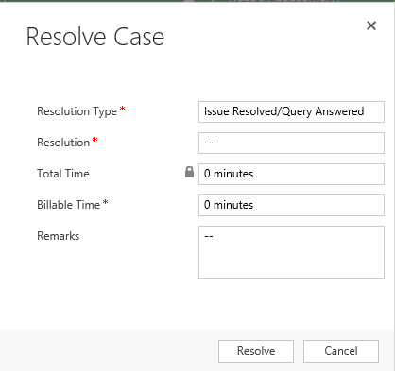

In the Resolution window, you will be able to fill in the following fields:
- Resolution Type – How you resolved the Case
- Resolution – Free Text box, brief description of resolution.
- Billable Time – This is a new field. It is NOT Mandatory. Do not complete this field.
- Total Time - This will be a read only field, as it has added up all of the time spent on the Activities created against this Case.
- Remarks -Here you can add in any further comments with regards about the Resolution here.

    - Click on ‘Resolve’ to Resolve the case.

    - The Status of the Case will automatically change to ‘Issue Resolved’.

- Automatic Emails

The Disability Workflow has some processes attached to the Workflow, which when run, will automatically send emails. These have been outlined above at the respective point in the process that they will be triggered. They are also listed below:

- Send Evidence Reminder Email: This triggers when the record is created and it is a Disability case. SPLD/Medical or Other Evidence is requested. The email will be sent 2 weeks after the case is created.

- Send Email on Send to Funding Body – This triggers when the record is created and Sent to Funding Body Changes

- Send Email on NA Advice Acknowledgment – This triggers when the advice is changed is set to ‘Yes’.

- Sending NA Reminder Email – This triggers when Advice is updated. The system will then wait for 7 days. If after 7 days, NA Booked does not equal Yes and Assessment Report received does not equal Yes – Email will be sent.

- Send Email NA Report Received – When Report received is set to ‘Yes’.

- Send Funding Body Email – When Funding Body Letter is updated and Funding Body Letter Sent contains Data.

- Send Email Reminder for Funding Body Letter – If Funding Body Letter is updated , and Advisor Appointment is not set to yes within 14 days.

- ISLP Approval Send Student Email – When record is created or ISLP updated. If ISLP – Yes and ISLP sent for Approval – Send Email. – Now On Demand Process.

- ISLP Reminder Email –

When ISLP is updated and ISLP Sent for Approval is Updated. Then Wait for 14 Days :
- If ISLP Approval Method is Empty AND ISLP Approval Received is Empty then
- Send a reminder Email
- OR IF ISLP Approval Method is empty AND ISLP Approval Rejected is Empty then
- Send a reminder Email

Note: Content of the emails can be found within ‘Disabilities Workflow Emails’ document.

