Process Document

CRM – Student Advice & Wellbeing
Liverpool John Moores University

Student Advice and Wellbeing
Manually Sending an On Demand Email

Version 0.2.
Author: DS Business Support
The Disability Advice Team have opted to send some Emails out automatically. The Emails and when they are automatically sent out are detailed separately in the ‘Disability: Processing a Case’ document.

The ISLP Approval Send Student Email has been set as an On Demand email. This means that this email will be created, but not be sent out automatically. Sending of the email will be a Manual Process. The instructions below will assist you sending an On Demand email.

- Ensure you are in the correct case and ensure that the selected chevron is ‘Learning Plan’. The email will not send if any other chevron is selected.

- Click on Run Workflow on top toolbar

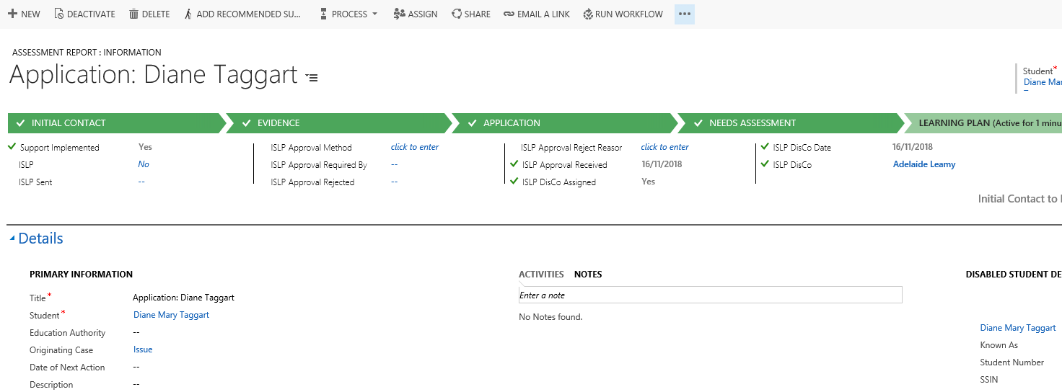

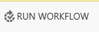

- Once you have selected Run Workflow, the Look Up Record window will appear.

- This window will show the Process which is available to run – ISLP Approval Send Student Email.
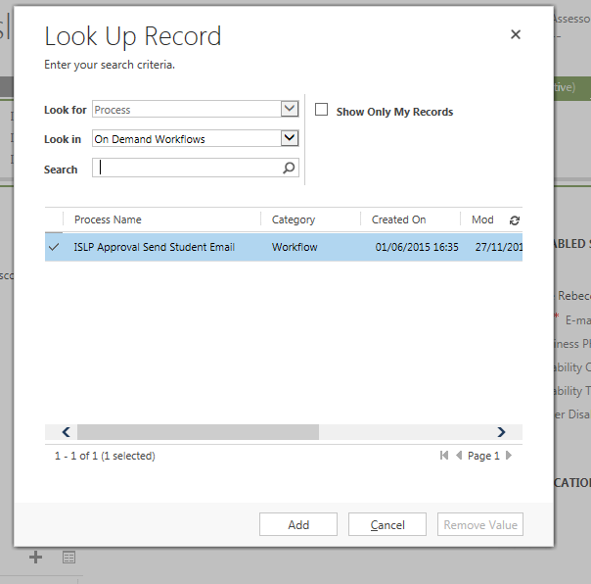

- Next, click Add.

The email will now be sent out as part of the Workflow process.

