Process Document:

CRM – Student Advice & Wellbeing
Liverpool John Moores University

CRM Activities: Adding a Phone Call

Version 0.2, October 2018
Author: DS Business Support Team

Adding a Phone Call to a case in CRM

Phone calls will be added retrospectively.
There are several ways of adding a Phone Call Activity to a case. However, it is important that you follow the following process so that the time spent on the phone call is correctly recorded. Any other way of adding the phone call may mean that time spent is not captured.

- In order to record a Phone Call you must first ensure you are in a Case and not a Contact record. Check you are in a case by looking for the ‘chevrons’ which will appear along the top of the screen, as shown below.
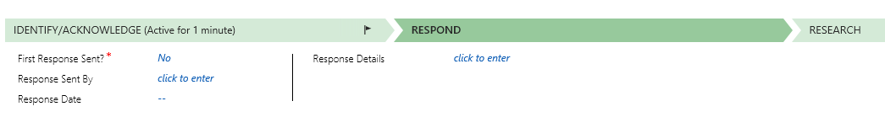

- Once you are in the correct case, navigate to the middle of the screen, and click on ‘Activities’

- Click on the small square box next to the funnel icon.

- This will open up the Activities Associated view page:

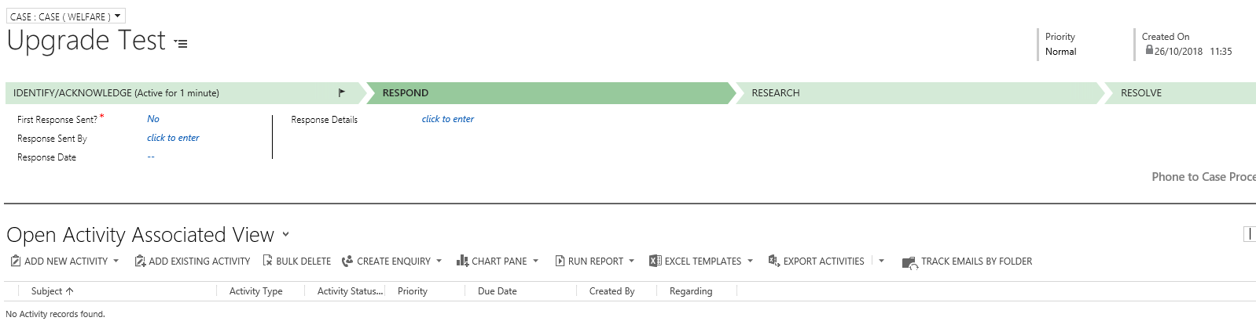

- From here, you can click on ‘Add a New Activity’:

- When you select ‘Phone Call’ from the list, the ‘New Phone Call’ window will open. You will note that the Call From information is already completed for you. However, you will need to enter ‘Call to’, a Subject, and a Description of what was discussed in the call.

- Please note that ‘Description’ will look like a blank space, however if you click into the box, you will see it is a free text field.

- Finally you would need to ensure you correctly record the time spent on the phone call. You can select the duration from the drop down list, or type the actual time spent.

- Click on to the Save and Close Icon once you have completed all relevant information.

- Return to the case by clicking on the Case Name on the top ribbon. When you return back to the case, the saved phone call will show under ‘Activities’ in the centre of the screen. You may have to refresh the screen to check it appears.

- Before resolving the case, you will need to ‘Complete’ all phone calls. You can do this by clicking on the top right hand corner of the activity, and clicking on the word ‘Complete’.

