Process Document

CRM – Student Advice & Wellbeing
Liverpool John Moores University

SAW Finance Team
Processing a Funding Application

Version 0.3 November 2018
Author: DS Business Support Team
Contents

- Processing a Funding Case – Advice

- Processing a Funding Application Case (Discretionary Funds)

- Activities

- Processing Funding Advice Case

A case will be created for the student. Please see Creating a Case Desk guide.

For the Funding Team, the case will either have a Subject of:

- Funding/Money or Discretionary Funds.

If the case is an ADVICE case then the subject will be Funding/Money and the Workflow will be the Simple Phone to Case Process. Details on how to process these cases are detailed in the guide: Processing an Advice Case. The chevrons across the top will display as below:
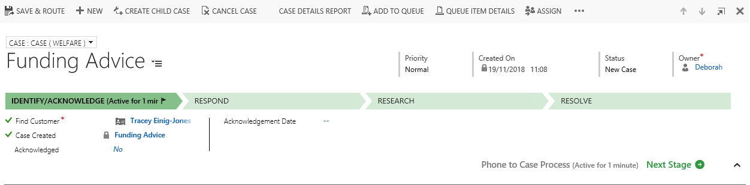

- Funding Application Case

If the case involves a FUNDING APPLICATION then the subject will be Discretionary Funds and the Workflow will be the Initial Contact to Funding Application Process. The chevrons across the top will display as below:

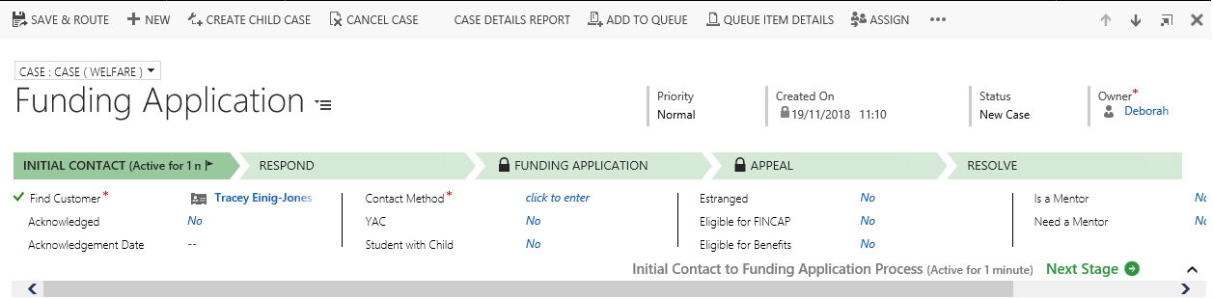

  - Initial Contact
You will note that the Name of the Student will have already be populated.
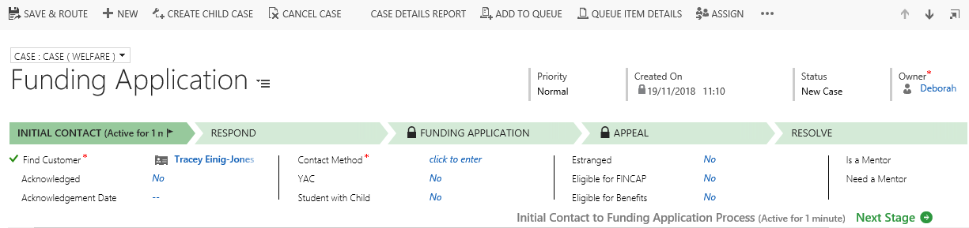
Mandatory fields in this section are:
- Find Customer – Already populated.
- Contact Method - This is where you will record how the student first got in contact with you.
Non Mandatory fields are:
- Acknowledged: Change to yes if you email the student to acknowledge application.
- Acknowledgement Date: If yes is selected for Acknowledged, then the date will default todays date.
- YAC
- Student with Child
- Estranged
- Eligible for FINCAP
- Eligible for Benefits
- Is a Mentor
- Need a Mentor

Note: You will need to acknowledge the Application by emailing the student (Please see guide on Activities – Sending Emails)

  - Respond

    - This is the second step of this workflow.
Mandatory fields include:
- First Response sent: Yes/No

Non Mandatory fields include:
- Response Sent By
- Response Date
- Response Details
- Allocate Appointment
- Documentation

    - If you organise an Appointment then you will need to arrange it separately via your Outlook and then also record it on CRM. Please see separate guide on Adding Appointments for details.

    - If you need to upload any Documents, then please seem separate guide on Uploading Documents.

    - Next, click on to the Next Stage.

    - A box will pop up, and will give you the option to Select Funding Source.

    - Click on the Create button to open the Funding Source Form.

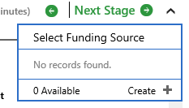
  - Funding Source Form
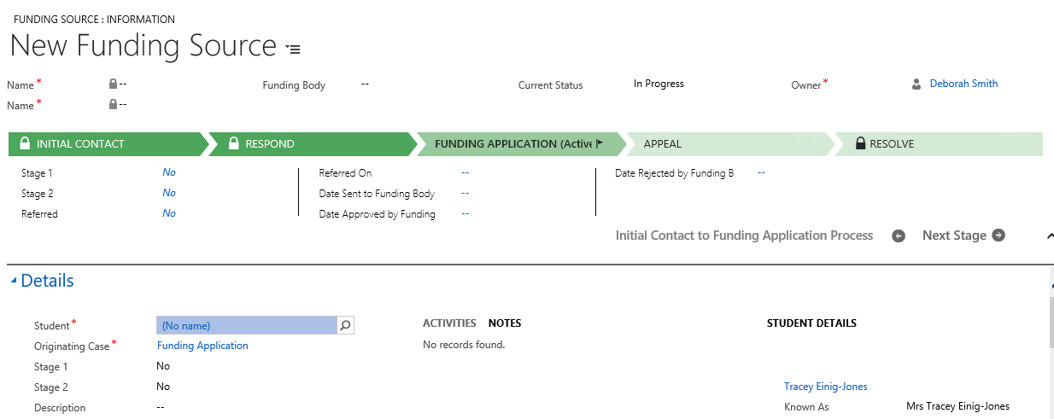
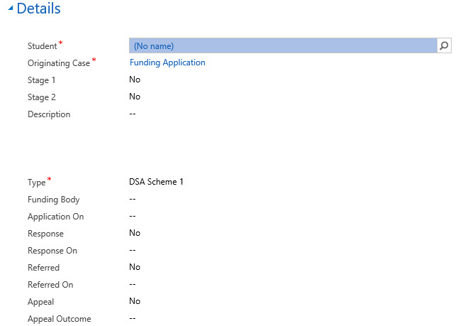
    - Fields to be completed include:

Mandatory fields:
- Student
- Orginating Case

You will also need to complete the Type field. The Type field will default to DSA Scheme 1.

Other options include:
- DSA Scheme 1
- DSA Scheme 2
- DSA Scheme 3
- Institution Access Grant
- Motability
- Social Services

    - Click on to Next Stage.

    - You will return to the Funding Application step.

  - Funding Application

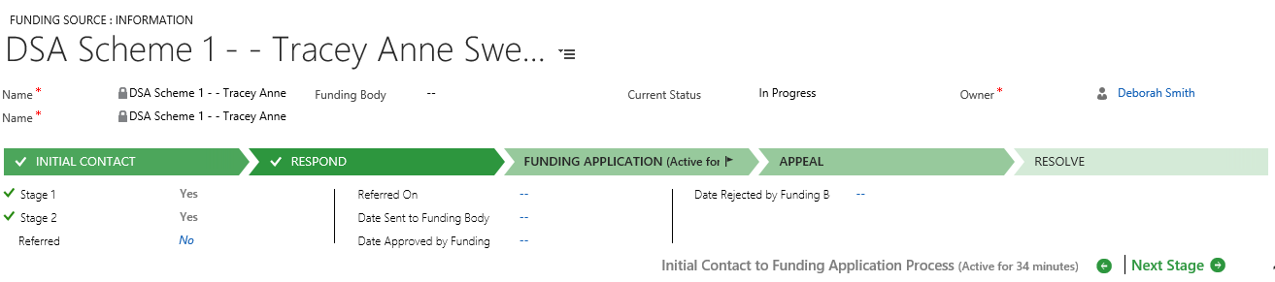

    - Here you can complete Non Mandatory information (*if required*) such as:

- Stage 1
- Stage 2
- Referred
- Referred On
- Date sent to Funding Team
- Date Approved by Funding Team
- Date Rejected by Funding Team

    - Click on to Next Stage.

Note: If you don’t need to record any of the above just click on Next Stage without completing any of the fields.

  - Appeal

    - You would complete this if a Funding Application Decision was Appealed.

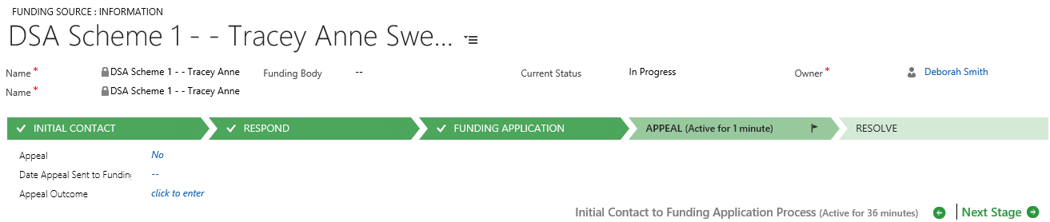

    - Here you can complete Non Mandatory Information (*if required*) such as:

Appeal: Yes/No
Date Appeal sent to Funding: Date
Appeal Outcome: Free Text.

    - Click on to Next Stage

Note: If you don’t need to record any of the above just click on Next Stage without completing any of the fields.

  - Resolve
This is the last stage of the process.
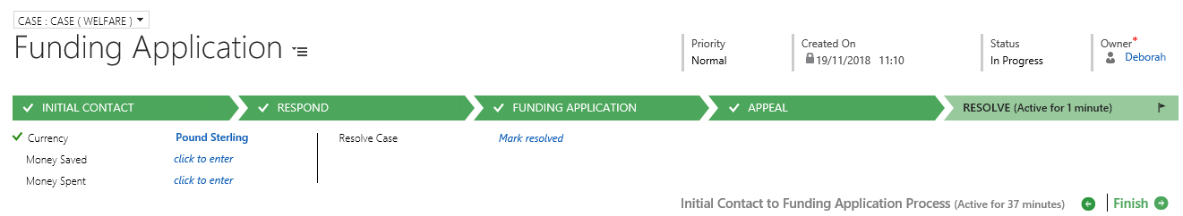

    - Non Mandatory fields available are:

- Currency: Will default to Pounds Sterling
- Money Saved: Please ignore this field
- Money Spent: Please ignore this field.
- Resolve Case

    - If you want to Resolve the case, you will need to click into the Resolve Case field.

    - This action will bring up a Resolve Case window.
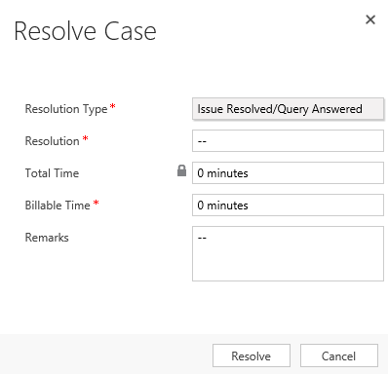

    - Select the Resolution Type from a Drop down menu.
    - Click into the Resolution field to type your Resolution.

    - Total Time: This will add up any activities you have added to the case (E.g. Phone Calls, Emails, and Appointments). This field is greyed out so that you cannot amend or overtype it.

    - Ignore Billable Time. It is NOT Mandatory & you should leave it blank.

    - Remarks – Any other notes you wish to add when resolving the case.

Note: All Activities must be complete before you can Resolve a case.

    - Click on the Resolve button.
Note: You will note that the Case Status changes from Active to Issue Resolved.

- Activities

There are separate guides for:

- Adding Phone Calls
- Adding an Appointment
- Uploading Documents
- Sending Emails
- Adding Notes

You can complete any of the above at any point throughout the life of the case.

