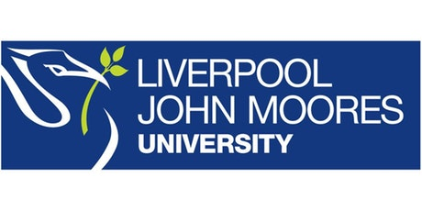

Process Document

CRM – Student Advice & Wellbeing
Liverpool John Moores University

Student Advice Wellbeing: Advice
Processing a Case

Version 0.2, November 2018
Author: DS Business Support Team

Contents:

- Processing the Case: Identify/Acknowledge & Respond

- Processing the Case: Research & Resolve

Introduction: Processing an Advice Case

Once you have created a case (details available in separate guide: ‘Creating a Case’), you will notice the chevrons along the top of the screen. These chevrons effectively make up the Case Management Flow for the case you have created. This flow will take you through the life of the case from beginning to resolution. The Case Management Flow changes depending upon the Subject selected on Case creation. For Advice cases the correct Case Management Flow is the ‘Phone to Case’ process.

For all Advice queries, the Subject selected will be ‘Advice’ or a sub –subject such as Funding Advice. This will ensure that the ‘Phone to Case’ process is used.

The Phone to Case Process is used for all Advice and Funding Advice queries and currently has four stages.

- Processing the Case: Identify/Acknowledge and Respond

  - Identify/Acknowledge Stage

This is the first stage of the case, and is about ‘acknowledging’ the case.
You will need to complete:
- Find Customer- Will autofill from the Student Name once Case has been created.
- Acknowledged- Yes/No. This is selected to indicate that the ‘New Case’ has been reviewed. This needs to be Yes to carry onto the next stage
- Case Created – Will autofill with the Case Name.
- Acknowledged Date- Automatically selects the date that ‘Yes’ is selected.
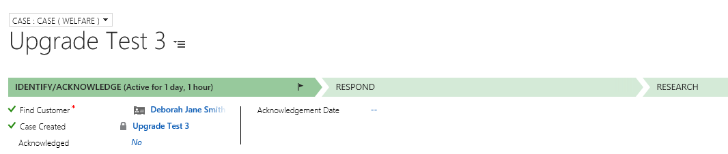

  - Respond Stage

    - Click Next Stage on the process bar and you will move onto Respond.

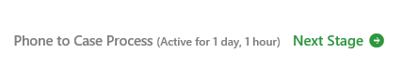
Fields to be completed are:
- First Response Sent - This is a Mandatory field. You will need to click Yes to move onto the next stage.
At this point you may need to send an email or make a phone call. Please see separate guides on how to do this.
- Response Sent by- Select name.
- Response Date- Select Date that first response was sent.
- Response Details- Free Text field to enter in the details of Response. You can also add this information into notes, or refer to an Email sent.
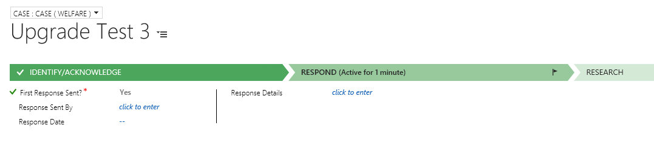

The Status will change as you move through the different stages of the Case.
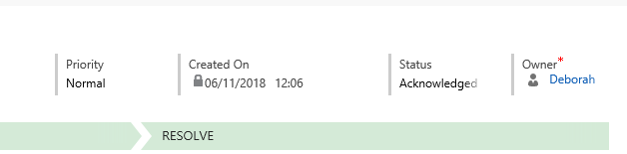

- Processing the Case: Research & Resolve Stage

  - Research Stage:
- Please click past this stage. This stage will eventually be removed from the process.

  - Resolve Stage:
- Once you click into the Resolve case – Mark Resolved, this will bring up the Resolution window.
Please Note: You will not be able to Resolve a case until all Activities have been ‘Completed’.

In the Resolution window, you will be able to fill in the following fields:
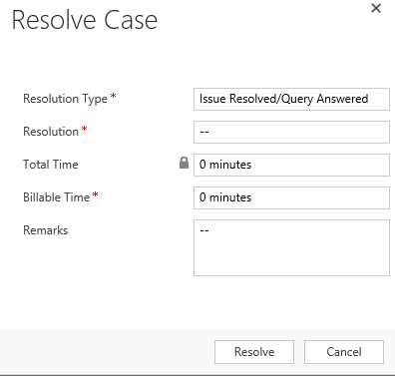
- Resolution Type – How you resolved the Case
- Resolution – Free Text box, brief description of resolution.
- Total Time - This will be a read only field, as it has added up all of the time spent on the Activities created against this Case.
- Billable Time – This is a new field. It is NOT Mandatory. Do not complete.
- Remarks -Here you can add in any further comments with regards about the Resolution here.
- Click on ‘Resolve’ to Resolve the case.
- The Status of the Case will automatically change to ‘Issue Resolved’.

