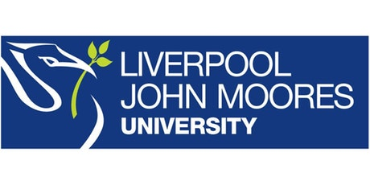
Process Document

CRM – Student Advice & Wellbeing
Liverpool John Moores University

SAW Funding Team
Scholarship Enquiries

Version 0.2 November 2018
Author: DS Business Support Team

Contents

- Scholarship Dashboard
- Creating the Scholarship Enquiry
- Completing the Scholarship Enquiry
- Status Changes

- Scholarship Dashboard

The Dashboard is called Scholarship Enquiry Dashboard.
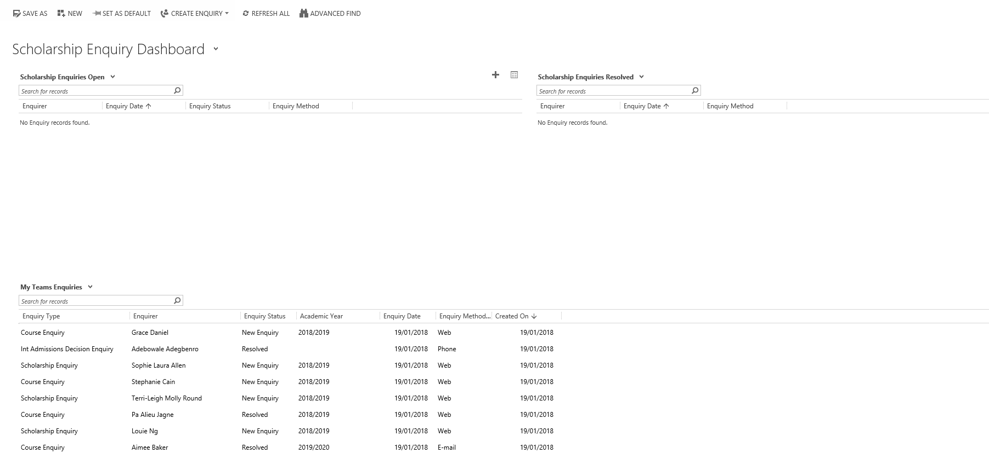
3
23
1

There are three sections to this Dashboard:

  - Scholarship Enquiries Open (1) (Top Left)

All Enquiries new or in progress.

  - Scholarship Enquires Resolved (2) (Top Right)

All Enquiries which have been resolved.

  - My Team Enquiries (3) (Bottom)

This will show all enquiries assigned to your team. The same view is visible on the SAW Finance Dashboard.

- Completing the Enquiry Form
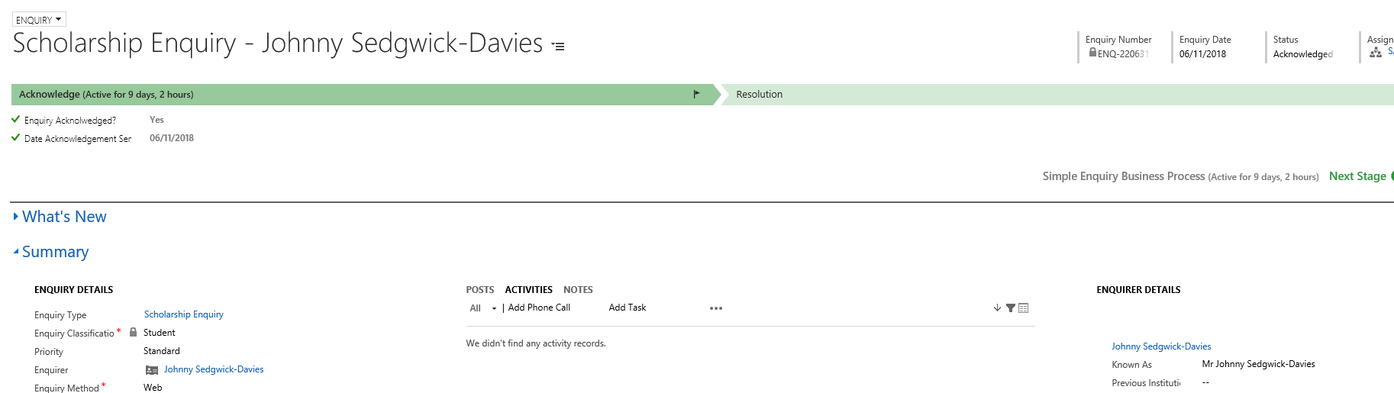

- Fields with a red asterix * are mandatory fields.

  - At the top of the screen you will notice two chevrons or stages, Acknowledge & Resolution.

  - To move the status to the next stage, you either need to update the status in the top right to ‘Acknowledged’. Clicking Yes in Enquiry Acknowledge field will also have the same effect in changing the status.

  - The next stage/chevron in Resolution.

  - You need only fill this in when you are ready to resolve the enquiry. This will only be done when the Application and Evidence have been received.

- Status Changes

  - It is vital that Status is changed as below at the appropriate stage, as these changes will enable us to communicate/report on prospective Scholarship applicants at different stages.

- Acknowledged:
This status change is used when the Enquiry has been sent in, but no Documents/Evidence or Application have been received yet.
- Responded/In Progress:
This status change is used when the Scholarship Application has been completed and you are awaiting Documents/Evidence.
- Resolved:
This status change will be used if you have received the Application and Documents/Evidence.

