# [Image result for liverpool john moores university logo](https://www.google.co.uk/url?sa=i&rct=j&q=&esrc=s&source=images&cd=&cad=rja&uact=8&ved=0ahUKEwjZuerSu4nXAhWGchQKHbT9CwIQjRwIBw&url=https://www.eventbrite.co.uk/o/liverpool-john-moores-university-roscoe-lectures-3233158788&psig=AOvVaw2rEDE_dQz3fMXV7J1A9n9g&ust=1508941556822069)

Process Document:

**CRM – Student Advice & Wellbeing**

Liverpool John Moores University

**CRM Activities: Sending Manual Emails**

Version 0.4, October 2018

Author: DS Business Support Team

**Contents:**

1. **Email Labels**
2. **Sending a Manual Email**
3. **Inserting a Template**
4. **Replying to an Email from a Case**
5. **Set Regarding**
6. **Email Labels**

There are three Email labels in CRM, to help us correctly store and manage the different email addresses that our Enquirers/Applicants/Students/Staff use.

These are:

* Primary Personal Email
* Secondary Personal Email
* LJMU Email

The following table shows which fields are Editable/Locked down and how this will change with the lifecycle of the student.

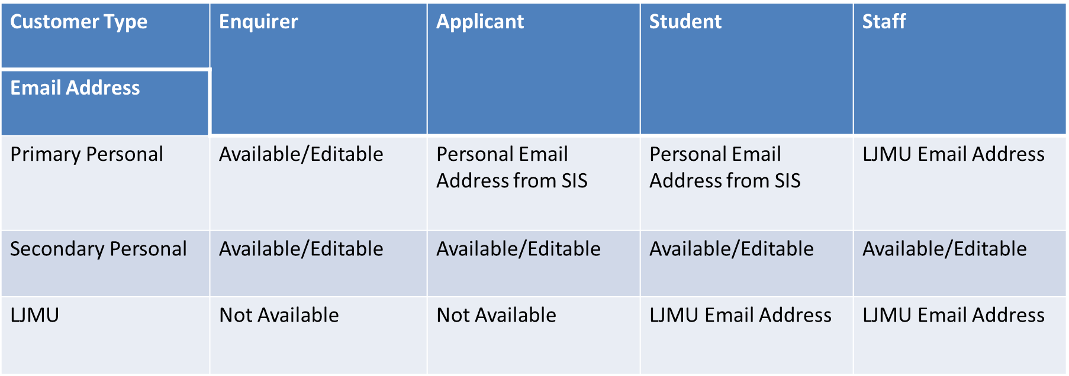







The Secondary Personal Email address will always remain unlocked, meaning that if a student requests that you contact them via a specific email address that is not already listed, then you can add it here.

As CRM is used by different users for different reasons, it is good practice to check this email address is entered each time you email, as it is possible that other users may amend it to suit their own needs

* 1. **SAW: Case View**
     1. From the Case screen, you will notice that the different Email labels appear in the ‘Welfare Contact’ Panel to the right of the the Case Screen.
     2. You will not be able to amend the Secondary Email address within this view. You will only be able to do this in the **Contact View** (see below)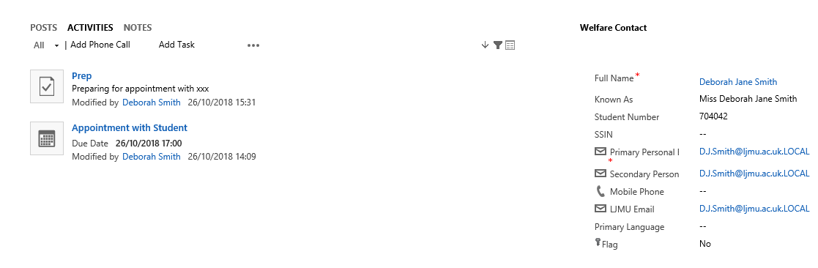
  2. **SAW: Contact View**
     1. The same labels will also show in the Contact Form under ‘Marketing Details’.
     2. You can click to the Contact record from the Case by clicking on the Highlighted Blue ‘Full Name’

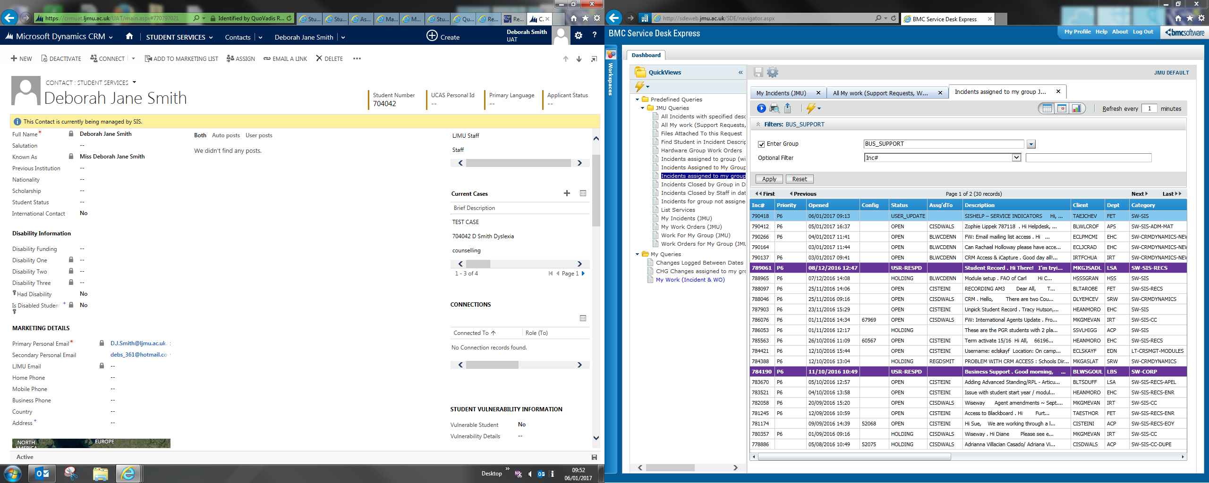

1. **Sending an Email**
   1. In order to send an Email you must first ensure you are in a **Case** and not a Contact record.
   2. Check you are in a case by looking for the ‘chevrons’ which will appear along the top of the screen. Also, check it says ‘Case’ and the name of the Case, as shown below.

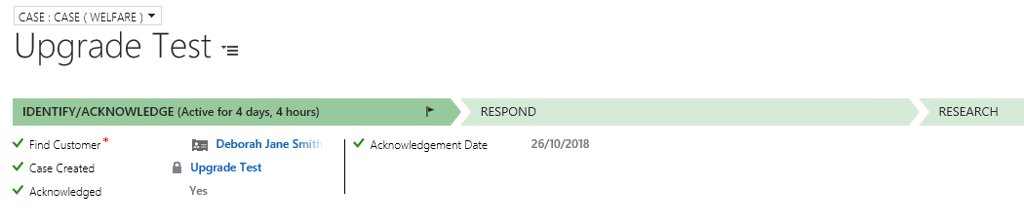

* 1. Click on to **Activities** in the Centre of the screen
  2. Click on to the **3 dots (ellipsis)** underneath
  3. Select **‘E-Mail’**

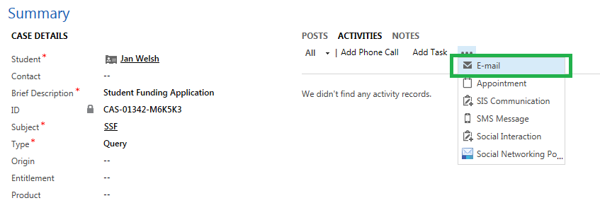

* 1. The New E-mail window will open.

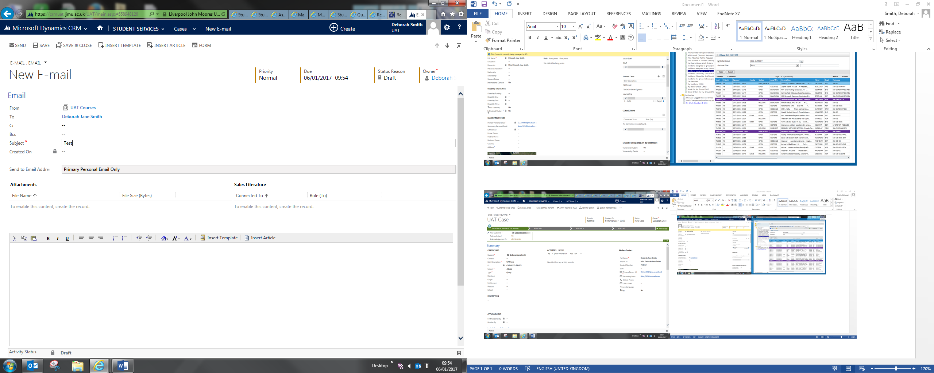

* 1. The From will default to your Team email automatically as this is set up for you at the time your access to CRM is applied.

**Note: The email will not send if the ‘From’ is an Individual name. It MUST be a Team.**

**Note: Please remember to check if any of your Emails have a status of Pending regularly. You have access to a Pending Email Dashboard. Pending means the email is stuck. Contact Helpdesk for support if required.**

* 1. **‘**Send to Email Address’ will always default to **Primary Personal Email Only**.

But, If you click into this, a drop down list of all the different Email Labels & Combinations will appear.

These are:

* Contact Default
* Primary Personal Email Only
* Secondary Personal Only
* LJMU Email Only
* Primary & Secondary Personal Emails
* Primary Personal & LJMU Emails
* Secondary Personal & LJMU Emails
* All

**You will need to select the correct Email Label(s) from the drop down menu option.**

*Please note that this drop down list relates only to the Emails held against the ‘To’ Contact and does not relate to anyone cc’d or bcc’d in. There is no option to select the Email address for those contacts cc’d or bcc’d.*

* 1. Next, complete the text of the email.
  2. Then, navigate to the bottom of the text box, and click on to Duration.
  3. Select the time spent writing the email.

Please note – that you can also record the duration by changing the Complexity – (Short – 5 mins, Medium – 15 mins or Complex – 30 mins)

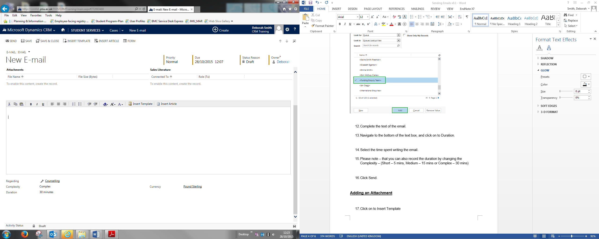

* 1. Click **Send.**
  2. Once the Email has sent, you will notice at the bottom of the email, there is a new field called **Contact Email Address.**

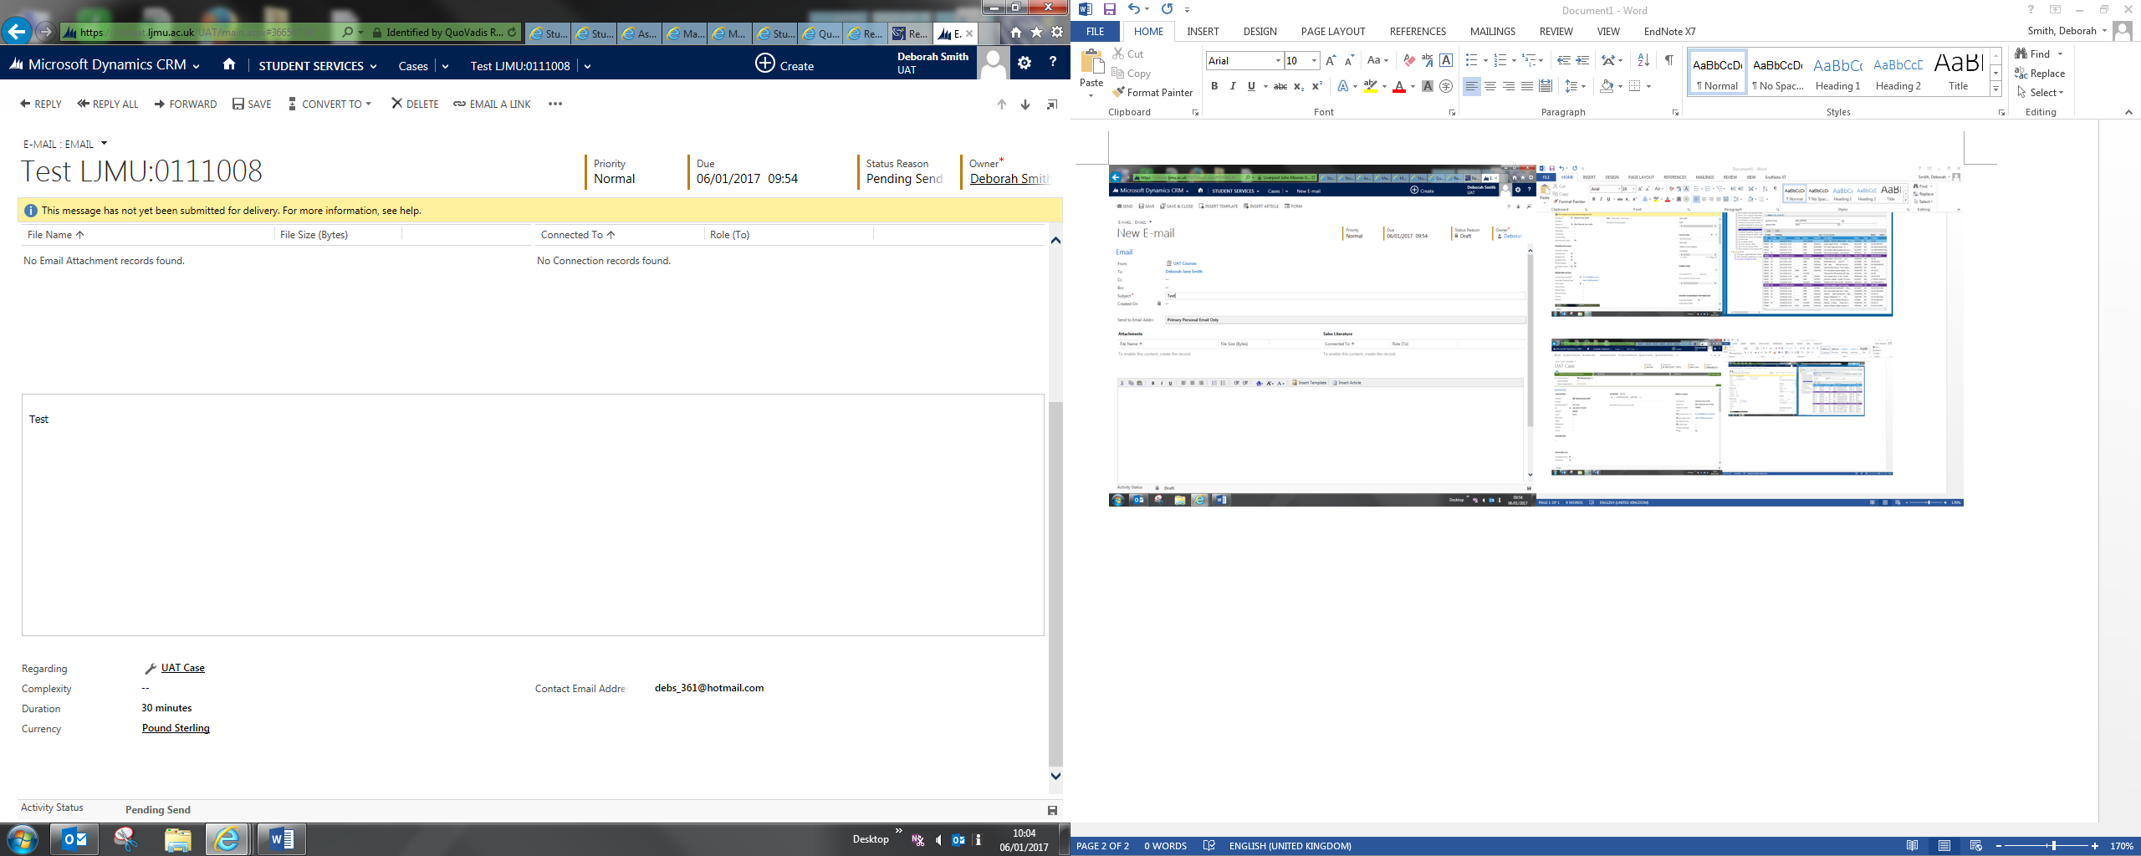

This field will display the Email address(es) which the Email was sent to and will correspond to the label you selected when you sent the Email.

This field is especially useful for Audit purposes: checking where an email has gone, **after** the email has been sent.

1. **Replying to an Email from the Queue or a Case:**
   1. If you click reply to an Email, the ‘**Send to Email Address’** field will default to ‘**Default Contact’.** This is effectively defaulting to reply back to the email address that the email was sent from.
   2. This can be changed if you wish to email a different email address, although you will need to check the Email labels within the Contact screen first.
2. **Inserting a Template**
   1. Click on to **Insert Template** which can be found at the top of the screen.

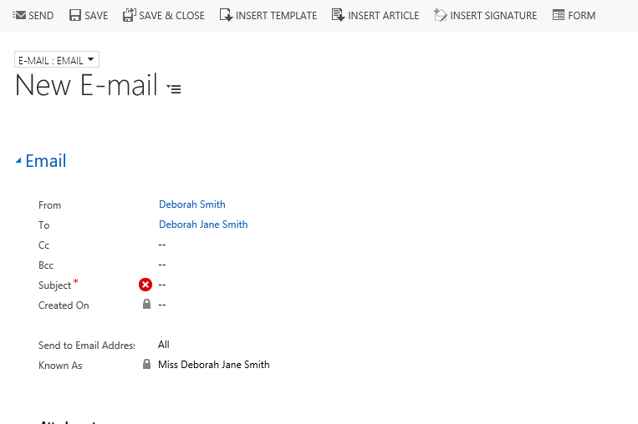

* 1. The Select Record window will pop up. Click on the To Recipients option.

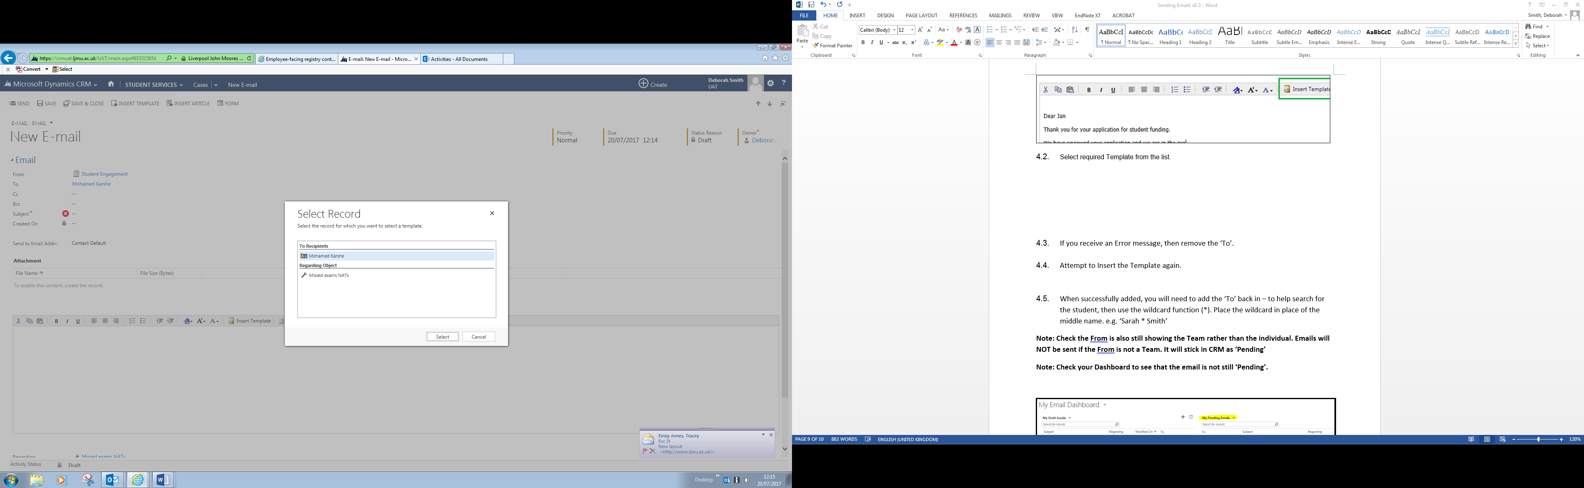

* 1. The **Select Template** box will pop up. Click on the required template.
  2. Click Select.

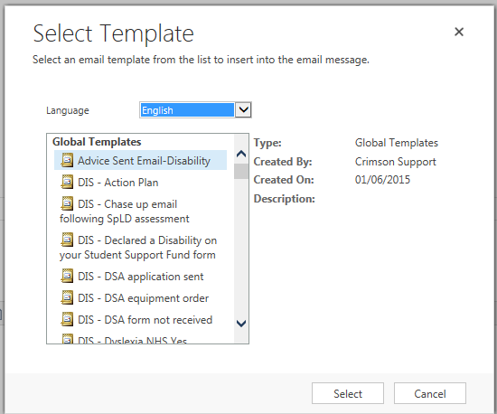

* 1. The Email template will populate in the Email.

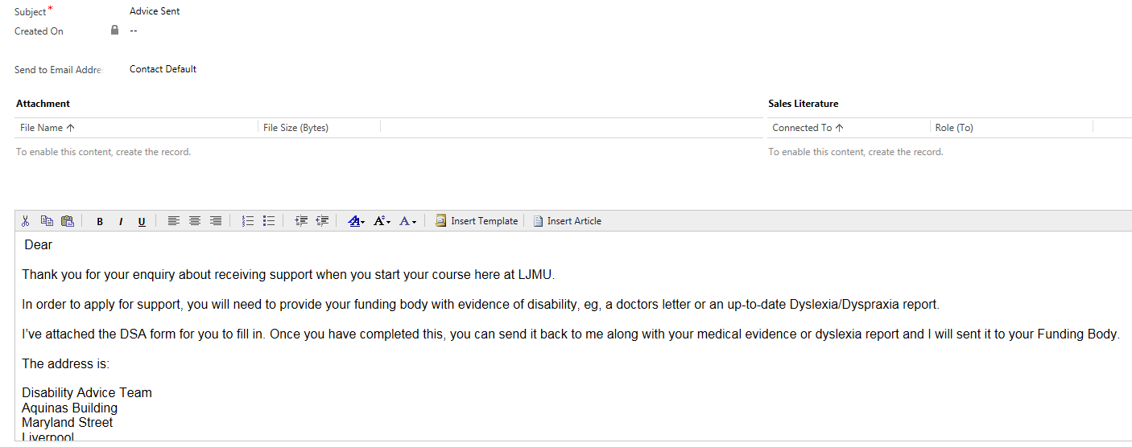

1. **Set Regarding**
   1. If you email a Student from a Case, then the Email will automatically ‘Set Regarding’ to the correct student and Case.
   2. Sometimes, if an email has not been set regarding the case for some reason, you will need to manually set it:
      1. First of all, find the Email. To do this, click on the students name to access their contact record, and look under Activities to find it.
      2. Open the Email
      3. Scroll to the bottom of the email where it says ‘Regarding’

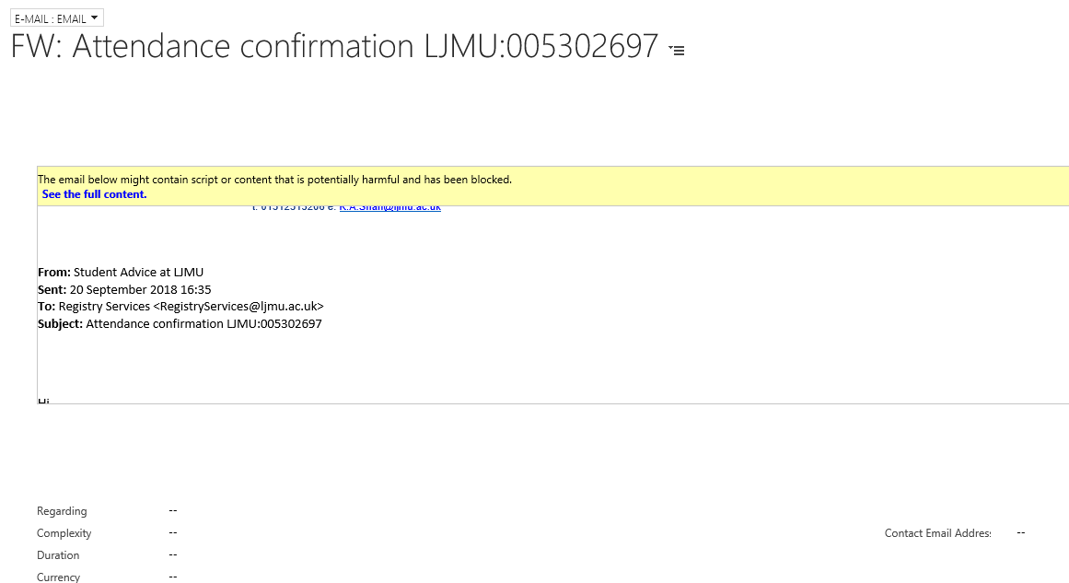

* + 1. Open up the Look Up
    2. Scroll down to Look up more Records:

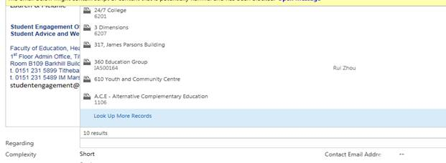

* + 1. This panel will open up. You need to change the options to the following:
* Look For: **Case**
* Look In: **My Active Cases**
* Search: Search for either the student name or what you have named the case.

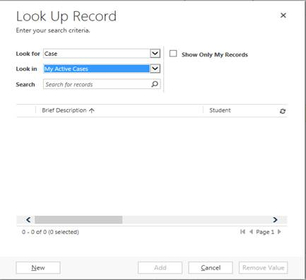

* + 1. Then select the correct case, by ticking it to the Left.
    2. Click **Add**
    3. This box will then disappear and you will end up back in your Email.
    4. You will notice that the **Regarding** now has a spanner symbol and the name of your case.
    5. Click **Save.**

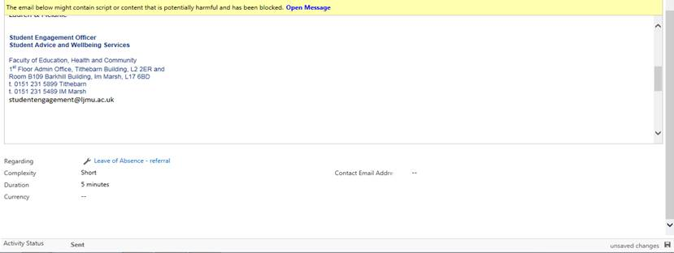

If you now head back into the case, the email will now appear on under Activities.