Process Document

CRM – Student Advice & Wellbeing
Liverpool John Moores University

Student Advice Wellbeing
Creating a Case: Subjects & Workflows

Version 0.2 November 2018
Author: DS Business Support Team

Contents

- Importance of Subjects and Processes in CRM

- Process Flow & Subjects:

  - Advice Cases

  - Disability Cases

  - Funding Cases

  - Counselling Cases

- Changing the Process Workflow

- Importance of Subjects and Workflows in CRM

The Top Line Subject drives the Process Flow (case stages), and should be selected initially to drive the correct Case Type. It is important that your drill down to a Sub Subject at a later date prior to closure. This is for accurate reporting. The process on how to do this is detailed in the Changing the Subject document.
However, if a Sub Subject is selected when creating a Case and this brings up the wrong Process flow, then you can switch Process. The Changing the Process Workflow steps are detailed at the end of this document.
Current Top Line Subjects are as follows:

- Process Flows & Subjects

  - Advice Cases

Advice cases will follow the Phone to Case Process. This is a simple workflow, as displayed below:

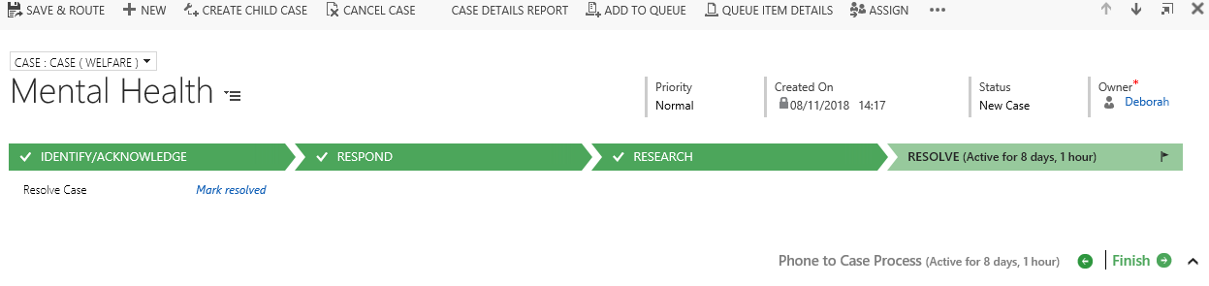

Top Line Subjects which will drive this workflow are:

- Advice
- Student Engagement
- Funding/Money
- Mental Health
- International
- Study Skills Disability
- Vulnerable Student

  - Disability Cases

Disability cases follow a different Workflow, called Initial Contact to Learning Plan Process. This is displayed below:

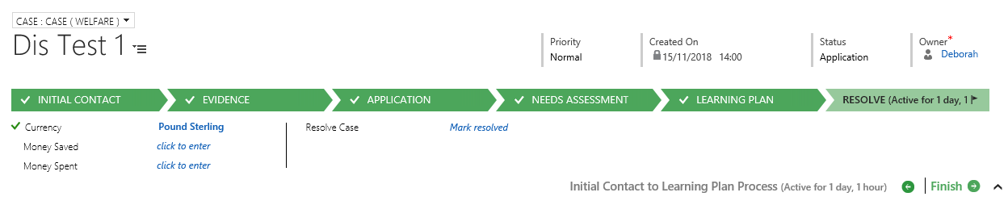

Top Line Subjects which will drive this flow are:

- Disability

  - Funding Cases:
The Funding Team use two different flows depending upon the type of case it is.

If the case is an ADVICE case then the subject will be Funding/Money and the Workflow will be the Simple Phone to Case Process. The chevrons across the top will display as below:

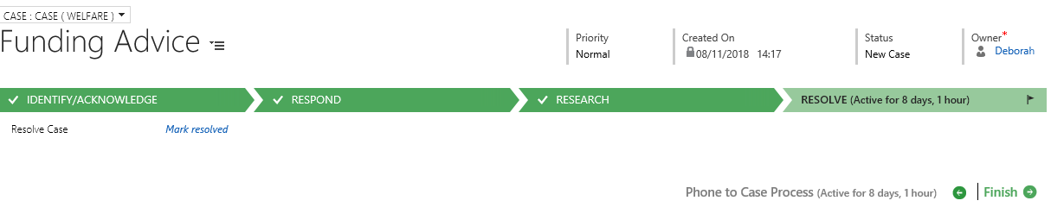

If the case involves a FUNDING APPLICATION then the subject will be Discretionary Funds and the Workflow will be the Initial Contact to Funding Application Process. The chevrons across the top will display as below:

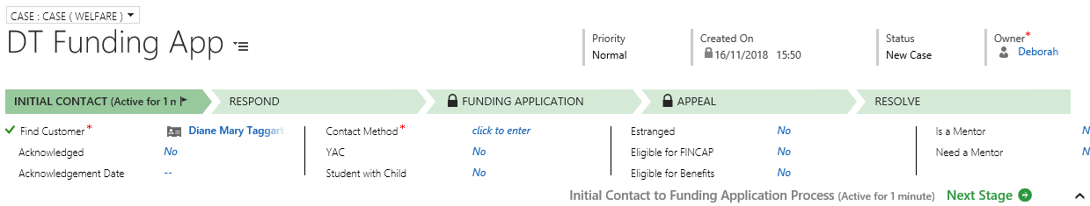
  - Counselling Cases

Counselling Cases will follow the Initial Contact to Allocation Process Workflow, as displayed below.
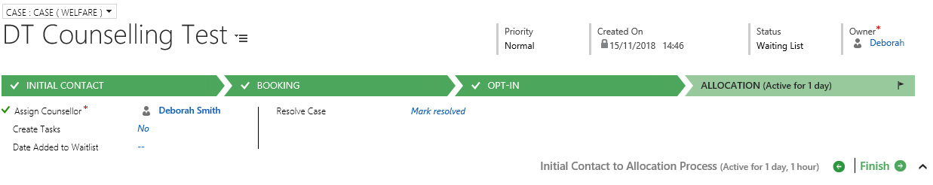

Subjects which will drive this flow are:

- Counselling

- Changing the Process Workflow

If the incorrect Process Workflow displays, then this can be fixed, by swapping the Workflow to the correct one.

Within a case, select the Ellipsis (Three dots) at the top of the case.

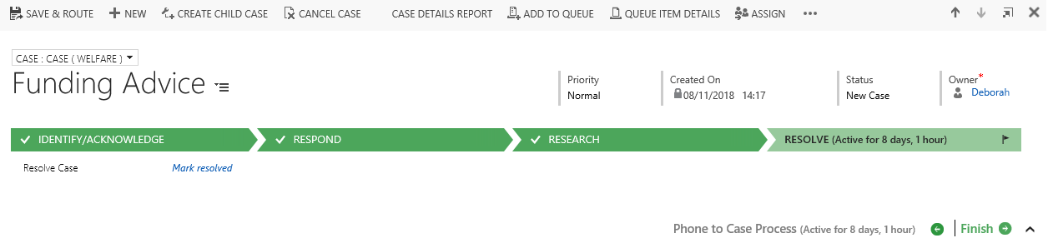

- Select Process from the dropdown
- Select Switch Process

This will bring up this window:

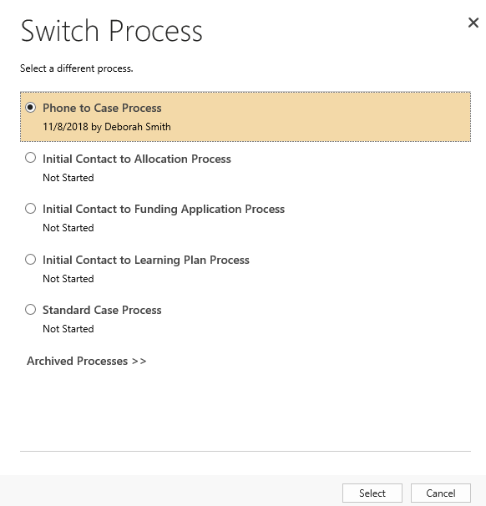

- The process you have selected currently will be highlighted, but you can select any of the options to switch the process to the correct Workflow.
- Click Select to Switch

Please Note: You may also need to change the Subject. Please refer to the Changing the Subject of a Case document.

