Process Document:

CRM – Student Advice & Wellbeing
Liverpool John Moores University

CRM Activities: Upload Documents

Version 0.2, October 2018
Author: DS Business Support Team

Uploading Documents to a case in CRM

- In order to upload documents you must first ensure you are in a Case and not a Contact record. Check you are in a case by looking for the ‘chevrons’ which will appear along the top of the screen, as shown below.
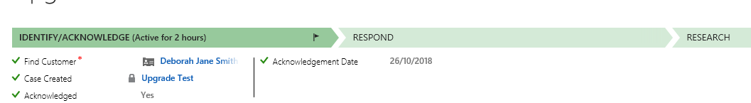
- Once you are in the correct case, navigate to the top Ribbon and click on to the arrow next to the Case Name (Case Name shown below as ‘Upgrade Test’) and click on to Documents Icon.

- Sharepoint will now open up within CRM automatically.
- To Add a document, click on the Add button

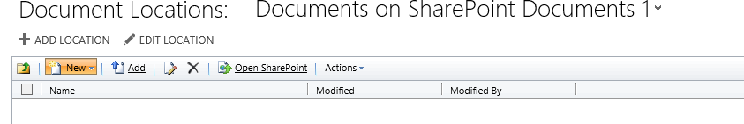

- Click Browse in the Choose a file field to search your own folders for the file to attach.

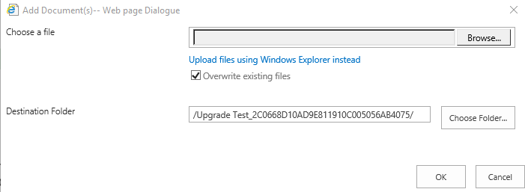

- Do not change anything in ‘Destination Folder’ field.
- Click Ok when correct file is located.
- The ‘Open Sharepoint’ button will open up Sharepoint in a separate window.

Please note: Sharepoint is automatically available when you follow the navigation in CRM above, you do not need to log in to Sharepoint separately.

**If you don’t think you have access to the document/Sharepoint CRM please ask your line manager to request access for you via Helpdesk**

