# Using Event attendance software

**Online**

Tap your ID card on the back of the device to login. Please note that you can also log out at any time by tapping your ID card on the back of the device.

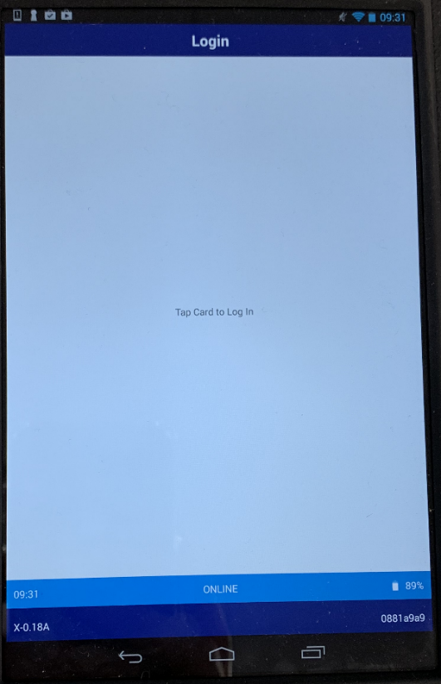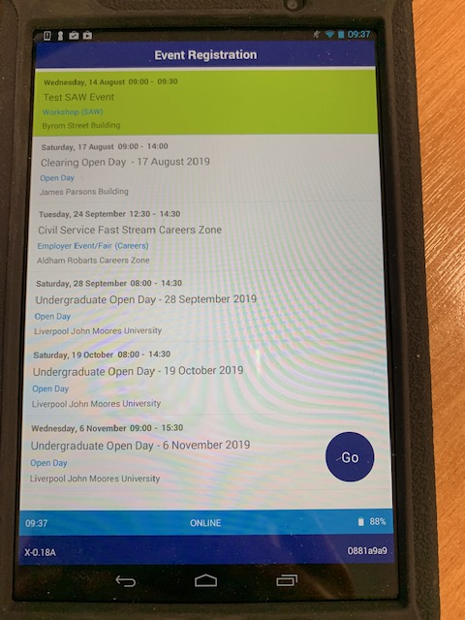

Once logged in – select your event and click **Go**

If you select the wrong event simply log out by tapping your card on the back.

*To refresh the event list swipe down from the top of the screen, then let go.*

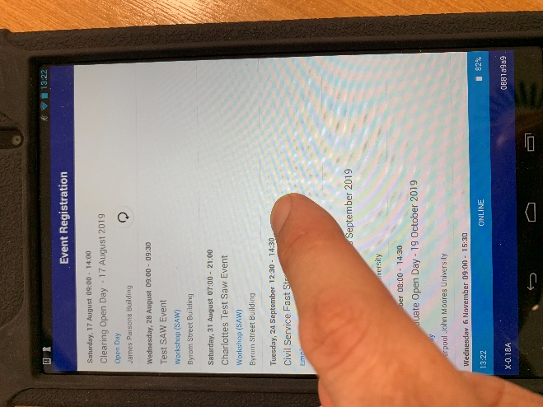

**Start capturing attendees**

From this screen you can start tapping student cards against the back of the device to record their attendance.

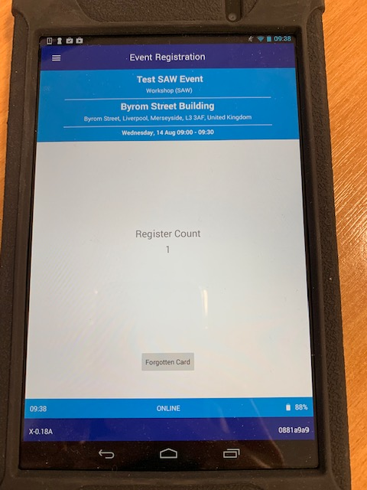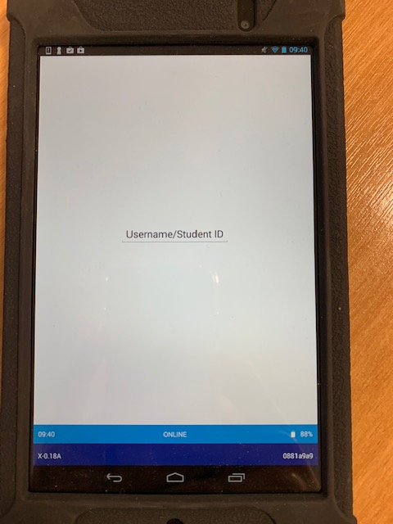

**Forgotten Card**

Click **Forgotten Card** and you will be shown a screen that will allow you to manually enter a student ID or Username, then click **Finished**

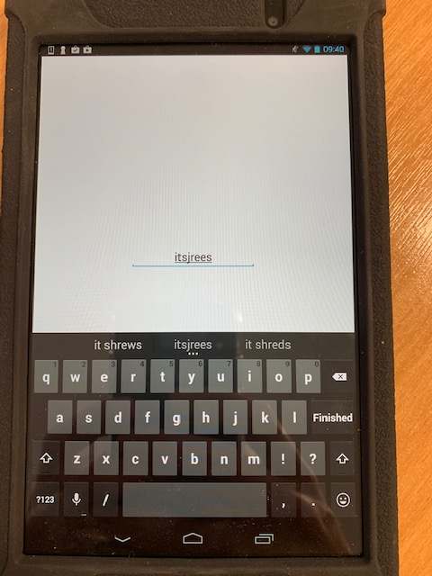

**Viewing recorded attendees**

Swipe right from the left-hand side of the screen to see a list of students who have been captured.

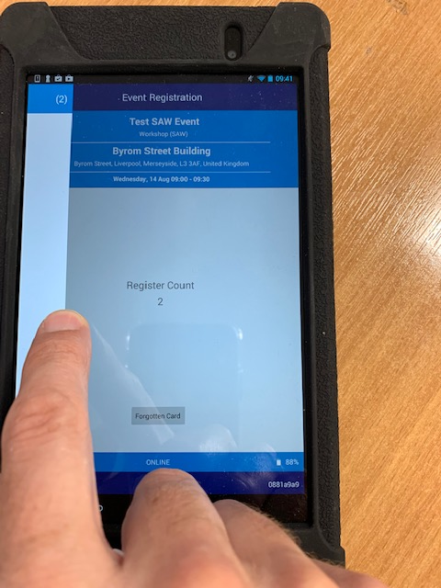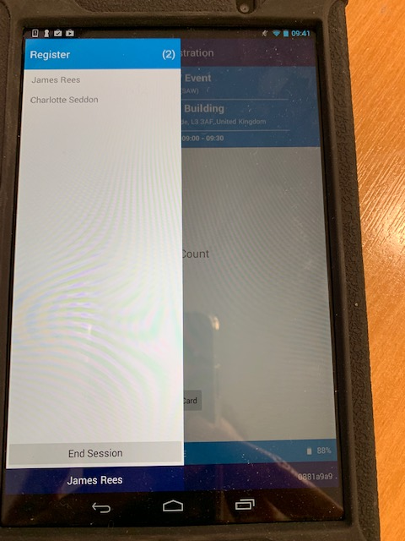

From this screen you can also end the session.

**Log out Screen**

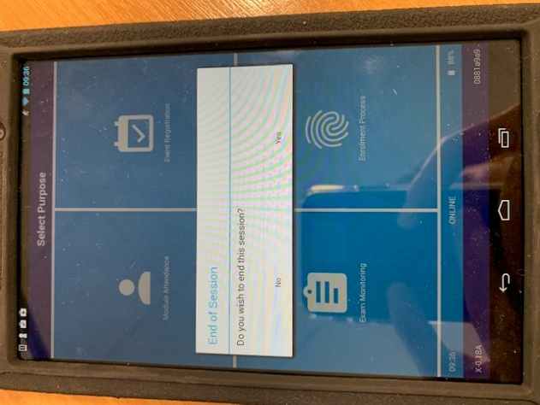

**Offline**

If the event venue does not have access to the LJMU Network then you need to ensure that the device is switched on and the event list is refreshed whilst within the LJMU network before going to the event venue. ***Do note then switch off the device.*** The device will then store the event list and you can pick the event and capture attendance in offline mode.

If you are prompted for an **offline PIN** please enter **9464**.

Offline mode works in the same way as online mode but the students names will not appear in the list.