# [Image result for liverpool john moores university logo](https://www.google.co.uk/url?sa=i&rct=j&q=&esrc=s&source=images&cd=&cad=rja&uact=8&ved=0ahUKEwjZuerSu4nXAhWGchQKHbT9CwIQjRwIBw&url=https://www.eventbrite.co.uk/o/liverpool-john-moores-university-roscoe-lectures-3233158788&psig=AOvVaw2rEDE_dQz3fMXV7J1A9n9g&ust=1508941556822069)Process Document

**CRM – Student Advice & Wellbeing**

Liverpool John Moores University

**Student Advice and Wellbeing:**

**Vulnerable Students Process**

Version 0.3 November 2018

Author: DS Business Support Team

**Contents**

1. **Introduction**
2. **Initial Vulnerability Referral**
3. **Referral received by SAW V.S. Users**
4. **Marking V.S status in CRM**
5. **Creating a V.S. case**
6. **Security/Access to V.S. Information**
7. **Monitoring V.S. /V.S. Meeting**
8. **Removal of V.S. Information**
9. **Dashboard**
10. **Reporting**
11. **Introduction**

This document will cover the process for certain SAW Users to manage students via the **Vulnerable Students** Process on CRM. This will replace the current paper/spreadsheet process.

Vulnerable Student Process SAW Users include:

|  |
| --- |
| **User** |
| Adrian Harmer |
| Jo Bleasdale |
| Yvonne Turnbull |
| Elaine Smith-Freeman |
| Sile MacRaghnaill |
| Rebecca Gee |
| Lynne Condell |

1. **Initial Vulnerable Student Referral**

* A student will approach a Student Advice Wellbeing (SAW) service.
* After meeting with the student, SAW staff will make a decision as to whether the student should be assessed for vulnerability(ies)
* If SAW staff believe there to be a risk, they will consult with their manager first.
* If the SAW manager is in agreement, they will then advise the SAW staff member to email a referral over to [vs@ljmu.ac.uk](mailto:vs@ljmu.ac.uk).
* An email template is available on CRM, called **VS Referral Template**.

1. **Referral Received by SAW V.S Users**

* Emails received into this mailbox will be displayed on the **Vulnerable Student Dashboard.**
* Emails will be monitored by VS Group at the weekly VS meeting.
* SAW Managers will make a decision at their regular meeting as to whether student should be highlighted as a Vulnerable Student.

1. **Marking Vulnerable Student Status in CRM.**

* Once the SAW Manager(s) have agreed that the student should be recorded as a Vulnerable Student, they will mark this information on the students contact record.
* To do this, you will need to search for the students contact record. A separate guide is available for ‘**Searching for a Contact’.**
* Ensure that you are on the right Contact ‘form’- **Student Services**, by checking above the students name:

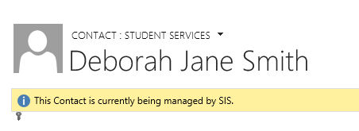

* If not, you can click on the arrow to change it to Student Services.
* The **Student Vulnerability Information** will appear on the right hand side, beneath ‘Connections’.

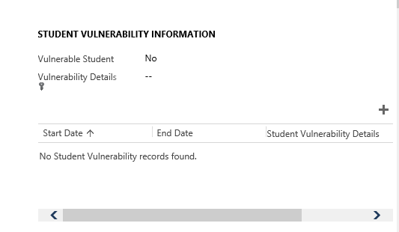

**There are two parts to recording this information. The first part is the high level information:**

* Click into the **Vulnerable Student field** and change to **‘Vulnerable Student’.**
* Click into the **Vulnerability Details** and add any relevant overall details. *This field is locked down and only SAW VS users will be able to see this.*

**The second part allows you add more detailed information about individual vulnerabilities.**

* By clicking on the **plus ‘+’** icon, a new window will appear.
* Click into the **start date** and add the date the VS monitoring is to begin.
* You can also enter further details about individual vulnerabilities here.

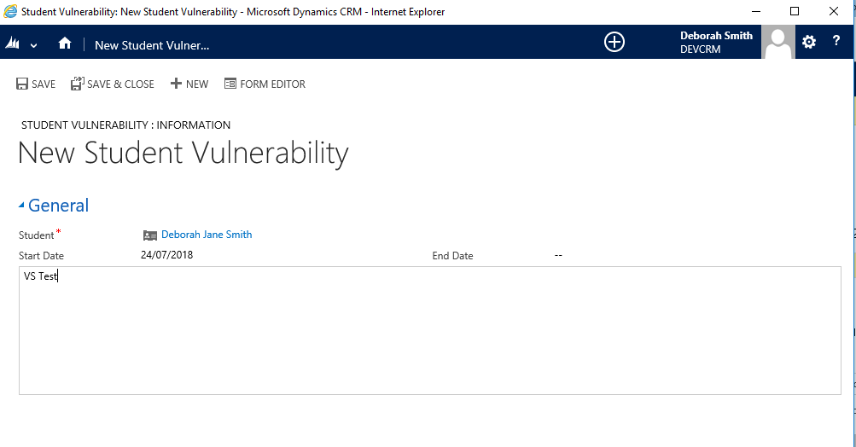Please remember to **Save**.

1. **Creating a Vulnerable Student Case**

A Vulnerable Student Case is created to further manage/assist the particular student.

* From the Contact record, you can also create a **Vulnerable Student Case**.
* To do this, click on the **Plus** icon next to Current Cases on the right hand side.
* Complete the usual information, but please select **Vulnerable Student** as the Subject from the Subject List.
* Brief Description: SAW may wish to agree a standard way of naming VS cases. E.G. ‘V.S - <STUDENT NAME>’
* Both Vulnerable Student Details & Active Cases information will be viewable within the Dashboard.
* The views can be maximised by clicking on the small box in the top right corner of each view:

1. **Security/Access to VS Information**

* All Users will be able to see that a student has been marked as a **‘Vulnerable Student’** via the information held on the Contact record.
* All SAW VS Users will be able to see the VS detail/ Individual Vulnerability data, start and end dates as displayed on the Contact record.
* However, access to view for **Vulnerable Student Cases** is a little bit different.

VS SAW Users are in different Business Unit as per the graphic below:

* SAW BU Users (Yvonne) will be able to see All VS Cases.
* SAW Counselling BU Users (Elaine & Adrian) will be able to see VS cases created by SAW Counselling BU Users and SAW ADF Users.
* SAW ADF BU Users (Sile, Rebecca, Lynne & Jo) will be able to see VS cases created by SAW ADF BU Users.

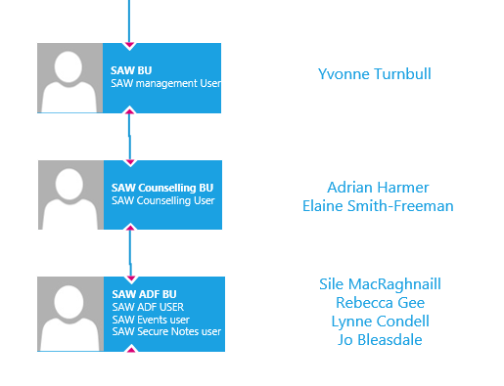

1. **Monitoring Vulnerable Students/ VS Meetings**

* Instead of monitoring spreadsheets etc, VS users will be able to view the VS Dashboard in CRM and view the information directly in the meeting.

1. **Removal of VS information from a student record**

* Navigate to the particular student contact record.
* Navigate to the **Student Vulnerability Panel.**
* Change **‘Vulnerable Student’** field to **‘No’**.
* You can also put an End Date on to Individual Vulnerabilities by clicking back into box and entering an End Date.

1. **Dashboard**

All Users will have access to a Dashboard on CRM: ‘**Vulnerable Students’**.

This dashboard will display the following:

* VS emails to be processed (Brand new emails – not regarding a contact/case)
* VS emails to be processed linked to a record (Emails regarding a contact/case)
* Students Flagged as Vulnerable (Shows ‘High Level’ VS information)
* Active Individual Student Vulnerabilities (Shows Detailed Individual Vulnerabilities)
* Active Cases - Vulnerable Students (Active VS cases – may not see all depending on individual’s security access)
* Resolved Cases – Vulnerable Students (Resolved VS cases – may not see all depending on individuals security access)

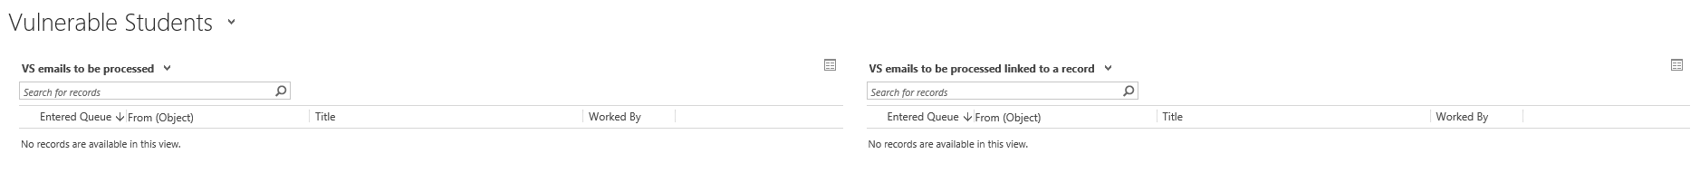



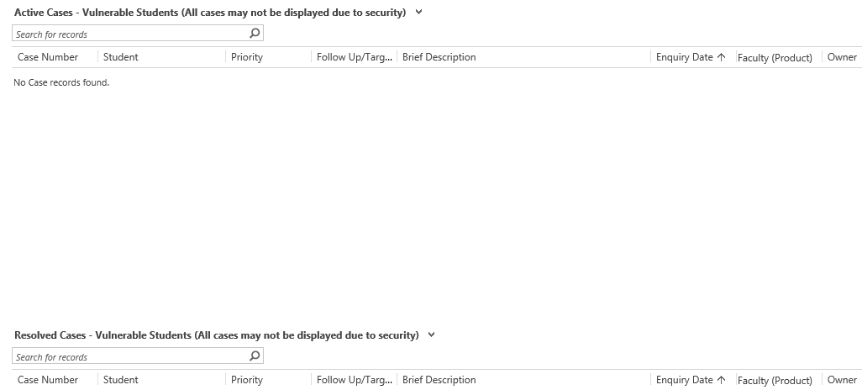

1. **Reporting**