Student Information System
Liverpool John Moores University

Admin Gradebook Changes

Version 1.0 25th July 2013
Business Support Office

Contents
Summary of Changes 2
What’s new in Admin Gradebook? 2
Entering Assignment Marks in to Admin Gradebook 2
Reviewing Cumulative Grades 4
Transcript Notes 5
Posting Grades 6
Student not on Grade Roster 7
Amending Posted Grades 8
Changing Transcript Notes 8
Appendix 1 – Grade Overrides 10

Summary of Changes
Page | Change | Date

What’s new in Admin Gradebook?
As a result of user feedback, one of the key objectives of the SIS stabilisation project was to make the grading related functions of the system user friendly and if possible, remove the need to use the grade roster. Whilst the grade roster still exists and access to the roster pages will remain, it is hoped that the vast majority of grading and related processes can now be completed in the Admin Gradebook.
Below is a summary of the grading and related processes which can be completed in the Admin Gradebook;
- Enter assignment grades
- Overall grade override (if required)
- Add transcript notes
- Changes to transcript note
- Posting, with the ability select/de-select student grades that you wish to post
- Changes to overall posted grade
- Requirement Designation – this remains unchanged.
Note: the Grade Roster must exist and the student must appear on the grade roster or the posting of grades and transcript notes is not possible. An example will be provided later in this document.
Due dates – no longer influence final cumulative grade

Entering Assignment Marks in to Admin Gradebook
The process for entering assignment grades remains unchanged and you should continue to use the ‘Class Gradebook’ or ‘Grade by Assignment’ as explained below.
Navigation: Main Menu > Curriculum Management > Grading > Admin Gradebook
- In the Search fields enter at least a Term value and a Course Catalogue number

- Click Search. The corresponding classes will then display, select the class required. This opens the Class Gradebook which lists all the enrolled students on the Class and all the Assignments attached to the Course (marks can be entered directly onto this mark grid).
Note: There is a class listed for each module team member – it doesn’t matter which value you select.
- Click Grade by Assignment. This page displays when an assignment was submitted to the Student Zone (future development) and the Due Date for each student (the Due Date displayed by default is the Class Assignment Due Date as recorded in the Class Assignments, however the Due Date for an individual student can be changed here (see the ‘Additional Gradebook Functionality’ section)

- Click on the Look up icon

- Select the required assignment (if there are multiple)
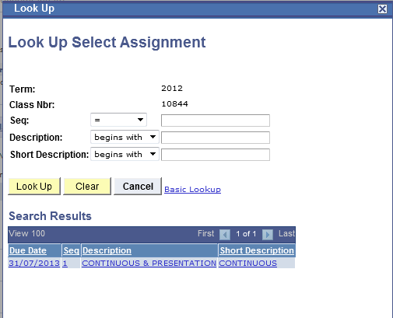

- Enter the Assignment mark by student ID and Assignment ID. These should be whole numbers. A mark left blank will be considered as 0 once the grade is posted. Please note, due dates are no longer considered when calculating an overall cumulative grade.

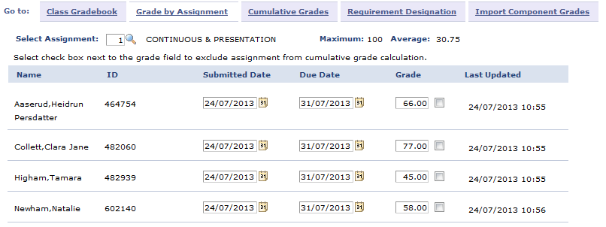
- Save the marks by clicking save at the bottom of the page. You can enter and change marks as often as needed.
Track and view Assignment Averages for the entire Class by scrolling to the bottom the Class Gradebook page. The Assignment average updates automatically for each assignment as the marks are entered. E.g.

Reviewing Cumulative Grades
The Cumulative Grades page has now been changed.
Once all the Assignments are entered for all the students, the overall Module grade can be reviewed and overridden (in the case of deferral) if necessary. See Appendix 1

- Click the Cumulative Grades tab. The page displays the Assignment marks recorded for each student under the Assignment headings plus the overall calculated module mark. Details of how the calculation uses the Assignment weightings from ModCat are detailed in the MODCAT training guide)
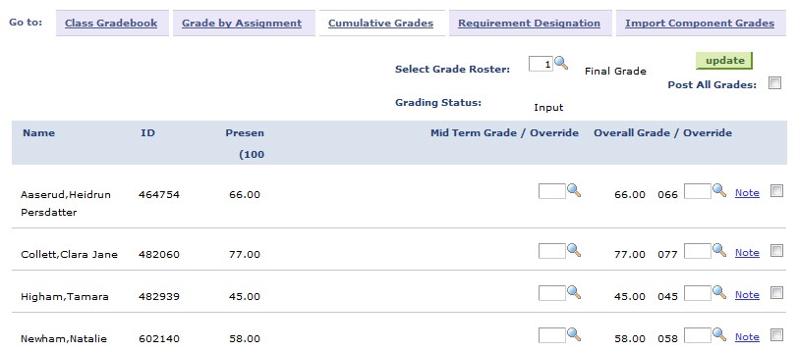

Transcript Notes
Previously, transcript notes were recorded on the grade roster or via quick enrol. These can now be added by clicking the note link, next to the relevant student on the Cumulative Grades tab.
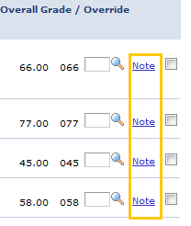
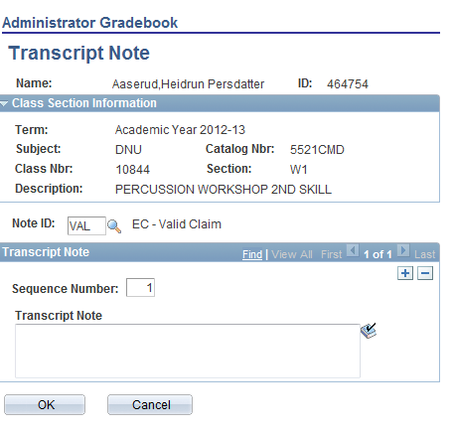
Just add the note and click ‘Ok’. The ‘OK’ will commit the transcript note to the system.

Posting Grades
Before posting becomes an option, you must first ‘Select Grade Roster’. If a Grade Roster does not exist, you should go to the grade roster and create one. See training document ‘Grade Roster Administration’ at http://www.ljmu.ac.uk/studentinformationsystem/123002.htm

You can then use the option to ‘Post All Grades’ or manually select/deselect the students you wish to post. Once you have selected one of these options, you click the ‘Update’ button – this will post the grades selected.

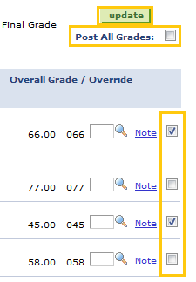
When you click the Update button, you will receive a confirmation message of how many grades will be posted similar to the below.
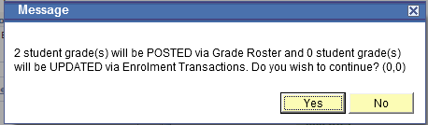

Student not on Grade Roster
If the student does not exist on the grade roster, you will receive the message below.
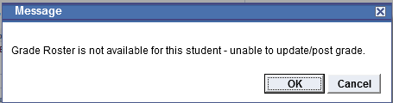
At this point, you should add append the grade roster. See training document ‘Grade Roster Administration’ at http://www.ljmu.ac.uk/studentinformationsystem/123002.htm
It is hoped that all enrolled students will appear on the grade roster as an automated process to append grade rosters is scheduled to run twice daily. However, if in the intervening period, an enrolment is processed and you need to add and post a grade, you should follow the guidance from the link above.

Amending Posted Grades
Previously, changing an overall posted grade would be via Quick Enrol transaction. This can now be done in Admin Gradebook.
A change to an overall grade is usually a result of assignment grades being changed. You should continue to change the assignment grades in either the ‘Class Assignments’ or ‘Grade by Assignment’ pages. This will result in a change to the overall cumulative grade.
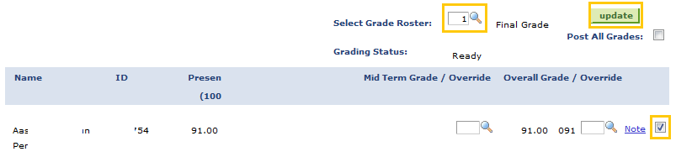
You should ‘Select Grade Roster’, select the student which you have changed the assignment grades for (leading to a new overall cumulative grade) and click update.
You will then receive the following message confirming the system has created and submitted an enrolment transaction to change the grade.
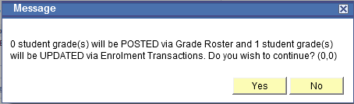
Click ‘Yes’ to confirm and process and ‘No’ to cancel.

Changing Transcript Notes
Click on the note link, next to the relevant student on the Cumulative Grades tab.
And amend the transcript note accordingly.
Click ‘Ok’ to save.

Appendix 1 – Grade Overrides

Grade | Meaning
DEF | Course Deferred. Should be entered only when a student has a successful Extenuating Circumstances claim
CMR | Component Marking Requirement – should be used if a student is required to complete and pass all assessed work for the module (previously XF)
INC | Incomplete. Where study of a course extends beyond the Assessment Board date (previously OG)
NS | If not Satisfied Requirement Designation (Competency)
D – System use only | Dropped. This a grade that the system uses when a student is dropped from a course
W – System use only | Withdrawn - This a grade that the system uses when a student is dropped from a course

