Student Information System
Liverpool John Moores University

User Guide: Gradebook Changes

Version 1.0: May 2016
Author: Business Support Office, APIS, Academic Registry

Contents
1. Summary of Changes 3
2. Introduction 3
Academic Framework 3
3. Process Map – Pre Assessment Board 4
4. Admin Gradebook 4
Recording ‘0’ Grades 5
Recording Non-Attempts (NAT) 5
What to do with students on LOA? 6
What to do with a valid DEF? 6
5. Repeat Codes 7
6. Extenuating Circumstances 8
7. Module Assessment Report (MAR) 8
8. 2016/17 Changes 9

Summary of Changes

Version | Date | Note;
1.0 | 03/05/2016 | New Document
1.1 | 16/05/2016 | Content added to ‘What to do with Students on LOA’ section
1.2 | 26/03/2018 | Section 4, what to do with LOA and DCG - mark entry guidance.

Introduction
The Admin Gradebook is the administrator portal for entering student assignment grades.
Following significant changes to the Academic Framework (commencing September 2016) and to support the changing needs of LJMU assessment boards, there have been a number of changes to the admin gradebook. The following document will outline the changes directly affecting the gradebook and the implications for the downstream reports/assessment board reports.
This document will cover the following;
- Recording of true ‘0’ (zero) marks.
- Recording Non-Attempts (NAT)
- The re-introduction of repeat coding
- The implications of true ‘0’ marks, non-attempts and repeat coding on the Module
- Assessment Report (MAR) and the Assessment Board Report (ABR).

Academic Framework
For all new entrants to LJMU, (commencing at the start of a programme) from September 2016, students will following the 2016/17 Academic Framework. For a full summary of changes, please click here.
Existing students (definition; those enrolled on a programme of study validated prior to 2016/17 academic year) continue on the pre 2016 (2015/16) academic framework.
 | Academic Framework
 | 2015/16 | 2016/17 (from September 2016)
Compensation allowed? | Yes (subject to programme and QLM) | No
Recording Non-Attempts (NAT) at assignment level | Yes | Yes
Consequence to NAT? | Student forgoes the weighting assigned to the respective component. | Not only must a student achieve a passing module mark, an attempt at ALL summative assessments in order to pass the module (excluding WSB)
Manually enter repeat code CMR? | Yes – any module with a component marking requirement, repeat codes should be entered manually. | No – CMR repeat code will be assigned automatically to all module that have a component marking requirement
Manually enter repeat code NAT? | No – NAT repeat codes are not required under the existing (pre 2016) academic framework. | No – any student with a NAT flag at assignment level (excluding WSB), will have a repeat code of NAT
Enter true ‘0’ grades in admin gradebook | Yes – as of 05/05/2016, it is possible to enter a grade of ‘0’ against an assignment. | Yes

Figure 1; 2015/16 and 2016/17 Academic Framework

Process Map – Pre Assessment Board
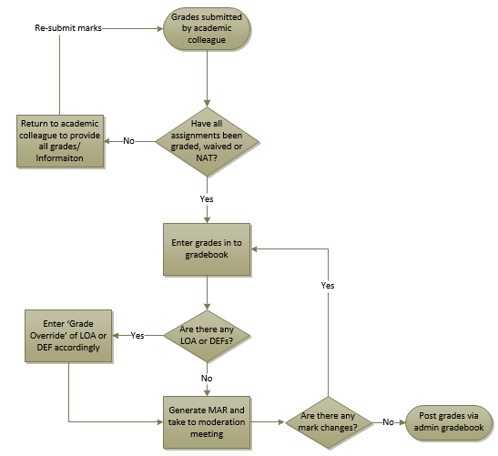
Figure 2: Pre-Assessment Board Process

Admin Gradebook
As we will have two academic frameworks running alongside each other for the next few academic years, students will be subject to different rules but the administrator grading process will remain consistent.
When accessing the admin gradebook, in will be indicated what academic framework the module follows.
For modules following the pre 2016 framework, you will see the following label in the admin gradebook;
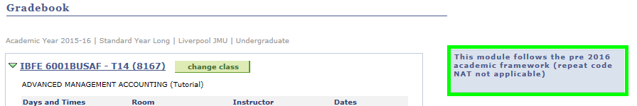
See figure 1 for differences in academic frameworks.
A label similar to this will show in the admin gradebook for modules which follow the 2016/17 academic framework

Recording ‘0’ Grades
It is now possible to enter ‘0’ grades against assignments in the admin gradebook.

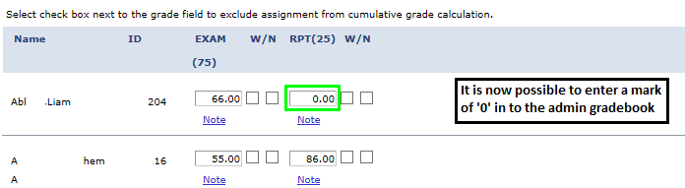
A mark of ‘0’ should only be entered when the assessment has been attempted and is worth nothing.

Recording Non-Attempts (NAT)

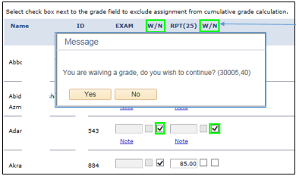
W – First tick box indicates waived
N – Second tick box indicates assignment ‘Not attempted’. Required for 2015/16 onwards.

Prior to posting, all assignment grade fields must be populated. When an assignment is flagged as ‘Non-Attempt’, the field is greyed out. If you attempt to post a module and there are missing assignment marks for a student you wish to post, you will receive the following;
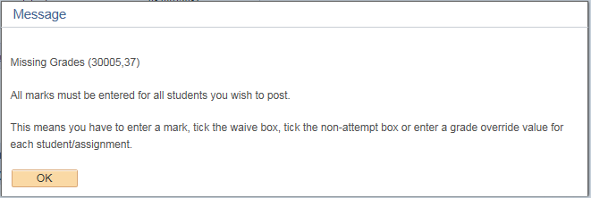

What to do with students on LOA?

If the LOA is agreed after the due date of any assessed work, all marks including WV/NAT should be recorded in the ‘Class Gradebook or Grade by Assignment’ page.

If the LOA is agreed before the due date of any assessed work, the components should be left blank in the ‘Class Gradebook or Grade by Assignment’ page.

In both of the above scenarios, if a student’s LOA request is approved prior to the completion of all assessed work, enter a grade override of ‘LOA’.

Note: any information in relation to the facts or timing of an LOA can be recorded as a ‘Note’ gradebook > cumulative grades (tab). See below.

Add the ‘ADMI’ ‘Note ID’. In the ‘Transcript Note’ free text box, indicate the assignment which the LOA covers. See below example.

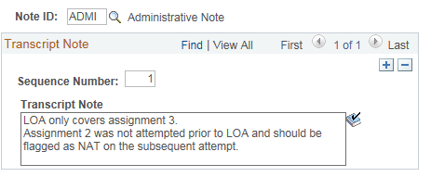

What to do with a valid DEF?

If a student has submitted a request for deferral or extenuating circumstances, enter a grade override of ‘DEF’. If the student has any other assignment marks, these should be entered on the ‘Class Gradebook’ or ‘Grade by Assignment’ page. Any components not attempted as a result of deferral should be recorded as ‘Not-Attempted’ (NAT).

What to do for Deferred Consideration

If deferred consideration has been granted, a transcript note of DCG should be entered.
The mark field(s) for the assessed components (for which deferred consideration has been granted) should be left blank. Do not record the component as NAT.
A grade override of ‘DEF’ should be recorded in the cumulative grades page.

Repeat Codes
Repeat codes have been re-introduced. The purpose of repeat codes are to control credit release. The repeat codes that have been introduced (See figure 1) are CMR and NAT.
2015/16
CMR (component marking requirement) means that all assessed component should be attempted and (crucially) passed for a student to be awarded credit. Any student that has a passing module mark AND failed an element of assessment should have a repeat code of CMR added to prevent credit release. Students with a failing module mark will not have credit released and therefore a repeat code is not mandatory.
NAT repeat codes are not required in 2015/16
To apply a repeat code, go to; Records & Enrolment > Enrol Students > Quick Enrol > Add a new value.
Enter;
- EMPLID
- Career
- Academic Institution (JMU)
- Term – enter the term the module is running in. (e.g. 2015)

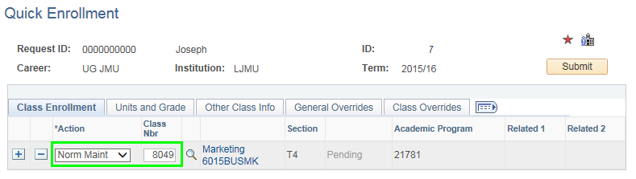
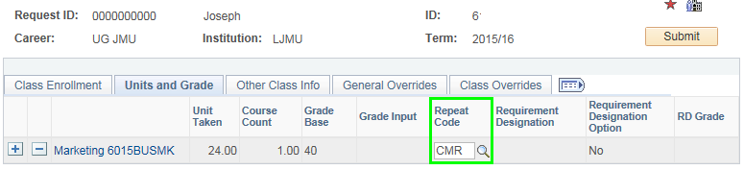

2016/17
REPEAT CODES ARE AUTOMATICALLY APPLIED
CMR (component marking requirement) – any module that carries a component mark requirement meaning that all assessed components must be attempted and passed. CMR repeat code will be assigned automatically from 2016/17 onwards. This will prevent credit release.
NAT – indicating non-attempt at an assignment. A repeat code of NAT will be assigned automatically from the start of the 2016/17 academic year to students commencing on a programme validated to commence from September 2016.
Students’ enrolled on a programme pre 2016 are following the 2015 academic framework and will not be subject to the NAT repeat code.

Extenuating Circumstances

There has been a change to the regulations regarding extenuating circumstances. Namely;

- A Student can now be deferred (DEF) at the module level even if they have an overall passing module mark. E.g. If a student has completed the CW element of the module (CW/Exam 80/20 weighting), achieved a CW mark of 98% (module mark 79%) and made a submission for extenuating circumstances due to illness on the day of an exam – which has been accepted, the student must take up the deferral opportunity despite already passing the module. For a final year student, this may lead to a delay in graduating.

For more information, please see the Academic Framework 2015/16.

Module Assessment Report (MAR)

To support the changes to the Academic Framework and the changing requirements of LJMU assessment boards, the customisations made to the administrator gradebook have allowed us to enhance the MAR.

Changes include;
- Displaying ‘0’ for assignment marks when a ‘0’ has been entered in gradebook
- Displaying ‘0’ for the module mark when the module assessments have been attempted and are worth nothing
- Including assignment marks of ‘0’ in the assignment mean
- Including module marks of ‘0’ in the module mean
- Displaying ‘NAT’ for the assignment mark when the NAT has been ticked in admin gradebook
- Displaying ‘NAT’ for the module mark when all assignments are NAT
- Excluding assignment NAT and module NAT marks from assignment and module mean respectively
- When an assignment has been ‘Waived’, the MAR now shows ‘WV’ (previous ‘W’)
- Module mean now excludes DEF and LOA marks
- Module mean now includes module mark where a repeat code of ‘CMR’ has been applied
- Assessment Items Summary (assignment mean) display’s on the front cover of the MAR
- Module Mean and Standard Deviation display on the front
- Module mean from ‘Student Enrolment’ (mean of students that have passed the module) has been removed.

The below screenshot is how the front cover of the MAR now looks;

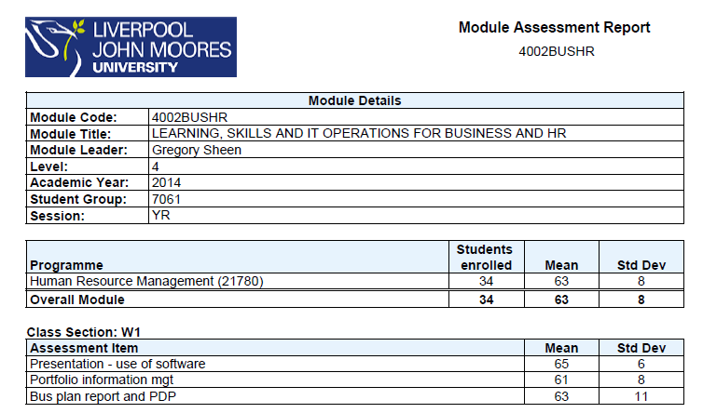

The below screenshot shows how the MAR looks if an assignment has been ticket as NAT in admin gradebook.

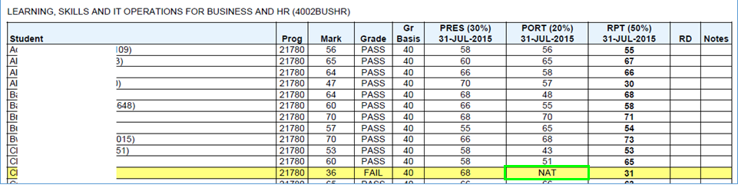

Reminder; only under the 2016 Academic Framework and for programmes validated for delivery from September 2016 are students required to achieve a passing module mark and attempt all assessments (excluding WSB) to achieve a grade of ‘PASS’. Any student that has not attempted all elements of assessment (excluding WSB) will have a repeat code of ‘NAT’ (to prevent credit release, GRADE = FAIL) automatically assigned regardless of the module mark.

2016/17 Changes

Students commencing study on a programme validated to commence September 2016 must adhere to the 2016/17 academic framework.

- For credit release, students are required to attempt (excluding WSB) all assessed components and have a passing module mark.
- As a mechanism to prevent credit release, any student that has not attempted all assessed components (excluding WSB) will have a repeat code of NAT automatically assigned. Repeat codes show in brackets in the ‘Grade’ column on the ABR, see below;

- CMR repeat code also displays in brackets
- Any student flagged as NAT for all assessed components will display as NAT on the MAR and ABR. Note – this is for DISPLAY purposes only. This doesn’t change how the award mark is calculated

