Student Information System
Liverpool John Moores University

User Guide
Recording Academic Misconduct on SIS

Note: Only authorised users are able to record Student Milestones for Academic Misconduct. Please request access via the Helpdesk.

Version 7: Oct 18
Business Support Office, Academic Registry
Contents
1
Student Information System 1
Summary of Changes 3
User Guide 4
Academic Misconduct 4
Introduction 4
Scope of this Document 5
Overview 5
High Level Process: 5
Business Process 6
The Academic Misconduct Penalty Tariff 6
System Process 7
High Level Process 7
Detailed Process Steps 7
Record Academic Misconduct (AMC) Milestones 7
Initial Milestone 7
Setting the AMP Pending Service Indicator 11
Decision: Proven 14
Apply Academic Misconduct Service Indicator 16
Decision: Unproven 18
Apply Module Indicators to the Student Record. 19
Entering a Transcript Note 19
Entering the Assignment Mark 20
Outcome 2 (40 – 69 points) 20
Student Records Administration 20
Outcome 3 (70 – 89 points) 21
Student Records Administration 21
Outcome 4 (90 - 99 points) 21
Outcome 5 (100 or more points) 24
Outcome 6 Fitness to Practise 25

Summary of Changes
Version: | Changes: | Detail | Date:
Version 1 | Major | New Document | 7/4/15
Version 1.1 | Major | Added procedural tables for AMP Decisions and Appeal process  Added process for Decision: Unproven  Made minor step changes | 23/4/15
Version 2 | Major | Changed text and screenshots to reflect UAT changes to LOVs | 15/5/15
Version 3 | Major | Removed Appeal process for ‘go live’  Production version | 22/5/15
 | Major | Amended process for adding multiple AMC outcomes on the same day | 11/6/15
 | Minor | Deleted point b) from ‘unproven’ process steps | 11/6/15
 | Minor | Added guidance to change Milestone Number from ‘10’ to ‘20’ (etc) | 12/06/15
Version 4 | Major | Updated to reflect 2016 Acad Framework and new AMC Polic | 16/12/16
Version 5 | Major | Refined Outcomes 1 & 2 to further reflect Policy changes. Corrected screenshots and text | 05/01/17
Version 5 | Major | Updated guidance to Outcome 1 and Outcome 2 | 04/01/17
Version 6 | Minor | Added clarity to the High Level process stating what should happen in the event of a successful appeal. | 06/09/18
Version 7 | Major | Added new Allegation categories for Cheating (see point hh:) | 26/10/18

User Guide

Academic Misconduct

Introduction
Academic Misconduct is deemed to cover all forms of cheating, plagiarism and unauthorised collusion.
This includes attempts to cheat, plagiarise, collude and any other deliberate attempt(s) to gain an unfair advantage in assessments.
Assessment includes all forms of written work (including in-class tests), e-assessments, presentations, demonstrations, viva voces, recognition of prior learning portfolios and all forms of examination.
Where there is evidence of Academic Misconduct, the University will take appropriate action. This action could range from the loss of marks in the relevant module with no opportunity to retake the assessment or the failure of a set of modules. In some cases module marks are reduced to zero making it impossible for students to achieve their target award.
The penalty students incur will depend on a number of factors including:
- Level of study
- The extent and seriousness of academic misconduct
- Previous proven cases of academic misconduct
Each year the University expels a number of students because of Academic Misconduct. Any proven cases of academic misconduct will remain on the student record and may be noted in any future requests for references. The University will also, where appropriate, inform relevant professional bodies. The consequences of Academic Misconduct can extend beyond the University and may severely impact upon the students chosen profession.

Scope of this Document

Overview
This document describes the system process that will underpin the business process for recording Academic Misconduct on the Student Information System.

High Level Process:
- If the case proceeds to the Academic Misconduct Panel then the relevant documentation used in the hearing and the outcome should be attached to the student’s record on SIS and provide the ability to report on academic misconduct in relation to the student/student programme/student module/student assessment
- If the student appeals then this detail should be recorded on SIS
- It should be evident to a SIS user whether the final decision was subject to an appeal. If the outcome of the appeal is successful, the ‘Proven’ milestone should be replaced by an ‘Unproven’ one.
- Access control should be applied to any academic misconduct information so that it is only viewable by the relevant staff in the faculties, Student Administration and Student Governance
- There should be additional reporting functionality available to enable reports to be generated for Programmes, Schools, Faculties plus Home/International students
- To provide a complete overview of academic misconduct the following information will need to be stored on SIS
  - Allegation type
  - Date allegation raised
  - Allegation Raised By
  - Date of panel
  - Assessment Type
  - Module Component
  - Outcome of panel (might be different to allegation)
  - Tariff Points
  - Summary of decision
  - An indicator to identify if an appeal was lodged and for each stage of the appeal
  - The stage of the appeal
  - Reason for appeal
  - Appeal outcome.
  - A link to the folder containing the documents associated with the case
  - An indicator to identify that a student had been referred to an AM Panel but withdrew from the university before the panel convened

Business Process
Where there is an allegation of cheating, plagiarism or collusion against a student, the general process is:
- The matter is referred to an Academic Misconduct Panel [AMP] which the student is invited to attend and respond to the allegation. Students accused of Academic Misconduct will be sent details of the allegation plus supporting evidence and asked to attend an Academic Misconduct Panel (AMP).
- During the hearing, a member of staff known as the Presenting Officer will present the case for Academic Misconduct. This member of staff is not part of the deliberating panel; their role is only to present evidence relating to the allegation.
- The student will have an opportunity to present their defence and challenge the evidence presented.
- The AMP considers the evidence and determines whether the misconduct allegation is proven or not.
  - In proven cases a penalty will be applied and the Assessment Board will be informed.
Penalties range from receiving a mark of 0 for an assessment component to a recommendation of expulsion from the University.
- Students have the right to appeal against the decision of an Academic Misconduct Panel. The grounds for appeal are strictly limited. Students cannot submit an Appeal just because they don't agree with the decision. There are also strict time limits for lodging an Appeal: normally within 10 working days of the written notification of the outcome of the Panel.
LJMU ensures fairness and consistency in the application of penalties to students, across all Faculties. The Academic Board, agreed that the most appropriate way to do this was to have an LJMU penalty tariff used by all Assessment Boards. This became operational across the University in September 2011:

The Academic Misconduct Penalty Tariff
Points Tariff | Penalty Incurred
Up to 39 points | Zero for assessment item
40 – 69 points | Zero for assessment item and module mark capped
70 – 89 points | Zero for module
90 - 99 points | Zero for module and no referral
100 or more points | Case referred to Assessment Board to determine one of the following:  - Recommendation for expulsion with an alternative exit award  as appropriate  - Recommendation for expulsion with any alternative exit award withheld
FTP | Referred to Fitness to Practise

System Process

High Level Process
- Once the Faculty Registrar (or nominated alternative) has concluded that an allegation should proceed to an AMP, the details should be entered:
  - as Milestones from that point only
  - a ‘pending’ Service Indicator applied.
- If an allegation is proven then:
  - A corresponding Service Indicator should be added to the Student Record
  - The appropriate module action should be applied (depending on the tariff points applied)
- Supporting reports can be accessed via WebHub.

Detailed Process Steps

Record Academic Misconduct (AMC) Milestones

Initial Milestone

Navigation: Main Menu>Records and Enrolment>Enrol Students>Student Milestones
As good practise it is always advisable to search for existing Milestones first. Use the ‘Find Existing Value’ tab in the search page to do this. This will ensure that you are not duplicating any existing AMC Milestone and will inform you of existing Milestones already attached to the student.

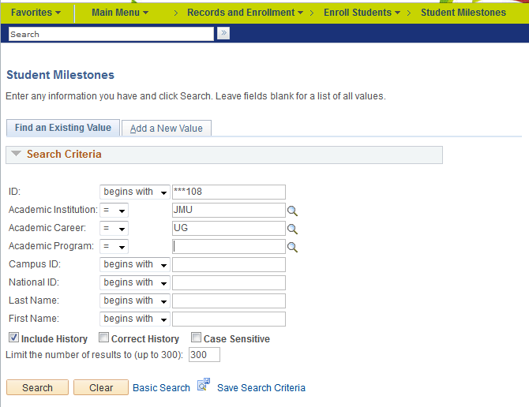
Figure 1 - Search Page
Add a New Value
- Enter Student ID: Students ID
- Academic Institution: JMU
- Academic Career: Students Career (UG, PGT etc)
- Academic Programme: The Programme that is being investigated by the AMP
- Click Add: A new, blank Milestone will be created for you.
- Academic Institution: Liverpool JMU
- Academic Career: Students Career
- Academic Programme: Students Programme
- Effective Date: Enter the applicable date
Note: The Effective Date that should be recorded should be the date that the action happened rather than the date that the information was recorded on SIS.
For example:
Milestone Level | Effective Date
CHG OF ALLER - Change of Allegation | Date of Allegation Change (likely to be same as AMP)
DEC_PROVEN - Decision: Proven | Date of AMP
DEC_UNPROVEN - Decision: Unproven | Date of AMP
REG_APPROV | Date of Faculty Registrar approval for AMP

- Milestone: Enter ‘AMC’ Academic Misconduct. This is the very first Academic Misconduct Milestone attached to that student – for that Career, Programme and Plan.
- Milestone Number: Automatically generated
- Milestone Level: Select appropriate Level from list of values. Select from:
Milestone Level | Usage
CHG OF ALLER - Change of Allegation | Used to indicate that there has been a change to either the allegation type or assessment item.
DEC_PROVEN - Decision: Proven | Used to record a proven allegation as decided by an AMP
DEC_UNPROVEN - Decision: Unproven | Used to record an unproven allegation as decided by an AMP
REG_APPROV | Used to indicate that an allegation is eligible to proceed to an AMP

- Milestone Complete: Automatically generated
- Academic Plan: Select the students Plan (Award Aim)
- Description: Displays the Milestone selected above.
- Formal Description: Displays the Milestone selected above.
- Milestone Title: The Module Code should be entered here.
Note: this is a free text box and only the Module Code should be entered. The Module title is not required.
- Comment: Used to record further information.
- Hide Comment on Student Self Service: Tick to hide the comment from the student
- Manage Milestone Documents: Select to attach a copy of relevant documentation about the case.
Note: Not used in the first stage of development
- Term Required: Enter the students current Term (Acad Year)
- Date Required: Enter AMP date if known or leave as default (last date of Term)
- Anticipated Term: Leave as is
- Anticipated Date: Leave as is
- Transcript Level: Not used
- Print Milestone Detail: Not used
- Advised by Committee: Not used currently
- Advisor/Evaluator: Record the staff member raising the allegation
- Attempts Allowed: Default value
- Attempt Number: Default value
- Grading Scheme: Default value – ‘JMU’
- Grading Basis: Select ‘AM’ Academic Misconduct grading basis
- Grade Input: Enter ‘PND’ for Pending
- Milestone Complete: Enter the type of allegation. Select either:
AMC – Cheating in examinations
AMC – Cheating: falsification of research data
AMC – Cheating: submission commissioned or purchased from a third party
AMC – Any other category of cheating
AMC - Collusion
AMC - Plagiarism
- How Attempted: Enter the Assignment Type that the allegation is relating too
- Date Attempted: Should be an ‘action date’ so should be the submission date of the assignment
- Save the record
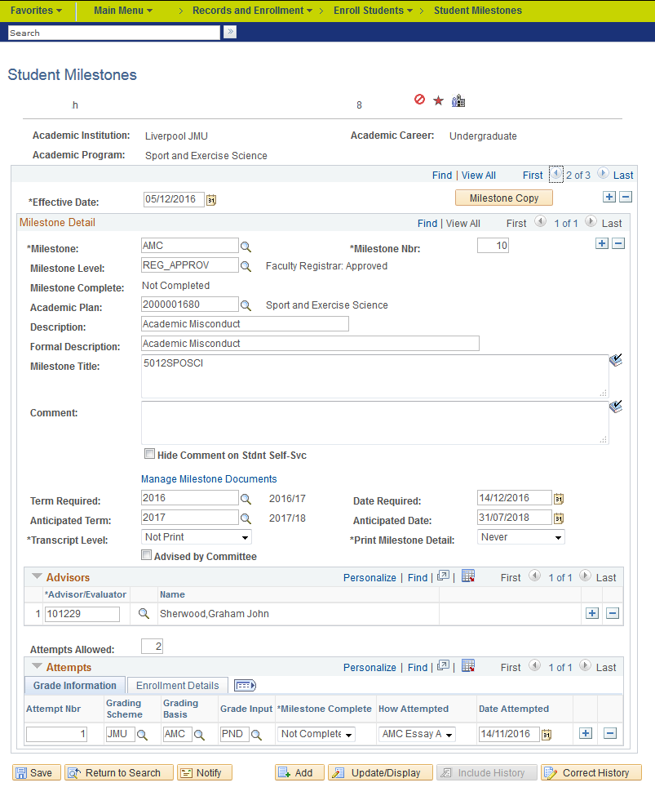
Figure 2: Completed Initial Milestone

Setting the AMP Pending Service Indicator

Navigation: Main Menu>Records and Enrolment>Enrol Students>Student Milestones>Related Content>Manage Service Indicators
Service Indicator Related Content allows application of Service Indicators without moving away from working in the current page. The AMP Pending indicator will display to admissions staff and in the event that the student withdraws prior to their AMP being convened, will appear as an admissions sanction until the AMP has sat and reached a decision. This will put the consideration of their current application on hold and may subsequently affect the admissions decision for the current application. In these instances, admissions staff may contact the administrator responsible for setting this to confirm whether or not they can continue to process the current application.
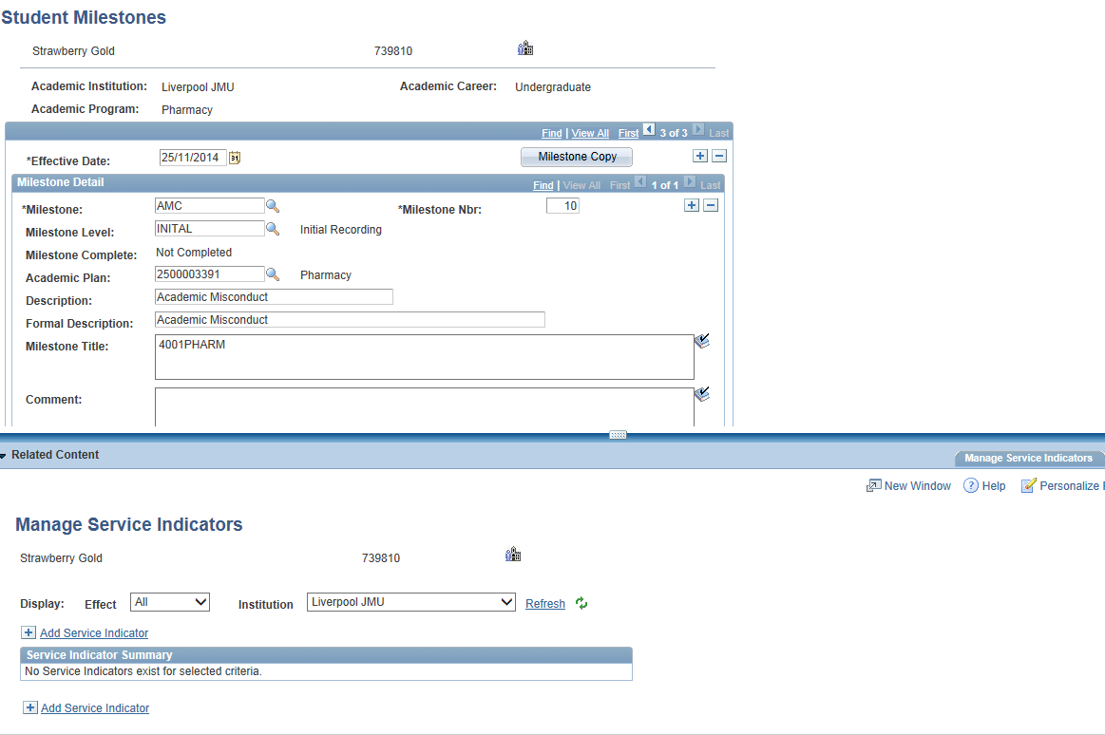
Figure 3: Service Indicator Related Content

Apply AMP Pending Service Indicator
- Select Service Indicator Code ‘AMP – AMP Pending’
- Select Service Indicator Reason Code ‘AMP – AMP Pending’
- Enter the Start Term (i.e. the current term)
- Start Date will default in as the date when the indicator is applied
- Placed Person will default in as per user
- Click OK
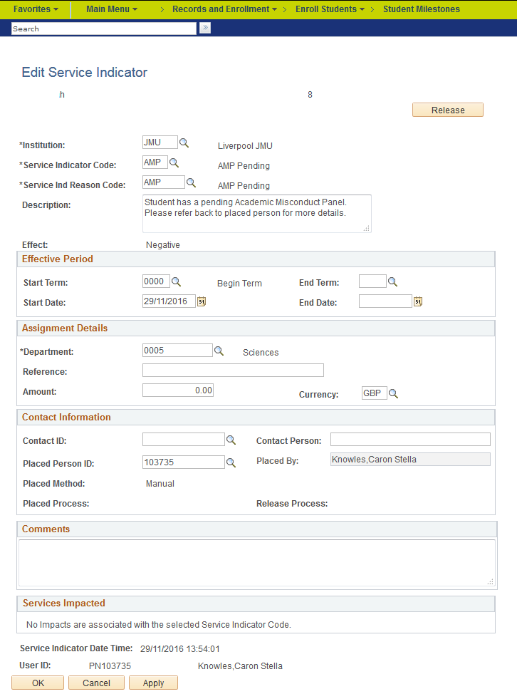
Figure 3: AMP Service Indicator Set Up

Additional Milestones – Same Day Allegations
There are occasions when multiple allegations need to be recorded that have occurred on the same day. This is usually when a student has allegations crossing several modules. In the majority of cases the Faculty decisions are made on the same day and need to be recorded as such.
For each allegation a new row should be created.
Navigation: Main Menu>Records and Enrolment>Enrol Students>Student Milestones
- Search for an Existing Value: There will already be an initial Milestone.
- Enter Student ID: Students ID
- Academic Institution: JMU
- Click Search: The students existing Milestone record will display (you might need to click the Include History at the bottom of the page first) and show:
- Academic Institution: Liverpool JMU
- Academic Career: Students Career
- Academic Programme: Students Programme
Note: the full detail of the previously entered Milestones will display – we need to add to this.
- Click the ‘Add a row’ button:
Note: Ensure that the Add Row is the one on Milestone Detail – not the one on the right of the Effective Date.
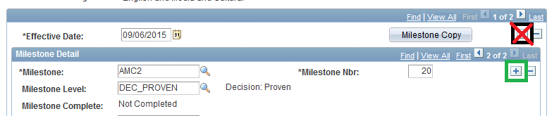
- Milestone: Select ‘AMC2’ (AMC3 and AMC4 are also available for multiple entries)
- Milestone Level: Select desired value
Complete the rest of the form as normal.

Subsequent Milestones

Decision: Proven
- Search for an Existing Value: There will already be an initial Milestone.
- Enter Student ID: Students ID
- Academic Institution: JMU
Navigation: Main Menu>Records and Enrolment>Enrol Students>Student Milestones
- Click Search: The students existing Milestone record will display (you might need to click the Include History at the bottom of the page first) and show:
- Academic Institution: Liverpool JMU
- Academic Career: Students Career
- Academic Programme: Students Programme
Note: the full detail of the previously entered Milestones will display – we need to add to this.
- Click the ‘Add a row’ button:
Note: Ensure that the Add Row is the one to the right of the Effective Date – not the one on the Milestone Detail.
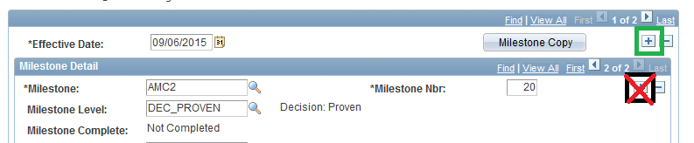
Note: All the detail is duplicated from the previous Milestone – this can be confusing but does lessen the amount of data that needs to be entered. You can overwrite the fields. The text that you need to amend is highlighted below. Ensure that you are entering data on row 1 of 2
e.g.
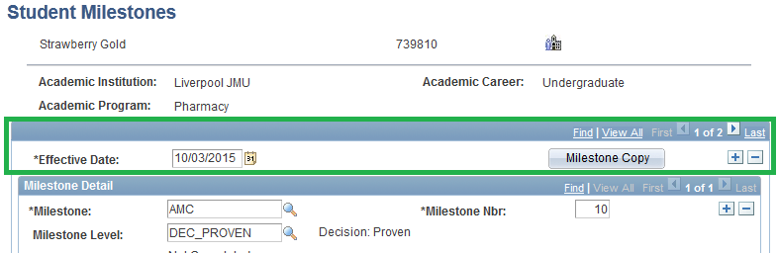
Figure 4: Add a New Row
- Effective Date: Enter the applicable date. This will be the AMP date.
- Milestone: ‘AMC’ will already be displayed, this this as is
- Milestone Number: Change to ‘20’ (or whatever the next increment is)
- Milestone Level: Select appropriate Level from list of values.
- Milestone Complete: Automatically generated
- Academic Plan: Will already be displayed
- Description: Displays the Milestone selected above.
- Formal Description: Displays the Milestone selected above.
- Milestone Title: Will already be displayed
- Comment: Will already be displayed
- Hide Comment on Student Self Service: Tick to hide the comment from the student
- Manage Milestone Documents: Select to attach a copy of relevant documentation about the case.
  - Note: Not used in the first stage of development
- Term Required: Will already be displayed
- Date Required: Will already be displayed
- Anticipated Term: Leave as is
- Anticipated Date: Leave as is
- Transcript Level: Not used
- Print Milestone Detail: Not used
- Advised by Committee: Not used currently
- Advisor/Evaluator: Will already be displayed
- Attempts Allowed: Default value
- Attempt Number: Default value
- Grading Scheme: Default value – ‘JMU’
- Grading Basis: Will already be displayed.
- Grade Input: Enter the exact Tariff Points as decided by the AMP
- Milestone Complete: Will already be displayed. However if entering a Change of Allegation, select the new appropriate value. Select either:
AMC – Cheating in examinations
AMC – Cheating: falsification of research data
AMC – Cheating: submission commissioned or purchased from a third party
AMC – Any other category of cheating
AMC - Collusion
AMC - Plagiarism
- How Attempted: Will already be displayed.
- Date Attempted: Change to date of AMP.
Then:
- Click the Add a New Row button (next to Date Attempted)
- Attempt Number: Default value
- Grading Scheme: Default value – ‘JMU’
- Grading Basis: Will already be displayed.
- Grade Input: Select the Tariff Band as decided by the AMP
- Milestone Complete: Will already be displayed. However if entering a Change of Allegation, select the new appropriate value. Select either:
AMC – Cheating in examinations
AMC – Cheating: falsification of research data
AMC – Cheating: submission commissioned or purchased from a third party
AMC – Any other category of cheating
AMC - Collusion
AMC - Plagiarism
- How Attempted: Will already be displayed.
- Date Attempted: Change to date of AMP.
- Save the record
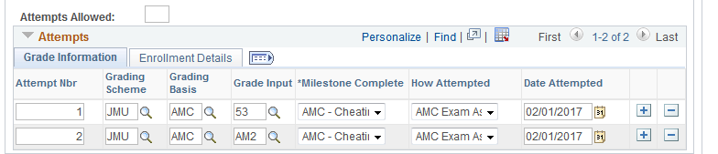
Figure 5: Recording Tariff Points and Bands

Apply Academic Misconduct Service Indicator

Navigation: Main Menu>Records and Enrolment>Enrol Students>Student Milestones>Related Content>Manage Service Indicators
- Click on the AMP Pending Service Indicator
- Click the ‘Release Button’
- Click OK
- Click ‘Refresh’
- Click ‘Add Service Indicator’
- Select Service Indicator Code ‘AMC – Academic Misconduct’
- Select the Service Indicator Reason Code that corresponds to the points tariff allocated at the AMP
- Enter the Start Term (i.e. the current term) – note that for AMC4 allocations this will also be displayed on the Assessment Board Report for the current term.
- Click OK
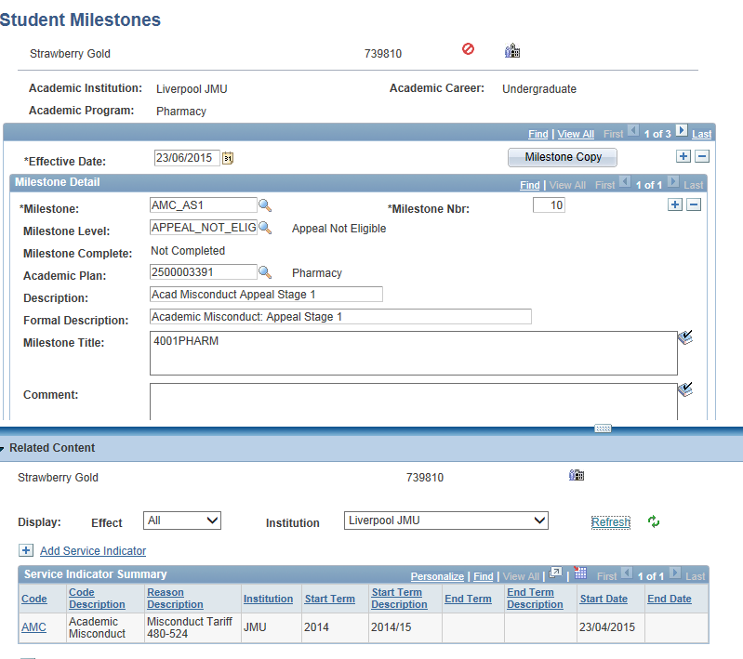
Figure 6: Milestones and Service Indicators

Decision: Unproven
Follow steps a) to dd) as above (Decision: Proven)
Then
- Delete the ‘Attempts’ detail entirely from the students Milestone record. The detail for Attempt Number, Grading Scheme, Grading Basis and Milestone Complete will remain. This is because they are default values and cannot be removed.
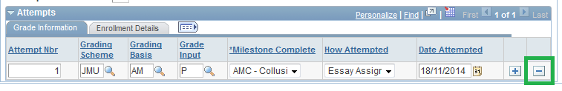
Figure 7: Deleting the Attempts detail
- Save the Record
- Release the AMP Pending Service Indicator by clicking the ‘Release’ button.

Apply Module Indicators to the Student Record.

Outcome 1 (Up to 39 points)

Student Records Administration
A Mark of 0 for Assignment

Entering a Transcript Note
It is a Transcript Note that captures the application of a Penalty and displays this on the student’s Assessment Board Report, Progress Report and Transcript.
Navigation: Main Menu>Curriculum Management>Grading>Administrator Gradebook
- Search for the class that the Penalty should be applied is applicable to
- Results of the search are displayed by Term, Session and Class offering.
- Click the Term and Class required
- Click on ‘Cumulative Grade’ tab
- Locate the student required
- Click the ‘Note’ link for the student. The Transcript Note form will open
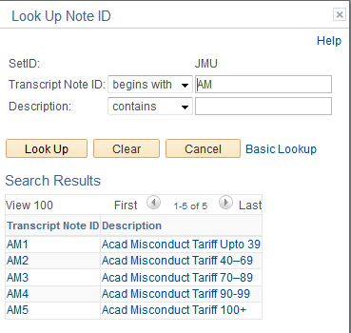
- In the Note ID list of values select the AM1 – Acad Misconduct Tariff Up to 39 points
- Click OK to Save

Entering the Assignment Mark
Navigation: Main Menu>Curriculum Management>Grading>Admin Gradebook
- Enter the Term of the Class required
- Enter the Class or Course Catalogue number
- Click Search
The Gradebook will open for the Class
- Enter zero zero into the mark grid for the assignment (the original mark can be over-written)
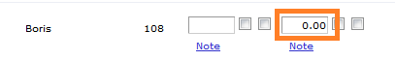
- Click Save
Note: The Cumulative grade will update automatically to show the amended overall Grade.

Outcome 2 (40 – 69 points)

Student Records Administration
Zero for assessment item and module mark capped
The module attempt will be capped at minimum pass mark e.g 40%
Navigation: Main Menu>Curriculum Management>Grading>Admin Gradebook
- Search for the class to be amended
- Results of the search are displayed by Term, Session and Class offering.
- Click the Term and Class required
- Enter the zero for the Assignment mark
- Click the Cumulative Grade tab
- Click the Note link
- Enter a Transcript Note = AM2
- The module should then be manually capped in the following manner:
  - Using Quick Enrol, select ‘Normal Maintenance’
  - Select the Class from the List of Values
  - Click the Class Overrides tab
  - Select and tick ‘Grading Basis’
  - Click the Units and Grade tab
  - Change the Grade Basis to the ‘Capped’ basis. Eg 40% to 40%C
  - Click Submit to process the change
  - Check the new Grade Basis on the Student Grades page

Outcome 3 (70 – 89 points)

Student Records Administration
Mark of 0 for the module.
Permission to re-submit if allowed a referral, which will be capped at minimum pass mark e.g 40%
Navigation: Main Menu>Curriculum Management>Grading>Admin Gradebook
- Search for the class to be amended
- Results of the search are displayed by Term, Session and Class offering.
- Click the Term and Class required
- Click the Cumulative Grade tab
- For the student enter a grade ‘override’ value of 000
- Click the Note link
- Enter a Transcript Note = AM3
- The student then should be enrolled on to the Referral class in the normal way (see Post Progression Processing Quick Guide). The Referral class will automatically be capped at the relevant official pass mark.

Outcome 4 (90 - 99 points)
Student Records Administration
A Grade of 0 for module – no opportunity for a Referral
Entering a Grade of 0
Navigation: Main Menu>Curriculum Management>Grading>Admin Gradebook
- Search for the class to be amended
- Results of the search are displayed by Term, Session and Class offering.
- Click the Term and Class required
- Click the Cumulative Grade tab
- For the student enter a grade ‘override’ value of 000
- Click the Note link
- Enter a Transcript Note = AM4
Applying the Academic Misconduct Repeat Code
Repeat codes are used by the system to manage multiple attempts at a module.
A specific Academic Misconduct repeat code is applied to the student’s record which will prevent any further attempts at that course
Repeat codes are applied directly to the student record through Quick Enrol
Navigation: Main Menu>Records and Enrolment>Enrol Students>Quick Enrol
- Add a New Value
- Enter student ID
- Click Add

- Change the Action to Normal Maintenance
- Enter the Class number. This is the class number that the student is enrolled on and the class for which the Repeat Code should be applied. The Class can be located easily from the List of Values
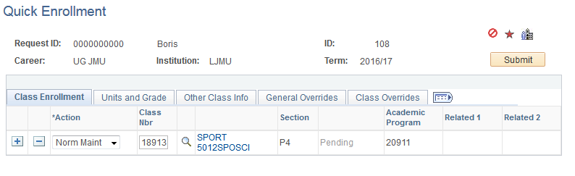
- Click the Repeat Code field on the Unit and Grade tab
- Select the Repeat Code of AM4 – Acad Misconduct Tariff 90-99 points
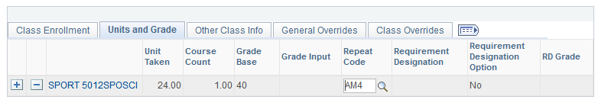
- Enter an Action Reason of ‘PEN’ Penalty Repeat Code Applied on the ‘Other Class Info’ tab
- Add a Transcript Note of ‘AM4 ’
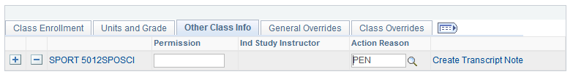
- Submit the Enrolment Request. This is crucial as unless the process is submitted the Note will not be part of the students record
- The process will complete with a status of ‘Success’ and the Repeat Code will now appear on the student record.
This Repeat Code will now appear on some of the student’s reports.

Outcome 5 (100 or more points)
Student Records Administration
Case Referred to Assessment Board. Recommend Expulsion with an Alternative Award as appropriate or recommend expulsion with any Alternative Award withheld
Applying a Plan Change
If the student is to be awarded an Alternative Award then the first step is to perform a Plan Change to the Alternative Award Plan (see Programme/Plan Change Quick Guide)

Completing the Student
The Completion process then needs to be followed to complete the student in the correct way (see Completion Quick Guide)
Entering an Expulsion
When a decision has been made to expel a student then the decision needs to be entered onto the student’s Programme/Plan Stack.
This is done by the Student Admin Centre where a student is Withdrawn, whilst the Expulsion Service Indicator is managed and applied by Student Governance.
Refer to the Withdrawal Quick Guide

Outcome 6 Fitness to Practise

For certain programs of study there may be an alternative or additional outcome (Fitness to Practise Referral) to record, fitness to practise.
5.1 Apply Outcome Service Indicator
Navigation: Campus Community > Service Indicators > Person > Manage Service Indicators
- Query the appropriate EmplID

- Click the + Add Service Indicator
- Select the AMC Service Indicator Code from the List

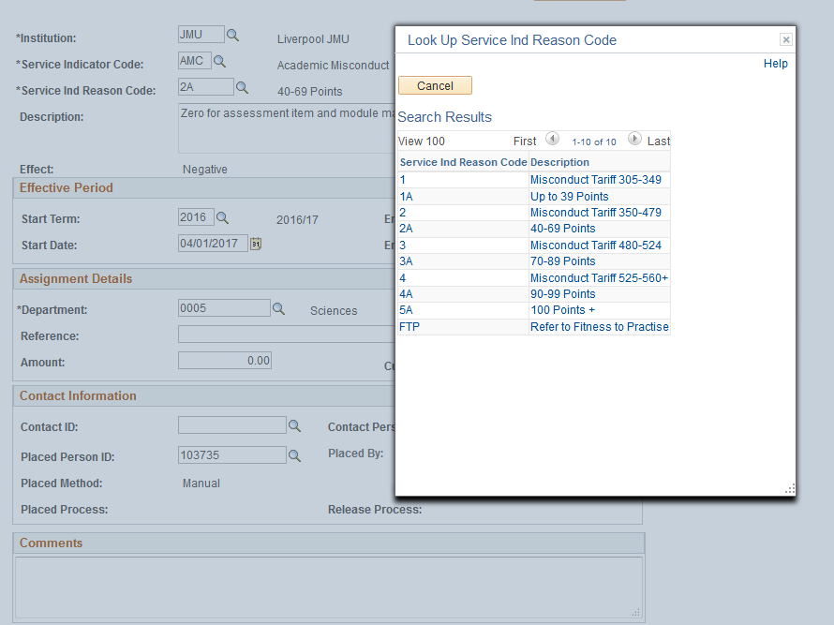
- Select Reason Code FTP
- Enter Start Term (current term)
- Start Date should default as should be Placed Person ID
- Click Apply/OK button
- Click Return to Search bu

