Student Information System
Liverpool John Moores University

User Guide: Block Enrol – various methods

Version 1.0: January 2018
Author: Business Support Office, APIS, Academic Registry

Contents
1. Summary of Changes 3
2. Introduction 3
3. Creating the Student Block 3
3.1 Via External File 3
3.2 Via Pop Select (PS QUERY) 6
3.3 Manual Student Group 8
4. Create Class Block 9
4.1 Add Merge Process 10

Summary of Changes

Version | Date | Note;
1.0 | 03/01/2018 | New Document
1.1 | 16/05/2016 | Content added to ‘What to do with Students on LOA’ section

Introduction

Block enrol is a method used to enrol/drop student EMPLIDs on to a class or group of classes within a given term.
Following the release of a bundle upgrade late 2016, new functionality allows us to create a student block using pop select functionality via a PS Query or via external file import. Previously creating a student block was a manual, sometimes time-consuming activity.
The following document will provide user guidance on the three ways (listed below) to create a student block within the Student Information System.
- External file import
- Pop select & PS Query
- Manual
Creating a class block remains unchanged but will be covered later in this document.

Creating the Student Block

Via External File
- Navigate to Records and Enrolment > Enrol Students > Block Enrolment > Create Student Block
- Add a New Value
- Name your Student Enrolment Block accordingly e.g. 35351
- Add
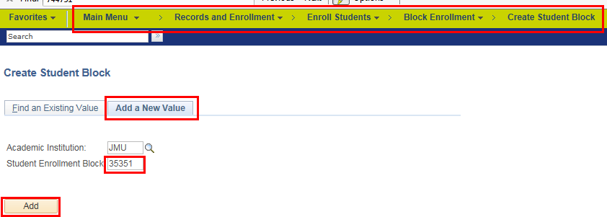

- Give your Student Enrolment Block a name
- Tick ‘Population Selection’
- Selection Tool = ‘External File’
- Upload File
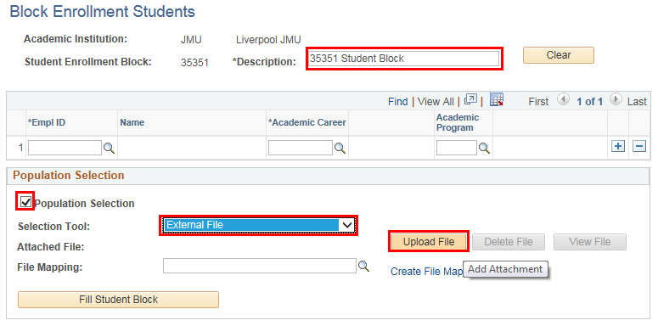
- Browse – look for your CSV file containing EMPLID and Career. E.g.
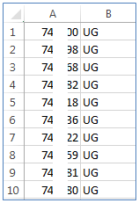
- Upload
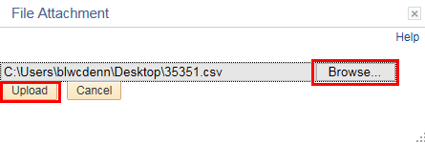
- Select the look up symbol
- Choose file mapping called ‘EMPLID_CAREER’.
Note: the file mapping is based on EMPLID and Career only. If you require any further mapping (e.g. programme code), please contact Business Support
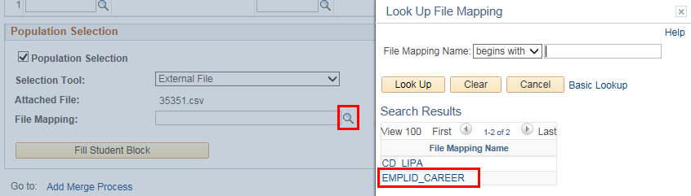
- ‘Preview Selection Results’ will show you the EMPLIDs you are importing

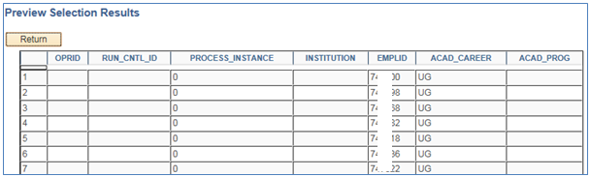
- If you are happy with the preview of results, select ‘Fill Student Block’
- Any student within the CSV file will be loaded in to the student block
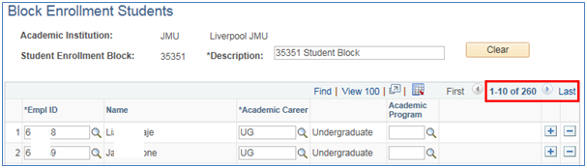
- Save
Now create your class block (a block of classes you wish to enrol the students on to).

Via Pop Select (PS QUERY)

Navigate to Records and Enrolment > Enrol Students > Block Enrolment > Create Student Block
- Add a New Value
- Name your Student Enrolment Block accordingly e.g. 35351
- Add
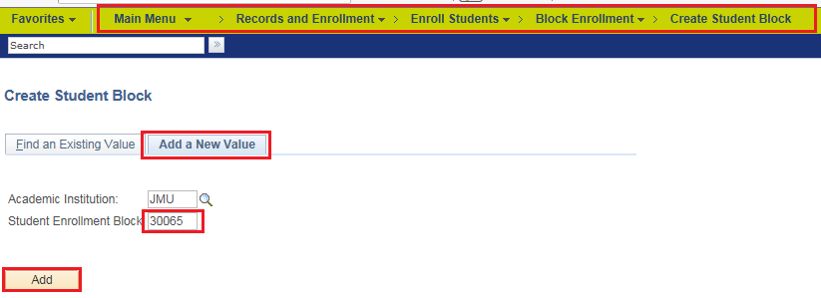
- Give your Student Enrolment Block a name
- Tick ‘Population Selection’
- Selection Tool = ‘PSQUERY’
Using the ‘look up’ icon, select the query called ‘ENROL_BY_CAR_PROG_ACAD_LOAD’. For any query, you may need to enter prompts. Note: there are a number of different queries available within the lookup list, the names of which should be self-explanatory. For further advice, contact the BST.
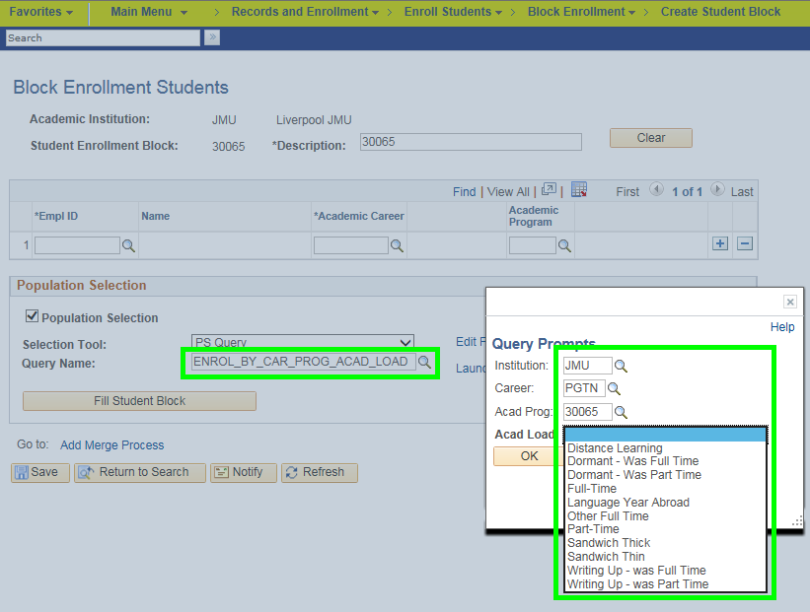
- Enter parameters as per screenshot above
- ‘Preview Selection Results’ will show you the EMPLIDs you are importing
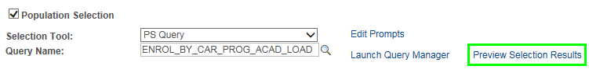

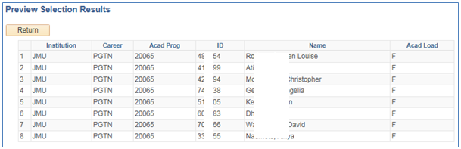
- If you are happy with the preview of results, select ‘Fill Student Block’
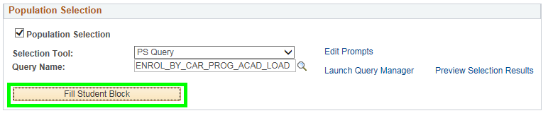
Any student within the ‘Preview Results’ will be loaded in to the student block
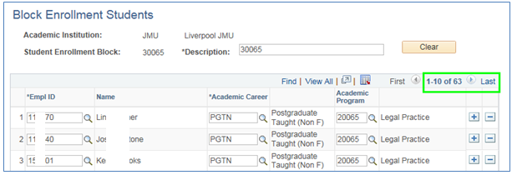
- Save

Manual Student Group

Navigate to Records and Enrolment > Enrol Students > Block Enrolment > Create Student Block
- Add a New Value
- Name your Student Enrolment Block accordingly e.g. 30065
- Add
- Give your Student Enrolment Block a name
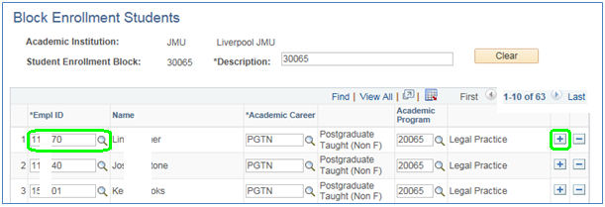
Manually enter or select the;
- EMPLID or search for the student via the look up.
- Student career (if a student is or has studied multiple careers, you will see those listed)
- Academic Program (if a student is or has studied multiple programmes, you will see those listed)
Add a new row and repeat the steps above for each student.
- Save

Create Class Block

Navigation: Main Menu> Records & Enrolment > Enrol Students > Block Enrolment > Create Class Block
- Add a New Value
- Name your class block (Tip: use the SAME code as for the Student Block)
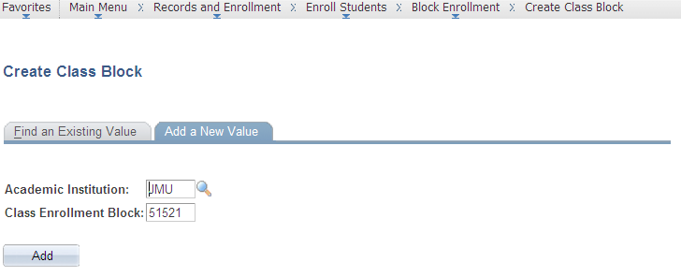
- Add description e.g. Programme code
- Select:

- Term
- Action (you can bulk drop as well as bulk enrol)
- Select class number (find through lookup list if required)
Add an additional row for each additional class/module you wish to enrol
- Save
Please note: the same enrolment date restrictions are in place that are used by Quick Enrol.
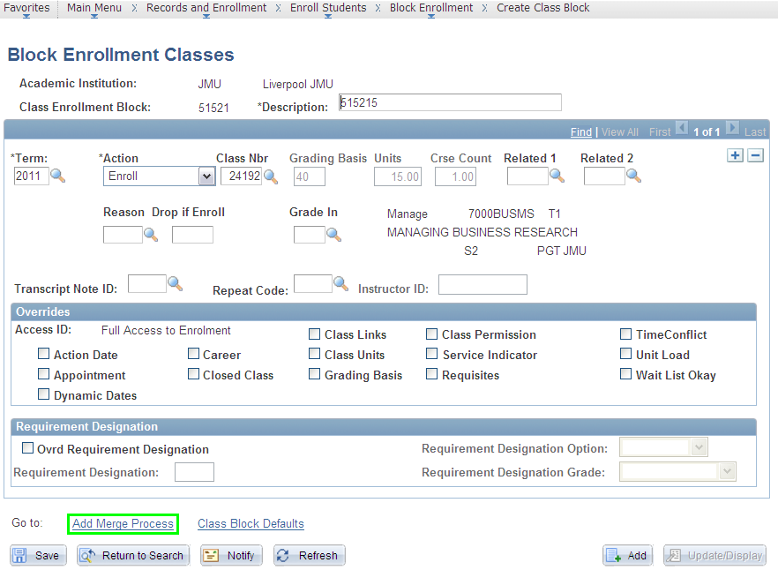

Add Merge Process

The merge process does exactly that, it merges the student block and class blocks together.
In the following order, enter:
- Student Block – the code will be the same one used when creating the student block.
- Class Block – the code will be the same one used when creating the class block
- Click Merge
- Click Submit
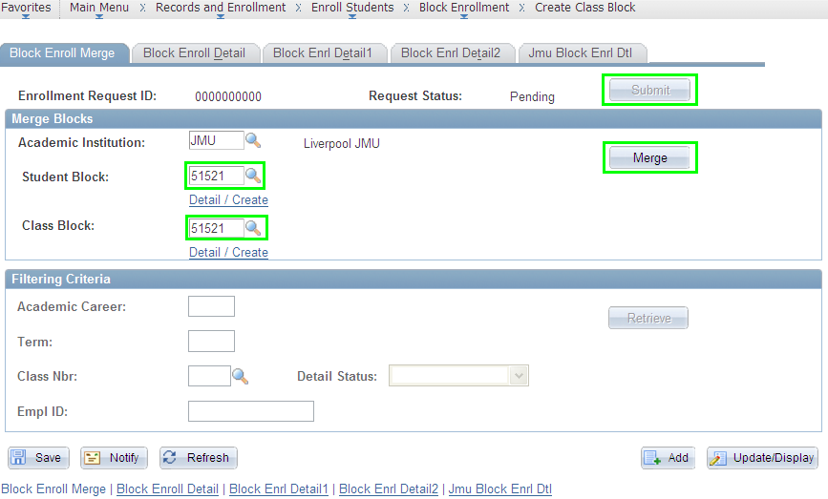
The request status will change from pending to ‘Success’ or ‘Errors’.

