Student Information System
Liverpool John Moores University

Enrolment Tasks 2012

Version 1.0 17th September 2012.
Author: Tracey Einig Jones

Contents
1
Student Information System 1
Introduction 3
1. Repeating Year Students 3
2. Programme Changes 4
3. Viewing Historical AA Reports 4

Introduction
In addition to students being enrolled on modules for their new level, there are some housekeeping tasks that may need to be undertaken to ensure that the student record is correct. Types of students that may need some further administration include:
- Repeating Year students
- Programme Change students

Repeating Year Students
These are students that do not have enough credit to progress to their next academic level.
The following steps should be followed in order.
- Students who cannot progress should be identified and sent to the Student Zone in order that a Progression hold (Negative Service Indicator) is placed on the student’s record. This hold will prevent any type of enrolment and is used at this stage to stop the bulk enrolment process enrolling the students automatically onto the next level.
- Student Zone staff apply the Progression hold.
- The bulk enrolment processes are ran to enrol all other returning students onto their next level of study, where those selections have been made in to Student Planner.
- Student Zone staff remove the Progression Hold and enter the relevant Study Agreement e.g. DEFERONLY or ADMIN/REF. This will ensure they are charged the repeating fee.
- Faculty staff can then enrol the students into their Referral and Deferral modules.
- Ensure that the graduation year has been amended
NB. Students that are still on the old UMF regs (modules enrolled prior to 11/12) will need their referrals adding by the PLN Helpdesk.

When enrolling students it is important to use the correct classes and Repeat Codes.
Students should also only be enrolled on ONE ESR class in a Level.
Previous Term Attempt | Previous Term Attempt Repeat Code | New Term Attempt | New Attempt Repeat Code
Deferred (first attempt) | DFA | Standard Class | DFA
Deferred (first attempt), then Failed | DFA- | Referral | REF
Deferred (Referral attempt) | DFR | Referral Class | DFR
Deferred (first attempt), then Failed | DFR- | ESR (Exceptional Second Referral) | ESR
Referral – Failed | REF- | ESR (Exceptional Second Referral) | ESR

Programme Changes
These are students that have transferred to a new Programme and will be studying Level 4 again.
- Check to see that the modules that the student is enrolled on are correct for the new programme
- Check the students Requirement Term:
  - For students whose credit from the previous programme is to count in the new programme don’t change the Requirement Term.
  - For students who are starting from zero credit change the Requirement Term as follows – In the Programme/Plan Stack, add a DATA row and an action reason of Requirement Change. This will ensure that the AA reports are then correctly displaying the correct Programme Version for the students.

Viewing Historical AA Reports
It is possible to view ‘old’ AA Reports by specifying the point in time that you wish to view. By default the point in time for all AA reports is ‘today’, this can be changed to any date that the student was active at LJMU.
The example below is a student who changed from Natural Science to Applied Psychology.
Navigate to: Main Menu>Academic Advisement>Student Advisement>Request Advisement Report
- Enter the Student ID and click Search
- Select either the AAR or Plan report, depending on which modules you want to view.
- Change the ‘As Of Date’ to a point in time that is EARLIER than the Action Date on the students Programme/Plan page.
For example the student below ‘Programme Changed’ from Natural Science to Applied Psychology on 12/08/11, so if we enter a date earlier than this we can see the AA Report for Biomedical Science and the modules that the student studied.
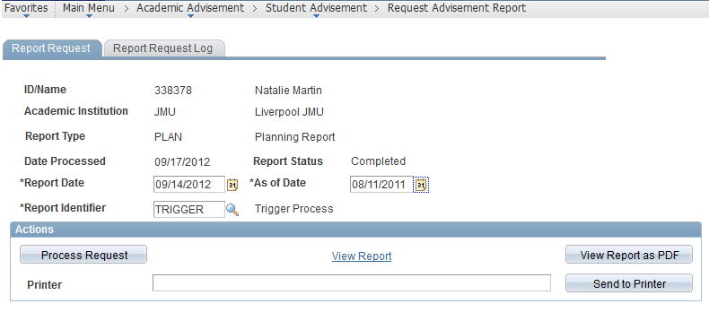

- Click the Process Request button
- The AA Report as it was on that date is now displayed.
