Student Information System
Liverpool John Moores University

Student Groups

Version 1: 25th September 2012
Business Support Office
Contents
1
Student Information System 1
Summary of Changes 2
Introduction 3
1. Repeating Year Students 3
2. Programme Changes 4
3. Repeat Codes. See: A Quick Guide to Applying Repeat Codes 4
4. ESR Attempts. 4
5. Viewing Historical AA Reports 5

Summary of Changes
Version: | Changes: | Date:
Version 1.0 | New Document | 25th Sept 2012

Introduction
Student Groups are a method for grouping Students into areas of common characteristics. These groups can then be used throughout the system to aid with processing.
Student Groups are set up on request by PLN through Helpdesk. This is because there is security setting attached, which allows for potentially sensitive groups to be set up and used by specific departments.

Adding Students to Groups
Navigation: Main Menu>Records & Enrolment>Career & Programme Information>Student Groups
- Search for the student that is to be placed into a Group
- Enter the Academic Institution
- Select the required Student Group from the Look Up – only those groups that you have security access to will be visable.
- Enter the Effective date. This is the date that the student becomes part of the group
- Enter Comments as required
- Save
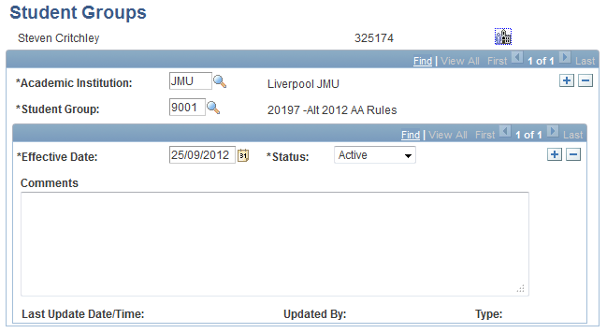

Removing Students from Groups
Navigation: Main Menu>Records & Enrolment>Career & Programme Information>Student Groups
- Search for the student
- Enter the Academic Institution
- Select the required Student Group from the Look Up – only those groups that you have security access to will be visible.
- Click the Effective Dated ‘Add a Row’ button – this is the lower set of buttons.
- Enter the Effective date. This is the date that the student leaves the Group
- Change the status date to Inactive
- Enter Comments as required
- Save
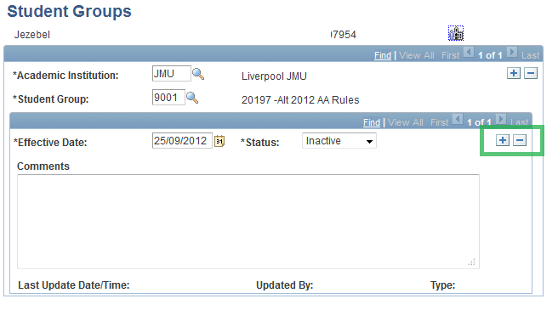

Changing a Group
If you need to change the group that a student is a member of, you need to end date the old group and add the new one.
Follow section 2 first to end date the first group and then follow section 1 to add the new group – but PLEASE NOTE, you must Add a Row, the higher level in order to add the new Group.

Viewing All Students in a Group
Navigation: Main Menu>Records & Enrolment>Career & Programme Information>View Student Groups by Student
- Enter the Academic Institution
- Enter the Student Group that you wish to view
- Click Search
- Change the Parameters if required
- Click ‘Get Results’
- The students that belong to that Group are now displayed.

