Student Information System
Liverpool John Moores University

User Guide: Faculty Administration
Extenuating Circumstances & Special Mitigation

Version 1, 22nd May 2017
Author: AP&IS

Contents
1
Introduction 3
1. Definitions 3
Extenuation Circumstances 3
Special Mitigation 4
2. Extenuating Circumstances/Special Mitigation Process Flow 5
3. Extenuating Circumstances Process 6
3.1 Recording a EC Claim submission (SAC Task) 6
3.2 Recording a EC/SM Claim submission (Faculty) 6
3.3 Recording the Date of the EC/SM Panel (Faculty) 8
3.4 Recording EC/SM Claim Outcomes 9
Transcript Note Values: 11
3.5 Recording EC/SM Claim Outcomes – Quick Enrol 12
3.6 Recording the Extenuating Circumstances Grade Outcome 13
3.7 Recording the Special Mitigation Grade Outcome 13

Introduction

Definitions

Extenuation Circumstances
A student may claim extenuating circumstances when timely, severe, acute and unexpected circumstances occur which have significantly affected their performance in module assessment(s) and where the possibility of alternative mitigation is inapplicable or inappropriate.
A student will submit an EC claim after receiving guidance from Student Advice & Wellbeing (SAW).
The form is submitted either:

Within 5 working days of the assessment event as an 'EC',
Or
After that date and before the meeting of the 'EC Panel' as a 'late EC'.

Further details surrounding the Rules and Regulations regarding Extenuating Circumstances can be found in the Academic Framework document.
A deferral is the only outcome of a valid extenuating circumstances application. There is no
change to the marks awarded or any further consideration given to the extenuating
circumstances at a Board of Examiners. Students should not be disadvantaged as a result of a valid EC application and any previously successful elements of assessment (marks or submitted materials) of a module will be carried forward to the subsequent attempt.

Special Mitigation

This procedure may be used by all students, new and continuing, undergraduate and postgraduate.
A student who declares themselves ‘fit to attempt’ at the start of a time-limited summative assessment item but whose performance was adversely and seriously affected by circumstances that occurred during the assessment to such an extent that the assessment item could not be completed, may submit a claim for ‘special mitigation’.
In the case of a valid special mitigation application, as determined by the Extenuating Circumstances Panel, the assessment item attempt is either:
- Declared null and void, deferred to the next appropriate opportunity and reported to the Board of Examiners or
- The module leader will assign a mark for the assessment item where there is sufficient evidence to do so and where this is approved by the Chair of the Board of Examiners.
This procedure is new in 2016-17. It applies only to time-limited assessment tasks, such as an examination, in-class test, some presentations, dance / drama performances. It does not apply to other forms of coursework such as essays, dissertations etc. where the student is not bound to a particular time slot. This procedure enables a student who considers themselves ‘fit to attempt’ the assessment but then falls ill during the event and is adversely and seriously affected such that they cannot complete the assessment the opportunity to have their attempt considered in the light of their particular circumstances. The student would not be eligible to make an extenuating circumstances claim.

It is important that the decisions related to special mitigation are based on clear evidence where, for example, the module leader recommends a mark, this mark must be based on the work submitted in that assessment, not on the student’s performance elsewhere in the programme, and must have been subject to the usual moderation procedures.

Extenuating Circumstances/Special Mitigation Process Flow

Student has Issue

Local resolution?
No
Yes
Academic staff update Gradebook
- Extension
- Defer
- Alternative

Was assessment attempted?

Yes
No
Student
Academic
SAC
Faculty Admin
Key
Special Mitigation Claim Form Submitted
Extenuating Circumstances Claim Form Submitted

EC/SM Claim Valid?
Yes
No
Not Valid
EC Claim ‘valid’
SM Claim ‘valid’
Module Failed (non submission
Yes
Refer to Module Leader (for consultation)

No
Sufficient evidence to allocate a representative mark?

Module Attempt Deferred
Yes
Allocate representative mark for assessment attempt

Extenuating Circumstances Process

Recording a EC Claim submission (SAC Task)
The SAC process focuses on taking receipt of an EC/SM request form and recording it in SIS using a Checklist. A Checklist is a 3C and this allows the tracking of the EC/SM form through the process and also displays to the student the status of their request. The module and Assignment that the EC/SM form is applicable to is also recorded and displayed by the SAC and this is displayed on Checklist 1 tab.

Recording a EC/SM Claim submission (Faculty)
Once an EC/SM form has been received by the Faculty office, this needs to be recorded on the Checklist.
- Query the Student in Student Services Center
Navigation: Main Menu>Campus Community> Student Services Center>General Info

- Check the status of the next action needed by clicking on the blue triangle to expand the checklist items

The Checklist itself through being Initiated shows that an EC/SM Claim has been received by the SAC and additionally the date that the form was forwarded to the Faculty/School Office has also been recorded by the SAC.
The first step of the Faculty process is to record the date and receipt of the form at the Faculty Office.
- Click on the Checklist link in order to action the next item – Form received by Faculty. The Checklist detail will open.
- Click on Checklist Management 2 tab

- Change the Status of ‘Rec by Fac’ to Complete and change the status date, to the date the form was received by the Faculty/School Office.
- Change the responsible ID of the person recording the form has been received.

- Click ok to save the record and return to the Student Center. The item will ‘disappear’ from the Checklist as the action is now complete.

Recording the Date of the EC/SM Panel (Faculty)
At the same time as recording receipt of the EC/SM form, the date of the Extenuating Circumstances Panel should also be entered. The date is important as it will be used to determine whether an EC Claim is valid or not. It also informs the students of the date of the Panel for their information.
If it is not possible to record the date at the same time as the previous step, it can be completed at any time convenient.
- Navigate to Checklist 2 as above
- Change the Status date to ‘pending’
- Enter the date of the EC Panel in the Status and Due Date field
- Enter the Responsible ID of the person recording the date
- Click ‘ok’ to Save

Note: It is possible to also record the date that the EC Panel met, by changing the above Status to Complete.
The checklist data also changes to reflect progress of the Checklist in both the Student Services Centre and Student Self Service.

Recording EC/SM Claim Outcomes
In addition to using the checklist to record and track an EC/SM Form in the system, it is also necessary to record the EC/SM Claim as a ‘Transcript Note’. It is a Transcript Note that captures the Outcome of the claim and displays this on the student’s Progress report and Transcript and the Assessment Board Reports.
The process for recording the Outcome changes is completed before the student grade is posted to their record and takes place in the Gradebook.
Navigation: Main Menu>Curriculum Management>Grading>Admin Gradebook
- Search for the class that the EC/SM Claim is applicable to

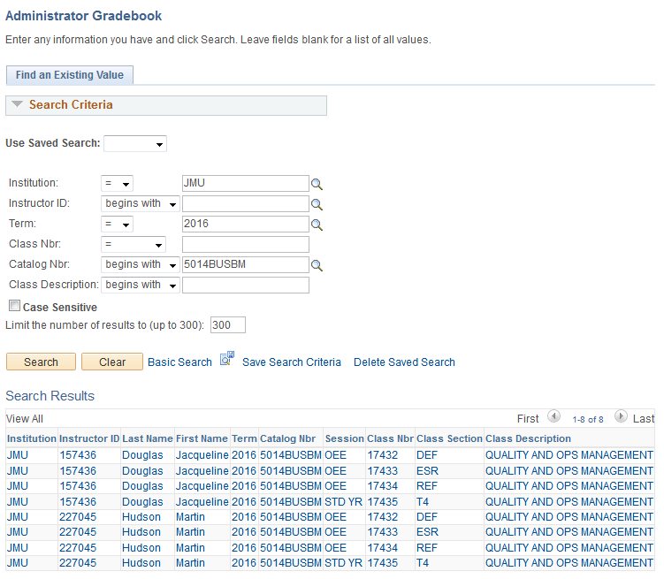
- Results of the search are displayed by Term, Session and Class offering.
- Click the Term and Class required
- The Admin Gradebook opens
- Select the Cumulative Grade tab
- Select the student that the EC/SM Claim applies to
- Click the ‘Note’ link
- Enter the required Transcript Note
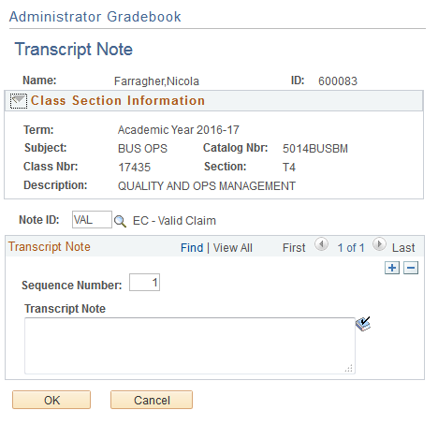

Transcript Note Values:
Extenuating Circumstances
NV | EC - Not Valid
EC | EC - Pending
VAL | EC - Valid Claim
NFA | EC - Valid. No Further Action
Special Mitigation
SM | SM: Pending
SMV | SM: Valid Claim No Further  Action
SMVD | SM: Valid Claim - Defer
SNV | SM: Not Valid

Note: Whenever a Transcript Note needs to be updated to record the change in an EC claim Outcome/SM Claim, the above procedure should be repeated and the correct value selected.
Note: Once the Grades have been ‘posted’ to a student’s record, Transcript notes can no longer be updated through the Gradebook (they still can be viewed!). An Quick Enrol should be used.

Recording EC/SM Claim Outcomes – Quick Enrol
Navigation: Main Menu>Records and Enrolment>Enrol Students>Quick Enrol
- Add a New Value
- Enter student ID
- Click Add
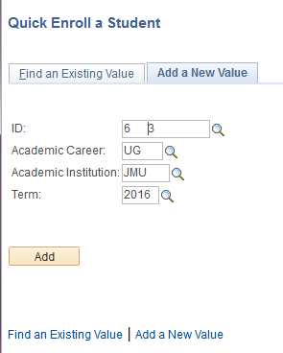

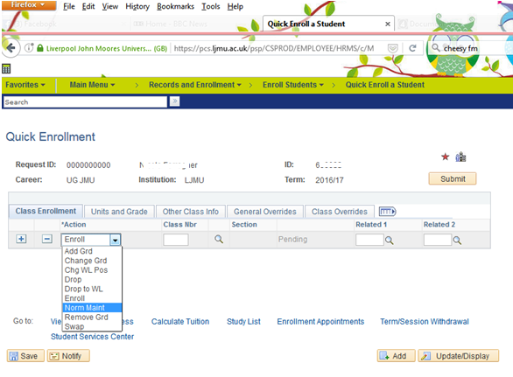
- Change the Action to Normal Maintenance
- Select the Class (module) for the EC/SM Claim
- Select the ‘Other Class Info’ Tab (3).
- Click the Create Transcript Note link and select the note required.
- Click ok to save
- Submit the Enrolment Request. This is crucial as unless the process is submitted the Note will not be part of the students record
- The process will complete with a status of ‘Success’ and the note will now appear on

Recording the Extenuating Circumstances Grade Outcome
Once an EC claim has been approved as Valid by the EC Panel, the only possible Grade outcome from the decision is for the student to be able to ‘defer’ the affected module attempt.
The grade that should be entered for the student is ‘DEF’ and this should be entered in Gradebook on the Cumulative Grade tab and posted in the normal manner.

Recording the Special Mitigation Grade Outcome
Once a SM claim has been deemed to be a valid claim then the claim must go to the module leader to establish if a representative mark can allocated. If a mark is given it should be recorded in Gradebook in the normal manner. As the Transcript Note of ‘valid’ has already been recorded, this mark will be visable as a SM mark.
If a mark can’t be allocated due to lack of supporting evidence then the module should be deferred in the normal manner.

