Results Notification – A User Guide
July 2020

Business Support

Contents

1 Version Control 2
2 Summary of Change 3
3 Maintain Results Notification Data 3
3.1 There are now 6 Progression Status to select from 3
3.2 Add Notes 4
3.3 Confirm 4
4 Record Publishing Tools (User Confirmed Status) 4
4.1 Publish Data Tool 4
4.1.1 Publish Options - Publish All 4
4.1.2 Publish Options – Publish Individual Records 5
4.1.3 Publish Option – Publish Records Previously not published 5
4.1.4 Update 5
4.2 Publish Data by Plan Code Tool 5
4.3 Review Published Records 5
4.4 Un-publish Records at a Student Level 6
4.5 Un-publish Records at Prog Level 6
5 Downloading and Zipping files 7

Version Control
Date | Author | Version | Change Reference
01/07/20 | Business Support Team | 1.0 | Results Notification – new document

Summary of Change
The current solution for results notification was implemented in 2014/15 and was intended to be used once only. The upshot of this is, there are elements of the technical solution that were not intended to be in place long-term and need changing.

To deliver increased efficiency, PDF documents will no longer be produced and will be replaced by a web page displaying results accessible via ‘MyLJMU.’

To deliver these changes, the following adjustments have been made in Web hub.

- Change from existing colour scheme
- New text box to provide optional supplementary information per student
- Additional check box indicating ‘ESR’
- Ability to ‘future date’ results information for timed release
- Multiple publishing options (e.g. ‘Publish All, Publish Individual’)
- Option to ‘Un-publish’
- Reduce the amount of progression outcome options
- Review of all ‘published’ results data

Maintain Results Notification Data
- You should select the progression status (template) for each student
- Add any notes/supplementary information to the student (optional)
- Confirm/Save the status selected. Only ‘confirmed’ records are eligible for publishing
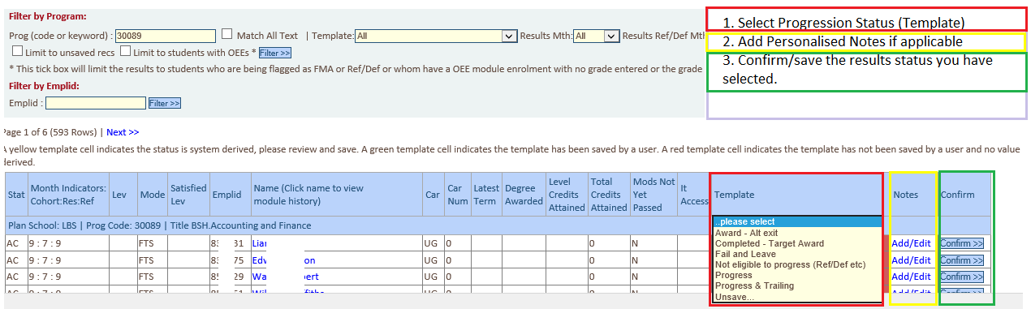

There are now 6 Progression Status to select from

- Not eligible to progress (Ref/Def etc)
- Progress
- Trailing
- Completed – Target Award
- Award Alternative Exit
- Fail and Leave

Add Notes
Should you need to provide the student with individual/personalised content as part of their results, you should add them in the ‘Add/Edit’ note.

Confirm
You should confirm/save the status you have entered in step 3.1.

Record Publishing Tools (User Confirmed Status)
There are five new options available to administrators and faculty registrars.
There are two options to publish, two to unpublish and a page to review what has been published.

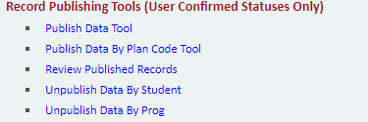

Publish Data Tool
Set the following:
- Results Day to Publish. This is the date the student will see their ‘progression status’ in My LJMU > My Results
- Release Time. (This should be 7am for end of year results)
- Publish option. You can; ‘Publish All’, ‘Publish Students Previously Not Published’ or ‘Publish Individual Records’.
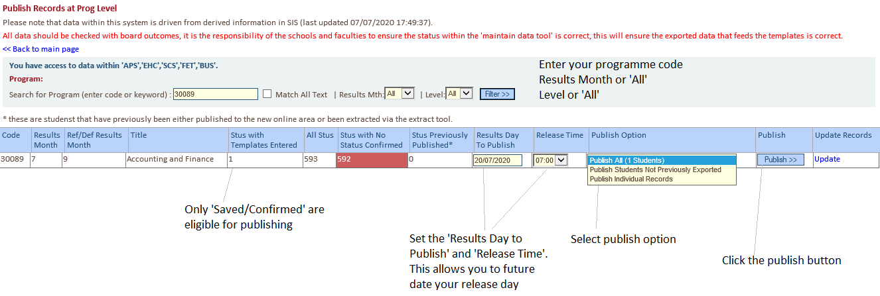

Publish Options - Publish All
Setting the publish option ‘Publish All’ and clicking the ‘Publish button’ will publish all records on the date and time entered as the ‘Results Day to Publish’ and ‘Release Time’

Publish Options – Publish Individual Records
This option requires you to manually select the records you wish to publish.
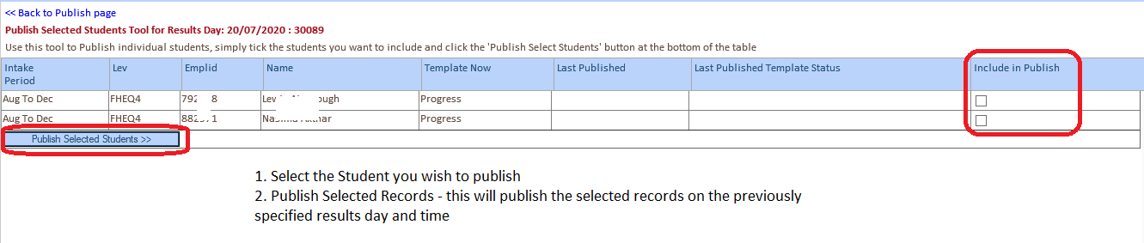

Publish Option – Publish Records Previously not published
Setting the publish option ‘Publish Records Previously Not Published’ and clicking the ‘Publish button’ will publish all records on the date and time entered as the ‘Results Day to Publish’ and ‘Release Time’

Update
The update button will take you to the ‘Maintain Results Notification Data’ page to continue processing.

Publish Data by Plan Code Tool
Selecting this option will allow you to specify publishing at a plan level. You should follow advice given in section 4.1 with regards to publishing options.
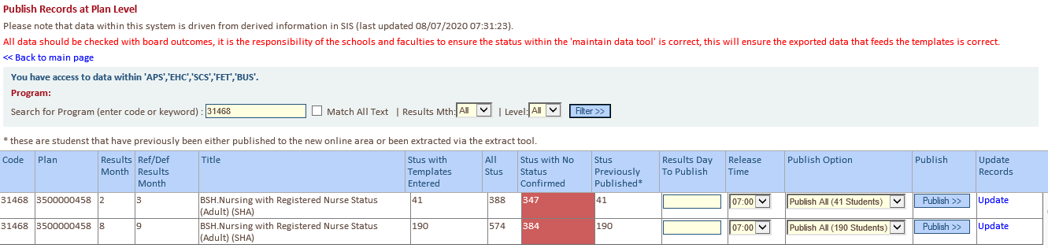

Review Published Records
This page allows a user to see at a glance the records that may typically require more attention.
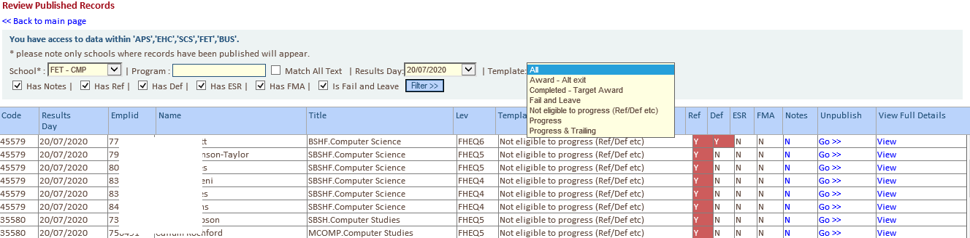
You must enter all or partial parameters from the following: school, programme and/or results date and template type.
You have the option to filter by: ‘Has Notes’, ‘Has Ref’, ‘Has Def’, ‘Has ESR’, ‘Has FMA’ or ‘Is Fail and Leave’. You can select one or more of the filter options.
From this page, you also have the option to:
- View notes
- Un-publish – if you un-publish a record from here, an email notification will be sent to the initial publisher. You should provide a meaningful note of why you have decided to take this action.
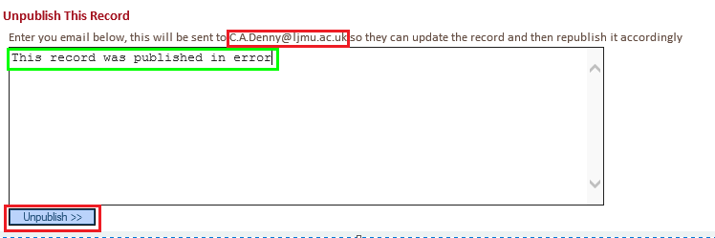
- view full details

Un-publish Records at a Student Level
On this page, you are able to search by Emplid and Results Day.
You should select the record(s) you wish to un-publish (or select all) and click the ‘Unpublish’ button.
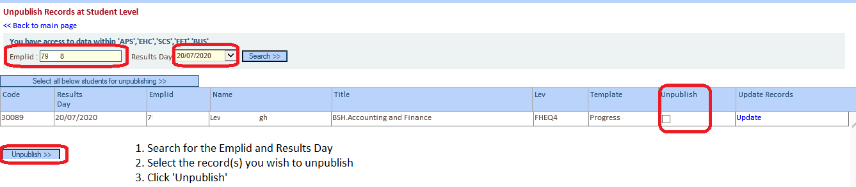

Un-publish Records at Prog Level
On this page, you are able to search by Program and Results Day.
You should select the record(s) you wish to un-publish (or select all) and click the ‘Unpublish’ button.
‘Un-publishing’ is not real time. It happens at on the hour, 15, 30 and 45 minutes past the hour.
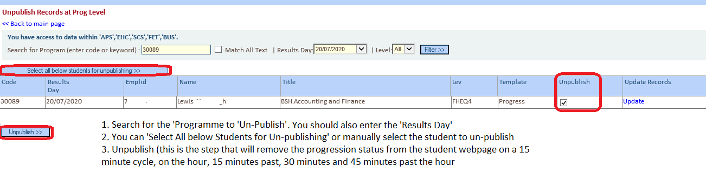

Downloading and Zipping files
The development work is ongoing and scheduled for completion w/c 13th July and this section will be updated.

