SOP003 Roles & Responsibilities for LJMU Sponsored Research
Responsibility for Policy: | Robin Leatherbarrow
Relevant to: | All staff and students conducting research
Approved by:
Responsibility for Document Review: | Dave Harriss
Date introduced: | April 2019
Date(s) modified:
Next Review Date:
RELEVANT DOCUMENTS
RELATED POLICIES & DOCUMENTS

This SOP needs to be a useful resource for investigators –please contact sponsor@ljmu.ac.uk with any suggestions for improvements.

Table of Contents
1. Introduction 3
2. Scope of Procedure 3
3. Procedure 3
3.1. Who 3
3.2. When 3
4. Definitions 3
4.1. Sponsor 3
4.2. Chief Investigator (CI) 3
4.3. Research Team 3
5. Pre-study set-up responsibilities 4
5.1. Sponsorship Approval 4
5.2. Health Research Authority Research Ethics Committee (HRA REC) Approval 4
5.3. Obtaining Ethical Approvals 4
5.4. Obtaining further Regulatory Approvals 4
5.5. Sponsorship contracts/agreements 5
5.6. Site set-up 5
6. During the course of the study responsibilities 6
6.1. Participant Recruitment 6
6.2. Study Master File 6
6.3. Delegation at site 7
6.4. Substantial and Non-substantial Amendments 7
6.5. Annual Reports 7
6.6. Safety Reports 7
6.7. SOPs 8
6.8. International Research 8
7. End of Study 8
7.1. Close Out 9
7.2. Disseminate Research Findings 9
7.3. Archiving 9
8. Roles and Responsibilities 9
9. Abbreviations 10
10. Associated Documents and References 10
11. Monitoring and Audit 10
12. Change History 10
13. Appendices 10

Introduction
This document significantly replicates the policy produced by the University of Liverpool, with changes made to encompass LJMU requirements. This is to facilitate research governance procedures in collaboration with the Liverpool Health Partners.

Scope of Procedure
The purpose of this SOP is to outline the where LJMU may delegate functions in relation to their Sponsor roles and responsibilities when sole sponsoring a research study or when co-sponsoring a research study with an NHS partner. For the purpose of this SOP, any reference to research does not include studies defined as Clinical Trials of an Investigational Medicinal Product (CTIMP). Once established, LJMU sponsorship of a CTIMP will follow procedures for CTIMPs published by the Liverpool Health Partners or by LJMU REG.

Procedure

Who
This SOP is aimed at all Chief Investigators (CI) and Principal Investigators (PI) of Research, their study teams and members of LJMU Research Ethics and Governance (REG).

When
This SOP should be referred to during study set-up, during the course of the study and at study completion.

Definitions
The following definitions are taken from the UK Policy Framework for Health and Social Care Research (v3.2 10th October 2017)

Sponsor
The sponsor is the individual, organisation or partnership that takes on overall responsibility for proportionate, effective arrangements being in place to set up, run and report a research project. All health and social care research has a sponsor. The sponsor is normally expected to be the employer of the chief investigator in the case of non-commercial research or the funder in the case of commercial research.

LJMU as a Sponsor will delegate roles and responsibilities to the Chief investigator and research team whilst still maintaining overall responsibility for the research

Please note that the LJMU does not allow individuals to Sponsor a research study.

Chief Investigator (CI)
The chief investigator is the overall lead researcher for a research project. In addition to their responsibilities if they are members of a research team, chief investigators are responsible for the overall conduct of a research project

Research Team
The research team is the group of people involved in the conduct of a research project. It may include care professionals, academics, patients and service users, members of the public, research professionals, students and/or scientists. Research team members’ accountability should be clearly agreed between them and their employer(s) and documented, especially where multiple disciplines, collaborating organisations or patients, service users and the public are involved in a single research team. For multi-site research, a single research team led by the chief investigator may undertake the activity at all the sites, or there may be different research teams at different sites, led either by the chief investigator or by a principal investigator who takes responsibility for the conduct of the research at the site.

Pre-study set-up responsibilities
The following must be in place before a study begins:

Sponsorship Approval
It is the CI’s responsibility to ensure that the relevant sponsorship approval process has been completed and that LJMU sponsorship or co-sponsorship has been confirmed. A condition of sponsorship approval is that the CI understands the delegated roles and responsibilities taken on behalf of LJMU as a sponsor. This will be stated in the Sponsorship Approval in Principle notification.

LJMU, as the (co-)sponsor, during the assessment of sponsorship for the study, will ensure through liaison with the Chief Investigator that there are sufficient resources, including staff, facilities and finances, in place for the duration of the study.

A request for LJMU to act as sponsor can be made in accordance with the LJMU Standard Operating procedures – SOP001 LJMU Research Sponsorship Application Process.

Health Research Authority Research Ethics Committee (HRA REC) Approval
Once Sponsorship Approval in Principle has been issued the CI may proceed to obtaining the required approvals for the research. Investigators can book their research in for review by telephoning the HRA Central Booking Service. The Central Booking Service (CBS) is the telephone booking service for all IRAS form applications for project-based research in the NHS (or HSC in Northern Ireland) and for Research Ethics Committee (REC) applications for tissue banks, databases and health research taking place outside of the NHS/HSC. Please note, that investigators must not book their research in for review before sponsor approval in principle has been confirmed.

Where there is a regulatory or policy requirement the CI is responsible for obtaining HRA REC approval for the study. The CI can delegate the responsibility to a suitably qualified member of the research team. The CI must oversee this process, check and sign off the application and obtain favourable opinion from the relevant REC. The CI is responsible for responding to any REC conditions of approval. Further information is included in the Governance Handbook for LJMU Sponsored Research.

Obtaining Ethical Approvals
If the proposed study involves recruitment of participants outside of the NHS REC remit the CI must ensure that the correct Ethical Approvals are applied for and obtained prior to the commencement of the research. Details of required approvals can be found in Appendix 1.

Obtaining further Regulatory Approvals
As well as REC approval studies may also require approval from other Regulatory committees, including but not limited to;
    - Administration of Radioactive Substances Advisory Committee (ARSAC)
    - Gene Therapy Advisory Committee (GTAC)
    - Confidentiality Advisory Group (CAG)
    - National Offender Management Service (NOMS)
    - Social Care Research Ethics Committee
    - Ionising Radiation (Medical Exposure) Regulations 2000 (IRMER) Approval
    - Human Fertilisation & Embryology Authority
    - MHRA Notification of no Objection for Devices

The Integrated Research Application System (IRAS) will assist in identifying where further approvals are required, but it is the responsibility of the CI to ensure that these are appropriately applied for and approvals gained before beginning the research.

Further information is included in the Governance Handbook for LJMU Sponsored Research.

Sponsorship contracts/agreements
It is the CI’s responsibility to ensure that all contracts and agreements are processed and signed off by relevant parties. These might include agreements and contracts for funding, co-sponsorship, collaboration, research site, material transfer and confidentiality.

For information, please refer to LJMU Standard Operating Procedure – SOP004 Production and Management of Contracts for LJMU Sponsored Research.

Site set-up
The CI is responsible for NHS site set up. For studies that include NHS research sites in England where the lead site is in England, once the CI receives the HRA Approval initial assessment letter (or HRA Approval letter in cases where no initial assessment letter is issued) they can contact participating NHS sites, the local study team (where there is one) to the Local Clinical Research Network (if the study is on the NIHR portfolio) to provide them with the 'local information pack' and finalise discussions around confirming capacity and capability. The local information pack should contain;
- Copy of IRAS Form as submitted for HRA Approval
- Protocol and amendments
- Participant information and consent documents
- Relevant model agreement
- Commercial studies only – NIHR Costing template (validated) and delegation log (including known research team names but not signatures)
- Organisation Information Document (OID) for non-commercially sponsored projects – template and guidance
- Any other documents that the sponsor wishes to provide to the site to support the set up and delivery of the study
- Copy of HRA initial assessment letter (if one is issued) and (when issued) HRA Approval letter and final documents.

The HRA initial assessment or HRA Approval letter will provide information relevant to study set up including:
- Working with participating NHS organisations
- Which participating NHS organisations need to confirm capacity and capability
- Training requirements
- HR arrangements
Any cost negotiations that are required with the participating organisation can be finalised at this stage. The HRA initial assessment or HRA Approval letter will confirm whether all, or some types of, participating organisations are not required to formally confirm capacity and capability.

Where formal confirmation from all or some of the participating organisations is required the relevant NHS organisation will provide the CI with confirmation via email that all the arrangements have been put in place to deliver the study and indicate that they are ready to start the study. Where formal confirmation from all or some of the participating organisations is not required, the HRA initial assessment or HRA Approval letter will specify the timeline for these organisations to object or request more time to consider, following provision by the sponsor of the full local information pack.

Once the investigator has sent confirmation of regulatory approvals (e.g. HRA, NGHS REC etc.), sign-off of contracts and agreements (if applicable) and NHS sites capacity & Capability to sponsor@ljmu.ac.uk, investigators should allow at least 10 working days for the LJMU Sponsor Permission to Proceed notification to be issued or for further information to be requested. The Sponsor Permission to Proceed Notification will list the roles and responsibilities of the CI that must be adhered to once the study has opened. This includes:
• Notify LJMU REG of the date of the first participant recruited into the study
• Creation and maintenance of a Study Master file
• Delegation at site
• Study amendments
• Annual reports
• Safety reports
• Standing operating procedures
• International research
• Auditing and oversight provision
• End of study
• Close out
• Dissemination of study findings
• Archiving

The LJMU Sponsor Permission to Proceed notification confirms that all sponsor requirements have been met and that the study may proceed to the next stage to open the study. If there is a no objection deadline in place participant recruitment can be initiated at an NHS site once NHS R&D office have confirmed via email to the CI that the study may proceed in advance of the no-objection deadline OR the no-objection deadline has passed.

When setting up NHS sites in England in studies where the lead site is in Scotland, Wales or Northern Ireland
The lead nation will undertake the UK study wide review (in England this is incorporated into the HRA assessment) and share the application and the outcome of the UK study wide review with the other participating nations. If there are sites in England the lead nation will share the application and outcome with the HRA.

CIs are advised to contact the HRA at the earliest opportunity so that the HRA Approval team can facilitate the review of the research study for English sites. If the lead nation is outside England, and there are NHS sites in England, HRA will accept the study-wide review and complete nation-specific elements before issuing HRA Approval. Once HRA Approval has been received the CI can provide sites with the local information pack and finalise capacity and capability arrangements as above. The HRA will provide additional support to applicants for studies where the lead NHS R&D office is in Northern Ireland, Scotland and Wales and the study has sites in England.

Where studies include participating NHS Organisations in Scotland, Wales or Northern Ireland the CI is are expected to have discussed the project with local researchers at the participating organisations and the relevant R&D office.

If the study includes non-NHS research sites, you may need to generate and submit non-NHS Site Specific Information (SSI) forms in IRAS.

In addition, if researchers who are not employed by the participating organisation will deliver research activities locally, the CI should work with the research management function for the site to put HR arrangements in place in accordance with the HR Good Practice Resource Pack (Research Passport guidance).

During the course of the study responsibilities

Participant Recruitment
The CI must inform LJMU REG of the date of the first participant recruited into the study.

Study Master File
The CI is responsible for the creation and maintenance of a Study Master File which will contain all essential study documents. The PI must ensure the Investigator Site File (ISF) for their site is maintained for the duration of the study.

For information, please refer to SOP006 Study Master File for LJMU Sponsored Research.

Delegation at site
The CI or PI at each site must ensure each member of the research team is qualified by education, training and experience to fulfil their role in the study. All delegation of duties must be documented on the study specific delegation logs and filed in the ISF and TMF.

Substantial and Non-substantial Amendments
If the CI makes a substantial amendment to the protocol, it is the responsibility of the CI to submit the relevant documents firstly to the Sponsor(s), then REC, and any other regulatory bodies required and finally, once all approvals have been gained, to NHS R&D departments. Amendments to the protocol cannot be put into practice until approval has been given by all authorities

For information, please refer to SOP009 Study Amendments to NHS REC & HRA Approved Research.

Annual Reports
The CI is responsible for submitting all relevant annual reports.

For studies approved by NHS REC & HRA, Using the appropriate forms, the CI is required to submit Annual Progress Reports to the NHS REC which gave the favourable opinion, the HRA (hra.approval@nhs.net) and the Sponsor (Sponsor@ljmu.ac.uk) on the anniversary of NHS REC Favourable Opinion, and annually thereafter until the End of Study Declaration has been submitted to the NHS REC which gave the favourable opinion, the HRA and the Sponsor.

For studies approved by NHS REC but do not require HRA approval, Using the appropriate forms, the CI is required to submit annual Progress Reports to the NHS REC which gave the favourable opinion and the Sponsor (Sponsor@ljmu.ac.uk) on the anniversary of HRA approval, and annually thereafter until the End of Study Declaration has been submitted to the NHS REC which gave the favourable opinion and the Sponsor.

For studies that have received HRA approval with no requirement for NHS REC approval, Using the appropriate forms, the CI is required to submit annual Progress Reports to the HRA (hra.approval@nhs.net) and the Sponsor (Sponsor@ljmu.ac.uk) on the anniversary of the HRA Approval, and annually thereafter until the End of Study Declaration has been submitted to the HRA and the Sponsor.

Safety Reports
The CI must take appropriate urgent safety measures in order to protect research participants against any immediate hazard to their health or safety, without prior authorisation from a regulatory body. The CI must notify the main REC immediately and in any event within three days, in the form of a substantial amendment, that such measures have been taken and the reasons why. Copies of the information must be provided to the REC that approved the study and LJMU REG (sponsor@ljmu.ac.uk);

Where required, the CI/PI is responsible for documenting and reporting all adverse events that occur during the study. Safety reporting is vital for all research projects.

- Adverse Events (AEs) & Adverse Reactions (ARs) are any unfavourable and unintended signs, including abnormal laboratory results, symptoms or a disease associated with treatment. These must always be recorded in a Case Report Form (CRF) or on the patient’s medical notes.
- Serious Adverse Events (SAEs) & Serious Adverse Reactions (SARs) are defined as any untoward medical occurrence(s) that at any dose results in death, hospitalisation or prolongation of existing hospitalisation, persistent or significant disability/incapacity or a congenital anomaly or birth defect. These events must be reported immediately to the sponsor.

The general process below should be followed in all research:
- RECORD - the event on the subject’s medical notes, a CRF or on a Safety Reporting Form
- ASSESS – An assessment should be undertaken by the Chief or Principle Investigator to evaluate seriousness, causality, intensity and expectedness
- REPORT – based on the assessment. The event should be reported in the form and within the timescales required.

There are a number of issues to consider at each stage and the timescales depend on the nature of the event. The CI must report Serious Adverse Events (SAEs) that are related to the study (i.e. they resulted from administration of any of the research procedures) and are unexpected (i.e. not identified in the protocol as an expected occurrence) to the REC that approved the study and the Sponsor (sponsor@ljmu.ac.uk) within 15 days of becoming aware of the event. Unblind double-blind trials where there are reports of SAEs.

SOPs
The CI must follow the agreed set of SOPs provided by LJMU REG, the Trust co- sponsor or the managing CTU for the duration of the study. If the Quality System to be used differs from those mentioned LJMU REG may undertake an audit of these SOPs to ensure suitability and adherence with the appropriate regulation and legislation.

International Research
For healthcare based research taking place at International Sites, it is the CI’s responsibility to remain up to date with any regulatory or legislative changes related to the research undertaken in every participating International Country. In the event that there is a change in regulation the CI must inform LJMU REG (sponsor@ljmu.ac.uk) of this change and make any required amendments to the study.

End of Study
The completion of a project should be defined in the protocol. Any changes to this definition should be notified to the appropriate regulatory bodies as a substantial amendment. In most cases, the end of study will be the date of the last visit of the last participant or the completion of any follow-up monitoring and data collection described in the protocol.

It is important to note that ‘closing to recruitment’ may not be the same as ‘completion’ and any follow up periods should be considered.

Studies may also be deemed as complete before the definition provided in the protocol. This is termed early termination and may be due to issues with recruitment, safety concerns that lead to the study being unsafe to continue, feasibility issues or withdrawal or completion of funding. It is imperative that where a study terminates early this is appropriately communicated to the Sponsor, REC and MHRA (where applicable). Early terminations must be reported within 15 days and a full reason must be provided. It is also worth noting that a substantial amendment may be required to be submitted at the same time as the End of Study notification to provide documentation that may need to be provided to the study participants.

Upon the completion of a study approved by an NHS REC (in most cases, the date of the last visit of the last participant or the completion of any follow-up monitoring and data collection described in the protocol), using the appropriate form, the CI is required to submit an End of Study Declaration (within 90 days of the end of the study) and End of Study Report to the NHS REC which gave the favourable opinion (within 12 months of the end of the study) and LJMU REG (sponsor@ljmu.ac.uk).

For studies that received HRA approval with no requirement for NHS REC approval the CI is required to notify the HRA (hra.approval@nhs.net) and LJMU REG (sponsor@ljmu.ac.uk) that the research has ended (in most cases, the date of the last visit of the last participant or the completion of any follow-up monitoring and data collection described in the protocol) including your IRAS ID and your contact information (phone and email).

A summary of the final project report will need to be sent to NHS REC and MHRA (if applicable) within 12 months of the end of the study. This may be sent with the end of study declaration or it can be sent subsequently. Please note, once the REC and MHRA have received an End of Study Declaration no amendments can be made to the study. There is no standard format for final reports. As a minimum, it should include;
- Whether the study achieved its objectives
- The main findings
- Arrangements for publication or dissemination of the research, including any feedback to participants

The LJMU REG should be forwarded a copy of these reports in all cases. For sponsored studies that do not have HRA NHS REC approval a final project report is still required to be submitted to the LJMU REG.

Any outstanding invoices payable or to be raised should be dealt with and arrangements in place for providing medications or treatment to participants after completion (if agreed).

Close Out
The CI is responsible for informing the LJMU RGS of close out activities.

Disseminate Research Findings

Archiving
LJMU Sponsorship Agreement will outline the procedure for Archiving. In most circumstances, the CI will be responsible for archiving all study related documentation in accordance with LJMU standard operating procedures.

For information, please refer to SOP010 Archiving Essential Documents for LJMU Sponsored Research.

Roles and Responsibilities
The CI is responsible for informing the Sponsor of any pertinent information at all stages of the study. This includes any amendments, adverse events, serious breaches, annual reports and End of Study. Any delegated Roles and responsibilities will be outlined in the Sponsorship Approval letter or, if applicable, the co-sponsorship agreement. At all times the Sponsor will maintain oversight of the study to ensure that the CI is undertaking any delegated responsibilities.

Occasionally projects do not finish recruiting or following-up participants within the time specified in the approved protocol. An extension to the study end date is considered by NHS REC to be a non-substantial amendment. While formal approval is not needed from the NHS REC, the HRA should be notified using the appropriate form. In all cases, you must information the LJMU REG of this change.

Abbreviations
CI Chief Investigator
CTU Clinical Trials Unit
CTIMP Clinical Trial of an Investigational Medicinal Product
DH Department of Health
GCP Good Clinical Practice
HRA REC Health Research Authority Research Ethics Committee
IMP Investigational Medicinal Product
IRAS Integrated Research Application System
ISF Investigator Site File
MHRA Medicines and Healthcare products Regulatory Agency
NIHR National Institute for Health Research
PI Principal Investigator
REC Research Ethics Committee
SAE Serious Adverse Event
SOP Standard Operating Procedure
SUSAR Suspected Unexpected Serious Adverse Reaction
TMF Trial Master File

Associated Documents and References
To be completed

Monitoring and Audit
Compliance with this SOP will be audited periodically as part of the LJMU REG audit plan.

Change History
Version No. | Effective date | Significant changes | Previous version No.
1.0 | See page 1 | This is the first version of this SOP | n/a

Appendices
Appendix 1 – Examples of Required Approvals
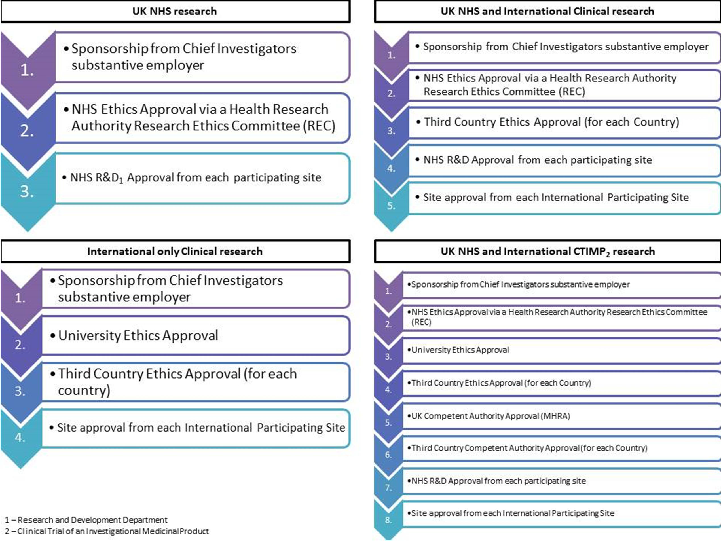
Appendix 1 – Examples of Required Approvals

Appendix 1 – Examples of Required Approvals
