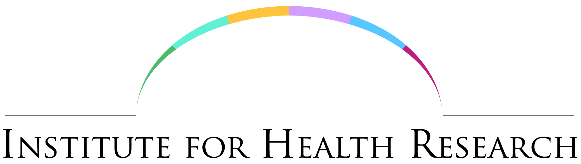
IHR Conference 1st May 2018

On the 1st May 2018, the LJMU Institute for Health Research (IHR) conference, with the theme of showcasing health research and collaboration, took place in the Royal Court Theatre, Liverpool. This event, funded as part of the Proximity to Discovery MRC grant, brought together over 130 academics, clinicians and healthcare professionals to listen to a diverse range of presentations from five invited guests, six members of staff and 12 early career researchers. One external guest commented, “it has been wonderful to hear about such a broad range of research demonstrating what LJMU is good at; working together across disciplines”

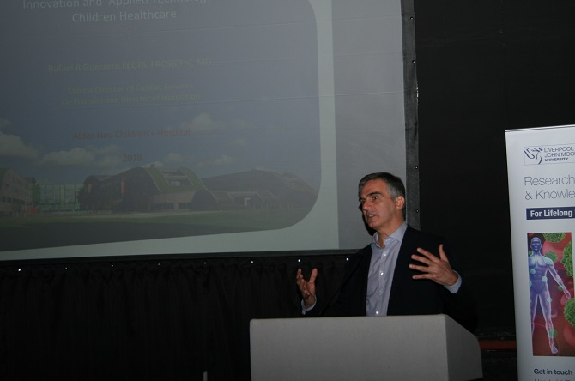
In the morning, Mr Rafael Guerraro from Alder Hey Innovation Centre gave a keynote presentation on collaboration for innovation; reminding us that innovation in healthcare is not just about gadgets but also processes and practises. Rafael has a passion for innovation and shared his experience of working successfully with LJMU collaborators to find solutions to problems and change the way healthcare is delivered.

Mr Paul Nolan from MerseyForest and Prof. Zoe Knowles, leader of the IHR Green Spaces Interest Group, talked about their shared vision of using the natural environment to improve health and wellbeing.
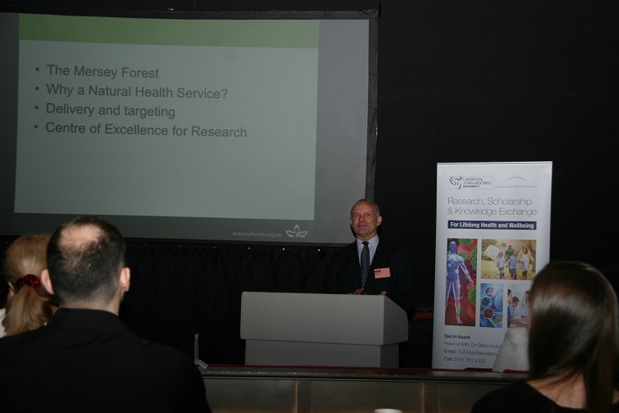
Information on Forest schools and the Natural Health Service as a mechanism for health behaviour change was presented and the sustained contribution from LJMU over nearly 10 years in providing robust evidence of the success of these interventions supported the need to embed this social prescribing within commissioning amongst the health sector. Mr Paul Nolan from MerseyForest talked about their shared vision with LJMU of using the natural environment to improve health and wellbeing.

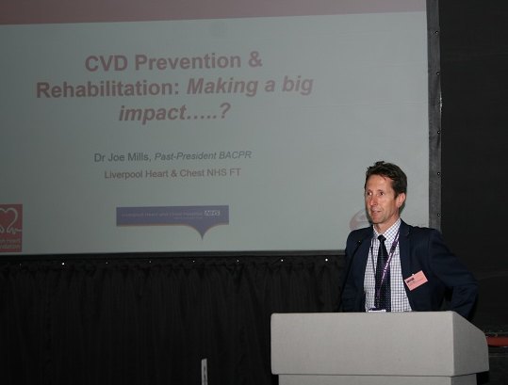
The afternoon keynote by Dr Joe Mills from Liverpool Heart and Chest Hospital emphasised the complexity of preventing and treating cardiovascular disease (CVD) and provided details of the various collaborative studies that he is engaged in with LJMU researchers. Physical activity and other lifestyle factors are the main contributing factors to CVD mortality. He discussed the requirement for a multidisciplinary approach to CDV prevention and indicated that prescribing exercise rehabilitation instead of medicines reduced hospital admissions and provided an increased quality of life to patients with heart failure and CVD.
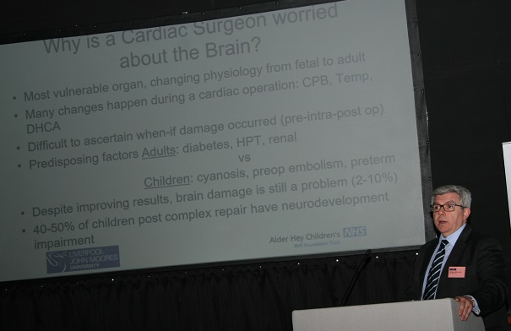

We then heard from Professor Attilio Lotto, a congenital cardiac surgeon, with a joint appointed at LJMU and Alder Hey, who discussed why a paediatric cardiac surgeon was worried about the brain and discussed his research between NAH and RISES. He provided evidence that lowering the body temperature provided cerebral protection.

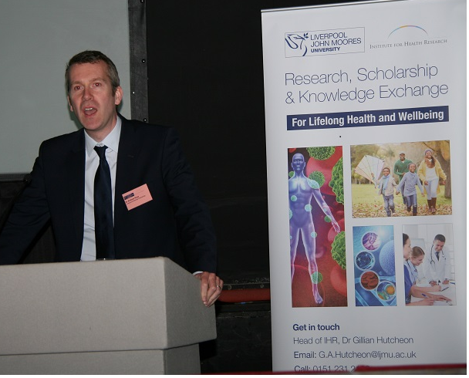
The final guest speaker, Dr Andrew Rose from the Liverpool Enterprise partnership (LEP) provided an insight into linking innovation in healthcare to local growth and the role of the LEP in providing strategic advice and support to the major healthcare and life science cluster that exists within the Liverpool City Region. He also discussed the Health Innovation Exchange and the HELIUM EDRF funded project that is being undertaken by the LEP, NAH and other EU partners.

A diverse range of IHR research was showcased throughout the day including; a presentation on the development of a portable device to monitor insecticide levels in walls to prevent malaria in developing countries by Dr Patryk Kot; the use of art to change how people feel as a mechanism to improve health and wellbeing, focusing on the aged population and the homeless, presented by Dr Julie Carrol and Elaine McNeil; a talk demonstrating that adverse childhood experience’s (ACES) are a strong predictor of poor health outcomes across the life-course and for future generations by Dr Zara Quigg who proposed that it is better to build strong children that mend broken adults; and the benefits of collaborating with the small and large pharmaceutical companies by Dr Andrew leach

The conference also offered 12 young LJMU researchers the opportunity to give 3-minute presentations on their research. It was overwhelmingly agreed that these young scientists were the stars of the conference revealing the diverse range of the research ongoing across the University.

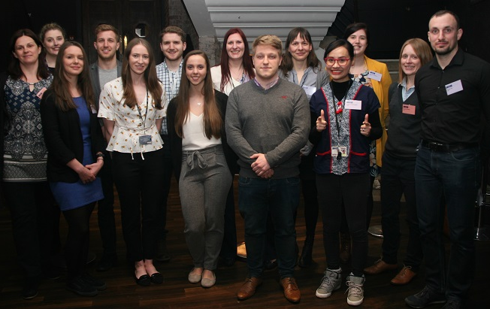

From left to right: Dr Gillian Hutcheon (Head of IHR), Rebecca bates, Melissa Parnell, Benjamin Buckley, Katie Hesketh, Joseph Maxwell, Madeleine France, Tanja Harrison, Arron Peace, Nora Morocza, Jirapon Chonmasuk, An-Sofie Gorrison, Dr Lynne Boddy (session chair) and Donato Leo.

Staff and postgraduate students also presented posters during the lunchtime networking event. The conference concluded with the award of prizes for the two best 3-minute presentations and the three best student posters.
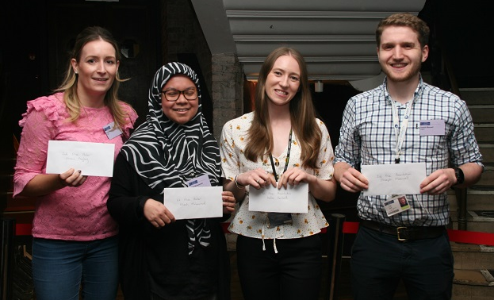Prize winners. From left to right: Emma Begley (2nd prize poster), Aleah Mohammad (1st Prize poster), Katie Hesketh (1st prize presentation) and Joseph Maxwell (2nd Prize presentation).

