2nd Annual Conference  9th September 2019  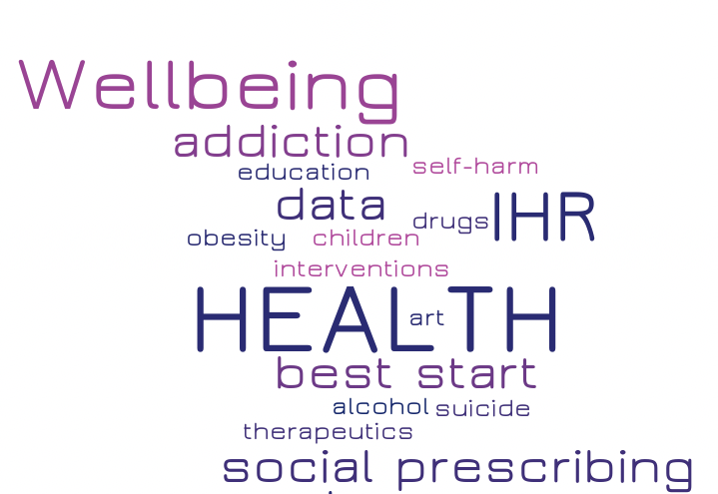  A showcase of health research undertaken by LJMU researchers and our collaborators  The conference sessions available throughout the day will showcase the research undertaken at the LJMU Institute for Health research in collaboration with our external partners and stakeholders to better understand and improve the health and wellbeing of people in Liverpool, nationally and internationally. | Presentations  ────  Breakout sessions  ────  Lunchtime poster session  ────  Register for a free ticket at  Available soon  ────  9am to 4pm  John Lennon Art & Design Academy  Institute for health Research  Liverpool John Moores University  0151 231 2130  https://www.ljmu.ac.uk/IHR  G.A.Hutcheon@ljmu.ac.uk

