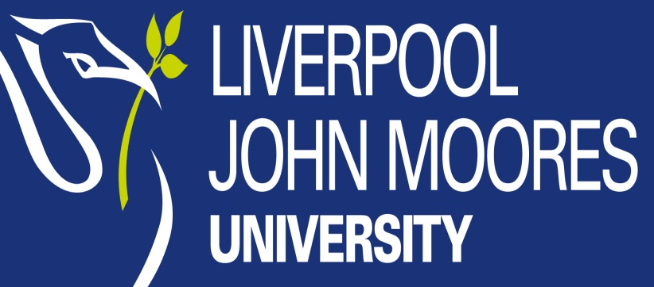

APPEAL FORM and GUIDANCE NOTES
ACADEMIC APPEALS AND ACADEMIC MISCONDUCT APPEALS

Please read through the Guidance Notes before making your appeal. These are designed to assist you with completing the form. The Guidance Notes are available at https://www.ljmu.ac.uk/about-us/public-information/student-regulations/appeals-and-complaints

The Liverpool Students’ Union operates an Advice Centre and will provide confidential help and advice regarding academic appeals. Liverpool SU Appeals Advice Webpage http://www.liverpoolsu.com/main-menu/academic-advice/academic-appeals
Telephone 0151 231 4900, Email: lsuadvice@ljmu.ac.uk

Student Advice and Wellbeing can also provide advice and support particular in the areas of financial issues, disability, study support, accommodation, health, wellbeing and counselling https://www2.ljmu.ac.uk/studentadvice/120502.htm

This document should also be read in conjunction with the University Academic Framework Regulations Section C9. https://www.ljmu.ac.uk/about-us/public-information/academic-quality-and-regulations/academic-framework and the Research Degree Regulations Section 15 https://www2.ljmu.ac.uk/RGSO/62172.htm

If you require this document in a different format please contact the Student Governance Team.

You must complete all sections of the form clearly and concisely. Failure to complete all sections of the form clearly and legibly could lead to delays in investigating your appeal or your appeal not being progressed.

You must send your completed form and supporting documents within 10 working days of the formal release of the relevant results or the notification of the decision of the Academic Misconduct Panel to the postal and email address at the end of this form.

If you are posting your appeal you should use the Recorded Delivery Service.

Section 1: Your Details

Full Name: |  | Student Number:
Programme of Study:
Academic Year you started at LJMU: |  | Year/Level:
Address for correspondence
Email Address

Section 2: Type of Appeal

Academic Appeal against the decision of the Board of Examiners or Research Degrees Committee.
Appeal against the decision of an Academic Misconduct Panel

Please tick to confirm that you have enclosed a copy of the Board pf Examiners Letter, Research Degrees Committee outcome Letter /Academic Misconduct Panel Outcome Letter.
Please note it is compulsory to provide this letter and failure to do so may result in your appeal being rejected.
Are you sending your Appeal within the 10 working day deadline? The University reserves the right not to progress appeals if they are submitted outside of the specified time limits. Discretion will only be given where there are exceptional reasons for late submission, supported by independent evidence. | YES | NO
If No please explain why you were unable to meet the deadline?

Section 3: Your Appeal
Please read the Appeals Guidance Notes to see if you have grounds for appeal. The University will deem an appeal ‘not eligible’ if your appeal does not reference or evidence an assertion of a material irregularity.

Please provide a full statement outlining your grounds for appeal. Please provide details of key events with dates. Continue on a separate sheet if necessary.

Your appeal

Section 4: Your Evidence

Data
Please list the documentary evidence enclosed in support of your appeal. Continue on a separate sheet if necessary.

Data
Data Protection Act 1998: Liverpool John Moores University is registered as a Data Controller [the organisation responsible for your information] with the Office of the Information Commissioner, Registration Z5616967. The University only uses student data in accordance with all the privacy and security requirements outlined in the Data Protection Act 1998 and the University’s Data Protection Policy which you can find on the University’s website under ‘About Us – Public Information’. Any personal information you provide on this form will only be used for the purpose of dealing with your appeal and you can access any personal information the University holds on you by getting in touch with the University’s Data Protection Officer at secretariat@ljmu.ac.uk Please note that if you provide any personal information about another individual they too can access the information held about them. The information will be held for a period of six years in accordance with our legal requirements.

Section 5: Declaration:

Please read the statements below and confirm the following:

- You have read the Appeal Regulations and Guidance Notes
- You are aware of the advice and support available.
- You have completed all sections of the form.
- You have attached all applicable evidence in support of your appeal
- You understand that LJMU will need to decide whether your appeal is eligible and submitted within the timeframes.
- You understand that ineligible appeals or late appeals will not be investigated under the appeals procedure.
- You agree with the documents and details in your appeal, including sensitive personal information being shared with relevant staff involved in the appeals process in order to respond to your appeal

I confirm that I am the student making the Appeal, I agree to the above and confirm that that I believe the facts stated in this form are true.

Signed: |  | Date

Submit your form and attached evidence by post to Secretary of the Appeals Panel, Liverpool John Moores University, Student Governance, Exchange Station, Tithebarn Street, Liverpool, L2 2QP or by Email to StudentGovernance@ljmu.ac.uk. You are advised to retain copies of all documents.

If you are posting your appeal you should use the Recorded Delivery Service.

