Student Information System
Liverpool John Moores University

A Quick Guide to Completing Students on SIS

Version 12: 17th Nov 2014
Business Support Office

Contents
1
Student Information System 1
Summary of Changes 3
Introduction 3
Completion Definitions – see Appendix 4 for Process Flow Diagram 3
1. Completion: 3
2. Completion with Alternative Exit Award 3
3. Completion with No Alternative Exit Award 4
4. Discontinuation with Alternative Exit Award 4
Alternative Exit Award Note 5
5. Completion/Discontinuation with No Alternative Exit Award (Failed Students) 5
6. Other Plan Changes 5
System Pages Updated 6
Running the SIS Completion Process 6
1. Completing a Group of Students 6
2. Using a Population Selection 7
3. Or Adding Students Manually 9
4. Viewing the Output 10
5. Completing a Single Student 10
6. Adding Students Manually through the Graduation Processing Page 10
7. Completing Students Manually through the Programme/Plan Stack 11
a) Completing Successful Students 11
8. Completing Failed Students. 13
9. Withdrawals and Alternative Exit Awards 16
9. Withdrawals and No Alternative Exit Award 17
10. Award Aim Changes: 18
a. Pre Board Changes 18
b. Post Board 18
Students Returning to Continue Studying 18

Appendix 1 19
Query Names and Prompts Reference 19
Appendix 2 – Revoke Process Flow Diagram 21
Appendix 3 – Completion/Discontinuation Process Flow Diagram 22
Notes: 23

Summary of Changes
Page | Changes: | Date:
7 | Minor text changes
11 | Added Revoke Degree process
9 | Merged the Processing an Individual Student doc into this guide for completeness
11 | Removed the Revoke Degrees process as this is to be done centrally.
3 | Inserted New Descriptions | 20th May 2013
7 | Minor text changes
4 & 12 | Added ‘Failed’ Student process | 11th June
NEW VERSION |  | 15th April 2014
3 | Completion Definitions updated | “
5 | Updated Title | “
6 | Updated title | “
17 | New section – Returning students | “
19/20 | New Appendix – Process Flow | “
All | Updated terminology | 1st May
 | Discon with no Credit | 2nd May
All | Final minor changes  Added TR1 and Revoke process flows.  Added a section on Prog Change and TR1 | 22 May
4 | Added Completion with No Alternative Exit Award  Re-inserted page numbering | 23rd May
17 | Added new DATA rown for ‘Fail and Leave – No Alt Award’ to be used in conjunction after ‘DISC’ | 17th Nov 2014
All | Minor updates to report names, Board names and replacing SAC with Registry Services  Correction to data row process  Removal of TR1 process and references to Interim Award | 11th March 2019

Introduction
This guide explains how to complete students. Students can be completed in different ways according to the modules and levels the students have attempted.

Completion Definitions – see Appendix 4 for Process Flow Diagram

Completion:
A student is to be completed with a status of ‘Complete’ if they at the time of the Board of Examiners:
- Are ‘active’ on their Programme of Study
- Are ‘level complete’, that is, that they have attempted and passed all levels of their programme.

Completion with Alternative Exit Award
A student is to be completed with an Alternative Exit Award if at the time of the Board of Examiners they:
- Are ‘active’ on their Programme of Study
- Attempted the Final Assessment in a final level module
- Are not ‘Level Complete’, that is, they have attempted all levels of their programme but have not achieved the required number of credits for their original award aim but have enough credits for a validated Alternative Exit Award.
As an example if a student attempts level 6 modules but does not achieve the full 360 credits required for their original award they should be completed with the relevant Alternative Exit Award.

Completion with No Alternative Exit Award
A student is to be Completed with No Alternative Exit Award if at the time of the Board of Examiners they:
- Are ‘active’ on their Programme of Study
- Attempted the Final Assessment in a final level module
- Have not achieved the required number of credits for their original award aim and nor do they have enough credits for a validated Alternative Exit Award.

As an example if a student is either a PGT student or studying a CPD, meaning that the entire Programme of Study is at one level and have by default are ‘active with a final level attempt’ and no credit is attained, the student should be completed with no Alternative Exit Award using Prog Action Reason of 1007 Fail and Leave.

Discontinuation with Alternative Exit Award
A student is to be discontinued with an Alternative Exit Award if at the time of the Board of Examiners, they:
- Are Level Complete
- Are no longer ‘active’ in their Programme of Study and
- Are leaving prior to attempting their Final Level
In this scenario if a student stops at level 5 and does not attempt any level 6 modules they should be discontinued with an Alternative Exit Award and Registry Services notified so that the correct Change of Circumstance procedure can be initiated. The University is required to report students in these circumstances to the UKVI (formally UKBA) and Student Loans Company. These students MUST NOT be ‘Completed’ with the Alternative Exit Award, they must be Discontinued.
OR
- Are NOT Level Complete
- ‘Active or ‘Discontinued’ without any Final Level Credit

Alternative Exit Award Note
Students who have been offered an Alternative Exit Award at the Board of Examiners should NOT be completed on SIS until the student has indicated whether or not they are intending to accept the Award (refer to the Deadline as defined in the Academic Calendar). Only complete the student on an Alternative Exit Award straight after the Board of Examiners if they have used up or are not eligible for any referral opportunities as these students do not have a choice whether to accept the Alternative Exit Award or not.
Process:
- Go to the Board
- Annotate the Faculty List with those students eligible for an Alternative Exit Award and get signed by the external
- Do a plan change on return to the office and re run the Pre Board View report (this presumes that all affected students will accept the offer of an Alternative Exit Award Award)
- Wait until Acceptance deadline has passed and complete the administration for all those students offered an Alternative Exit Award who have not replied with their preference.
- Or, change the Plan again to update the desired Target Award.
- Complete with the date of the Board (or a day or 2 after if the Degree Mark process has added a row after the Board date).
- Conferral date = 11th day of the month after the Board of Examiners date.

Completion/Discontinuation with No Alternative Exit Award (Failed Students)
Students that have NO CREDIT at all will be deemed to have Failed the Programme and should be completed as such (see section 7)

Other Plan Changes
- If a student requests to amend their target award prior to the end of their Programme (eg MEng to BEng), then a plan change or programme change is done (where applicable and with a PLAN action reason of change of routeway) and the student can be completed rather than discontinued on an Alternative Exit Award if they do not achieve the credits required for the new award.
Note: If this does involve a programme change Registry Services should be notified as it may have similar implications to those stated under b) and require notification to UKVI and Student Loans Company.

System Pages Updated
The Completion process adds the following to the Student Record:
- Updates the Student Degree table with the approved calculated Award Mark and Classification
- Adds an effective dated row of ‘Completed’ to the students Programme/Plan stack
NOTE: Pages can only ever be added to Student Programme/Plan – they can’t be inserted. So if there are actions that have taken place since the date to be used for the Completion row this will cause the process to fail. Either use a later Completion Date or raise a Helpdesk to get the other dated rows amended.

Running the SIS Completion Process

Completing a Group of Students
The process for completing a group of students is all done on one page.
The first step is to decide how you want to select the students to be processed
- You can select to use either a Population Selection (see Appendix 1). The highlighted value is the recommended query to use.

SSR_GRADPRG_AA_RESULTS Graduation Prog AA Results
SSR_GRADPRG_CHKOUTSTAT Graduation Prog Degr Checkout
SSR_GRADPRG_CHKOUTSTAT2 Graduation Prog Term Chkout St
SSR_GRADPRG_EMPLID Graduation Prog Emplid
SSR_GRADPRG_EXPGRADTERM Graduation Prog Exp Grad Term
SSR_GRADPRG_GRADTRACK Graduation Prog Grad Tracking
SSR_GRADPRG_STDNTCARTERM Graduation Prog Stdnt car term

- Or enter the students individually

A ‘Pop Select’ is a tool that allows you to select a query that matches the group of students that you wish to process. Several pre-built queries are provided for you, but it is recommended that you select ‘SSR_GRADPRG_CHKOUTSTAT2 Graduation Prog Term Chkout St as this query will only retrieve those students that are Graduating in the specified Academic Year.

Navigation: Main Menu>Records and Enrolment>Graduation>Graduation Processing
- Enter a Runtime Control ID
- Add a new value. Programme Code is recommended
- Click Add/Search
- Enter the Institution – JMU
- Enter the Career of the students to be processed.
- Then either:

Using a Population Selection
- Tick the Pop Select checkbox to activate the functionality.
- Select ‘PS Query’ as the selection tool
- Select the required Query name from the drop down list (see Appendix 1)
- The ‘Edit Prompts’ link will open, this allows you to further specify the group of students to be processed.
- Enter the required values and click ‘ok’ (Degree check out status should be set to Applied for Graduation
- Click Preview Selection Results to check that the correct students are returned
- If incorrect select cancel and try a different query or enter the students manually
- If correct click Return. If the results are close, they can still be loaded and then amended.
- Click Load Selection Results
- The Student List will then be populated
- Sort the columns by clicking on the Headings.
- Exclude any students that aren’t to be processed by clicking on the ‘Exclude’ box.
IMPORTANT – please ensure that you exclude students from all the pages of displayed data, as large Programmes can run to many pages, or click ‘View All’. If there are a lot of students to be excluded, then it would be advisable to change the Query used in order to define a more appropriate student population (see Appendix 1)
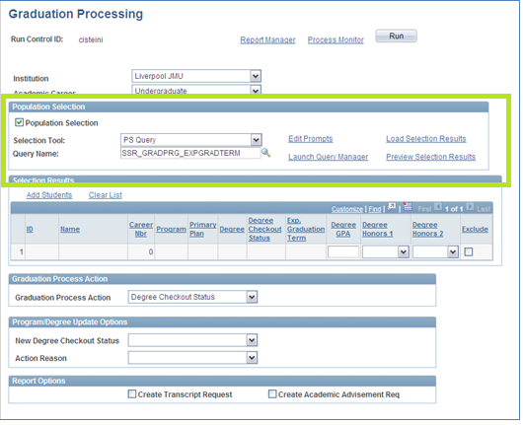
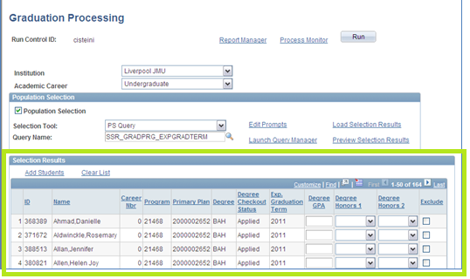

Or Adding Students Manually
Leave the Population Selection checkbox unticked.
- Click the Add Students link
- Enter the required selection criteria – Empl ID – Student ID
- Click Search
- Click on the green tick to select student.
- Click Add Student link, to select another student
Alternatively if you wish to add to the pre-populated list, just click on the Add Students link and follow the above steps.

Proceed with:
- Enter the Degree Details
- Scroll to the bottom of the page
- Enter a Graduation Process Action. Different actions allow different processes to take place.
Select Update All, allows all the above process selections to be updated at once.
- Complete fields as required.
Select a New Degree Checkout Status of Degree Awarded, this will trigger some new fields to be displayed.
- Enter an Action Reason – Successful Completion of Course (exclude Alternative Exit Awards at this point).
Note: Only if no credit at all has been earned for the students Programme of Study should an Action Reason of ‘Fail not Permitted to Progress’ be recorded. In most cases an Alternative Exit Award Plan of at least ‘Institutional Credit’ can be awarded.
- Select the Completion Term = Academic Year
- Select the Programme Effective Date – this should equal the Assessment Board date. Select User Date from the drop down list and then enter the date to be used for all student records listed above
- Enter the Confer Date to be recorded (this is usually the 11th day of the month after the programme is completed). Select User Date from the drop down list and then enter the date to be used for all student records listed above
- Update Degrees Values – Select ‘DegMarkGPA’. This will ensure that we use the values that have already been calculated by the Award Mark Calculation process.
- Click the Update Degree Values button. The previously calculated Award Mark and Classification values will be inserted against each student. If any are missing or are incorrect, exclude them from the process to investigate why.
Note: Degree Marks and Classifications should not be amended at this point. If the values are incorrect, check the module marks and re-run the Pre Board View Reports
- Scroll to the top of the page and click Run to process the students
- Click ‘ok’ to start the process
- Click Process monitor to view the status of the process.

Viewing the Output
The completion process will add a ‘Completion’ row to the students Programme/Plan stack, additionally it posts (finalises) the students Degree details and creates a Degree record for each student.
To view the Completion Details:
Navigation: Main Menu> Records and Enrolment>Career & Programme Information>Student Programme/Plan
Navigation: Main Menu> Records and Enrolment>Graduation>Student Degree

Completing a Single Student
The process for completing a single student is identical to that above, except that you will need to ‘add’ the students manually, rather than using a Pop Select.

Adding Students Manually through the Graduation Processing Page
- Leave the Population Selection checkbox unticked.
- Click the Add Students link
- Enter the required selection criteria – Empl ID – Student ID
- Click Search
- Click on the green tick to select student.
- Click Add Student link, to select another student
- Continue the process steps from 4. Above
OR

Completing Students Manually through the Programme/Plan Stack
Navigation: Main Menu>Records and Enrolment>Career and Programme Information>Student Programme/Plan
- Completing Successful Students. Students that have an award including an award of credit.
Students that are taking an Alternative Exit Award should have their Plan Changed to the relevant Award before continuing. Students that are Discontinued should follow the process ‘Withdrawals and Alternative Exit Awards below.
- Query the student
- Add a new effective dated row.
Note: There are occasions that the adding of an Effective Dated row here will not save. This will be because one or more of the other rows has a date that would be later than the date that you are trying to enter. If this is the case please raise a Helpdesk request with the students ID and we will fix this for you.
- Enter a Programme Action of ‘Comp’ = Completion
- Enter an Action Reason of ‘1002’ = Successful Completion of Course
- Click the Student Degree tab
- Change the Completion Term – if required
- Enter the Degree Honours value = Select the Classification awarded from the drop down list.
- Enter the Degree GPA = Award Mark.
- Click Update Degrees. This button posts the Degree to the Student Record and saves the Programme/Plan stack.

Next Update the Degree Information
Navigation: Main Menu>Records and Enrolment>Graduation>Student Degrees
- Search for the student
- Change the Confer Date as required (this is usually the 11th day of the month after the programme is completed).
- Click the Degree Honors tab
- Change the Award Date to match the Confer Date
- Save

Completing Failed Students.
Students that have NO CREDIT at all will be deemed to have Failed the Programme and should be completed as such. Single Module CPD Programmes are good examples of this scenario.
Students that have ‘failed’ their Programme should be Completed in the following way:
- Query the student
- Add a new effective dated row.
Note: There are occasions that the adding of an Effective Dated row here will not save. This will be because one or more of the other rows has a date that would be later than the date that you are trying to enter. If this is the case please raise a Helpdesk request with the students ID and we will fix this for you.
- Enter a Programme Action of ‘Comp’ = Completion
- Enter an Action Reason of
  - ‘1004’ = Fail not Permitted to Progress or
  - 1006 Ineligible for Award
  - 1007 Acad Failure/Bad Stand/No Prog
- Click the Student Degree tab
- Change the Completion Term – if required
- Enter the Degree Honours value = Select the Classification of ‘F – Fail’.
- Enter the Degree GPA = Leave blank.
- Click Update Degrees. This button posts the Degree to the Student Record and saves the Programme/Plan stack.

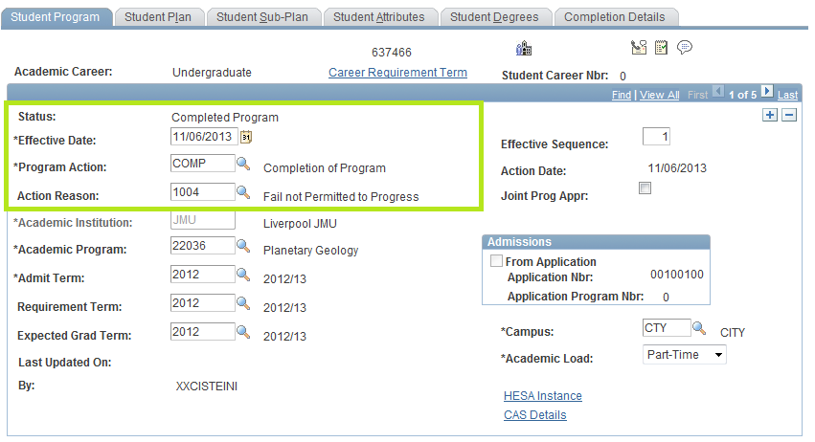

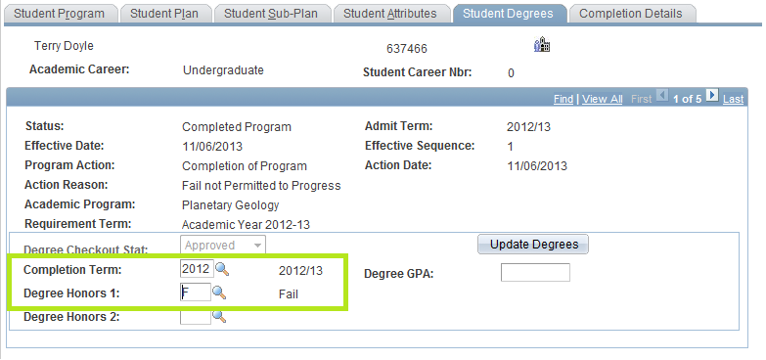

Navigation: Main Menu>Records and Enrolment>Graduation>Student Degrees
- Search for the student
- Change the Confer Date as required (this is usually the 11th day of the month after the programme is completed). Although no formal award is being attained we do still record a Conferral Date as this records the date that the Completion and No Award were applied.
- Click the Degree Honors tab
- The Honours code will be displayed a ‘F’ (Fail)
- Change the Award Date to match the Confer Date if needed
- Save
As the student now has a Degree Status of ‘Awarded’ they will no longer appear in the Board of Examiner Reports. In addition a Certificate will not be produced although an Official Transcript will still be available if required.

Withdrawals and Alternative Exit Awards
This is a process for those students that have Withdrawn from the University prior to the Board of Examiners. At the next Board of Examiners the decision is made to award the students an Alternative Exit Award based on their attained credit.
The student Status on the Programme/Plan page remains at Discontinued, the Plan change action is added on top of this. The student’s status does not change.

Navigate to: Records & Enrolment>Career & Programme Information>Student Programme/Plan
- Add a new effective dated row to the Programme
- Enter a Programme Action of Plan Change
- Enter an Action Reason of ‘Alternative Exit Award Awarded’
- Click on the Plan Tab
- Enter (overwrite) the new Plan (Alternative Exit Award)
- Save
The student can’t be ‘completed’ in the normal way as they have already been discontinued. But the Student Degree data can still be recorded manually.
Navigate to: Records & Enrolment>Graduation>Student Degrees
- Search for the student
- Enter the Degree from the List of Values
- Enter the Primary Career
- Enter the Completion Term
- Enter the Confer Date
- Enter the Degree Status = Awarded
- Click on the Degree Honours Tab
- Enter the Honours Code (Classification)
- Enter the Award Date
- Click on the Degree Plan Tab
- Change the Degr Stat (degree status) to ‘Awarded’
- Enter the Plan (from the list of values – if more than one select the first)
  - If the list of values is blank, double check that you have selected the correct values on the other 2 tabs)
- Save

Withdrawals and No Alternative Exit Award

This is a process for those students that have Withdrawn from the University prior to the Board of Examiners. At the next Board of Examiners the decision is made not to make an Award as no credit has been attained.
The student Status on the Programme/Plan page remains at Discontinued. The student’s status does not change. There is no Plan Change to add. However it is recommended that a DATA row is added so that other users are then aware that a ‘Fail and Leave – No Alt Award’ has been recorded.
Navigate to: Records & Enrolment>Career & Programme Information>Student Programme/Plan
- Add a new effective dated row to the Programme
- Enter a Programme Action of ‘DATA’
  - Enter an Action Reason of ‘Fail and Leave – No Alt Award
- Save

Award Aim Changes:

Pre Board Changes
These are a result of situations such as a student’s request, or changes of circumstance (Placements).
Navigate to: Records & Enrolment>Career & Programme Information>Student Programme/Plan
- Student Programme/Plan Stack (include mode)
- New Effective Dated Row
- Programme Action - Plan Change
- Programme Action Reason – 1029 Award Aim Change
- Click the Plan tab, change (overwrite) the Plan to the new Award
- Save

Post Board
These are the result of a student’s failure to achieve the required credit to be awarded the current Award
Navigate to: Records & Enrolment>Career & Programme Information>Student Programme/Plan
- Student Programme/Plan Stack (include mode)
- New Effective Dated Row
- Programme Action - Plan Change
- Programme Action Reason – 1031 Alternative Exit Award Awarded
- Click the Plan tab, change (overwrite) the Plan to the new Award
- Save

In both cases above, the Pre Board View Report should also be re-ran in order to reflect the changes made to the Students Programme.

Students Returning to Continue Studying
It is acknowledged that students do sometimes return to complete their Programme at a later date and after a record has been completed and so to aid administration the steps that need to be followed (see Appendix 2) to reactivate students are:
- If the student has been previously DISCONTINUED then:
  - The student should be readmitted and RP(E)L recorded
- If the student had been Completed in error OR wishes to ‘Top Up’ (that is continue on the same programme)’ OR successfully appeals then the Completion should be Revoked.
    - Faculties should request the Certificate is returned to them
    - Faculties should raise a Helpdesk requesting the Award is to be ‘revoked’
    - Once received by Faculty the Certificate should then be passed to the Awards Team in Academic Registry
    - Once processed the record in SIS will then be ‘revoked’ and the student will be able to complete Student Registration (if required to do so) and be enrolled on modules.

Appendix 1

Query Names and Prompts Reference
Query Name | Prompts Used | Notes | Recommended to Use? Y/N
SSR_GRADPRG_AA_RESULTS | Institution  Career  Academic Programme  Exp Grad Term  Item Status | Item Status refers to Academic Advisement | N
SSR_GRADPRG_CHKOUTSTAT | Institution  Career  Academic Programme  Degree Checkout Status | By Selecting a Degree Checkout Status – Applied the user will return only those students that have an automated Award Mark successfully generated | Y
SSR_GRADPRG_CHKOUTSTAT2 | Institution  Career  Academic Programme  Exp Grad Term  Degree Checkout Status | By Selecting a Degree Checkout Status and Exp Grad Term – Applied the user will return only those students that have an automated Award Mark successfully generated | Y
SSR_GRADPRG_EMPLID | Emplid | Allows 1 student to be processed | Y
SSR_GRADPRG_EXPGRADTERM | Institution  Career  Academic Programme  Exp Grad Term | By selecting th required Exp Grad Term only those students with a matching year on the Programme/Plan stack will be returned. | Y
SSR_GRADPRG_GRADTRACK | Institution  Career  Rev(iew) Status | By selecting a Rev Status = AMCL, all students in that CAREER will be displayed | N
SSR_GRADPRG_STDNTCARTERM | Institution  Career  Academic Level  Term | By selecting an Academic Level for a certain Term those matching students will be displayed. The Academic Level needs to match that displayed on the Term Activate a Student page and the Term Start value | With Caution

Appendix 2 – Revoke Process Flow Diagram
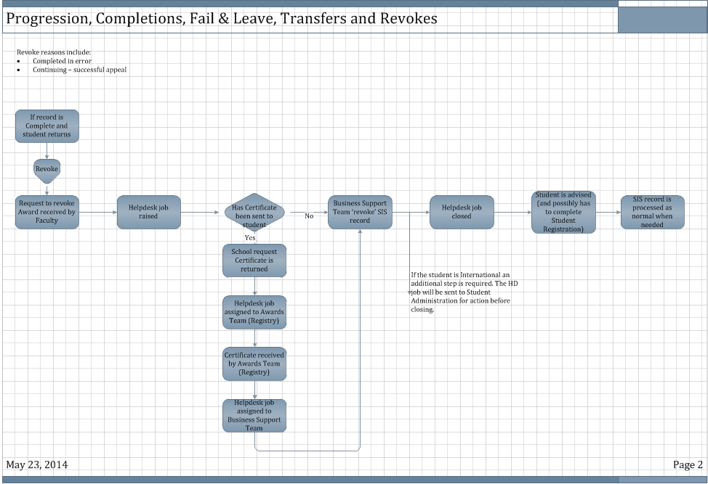

Appendix 3 – TR1 Process Flow Diagram

Appendix 3 – Completion/Discontinuation Process Flow Diagram

Please note:
- The first question considered is whether or not the student is Level complete.
Each final outcome is the end of the process, However, if the student decides to return, the next steps are included for reference (see also section ‘Students Returning to Continue Studying’ above.
Student Status | Award Type | Reason | Action Required
Complete | Target Award |  | No further action
Complete | Alternative Exit Award | Completed in error or student decides to return. | Revoke Award
Discontinued | Alternative Exit Award |  | Readmit with AP(E)L or Credit Transfer
Discontinued | No Alternative Exit Award |  | Readmit with AP(E)L or Credit Transfer

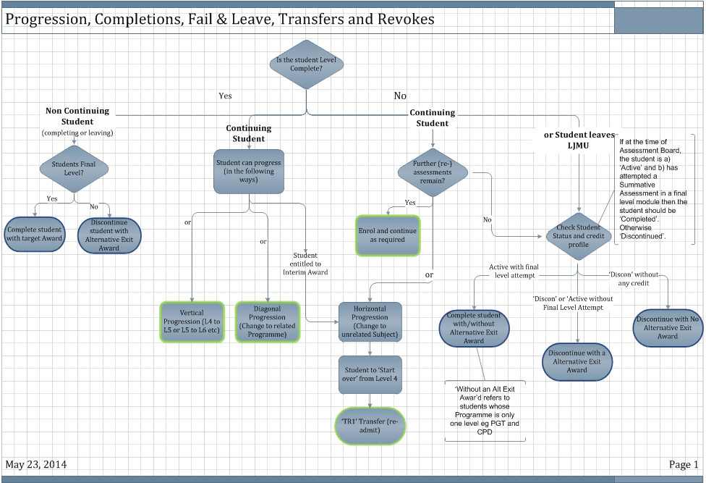

Notes:

