Student Information System

Liverpool John Moores University

A Quick Guide to Deferral Enrolments

Version 1.0. 20th April 2013
Author: Business Support
Contents
1
Student Information System 1
Liverpool John Moores University 1
A Quick Guide to Deferral Enrolments 1
Introduction 3
1. Enrolling Students on to Deferral Classes 3
2. Applying Repeat Codes 7
3. Repeat Codes table 9
4. Scenarios for students on deferred modules 10
Appendix 1 11

Change log
Date | Updated by: | Change Description
22/04/2013 | C. Denny | Appendix 1, added explaining Finding the DEF class in Admin Gradebook

Introduction
Post Assessment Board processing is the period in which decisions made in the Board then need to be reflected on the Student Record.
The processes detailed below are the manual steps to complete the tasks that will reflect the Boards decisions and ensure that the student’s record is accurate for the next assessment period.

Enrolling Students on to Deferral Classes

Faculty administrators, typically programme administrators, are responsible for enrolling students onto Deferral classes. Enrolment on to the DEF class is strictly for deferred first attempts only. Deferred referrals or deferred exceptional second referrals should be enrolled on the REF and ESR class respectively applying the relevant repeat code as per the table in section 3.
With the introduction of the DEF class, there are now 3 classes which are scheduled under the OEE session
- DEF – Deferral is for a student who has deferred their first attempt
- REF – Referral, this is the students first referral
- ESR – Exceptional Second Referral, this is the student’s second and final attempt and is not automatic. Enrolment onto an ESR is not an automatic entitlement. Further details of this can be found in the Academic Framework and Progression Training documents
The grading basis for all DEF classes is uncapped as it is considered to be a student’s first attempt.
Navigation: Records and Enrolment > Enrol Students > Quick Enrol
- Ensure the Add a New Row tab is displayed
- Enter the student ID
- Enter the students career (for the students programme that the classes are associated with)
- Enter the Academic Institution (if needed)
- Enter the Term that the classes need to be studied

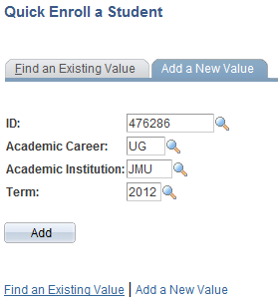
- Click Add. This opens the Enrolment request page
- Don’t change the Enrolment Action. Keep the value at ‘Enrol’
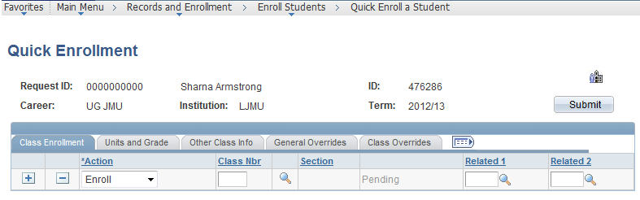
- Enter the Class number if known or click the Class Search icon
- The Course Search parameters will display
- Enter the course Catalogue number needed (this can easily be located using the Student Grades page)

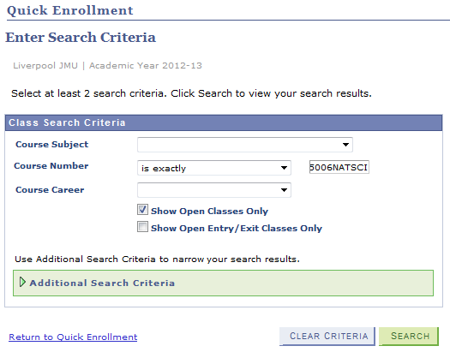
- If required, change the ‘Course Career’ to match the student’s career.
- Click Search

- The results will display ALL matching classes. Remember this will include standard, DEF, REF and ESR classes.
- Click ‘View all Sections’ to display all the matching classes.
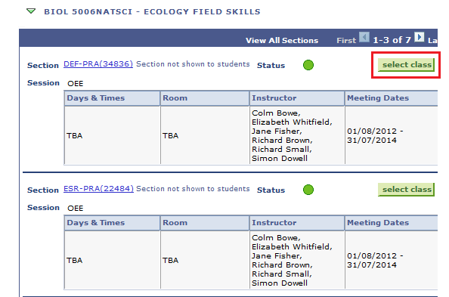
- Click the ‘select Class’ button next to the required class deferral class, this will be the DEF class
* Deferral classes don’t have any related classes. Only the primary graded class will be displayed *

- Enter a Start Date. Like REF and ESR classes, the DEF class runs from the beginning of each 15 session (Semester 1, Semester 2 and summer). Enter the Start Date that relates to which session the DEF class is being studied.
E.g.
Session | Start/Action Date
Semester 1 | 01/09/20**
Semester 2 | 01/01/20**
Summer | 01/04/20**

** = the year in which the enrolment on to the DEF class commences.
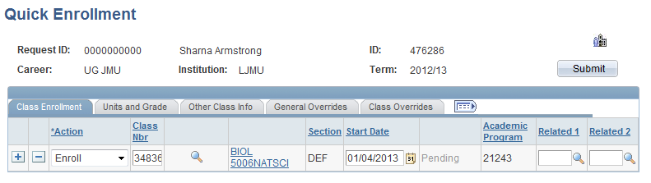
- Click the Other Class Info tab
- Click the Other Class Info tab
- Enter the Action Reason of ‘004’ Deferral Class
- Click the General Override tab
- Click the Action Date check box
- Enter the Action Date. This should be identical to the Start Date entered as per the above table
- Click the Add New Row if further classes needed to be added
- When all Courses and Classes have been added, click the Submit button.
- The process will then enrol the students onto the Classes.
The grades for these courses should be recorded and posted as standard per guidelines found at http://www.ljmu.ac.uk/studentinformationsystem/123002.htm

Applying Repeat Codes
Repeat codes are used by the system to manage multiple attempts at a course. Repeat codes can be applied via ‘Quick Enrol’.
Repeat codes are applied directly to the student record through an Enrolment Request
Navigation: Main Menu>Records and Enrolment>Enrol Students>Enrolment Request
- Add a New Value
- Enter student ID
- Enter the Academic Career
- Enter the Academic Institution
- Enter the Term
- Click Add

- Change the Action to Normal Maintenance
- Enter an Action Reason of ‘RC’ Repeat Code Applied
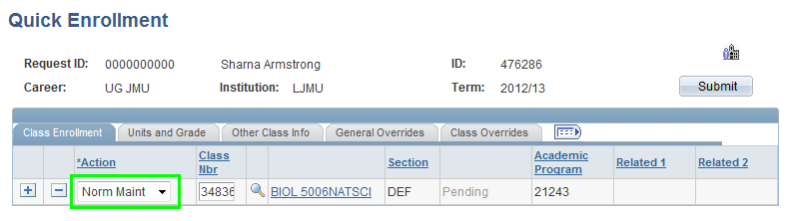

- Enter the Class number. This is the class number that the student is enrolled on and the class for which the Repeat Code should be applied. The Class can be located easily from the List of Values
- Click the ‘Units and Grade’ tab.
- Select the required Repeat Code (see section 3)
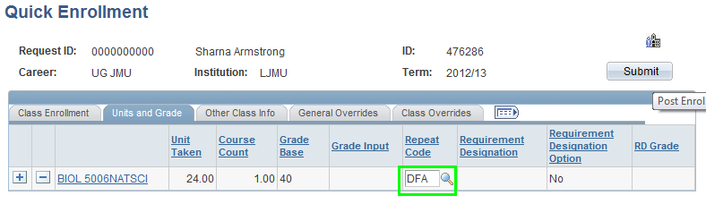
- Click Submit. This is crucial as unless the process is submitted the Note will not be part of the students record
- The process will complete with a status of ‘Success’ and the Repeat Code will now appear on the student record.
This Repeat Code will now appear on the student’s reports and be used to derive the attempt number at the module.

Repeat Codes table

The below table shows which repeat codes are used for which classes - subject to passing or failing the module.
CLASS | Repeat Code | Definition | Notes
DEF | DFA | Deferred Attempt | This indicates student is on a deferral class.
DEF | DFA+ | Deferred Attempt: Passed | If Passed
DEF | DFA- | Deferred Attempt: Failed | If Passed
REF | DFR | Deferred First Referral | This indicates student is on a deferred referral class.
REF | DFR+ | Deferred First Referral: Passed | If Passed
REF | DFR- | Deferred First Referral: Failed | If Failed
ESR | DLR | Deferred Last Referral | This indicates student is on a deferred exceptional second referral class
ESR | DLR+ | Deferred Last Referral: Passed | If Passed
ESR | DLR- | Deferred Last Referral: Failed | If Failed

Scenarios for students on deferred modules

The below scenarios offer advice on what you should do in certain deferral situations.
Student 1 - defers a first attempt (FA), A grade of DEF is added and a valid transcript note (VAL or DCG).
The deferred FA is enrolled as a DEF class section with a repeat code of DFA and a start date/action date of 01/04/20__ (the summer referral) or 01/01/200__ depending on the next offering. This is an uncapped class and the mark is added once received and the repeat code amended to DFA- or DFA+
If the student defers the summer deferral then a DEF grade and transcript note needs to be added to the summer referral. In the next academic year another DEF class section is added with another repeat code of DFA.
Student 2 - defers a first attempt, a grade of DEF is added and a valid transcript note (VAL or DCG.
The deferred FA is enrolled as a DEF class section with a repeat code of DFA and a start date/action date of 01/04/20__ or 01/01/20__ depending on the next offering. The student attempts this deferral but fails. The repeat code is amended to DFA-.
In the next academic year the student is enrolled on a normal REF class with a repeat code of REF. Once a mark is finalised the repeat code is amended to REF+ or REF-.
Student 3 - is enrolled on a REF class in September. This is then deferred in May. A grade of DEF is added and a valid transcript note. The repeat code is DFR.
The student has another opportunity to do the referral in summer, the DEF grade should not be overwritten and the student should not be enrolled on the ESR offering as these classes carry a charge and the student will be invoiced. Should this happen, please email the helpdesk requesting the creation of a deferred referral class.
Student 4 - is enrolled on an ESR class in September. This is then deferred in May. A grade of DEF is added and a valid transcript note. The repeat code is DLR.
The student has another opportunity to do the ESR in summer, the DEF grade should not be overwritten and the student should not be re-enrolled on the ESR offering as this is not possible. Should this happen, please email the helpdesk requesting the creation of a deferred ESR class.

Appendix 1
Finding the DEF class in Admin Gradebook
Navigation: Main Menu > Curriculum Management > Grading > Admin Gradebook
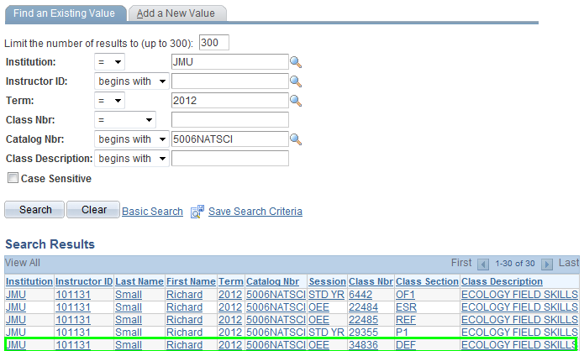
- In the Search fields enter at least a Term value and a Course Catalogue number
- Click Search. The corresponding classes will then display
- Select the DEF class section
Note: There is a DEF class listed for each module team member – it doesn’t matter which value you select.
Admin Gradebook and Grade Roster processing is the same as for standard, referral and ESR offerings. For more information, view relevant guides on our website. http://www.ljmu.ac.uk/studentinformationsystem/123002.htm

