Student Information System
Liverpool John Moores University

Quick Guide: Managing Programme Leader and Personal Tutor Data

Version: 1.0. 7th April 2015
Author: Business Support Team

Contents
Summary of Changes 2
Introduction & Requirements 2
Scope of Document 3
Responsibility Matrix 3
1. Programme Leaders/Committee Information 3
1.1 Updating Programme Committees (Programme Leaders) 3
1.2 Attaching Programme Committees – By Process 5
1.3 Attaching Committees to Student Records - Manually 5
1.4 Recording Degree Apprenticeship Administrators 6
2. Personal Tutors – Manual Steps 8
2.1 Attaching Personal Tutor – Batch Process 9
2.2 Web hub Report to help (Faculty) provide (BST) Personal Tutor File 9

Summary of Changes

Version: | Changes: | Date:
Version 1.0 | New Document | 7th April 2015
 | Responsibility matrix added | 15th April 2015
 | Section 2.2 added | 14th May 2015
 | Section 2.2 adjusted to show web hub reporting | 28th September 2017
Version 1.1 | Section 1.4 Recording Degree Apprenticeship Administrator | 26th October 2021

Introduction & Requirements
SIS Phase 3 identified the need for a central repository to store personal tutor and programme leader information as the information is not held on a single accessible system.

Campus solutions delivers functionality in which advisors (EMPLIDs) and committees can be assigned to a student person record which can help deliver institutional requirements.

This information will initially be used to inform;
- Attendance Monitoring
- Reading Lists
- Key Information Set (KIS)
- Students – who their personal tutor and programme leader is
- Academic staff - who their personal tutees are, also providing person and programme details for students.

Scope of Document
- To discuss how a customised solution can facilitate the requirement and help reduce the need for manual intervention to maintain personal tutor and programme leader details against student records.

- Using existing delivered functionality within the Student Information System, how a staff user can add and update personal tutors and programme committee that are attached to student records.

Responsibility Matrix

 | Business Support | Information & Reporting Team | Faculty Admin
Creating committee |  | X
Amend/update committee |  |  | X
Attaching committee to student records | X
Provide personal tutor data to BST |  |  | X
Upload (by external file) personal tutor information - once per cohort. | X
Update/maintain personal tutor information in year |  |  | X
Produce reports to identify missing data |  | X

Programme Leaders/Committee Information

For any newly created programmes, the Information and Reporting team will create the programme committee and add the programme leader. As programmes are validated for 5 years, the end date for the committee members should be dated accordingly.

Any subsequent changes to the committee are managed at faculty level as agreed at project sign-off.

1.1 Updating Programme Committees (Programme Leaders)
The below details how to update a committee/programme leader. This should be done whenever the programme leader changes.

Navigation: Campus Community > Committees > Manage Committees

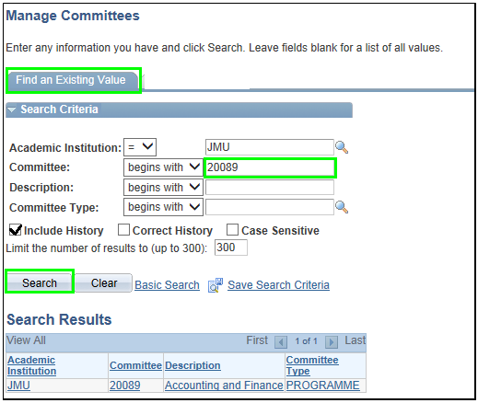

- Committee: Enter Programme Code
- Tick the ‘Include History’ box and click search
- Select appropriate value from the list.
- Add a new ‘Effective Date’ by clicking the symbol. The effective date should be the date in which the programme leader changes
- Find the ID of the programme leader. Note that this list only contains LJMU staff.

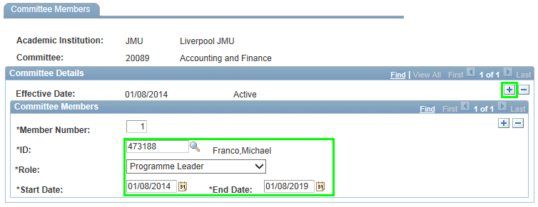

- Role – Programme Leader (THIS SHOULD NOT CHANGE)
- Enter Start Date - The ‘Start Date’ should be the date of programme leader commencement.
- Enter End Date - The ‘End Date’ should be the date programme leader ends.
- Save

Note: As all programmes are validated for 5 years in the first instance, the start date for all programmes was set as 01/08/2014 and the end date as 01/08/2019.

Even when a programme has been officially closed, the committee will remain as ‘Active’.

1.2 Attaching Programme Committees – By Process

To remove any manual effort and to make the process as efficient as possible, committees (were available) will be assigned to students using an automated process which will be scheduled by business Support team (frequency = daily)

1.3 Attaching Committees to Student Records - Manually
Only when there is an urgent requirement (more than once per day) should the manual task of attaching a committees be used.

Navigation: Records and Enrolment > Student Background Information > Student Advisor

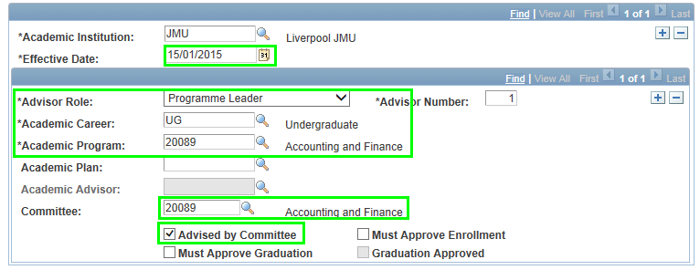

- Enter ‘Effective Date – this will be set to the system date if an existing advisor or committee are not against the student record. Any subsequent changes to the advisor or programme committee should be made by adding a new effective dated row.
- Advisor role = Programme Leader
- Career – enter career
- Program – enter programme code
- Tick the ‘Advised by Committee’ – this makes the ‘Committee’ field Live
- Enter Committee name (this should be the programme code)

Note: Multiple committees can be attached to a single student record.

1.4 Recording Degree Apprenticeship Administrators
The Student Information System is the authoritative system for managing (assigning and amending) access to the Degree Apprentice Portal for LJMU Staff.

Navigation: Campus Community > Committees > Manage Committees

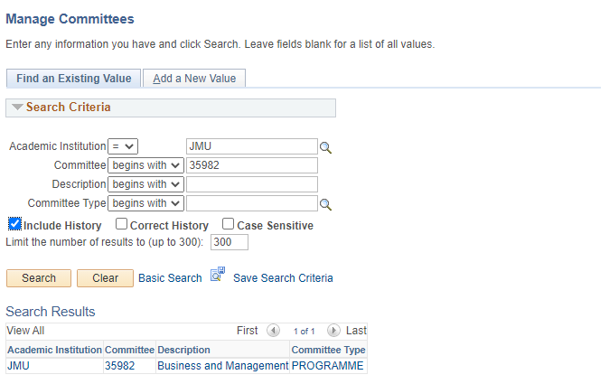

- Committee: Enter Programme Code
- Tick the ‘Include History’ box and click search
- Add a new ‘Effective Date’ by clicking the symbol. The effective date should be the date the change is effective from.
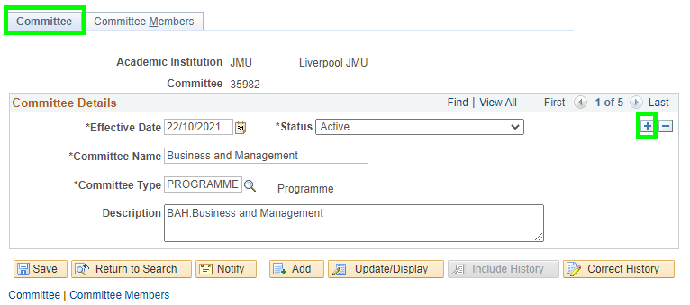

- Now go to the ‘Committee Members’ tab

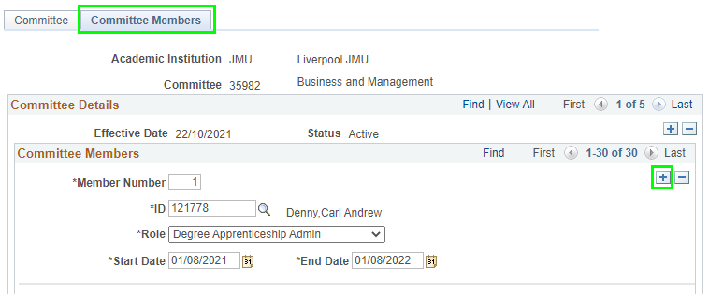

- Add a row in the ‘Committee Members’ section
- Find the ID of the required staff user. Note that this list only contains LJMU staff.
- Role – Degree Apprenticeship Admin
- Enter Start Date - The ‘Start Date’ should be the date named user requires access to the DA portal from.
- Enter End Date - The ‘End Date’ is the date access will expire for the named user(s) requires access to the DA portal.
- Save

Note: you should add additional rows and complete details as indicated above for every staff user that requires access to the portal

Personal Tutors – Manual Steps
Student Advisors or Personal Tutors can be added against any active student record within the Student Information System.

Navigation: Records and Enrolment > Student Background Information > Student Advisor
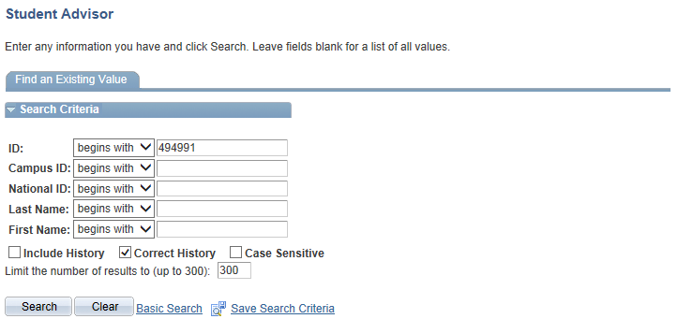

- Search for student using ID number or combination last and first name

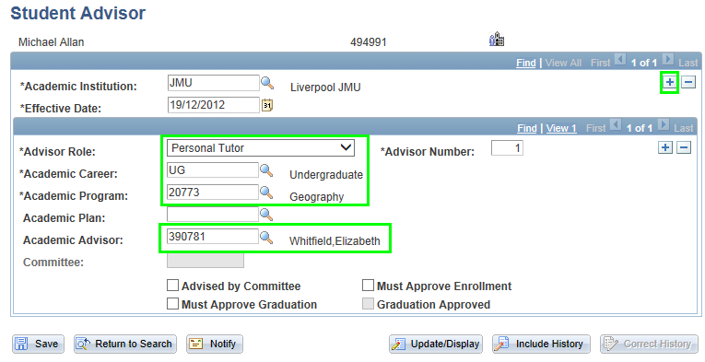

- If existing ‘Student Advisor’ data showing, add new ‘Effective Dated’ row and set date accordingly
- Advisor Role = Personal Tutor
- Academic Career
- Academic Program
- Academic Plan (optional)
- Academic Advisor – enter advisor ID or search using the look up
- Save

Repeat above steps if personal tutor changes in year.

Note: Multiple advisors/personal tutors can be attached to a single student record.

See Web Hub reports to identify missing data. E.g. students without an advisor, when academic programme on student advisor page does not match academic programme on Student Program/Plan page.

2.1 Attaching Personal Tutor – Batch Process
Faculty staff currently provide ITS with a file which lists students and personal tutors annually for the purpose of attendance monitoring. This information will now been stored within SIS and used for other downstream systems.

Personal tutors can be added manually as detailed in an earlier section of this document.
The idea of the custom ‘Tutor Process’ is that it will assign personal tutors against student records by way of an external file import.

Web hub Report to help (Faculty) provide (BST) Personal Tutor File

There are a number of reports set up to help you provide me with this information, please use one of the reports detailed below.

The Web hub reports can be found at Web Hub > Data Quality > SIS Data Issues

http://aphub.ljmu.ac.uk/Staff/WH2/DataQuality/SIS/index.asp

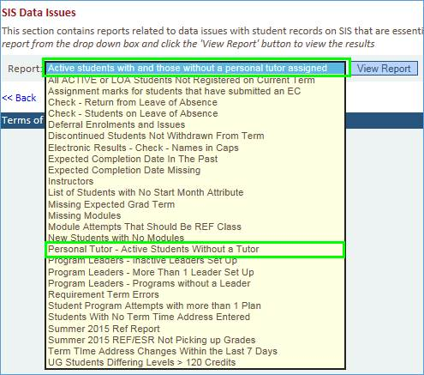

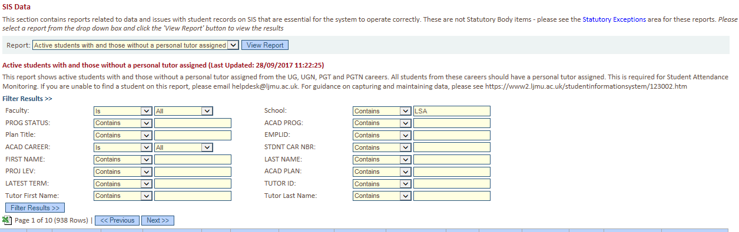

Enter the appropriate parameters (e.g. school, programme code)

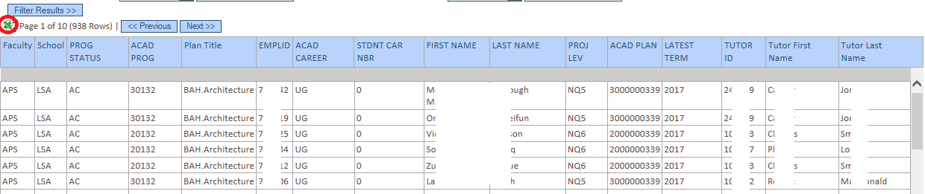

Export the information to Excel

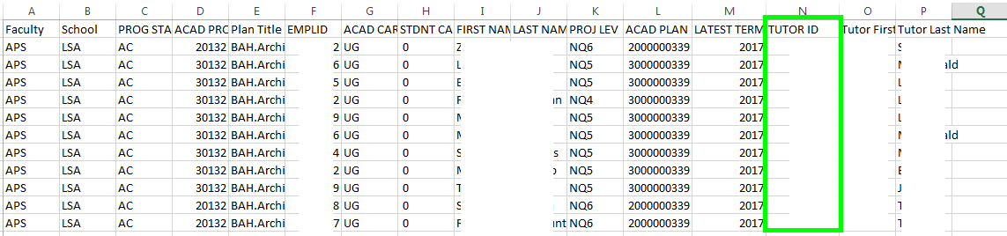

Populate column ‘N’ with the personal tutor number.

Once all personal tutor IDs have been added, save the file and send to Business Support via helpdesk.

