Student Information System
Liverpool John Moores University

A Quick Guide to Pre Assessment Board Processing

Version 1.0 2nd April 2011.
Author: Tracey Einig

Note: This is not a training guide

Contents
Introduction 3
1. Applying Compensation 3
2. Recording Extenuating Circumstances Requests 7
Extenuating Circumstances Process Flow 8
Receipt and Tracking Extenuating Circumstances Requests 9
Recording a EC Claim submission (Student Zone) 9
Recording a EC Claim submission (Faculty) 9
Recording the Date of the EC Panel (Faculty) 11
Recording Extenuating Circumstances Claim Outcomes – Grade Roster 12
Recording Extenuating Circumstances Claim Outcomes – Enrollment Request 15
3. Recording the Extenuating Circumstances Grade Outcome 17
Pre-Requisites 17
4. Posting Grades 18
Posting Grades for a Single Class 18

Introduction
Pre Assessment Board processing is the period between a course being fully graded and the Assessment Boards themselves.
The processes detailed below are the manual steps to complete the tasks that will allow the Progression process to run and correctly initiate progression for those students eligible.

Applying Compensation
Compensation is applied to Courses that have been initially graded with a mark of between 30 – 39. A series of pre-requisites need to be met before applying the compensation (please refer to the Academic Framework documentation). Compensation is applied before running the Progression process.
Compensation is awarded in SIS by changing the Grade Basis that applies to the students enrolment on the class. This is done by changing the Grade Basis for each student that requires Compensation applying. This Compensation Grading Basis ensures that the original grade is retained but releases the credit, which will allow to the student to progress provided that the Compensation is not awarded for more than 24 credits for any one level.

In the example record above we can see that the Grade Roster shows us that the class as been marked and the marks are Ready for Review and the Grading Basis for all students is displayed as the default value (40%). Some of the students have received marks of between 30 and 39 and the Progress Identifier report tells us which students are eligible to receive Compensation (as both their grade allows it and the Course is not flagged as being non-compensational).
In order to change a grading basis for an individual student an ‘Enrolment Request’ needs to be created
Navigation: Main Menu>Records and Enrolment>Enrol Students>Enrolment Request
- Add a New Value
- Enter student ID
- Click Add

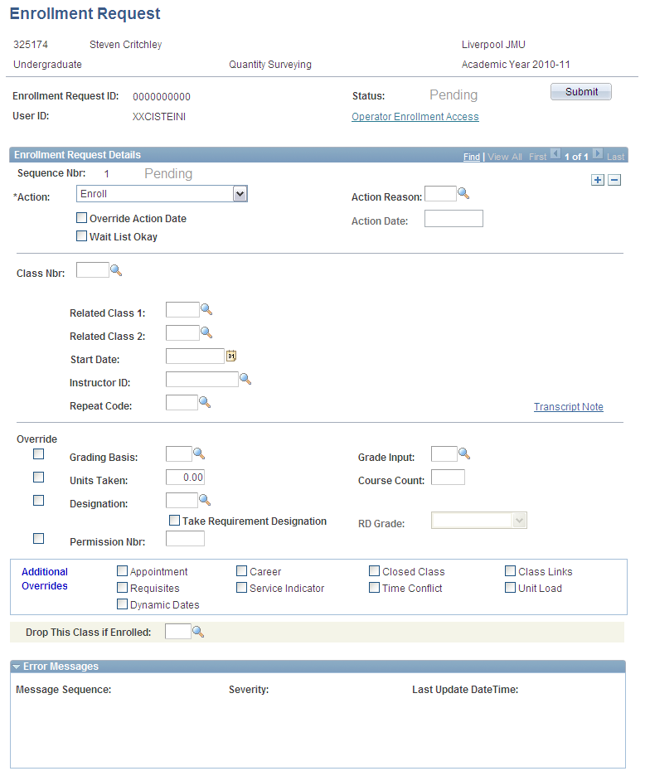

- Change the Action to Normal Maintenance
- Enter an Action Reason of Compensation Applied

- Enter the Class number. This is the class number that the student is enrolled on and the class for which the Compensation should be applied.

- Tick the Grading Basis override box
- Select the 40F Grading Basis

- Click Submit to process the Grade Basis change. When the process is complete the page will automatically update to indicate whether the process was successful or whether there was an Error. If the process does Error, the reasons for the error will be displayed at the bottom of the page.

The Grading Basis for the student has now been changed and the Grade Roster reflects the change (remember to change the Grade Roster back to ‘Not Yet Reviewed’ and click ‘Create’ to apply the Grade Basis change to the Grade Roster.

This individual change to a grading basis once applies will be used by all the SIS student records process and appear throughout the student record both for staff and for students in Student Self Service

Recording Extenuating Circumstances Requests
The process of recording Extenuating Circumstances requests in SIS is a 2 part process and uses both Checklist functionality and Transcript Notes.
A student may claim extenuating circumstances when timely, severe, acute and unexpected circumstances occur which have significantly affected their performance in module assessment(s) and where the possibility of alternative mitigation is inapplicable or inappropriate.
A student will submit an EC claim after receiving guidance from Student Advice & Wellbeing (SAW).
The form is submitted either:

Within 5 working days of the assessment event as an 'EC',
Or
After that date and before the meeting of the 'EC Panel' as a 'late EC'.

Further details surrounding the Rules and Regulations regarding Extenuating Circumstances can be found in the Academic Framework document.

Extenuating Circumstances Process Flow
Student has Issue
Local resolution?

No
Yes

Extenuating Circumstances Claim
Academic staff update Gradebook
- Extension
- Waiver
- Alternative

No
Yes
Key:
Extenuating Circumstances Claim Form Submitted
Process End

Student
Academic
Student Zone
Extenuating Circumstances Claim Valid?
Faculty

No
Yes
Claim Addressed?
Not Valid

Module Failed
Yes
No
Further Action required
No

No
Yes
Module Deferred
No
Further Action required

Receipt and Tracking Extenuating Circumstances Requests

Recording a EC Claim submission (Student Zone)
The student zone process focuses on taking receipt of an EC request form and recording it in SIS using a Checklist. A Checklist is a 3C and this allows the tracking of the EC form through the process and also displays to the student the status of their request. The Course and Assignment that the EC form is applicable to is also recorded and displayed by the Student Zone and this is displayed on Checklist 1 tab

Recording a EC Claim submission (Faculty)
Once an EC form has been received by the Faculty office, this needs to be recorded on the Checklist.
- Query the Student in Student Services Center
Navigation: Main Menu>Campus Community> Student Services Center>General Info

- Check the status of the next action needed by clicking on the blue triangle to expand the checklist items

The Checklist itself through being Initiated shows that an EC Claim has been received by the Student Zone and additionally the date that the form was forwarded to the Faculty/School Office has also been recorded by the Student Zone.
The first step of the Faculty process is to record the date and receipt of the form at the Faculty Office.
- Click on the Checklist link in order to action the next item – Form received by Faculty. The Checklist detail will open.
- Click on Checklist Management 2 tab

- Change the Status of ‘Rec by Fac’ to Complete and change the status date, to the date the form was received by the Faculty/School Office.
- Change the responsible ID of the person recording the form has been received.

- Click ok to save the record and return to the Student Center. The item will ‘disappear’ from the Checklist as the action is now complete.

Recording the Date of the EC Panel (Faculty)
At the same time as recording receipt of the EC form, the date of the Extenuating Circumstances Panel should also be entered. The date is important as it will be used to determine whether an EC Claim is valid or not. It also informs the students of the date of the Panel for their information.
If it is not possible to record the date at the same time as the previous step, it can be completed at any time convenient.
- Navigate to Checklist 2 as above
- Change the Status date to ‘pending’
- Enter the date of the EC Panel in the Status and Due Date field
- Enter the Responsible ID of the person recording the date
- Click ‘ok’ to Save

Note: It is possible to also record the date that the EC Panel met, by changing the above Status to Complete.
The checklist data also changes to reflect progress of the Checklist in both the Student Services Centre and Student Self Service.

Recording Extenuating Circumstances Claim Outcomes – Grade Roster
In addition to using the checklist to record and track an EC Form in the system, it is also necessary to record the EC Claim as a ‘Transcript Note’. It is a Transcript Note that captures the Outcome of the claim and displays this on the students Progress report and Transcript.
The process for recording the Outcome changes is completed before the student grade is posted to their record and takes place on the Grade Roster.
Navigation: Main Menu>Curriculum Management>Grading>Grade Roster or Admin Gradebook
- Search for the class that the EC Claim is applicable to

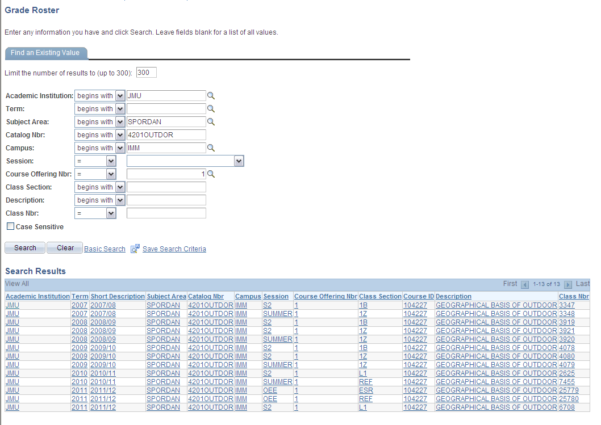

- Results of the search are displayed by Term, Session and Class offering.
- Click the Term and Class required

- The Rosters will already be created for you
- Click the Grade Roster tab
- Locate the student required

- Click the ‘Note’ link for the student. The Transcript Note form will open.

- In the Note ID list of values select the EC Pending value
- Click OK to Save

Note: Whenever a Transcript Note needs to be updated to record the change in an EC claim Outcome, the above procedure should be repeated and the correct value selected.
Note: Once the Grades have been ‘posted’ to a student’s record, Transcript notes can no longer be updated through the Grade Roster (they still can be viewed!). An Enrollment Request should be used.

Recording Extenuating Circumstances Claim Outcomes – Enrollment Request
Navigation: Main Menu>Records and Enrolment>Enrol Students>Enrolment Request
- Add a New Value
- Enter student ID
- Click Add

- Change the Action to Normal Maintenance
- Enter an Action Reason of ‘TN’ Transcript Note Update

- Enter the Class number. This is the class number that the student is enrolled on and the class for which the Transcript Note should be applied. The Class can be located easily from the List of Values
- Click the Transcript Note link and amend the note.
- Click ok to save
- Submit the Enrolment Request. This is crucial as unless the process is submitted the Note will not be part of the students record
- The process will complete with a status of ‘Success’ and the note will now appear on the student reports.
Note: The Note will not automatically update the Grade Roster view. In order that the Note be viewable via the Grade Roster (both normally and via Faculty Self Service the following steps need to be completed first)
- Open the Class Grade Roster
- Tick the Override check box
- Click Create
This process re-creates the Grade Roster and then reflects the changes made to Transcript Notes through the Enrollment Requests

Recording the Extenuating Circumstances Grade Outcome
Once an EC claim has been approved as Valid by the EC Panel, the only possible Grade outcome from the decision is for the student to be able to ‘defer’ the affected Course attempt.
As the student is only postponing the generation of an overall Course grade, this same Course attempt should be used to record both the original ‘deferral’ grade and the actual grade achieved at the next attempt sitting as it ensures that:
- the student is not enrolled on a duplicate class
- that his attempts at the Course are not compromised (as he has not failed)
- that his fee can be calculated correctly (as there is no charge for a course that has been deferred)
- The Progression process and HESA return are calculated correctly
- And the changes in the assignment marks, cumulative grade and official grade can all be recorded correctly

Pre-Requisites
A student must have:
- A valid enrolment on the relevant class
- Explored other possible solutions with the relevant Academic staff member first
- Submitted a valid Extenuating Circumstances claim form
- Failed the Course attempt (this means that the student has not received a valid pass mark for the Course attempt)

If all the pre-requisites have been met then a Grade over-ride should be made on the Grade Roster of ‘DEF’. The deferred grade when posted to the student record will display as a Course still ‘in progress’ in the relevant student reports.
The process for applying the Deferral Grade is described in the Grade Roster Administration Quick guide, section 10 – Changing Grades Before Posting.
The grade should then be posted the normal way as described in the Post Assessment Board Processing Quick Guide
Once the student has sat the deferral assessment (at the next possible opportunity after the deferred attempt) the official grade should be recorded using the process described in Changing Grades After Posting.

Posting Grades
The final part of the pre-progression process is to ‘post’ the grades. This is the process by which the approved grades are taken from the Grade Roster and posted officially as final grades to the student record. Grades that are not as a status of ‘Approved’ on the Grade Roster cannot be posted.

Posting Grades for a Single Class
Navigation: Curriculum Management>Grading>Grade Roster
- Search for the class to be required

- Results of the search are displayed by Term, Session and Class offering.
- Click the Term and Class required

- The Grade Roster will have an approval status of ‘Approved’, only Grade Rosters in this status can be Posted
- Click the Post button. This runs the process that posts the grades to the student record.
Note: any changes that then need to be made to a student grade record needs to be done through the Enrollment Request or Quick Enrol components.

