Student Information System
Liverpool John Moores University

A Quick Guide to:
Leave of Absence Administration – Faculty Admin

Version 2, 5th December 2013
Authors: Tracey Einig Jones, Kelly Fahy and Diane Taggart
Contents
1
Student Information System 1
Summary of Changes 2
Introduction 3
Leave of Absence Process: 4
Business Process Steps 4
SIS Process Steps 4
1. Query the Student Record 4
2. Check Negative Service Indicator 5
3. View the Student Record 6
4. Amend the Student Marks 7
5. Calculate Suspension Fee 8
6. Suspend the Student from the Programme 8
7. View the Suspension Form 9
8. Resume the Student on the Programme 11
9. Student Registration 12
10. Class Enrolment 12
11. View the Resumption Form 12

Summary of Changes

Version: | Changes: | Date:
Version 2 | New Document | 5th Dec 2013
Version 2a | Minor text changes | 19th May 2014

Introduction

The process of administering a Leave of Absence (also known as Student Suspension/Resumption or Intermit) from a programme of study is jointly a Student Records and Student Finance responsibility.
The SIS page, ‘Student Services Centre’ should be used by staff to view and administer the whole student record in the first instance. This form gives a complete overview of the student, including personal details, active admissions, student record and student finance information. From the Student Services Centre the entire system can be accessed easily as it acts as a central point for navigation.

Leave of Absence Process:

Business Process Steps
- Student advises LJMU of intention to suspend
- Student referred to Faculty for academic advice & referred to SAW for further guidance
- Student advised to put request in writing stating reasons for suspension
- Faculty agree period of suspension
- Faculty completes first part of change of circumstance form
- Grade of LOA entered against modules within Grade book
- Student Admin informed by Faculty of student suspension of study
- Change of circumstance form completed
- Systems updated – Programme status of LOA entered
- Change of circumstance forms processed and returned to SLC/Faculty

SIS Process Steps
The steps to be followed apply only to the Faculty Admin staff. Student Admin Centre procedures can be found in the appropriate guidance documentation.

Query the Student Record
Navigation: Main Menu>Campus Community>Student Services Centre
Enter the student number and or first/last names to view the record.
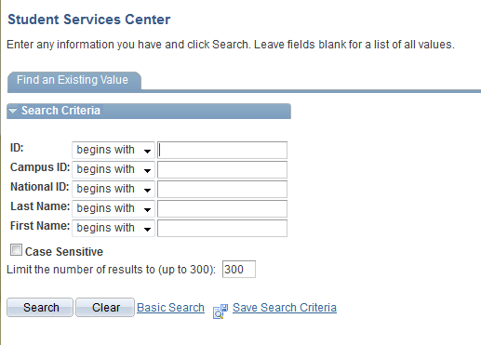

Check Negative Service Indicator
Navigation: Main Menu>Campus Community>Student Services Centre>General Info
If the student at this stage has any remaining unpaid fees or other debt then a negative service indicator will have been applied to the student.
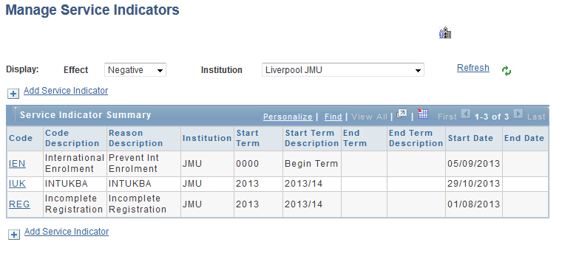
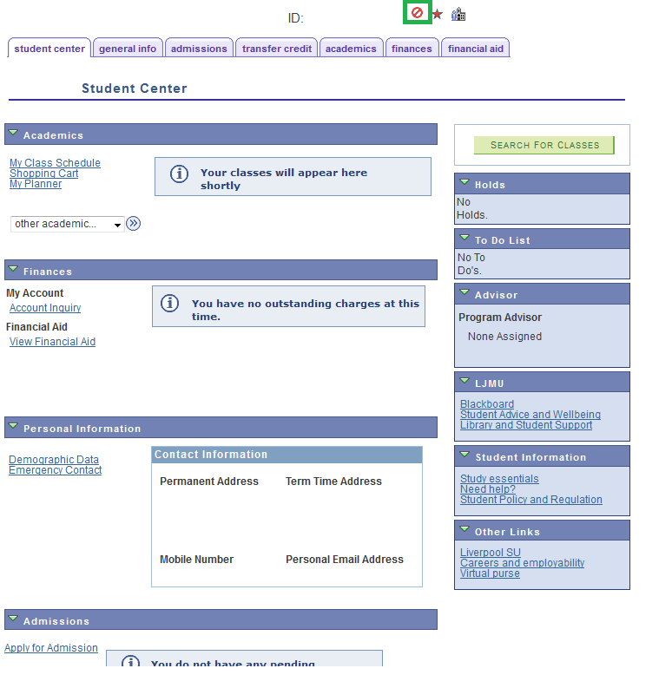

View the Student Record
Navigation: Main Menu>Campus Community>Student Services Centre>Academics
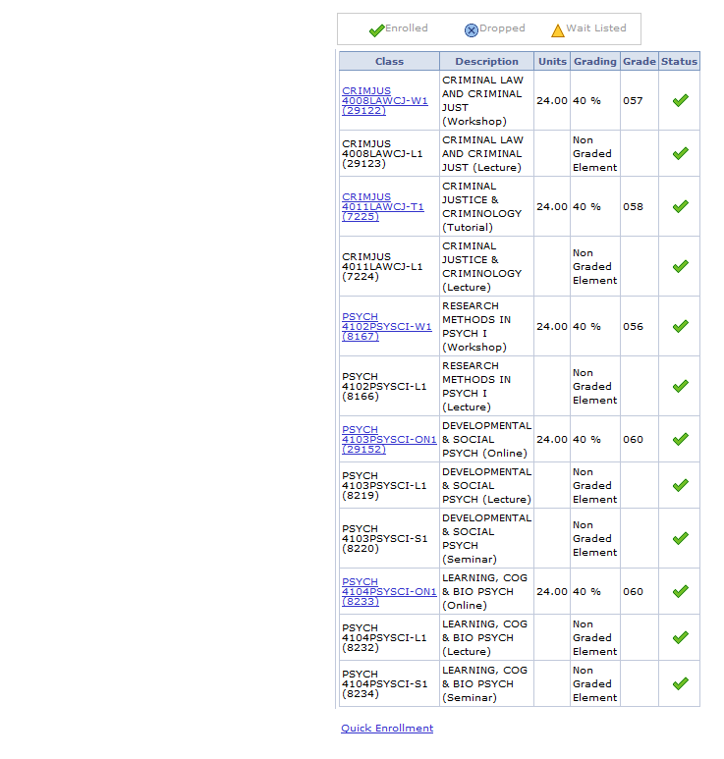
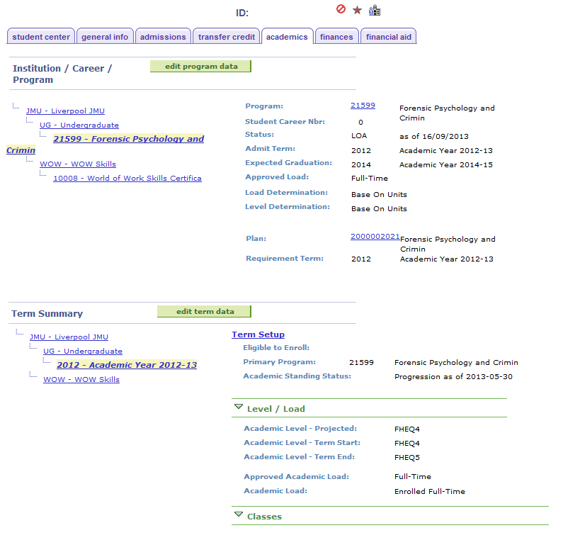

Amend the Student Marks
Navigation: Main Menu>Curriculum Management>Grading>Gradebook
Depending on the time of year when the student suspends study will affect what should happen with both the Assignment and overall Module grades.
The following table should be used for reference and further detail can be sought from the Business Support Team.
For all scenarios, the Term Withdrawal and Programme Status changes from ‘Active’ > ‘LOA’ and ‘LOA’ > ‘RLOA’ will be processed by the Student Administration Centre.

Scenario 1: Student Suspends at beginning of Term* – No assignment deadlines have passed so no Assignment marks are recorded.
- Cumulative Grade = 0
- Override Module Grade with = LOA grade
- Run the Assessment Board Report
*Note!: If modules are dropped prior to the University’s Module Deadline Date, these modules will no longer be viewable in Gradebook.
- On student programme status being recorded as’ LOA’ no modules should be dropped by SAC or Faculty. On ‘RLOA’ Re-enrol modules for new Term.

Scenario 2: Student Suspends mid-term – Some Assignment Deadlines have passed (Module therefore is Partially completed)
There are 2 sub scenarios here, each are dependent on the ‘current’ cumulative grade (generated when the Assignment marks are entered)
a)
- Current cumulative Grade = Fail (less than required Pass mark)
- Override Module Grade with = LOA grade
- Run the Assessment Board Report
- On student programme status being recorded as’ LOA’ no modules should be dropped by SAC or Faculty. On ‘RLOA’ re-enrol modules and roll forward existing Assignment Marks
b)
- Current cumulative Grade = Pass
- Override Module Grade with = LOA grade
- Run the Assessment Board Report
- On student programme status being recorded as’ LOA’ no modules should be dropped by SAC or Faculty. IF the student wishes to improve mark (Partial completion of module only): on RLOA re-enrol modules and roll forward existing Assignment Marks otherwise no re-enrol is required.

Scenario 3: Student Suspends mid-term – All Assignment Deadlines have passed (Module therefore is completed).
There are 2 sub scenarios here, each are dependent on the ‘current’ cumulative grade (generated when the Assignment marks are entered)
a)
- Current cumulative Grade = Fail (less than required Pass mark)
- Do not use ‘LOA’ grade override
- Run the Assessment Board Report
- On student programme status being recorded as’ LOA’ no modules should be dropped by SAC or Faculty. Student has failed. Re-enrol on next attempt on return from’ RLOA’ on new Term.
b)
- Current cumulative Grade = Pass
- Do not use ‘LOA’ grade override
- Run the Assessment Board Report
- As Student has passed, no action required

Calculate Suspension Fee
Note: The Student Administration Centre will calculate the suspension fee

Suspend the Student from the Programme
Navigation: Main Menu>Campus Community>Student Services Centre>Academics
Note: The Student Administration Centre will update the students Programme/Plan status to ‘LOA’ – Leave of Absence. They will also add a further DATA row, the Effective Date of which will indicate the anticipated Return from Leave of Absence date.

View the Suspension Form
The Change of Circumstance Suspension form will be created for each suspended student overnight after the Leave of Absence programme action has been added to the student record. Users are not required to view the Change of Circumstance Suspension form as part of the process, so the steps below are for information only.
Navigation: Records and Enrollment>3cs Summary>Communication Summary
- Search for the student

- Click the Search button in the Selection Criteria. This will search for the letters that have been generated overnight

- The search results will show the date that the letter process ran and completed.
- Click the View link. A new tab opens

- Click the View Generated Communication link to view the Change of Circumstance – Suspension form

Resume the Student on the Programme
Navigation: Main Menu>Campus Community>Student Services Centre>Academics
On returning from Leave of Absence the student record needs to be reactivated and so the resumption of studies needs to be recorded. The Student Administration Centre will complete this and any fee amendment.

Student Registration
Once the student has presented themselves in person back at the Institution they will need to complete that Terms Student Registration form online.

Class Enrolment
The student should now be enrolled onto their Classes. Standard classes should be used for the new Term and Assignment Marks rolled over as per Section 4. See Enrollment Process documentation for How to Enrol.

View the Resumption Form
The Change of Circumstance Resumption form will be created for each Resuming student overnight after the Return from Leave of Absence programme action has been added to the student record. Users are not required to view the Change of Circumstance Resumption form as part of the process, so the steps below are for information only.
Navigation: Records and Enrollment>3cs Summary>Communication Summary
- Search for the student

- Click the Search button in the Selection Criteria. This will search for the letters that have been generated overnight

- The search results will show the date that the letter process ran and completed.
- Click the View link. A new tab opens

- Click the View Generated Communication link to view the Change of Circumstance – Resumption form

