Transfer Credit quick guide

Tab 1: Transfer Course Entry. Recording RPL Details
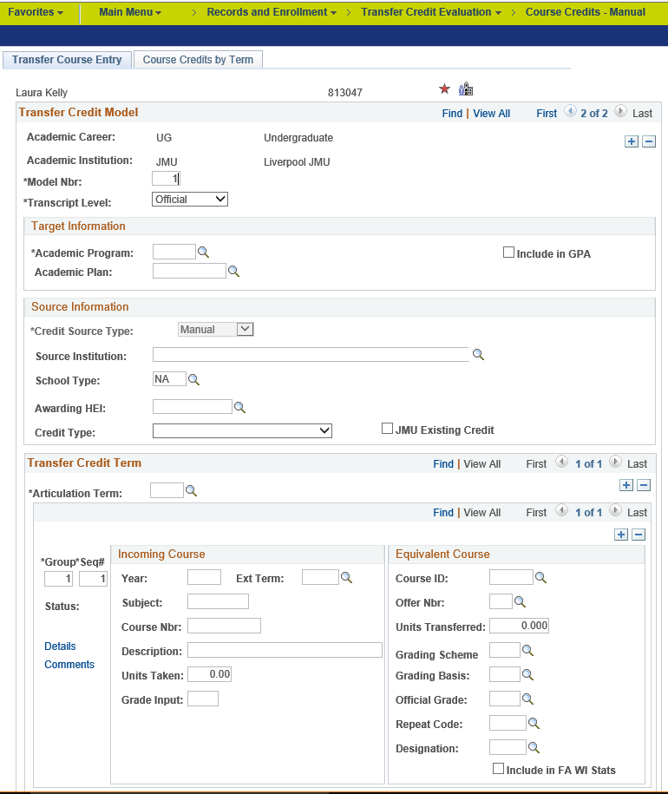
SIS Navigation
Target Information:
Students current Programme and Plan
Include in GPA:
Always ticked

Source Information:
Where the Incoming Credit has been attained
JMU Existing Credit:
Stop here and ‘Post’. Let Business Support know if the modules are already on SIS we’ll move them to the new Programme for you.

Articulation Term:
This needs to match the students current Academic Term
Incoming Course:
This is the detail of the previous Institution’s qualifications:

Year: When were the quals attained?
Subject: of qual.
Course Nbr: Module Code
Description: What was the qual?
Units Taken: Credit value of qual
Grade Input: The attained grade.
Equivalent Course:
This is the detail of which LJMU modules the Incoming Credit should be mapped to (most values default in):

Course ID: JMU Module Code
Units Transferred: JMU Credit Value
Official Grade: The JMU agreed grade
Repeat Code: If the module is NOT to count toward the Final Award, enter a Repeat Code of ‘TC’.

JMU Existing Credit:
Add and remove rows as needed to capture all modules.

Transfer Credit quick guide

Tab 2: Caculate, Post and Unpost
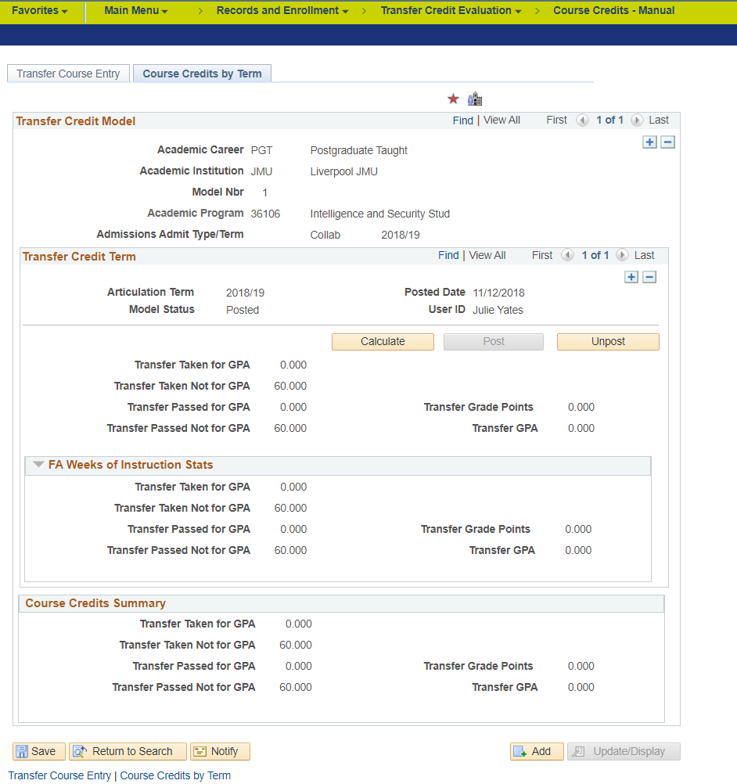

Model Status:
In order to ‘see’ Transfer Credit on the Student Record and Board Reports this status needs to be ‘Posted. If there is no active Student Record then the status only changes to Complete or Submitted. Make sure the student is active in the Term that is indicted in the Articulation Term on the 1st tab.
Calculate:
This button ‘adds’ all the entered credit on the previous page. You must ‘calculate’ before posting.
Unpost:
This button moves all the Credit back from the Student Record and allows changes to the Transfer Credit record to be made. Changes need to be ‘calculated’ and ‘posted’ again.
Post:
This button moves all the Credit to the Student Record. Once posted, Transfer Credit can’t be amended unless it is ‘unposted’

