Mitel MiCollab AWV

User Guide

LJMU use Mitel’s Audio, Web and Video (AWV) conference client for collaboration. This works in much the same way as other collaboration tools, such as Skype for Business, Cisco WebEx etc.
You can also use this to set-up simple audio conferences.

Contents
- Scheduling a conference…….. | Page 2
- Joining a conference…………… | Page 6
- Sharing a presentation……….. | Page 7
- Video conferencing…………….. | Page 8

- Scheduling a conference
To schedule a conference, browse to https://micollab.jmu.ac.uk and login using your normal LJMU username and password.
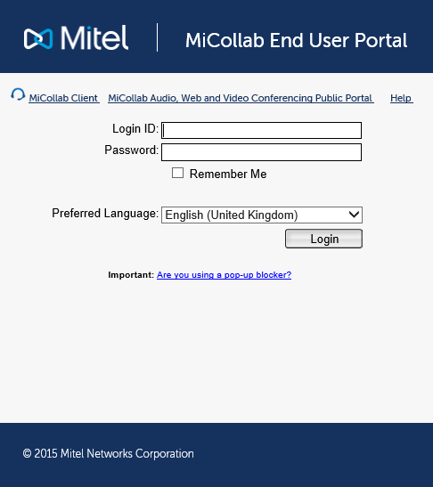

Then click on the Audio, Web and Video Conferencing option in the left-hand pane and then select One-time Conference
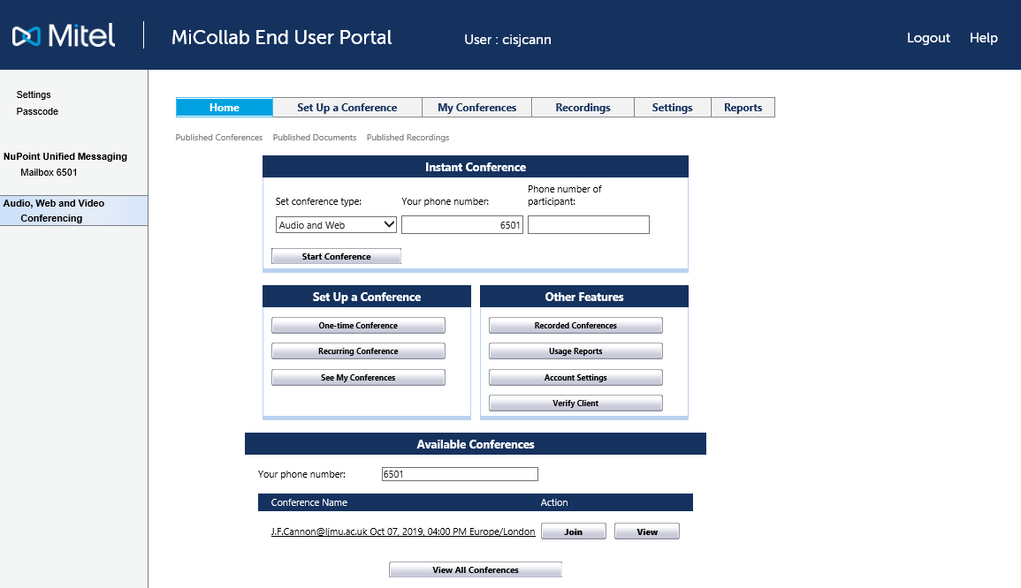

Give your conference a name, select the date and time then click OK.
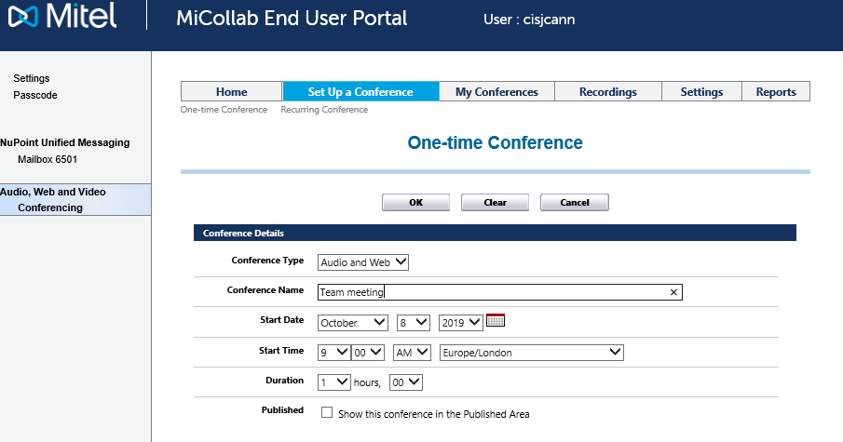
Note: This is the minimum information required to schedule a conference. You will see other options lower down this screen that you can use, for example to;
- Prompt users to say their name as they join the conference
- Password protect the conference

Details of your conference will appear on the next screen. You can either copy and paste the Participants link into an email or use the Calendar or Email buttons to generate Calendar or email entries.
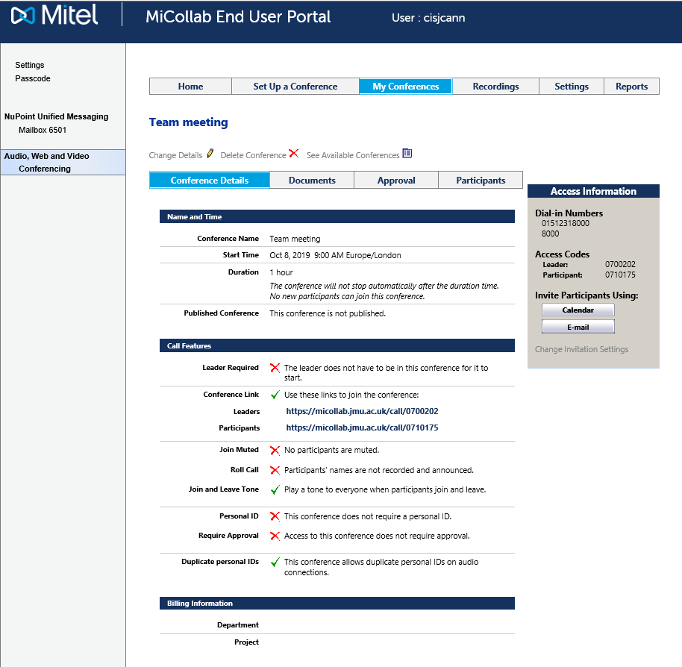
Link
Note: If you join the conference as the leader, you have the options such as being able to mute other participants.

Example of Calendar entry
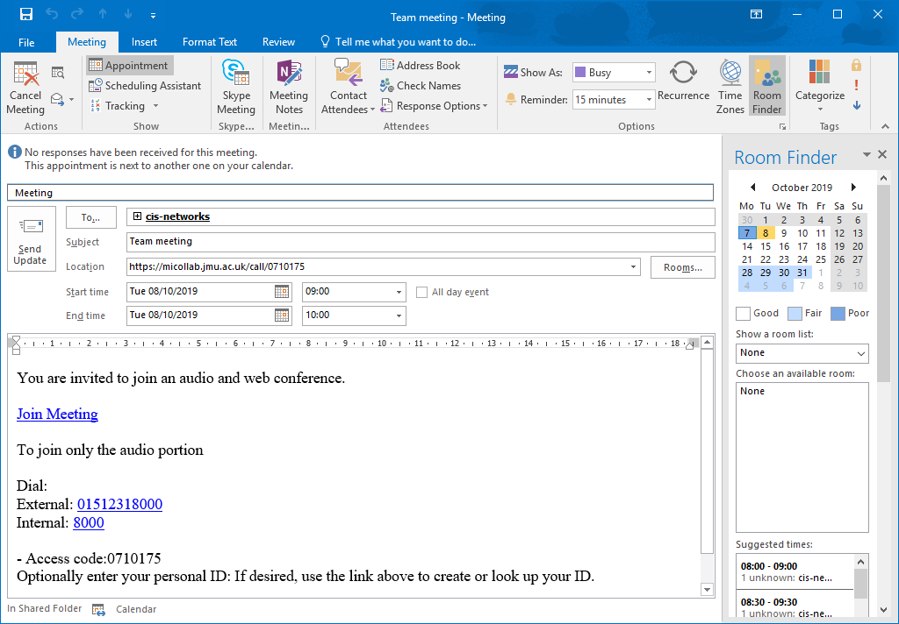
Link
Example of Email
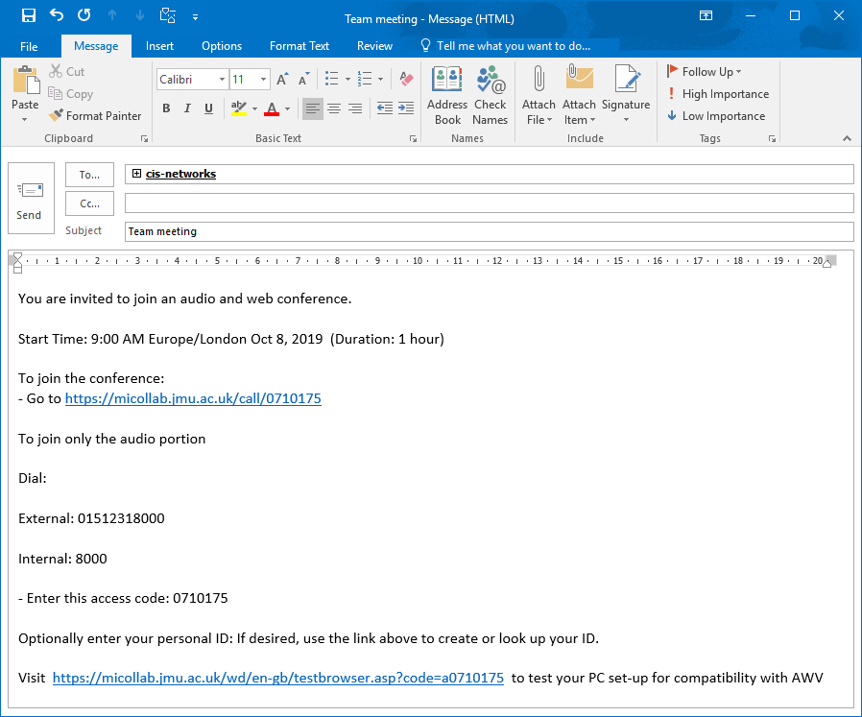
Link

- Joining a conference
Click on the link in the email invitation e.g. https://micollab.jmu.ac.uk/call/0710175
Click on Join via Windows Client
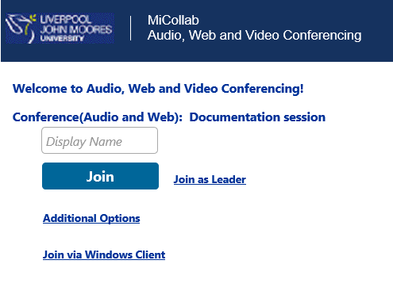
Note: Participants can simply enter a name and click join, but need to join via the Windows Client if they wish to present.
Participants can either dial in by phone, or use the microphone and speakers on the PC for audio.
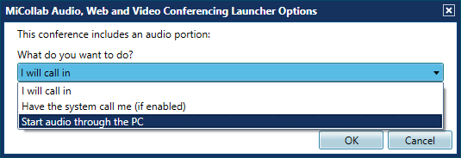
You will then be in conference.

- Sharing a presentation
Click the Share button and select Desktop Application
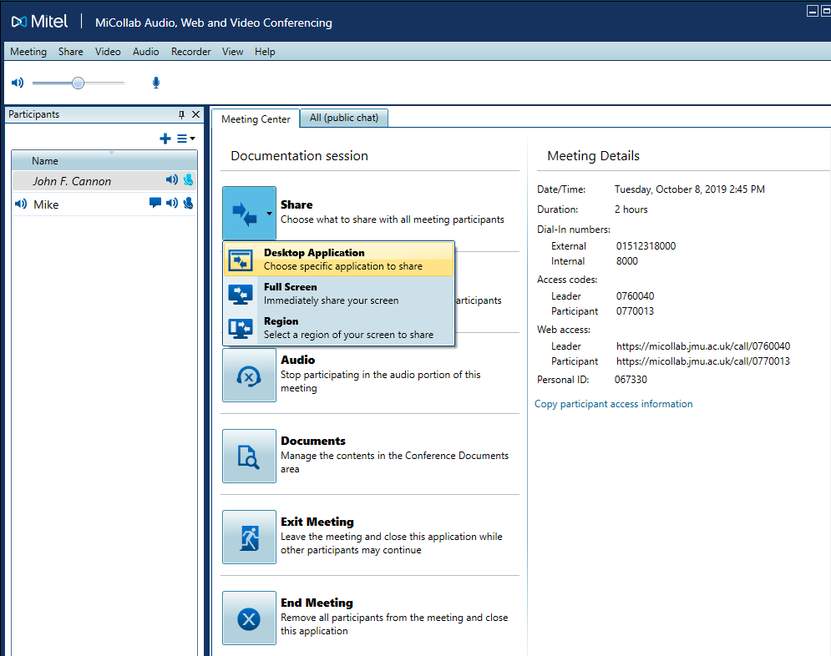
Select which application you wish to share (e.g. Powerpoint Slide Show)
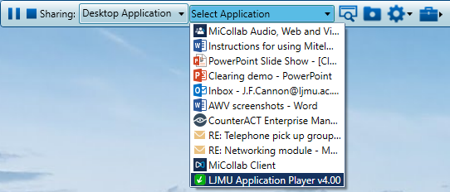

Participants can view your presentation in the Viewer tab… and make this Full Screen by clicking on the Full Screen button.
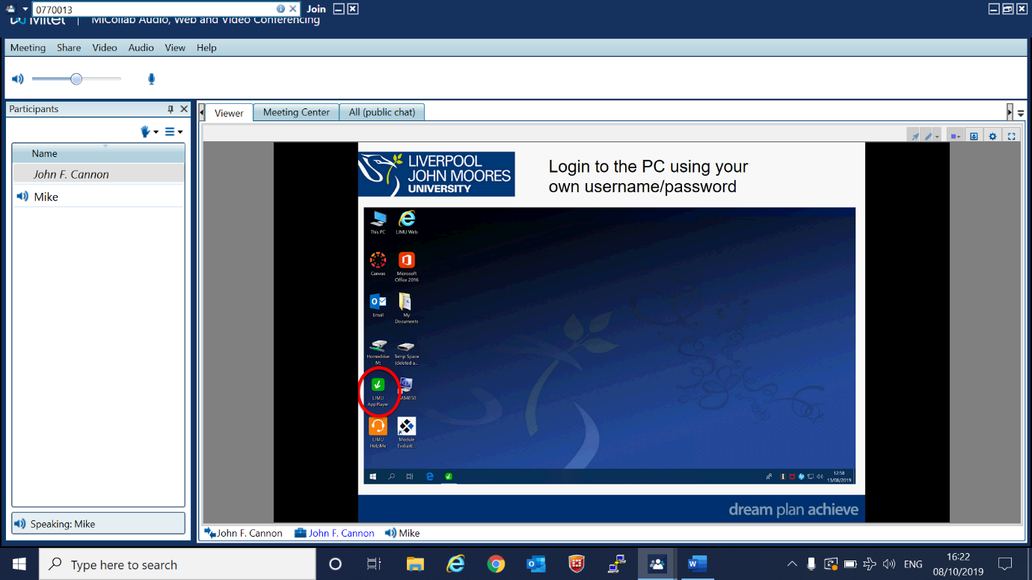
Full Screen

- Video conferencing
Click the Video button
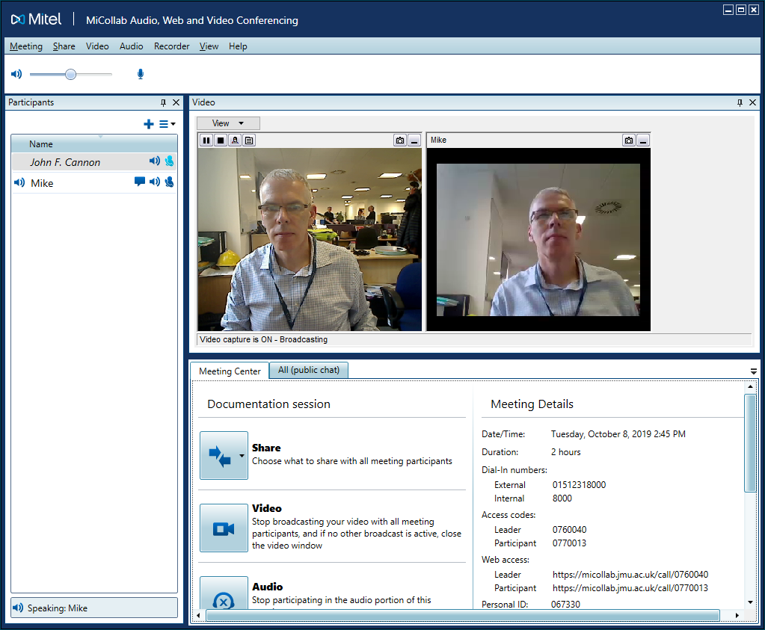
Note: You can resize the video window to suit. To restore the default view select Restore Default View from the View menu
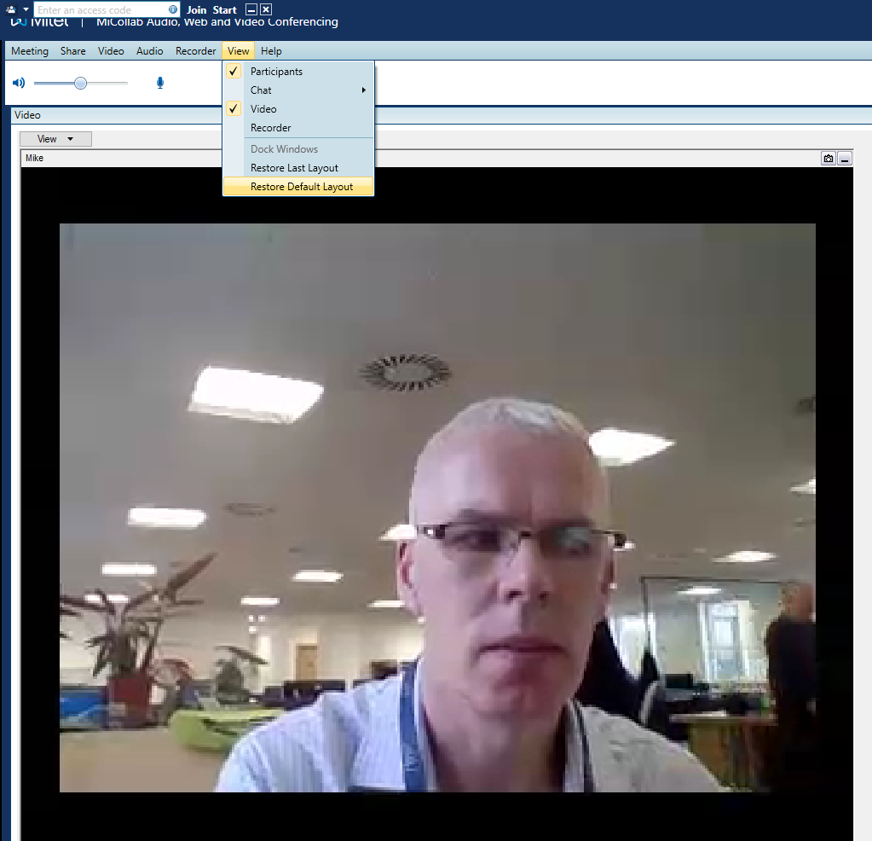
Appendix A – installing the AWV client
In order to present within a conference you need to run the MiCollab Audio, Web and Video Conferencing Client.
On an LJMU PC, you can run this from the App Player .
Search Mitel and select MCAClient.
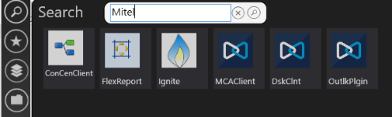

Enter micollab.jmu.ac.uk as the server hostname and the display name you wish to use.
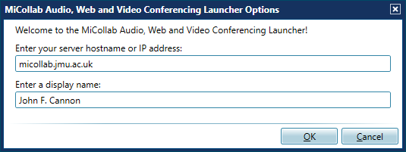
The AWV client runs as a small window in the top left of your screen.

