Corporate Business Change Initiatives
Liverpool John Moores University

A User Guide to:

Requesting and Recording Annual Leave and other Absences types in Staff Infobase

Version Final - 1st September 2014
Author: Shirley Wedgwood
Reviewers: Neil Larsen & Ann Sidaway
1

Contents

Introduction 3
1. Absence Recording Process: 3
2. InfoBase Process Steps 3
3. InfoBase Main Menu Navigation 4
4. Creating Annual Leave or Other Absence 5
5. Completed Absences 10
6. Requesting a Half Day Absence 11
7. Delete an Absence 15
8. Absence Calendar 17
9. Annual Leave Carryover 2014 Days ICD 21
10. Annual Leave Adjustment Purchase Days ICD 27
11. Annual Leave Entitlement Adjustments 32

Introduction

The recording of personal absences in Staff Infobase is the responsibility of all LJMU employees.

This guide is an overview of the new absence recording process and should be navigated through when recording any leave of absence in your personal Staff Infobase record.

Absence Requesting & Recording Process:

Business Process Steps
- Employee records and requests leave in Staff Infobase
- Absence is forwarded to line manager for authorisation/approval
- Line Manager authorises leave request
- Employee receives confirmation email

InfoBase Process Steps

The steps to be followed apply to all LJMU employees.

InfoBase Main Menu Navigation

Navigate to the Staff Infobase Sign In Page and enter your Single Sign-On username and password to sign in.

Once you have signed in expand the LJMU Employee Self Service from the main menu and select the Absence Management link.

Fig 1
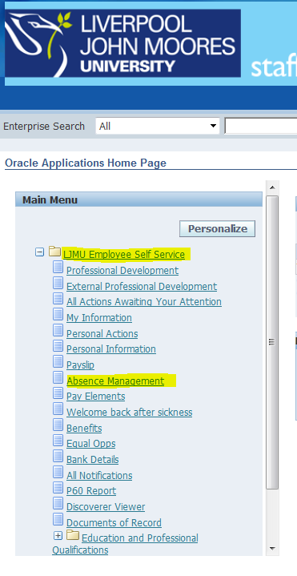

Creating Annual Leave or Other Absence

Click on the Book Annual Leave or Other Absence Button.

Fig 2

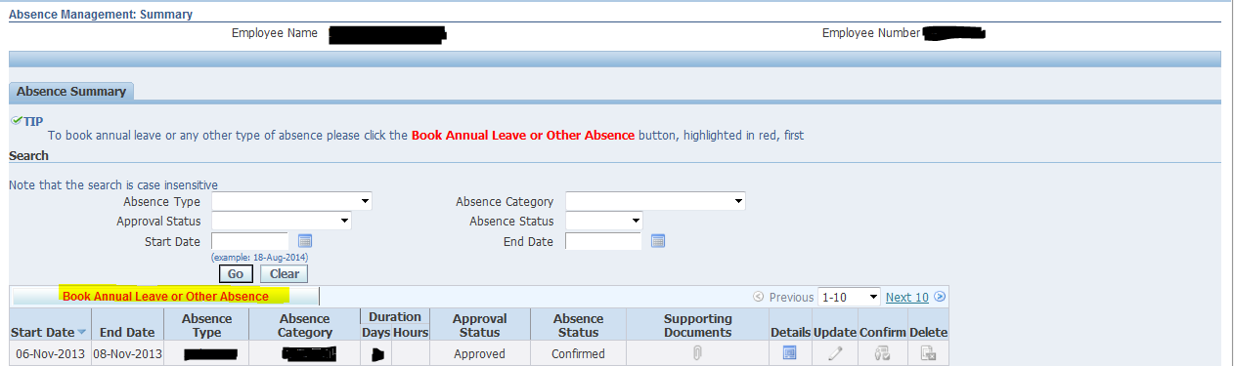

Create Absence: Enter Absence Details

Select your absence type from the dropdown menu.

Fig 3

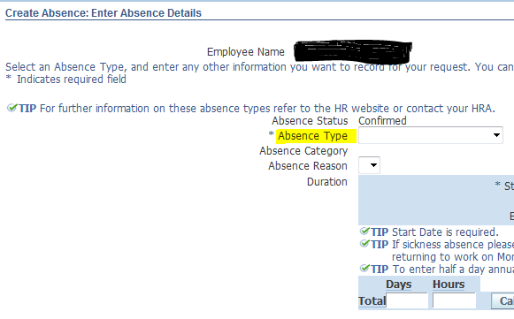

Create Absence: Enter Absence Details

Enter the start and end dates of your absence using either the small or large calendar or you can free type the dates. Please Note: if using the large calendar you must click in the end date row before entering your end date.

Your leave end date should be the last day of leave NOT the date you will return to work. When you have entered start and end dates click calculate duration.

Fig 4

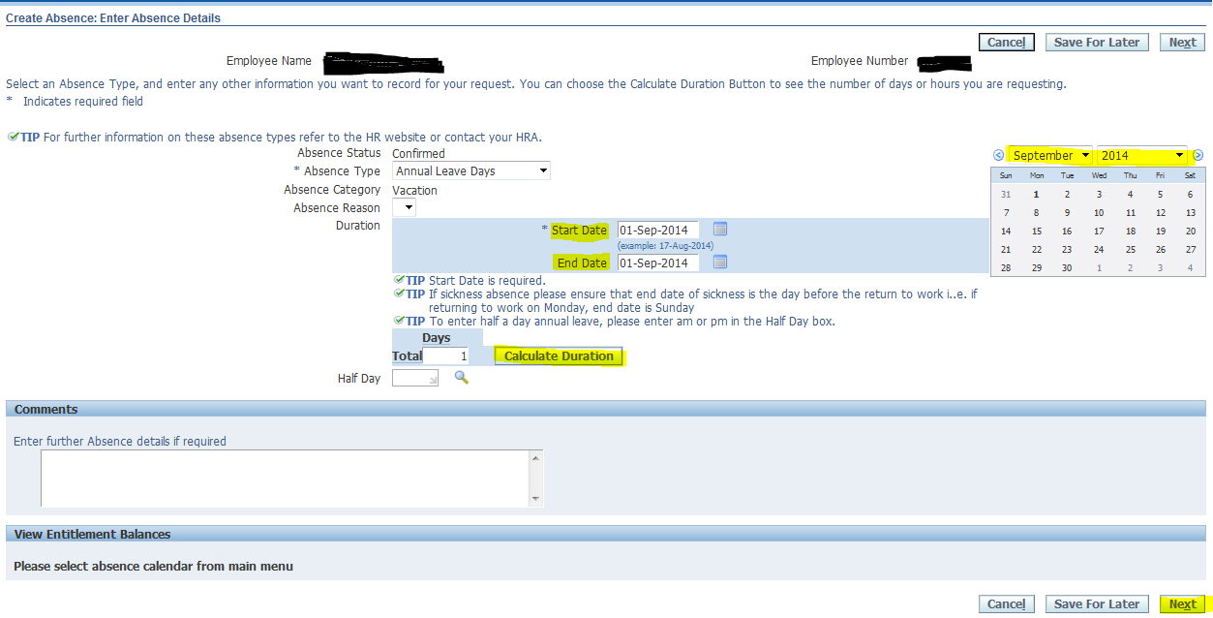

Select Next

Create Absence: Warning Message

Please note this message only affects those staff leaving the University who have exceeded their leave entitlement.

Fig 5
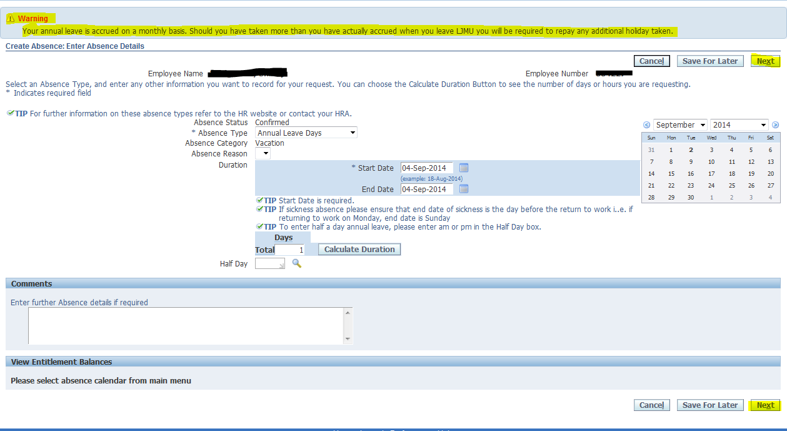

Select Next again

Create Absence: Review

Please review your request details and if you are happy click submit.

If you need to make any changes click the Back button and you will be returned to the Create Absence: Enter Absence Details page (see Fig 4) where you can make any changes to your absence request.

Fig 6
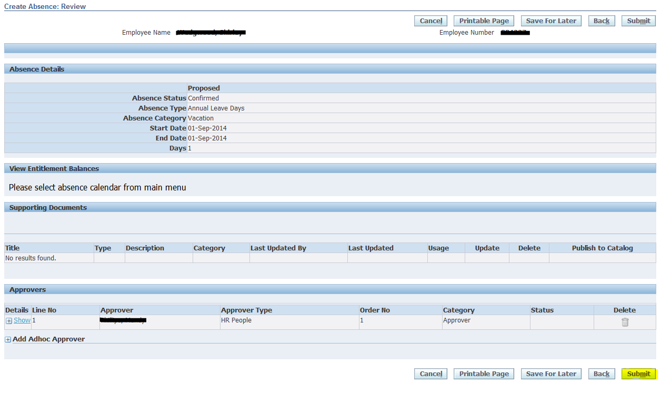
Select Submit

Absence Management: Summary

Your approval status will appear in the Absence Management: Summary.

Fig 7

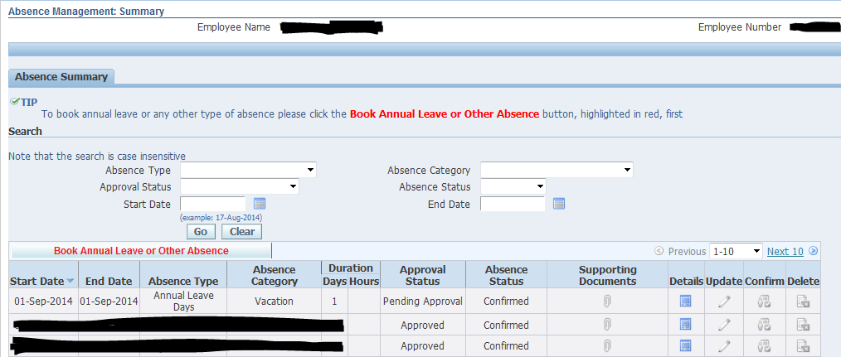

Completed Absences

Your completed absence request will be forwarded to your Line Manager/Supervisor for approval. Once approved you will receive a notification email.

Requesting a Half Day Absence

Navigate to the Staff Infobase Sign in Page and enter your Single Sign-On user name and password to sign in.

Once you have signed in expand the LJMU Employee Self Service from the main menu and select the Absence Management.

Fig 8

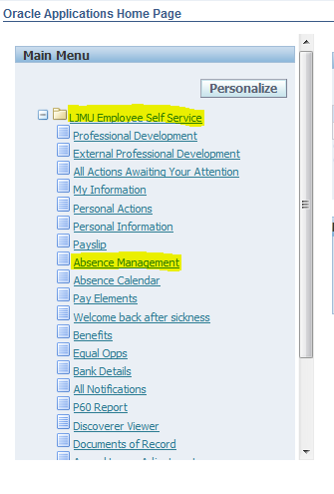

Creating a Half Day Absence

Click the Book Annual Leave or Other Absence Button.

Fig 9

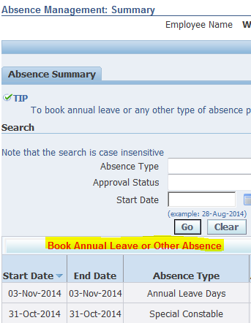

Create a Half Day Absence: Enter Absence Details
- Select absence type
- Select start and end date
- Type am/pm in the Half Day row, then select from the drop down menu
- Calculate Duration
Please note if you wish to book a half day absence as part of a longer period you will need to book your half day absence separately from your full days e.g. you wish to book Monday, Tuesday & Wednesday AM, you will need to book Monday & Tuesday as 2 full days, then book your Wednesday AM as a separate absence. This allows the Absence Calendar to be updated correctly.
This does not apply to staff who work half a day as standard. E.g. you only work 3.5 hours on a Friday and you wish to take a Friday off. (in this case just book the Friday off as normal)
Fig 10
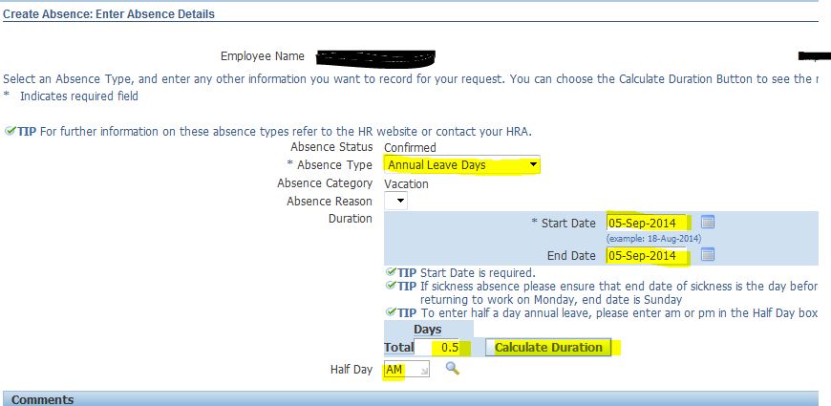

Create Absence: Review
Please review your request details and if you are happy click submit.

If you need to make any changes click the Back Button and you will be returned to the Create Absence: Enter Absence Details page (see Fig 4) where you can make any changes to your absence request.

Fig 11

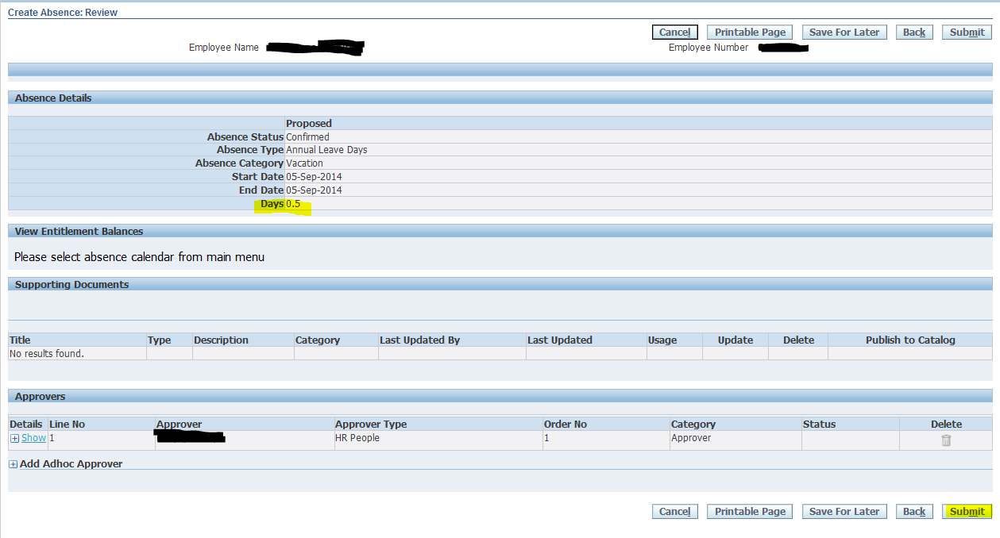

Delete an Absence

Navigate to the Staff Infobase Sign in Page and enter your Single Sign-On user name and password to sign in

Once you have signed in expand the LJMU Employee Self Service from the main menu and select the Absence Management

Fig 12

Absence Management Summary

Click the delete button against the absence you want to delete and click submit on the Delete Absence: Review screen.

Please note you can only delete future absences that have been approved by your Manager. If you need to delete a past absence please speak to your line manager for approval.

Fig 13

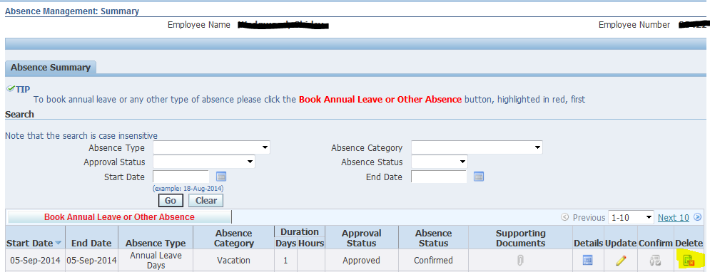

Absence Calendar

The Absence Calendar displays all absences e.g. entitlement, booked and remaining etc.

Navigate to the Staff Infobase Sign in Page and enter your Single Sign-On user name and password to sign in

Once you have signed in expand the LJMU Employee Self Service from the main menu and select the Absence Calendar

Fig 14

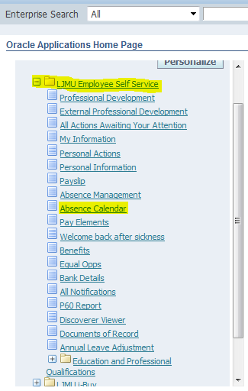

Absence Calendar: Detail View
- Select Absence Calendar
- Select Detail in the Calendar Type row
- Select a date from calendar window,
- Once you have selected your date click Display Calendar
Fig 15

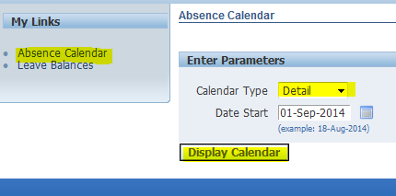

Your absence calendar will show the leave you have booked.

Fig 16

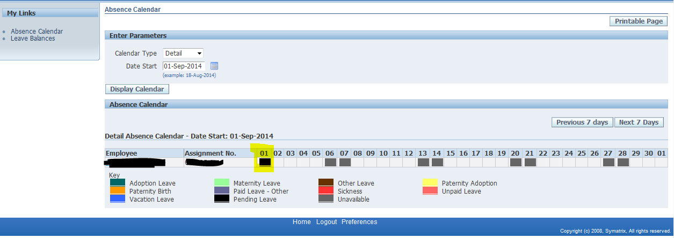

Absence Calendar: Summary View

This view show you the absences of your team members

- Select Absence Calendar
- Select Summary in the Calendar Type row
- Select a date from calendar window,
- Once you have selected your date click Display Calendar

Fig 17

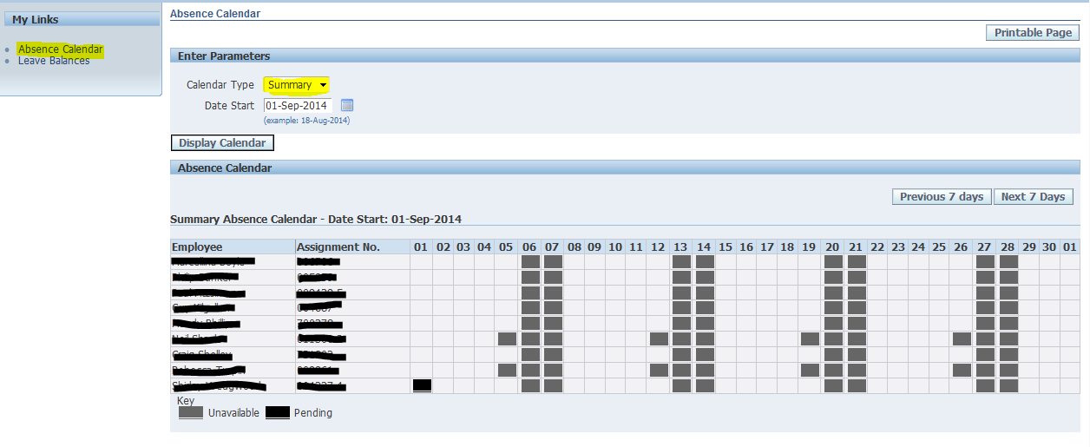

Absence Calendar: Leave Balances
This view gives you an overview of your annual leave details.

To view your leave balance click Leave Balances

Fig 18

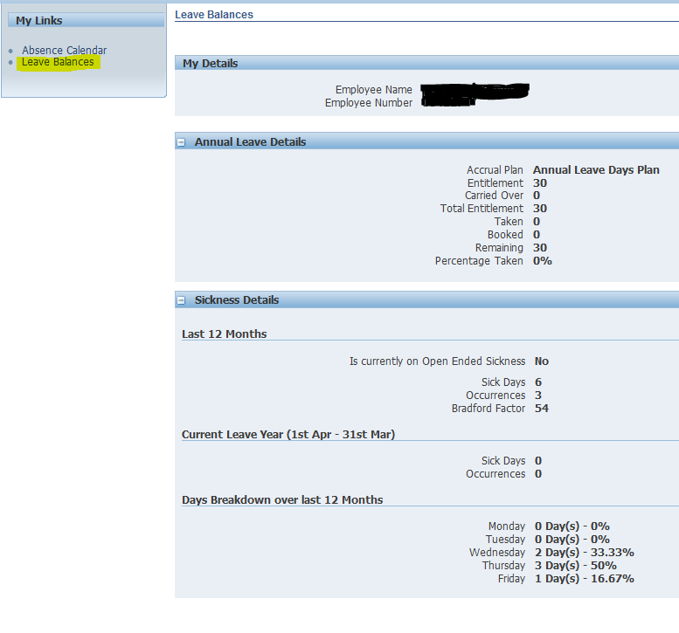

Annual Leave Carryover 2014 Days ICD

Navigate to the Staff Infobase Sign In Page to enter your Single Sign-on username and password to sign in

Once you have signed in expand the LJMU Employee Self Service from the main menu and select the Annual Leave Adjustment Link.

Fig 19

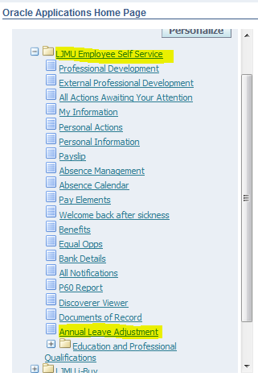

Annual Leave Adjustment Carryover 2014 Days ICD: Overview

Select the Annual Leave Adjustment button

Fig 20

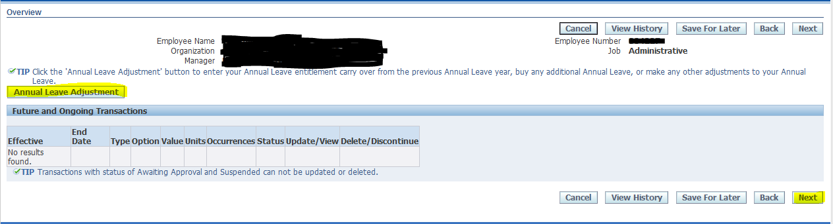
Select Next

Annual Leave Adjustment Carryover 2014 Days ICD: Compensation Details

Select Annual Leave Carryover from the drop down menu

Fig 21

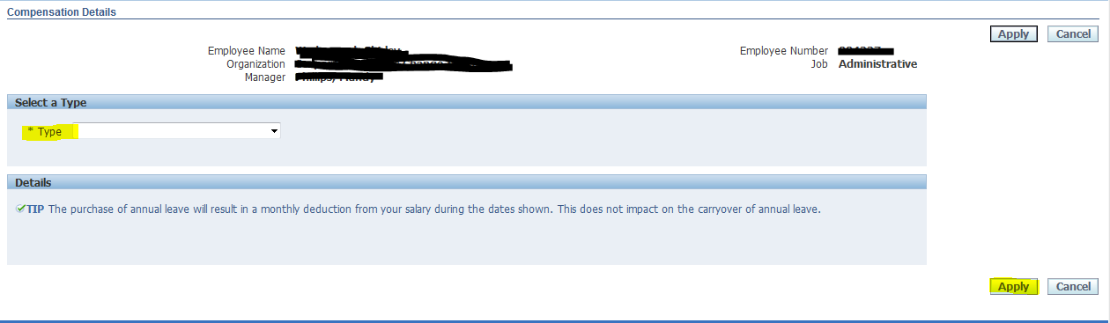

Click Apply

Enter the number of days that you wish to carry over here

Fig 22

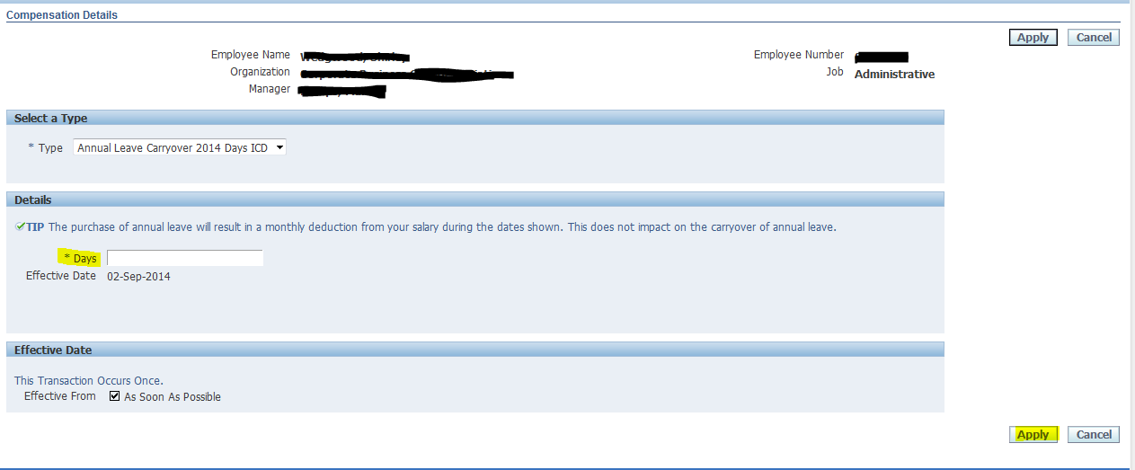

Click Apply

Annual Leave Adjustment Carryover 2014 Days ICD: Overview

Check your request details

Fig 23

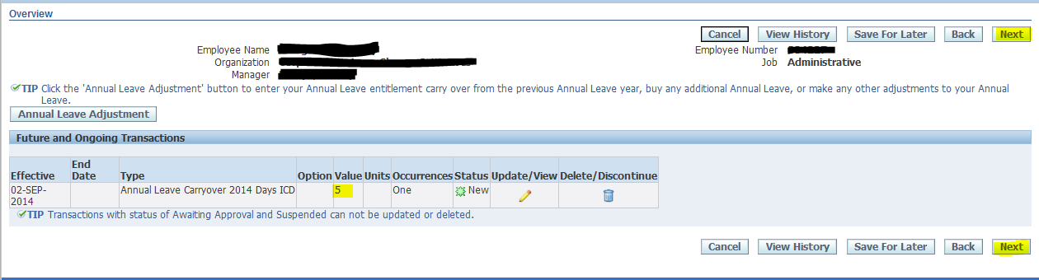

Select Next

Annual Leave Adjustment Carryover 2014 Days ICD: Review

Review your request details here

Fig 24

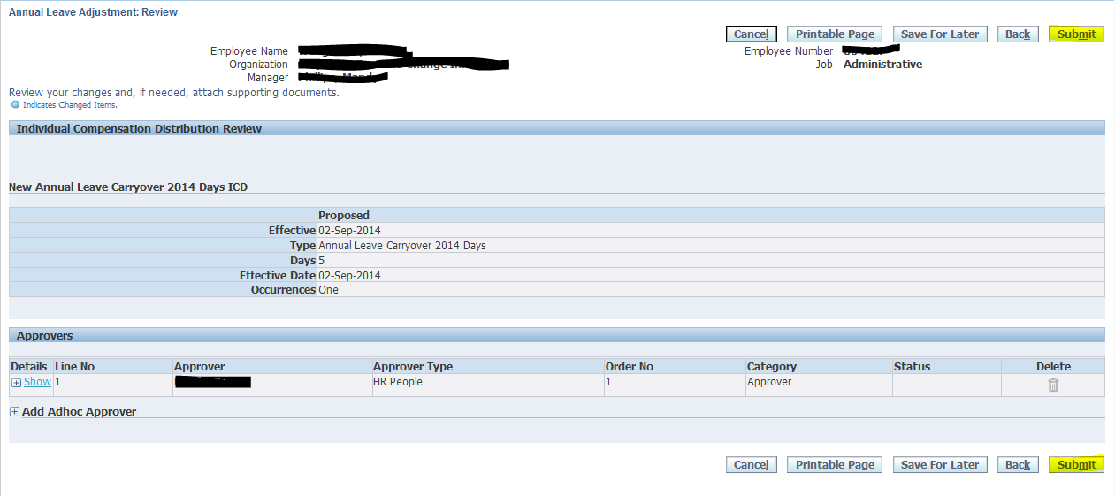

Select Submit

Annual Leave Adjustment Carryover 2014 Days ICD: Confirmation

Confirmation that your request has been submitted to your manager for approval.

Fig 25

Annual Leave Adjustment Purchase Days ICD

Employees can purchase additional annual leave. The payment of which is deducted from your monthly salary.

Navigate to the Staff Infobase Sign In Page to enter your Single Sign-on username and password to sign in

Once you have signed in expand the LJMU Employee Self Service from the main menu and select the Annual Leave Adjustment Link.

Fig 26

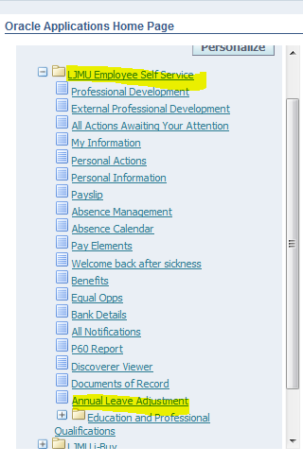

Annual Leave Adjustment Purchase Days ICD: Overview

Select the Annual Leave Adjustment button
Fig 27

Select Next

Annual Leave Adjustment Purchase Days ICD
Select a type of adjustment

Fig 28

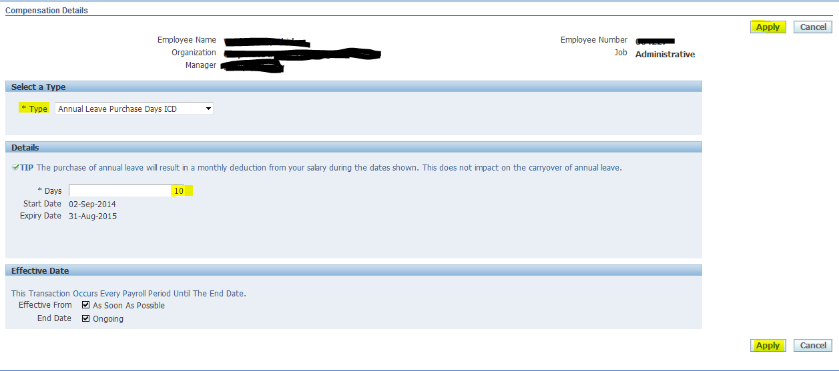

Click Apply

Annual Leave Adjustment Purchase Days ICD: Overview

Check your request details here

Fig 29

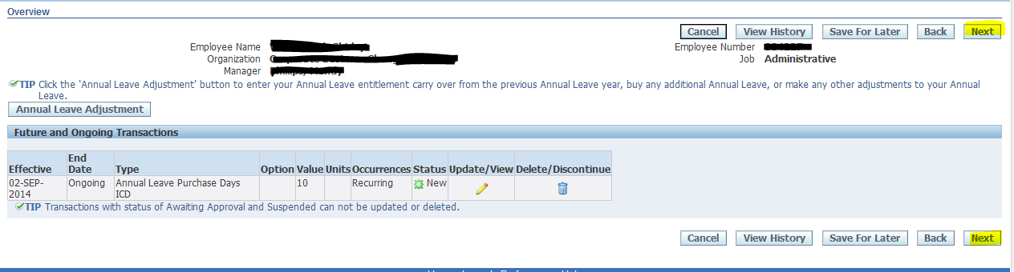

Select Next

Annual Leave Adjustment Purchase Days ICD: Review
Review your request details here

Fig 30

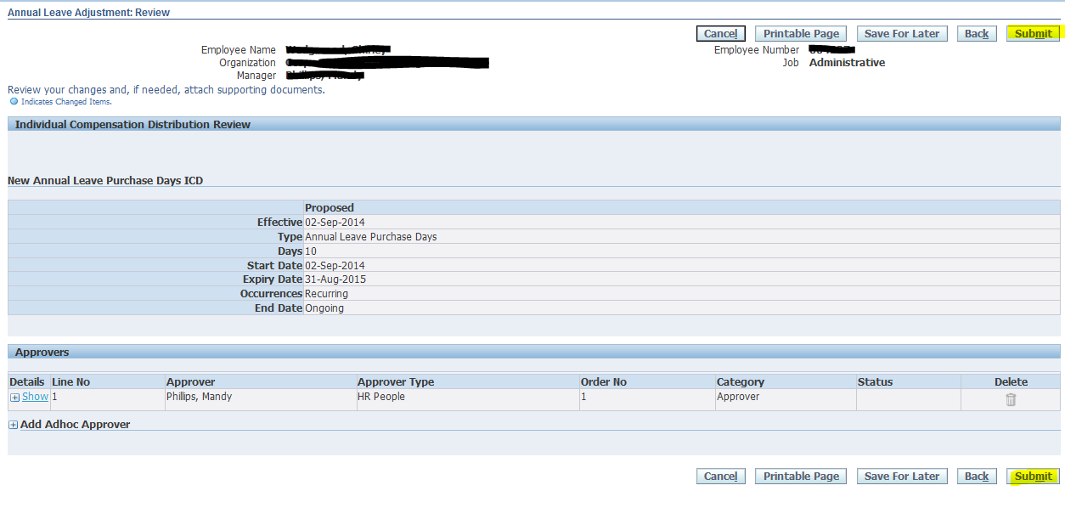

Select Submit

Annual Leave Adjustment Purchase Days ICD: Confirmation
Confirmation that your request has been submitted to your manager for approval.
Fig 31

Annual Leave Entitlement Adjustments

The Annual Leave Entitlement Adjustments allows you to make adjustments to your annual leave entitlement.

For further explanation of this process please contact your HR Advisor.

