Requesting Overtime User Guide
Log into Staff Infobase and choose LJMU Employee Self Service, you can then click ‘Overtime Entry’
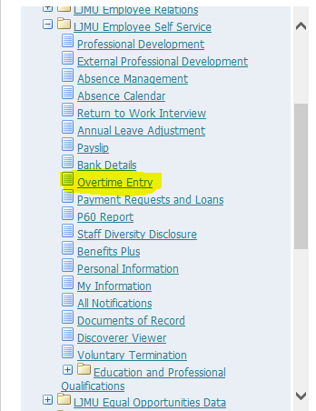

On the next screen click the ‘Overtime Payment Request’ button

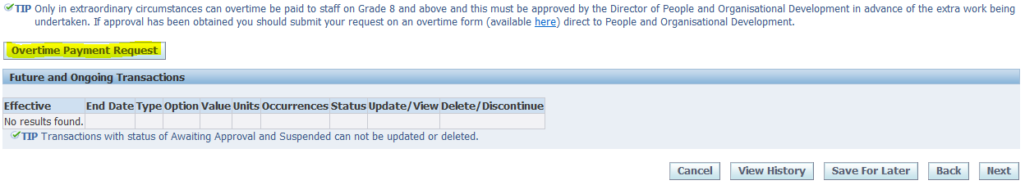
Now click the drop down menu button for ‘Type’
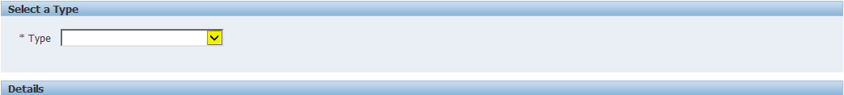
Select the rate of overtime that applies from the list

You will then be taken to the overtime form where you can complete the details.
Hours : Number of hours worked at that overtime rate
Date of Overtime : Date the overtime was carried out, if this is multiple dates at the same rate please just enter the 1st date this started. If you have completed overtime on different days at different rates these will need to be entered separately.
Overtime Reason : Choose the most appropriate from the drop down list.
Cost Allocation : You can enter cost allocation details here if the work was carried out for a different cost centre, if this is left blank the overtime will be charged to your own cost centre.
Once you have completed this form click ‘Apply’
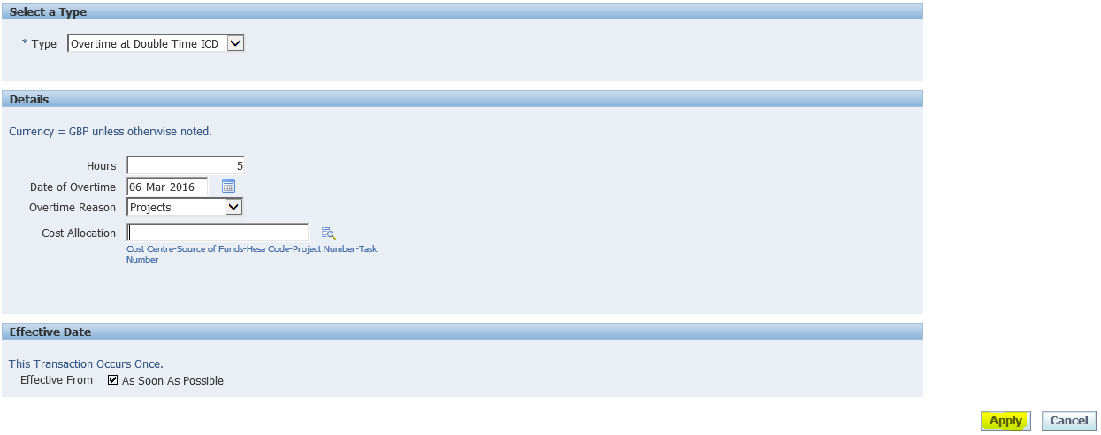
You will now get this screen which gives you an overview of what you have entered. Here you can ‘Save for Later’ if you need to go away to check anything and come back to it later, ‘Update’ if something needs amending, or ‘Delete’ if you need to start again.
If you are happy with everything you can click ‘Next’

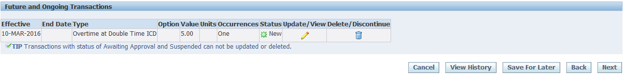
Now as long as you are happy with everything you can click ‘Submit’ and it will be sent to your Line Manager for approval, once it has been approved it will be picked up in the next available pay run.

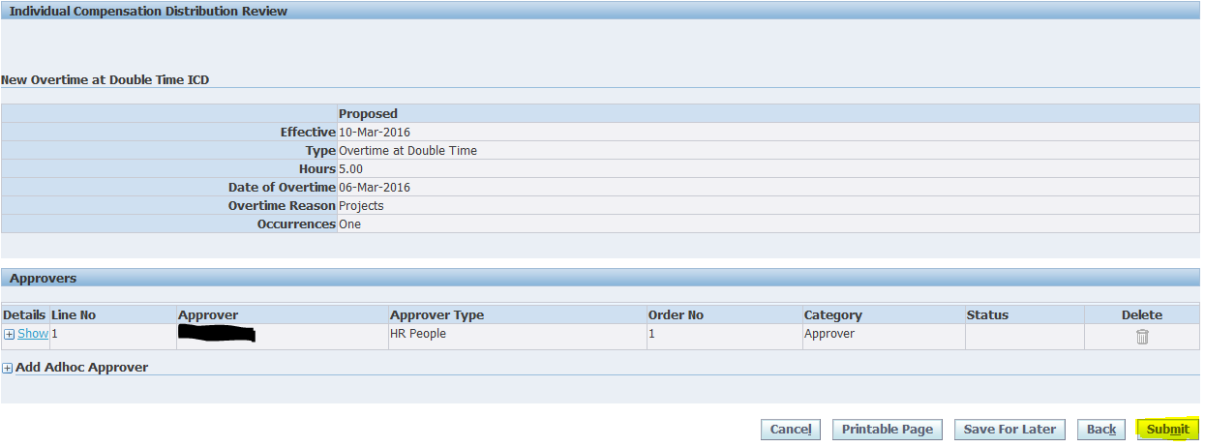
If you need to enter another overtime you then need to click ‘Overtime Payment Request’ and enter the details.
