Corporate Business Change Initiatives
Liverpool John Moores University

Return to Work Form for Managers - User Guide:

Version : Final
Date: 19th February 2015
Author: Shirley Wedgwood
Reviewers: Neil Larsen, Ann Sidaway, Catherine Nevin and Naomi Scharf.
1

Contents

Introduction 2
1. Return to Work Form for Managers 2
2. InfoBase Process Steps 3

Introduction

The return to work interview process is the responsibility of all Line Managers following an employee’s period of sickness.

This guide is an overview of the new return to work form process for Line Managers and should be navigated through following the return to work of the Employee after a period of sickness.

Please note, where possible, the return to work form should be completed during the interview.

Return to Work Form for Managers

Business Process Steps
- Line Manager conducts return to work interview
- Line Manager completes the Return to Work Form

InfoBase Process Steps

The steps to be followed apply to all LJMU Line Managers.

In LJMU Staff InfoBase select the following from the Main Menu
- LJMU Manager Self Service
- Return to work interview
- Click action box for member of staff from list
- Click Add to add a new record
Complete form
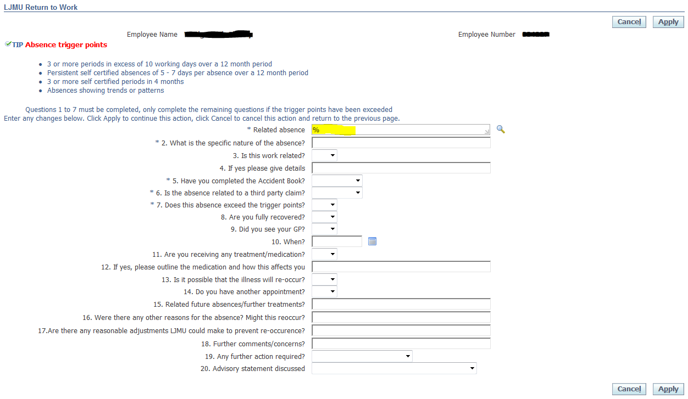

Tip : Type % in ‘Related Absence’ box then click on magnifying glass to bring up absence list (see highlighted field above), most recent absence will appear at the top
Click Quick Select for the appropriate absence
Continue to complete form
Once form is complete continue as follows:
- Click apply –an Extra Information page will appear
- Click Next – the Review Page will appear, check review page carefully
- Click Submit – a confirmation page will appear

