

**Zero Hours Batch Element Entry User Guide**

**Managers entering Zero Hours**

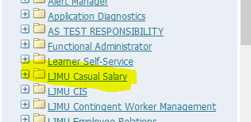

Select the LJMU Casual Salary responsibility

This opens a web form

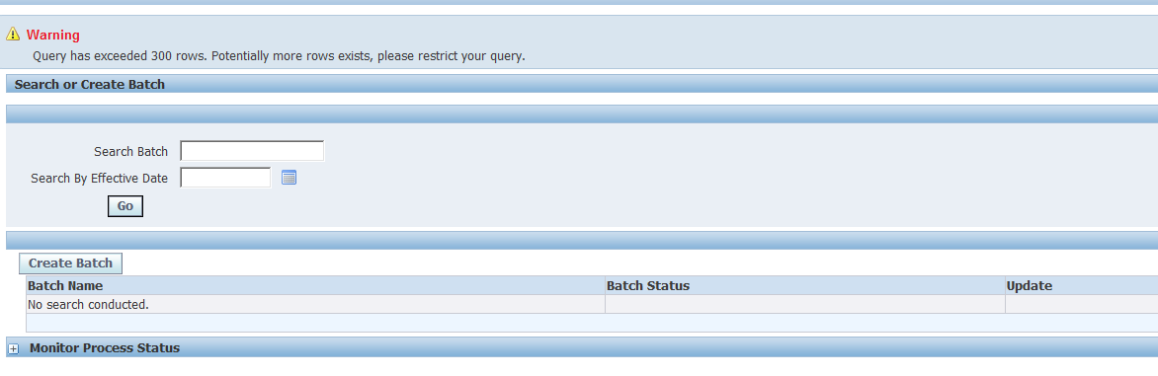

Click on **Create Batch**

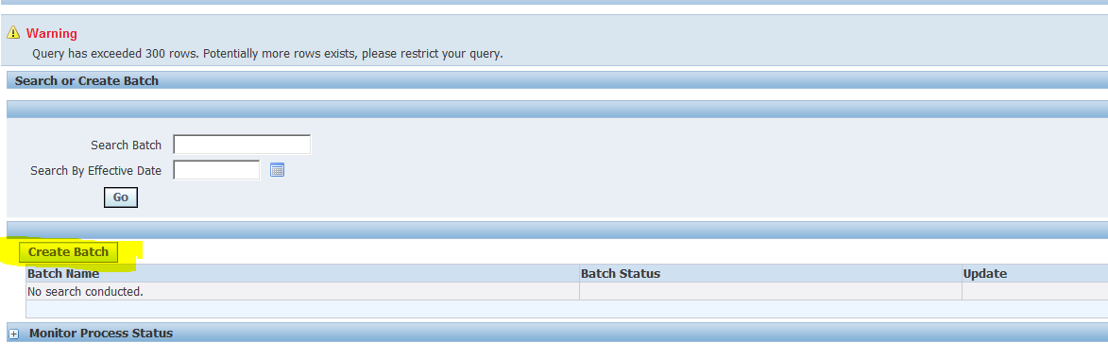

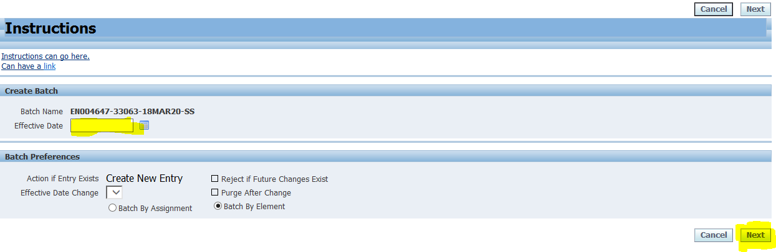

Enter an Effective Date, always use the 1st of the month e.g. 01-FEB-2016 and click **Next**

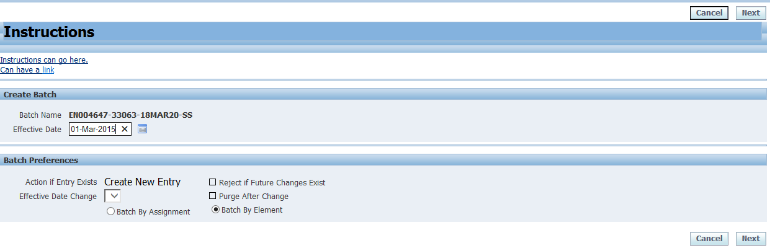

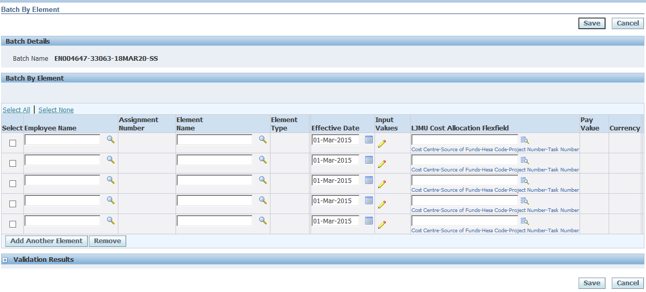

Select Employee who has worked some hours by typing their surname (using the Magnifying glass  if required) and click on  to select the right person

Enter the Element Name ‘**Casual Staff Salary Manager’** (you can just type the first few letters and hit the ‘Tab’ key on your keyboard) and check the Effective Date

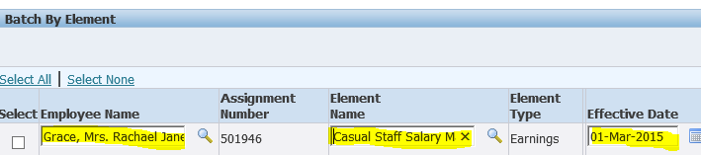

Click on the yellow pencil  to add the hours

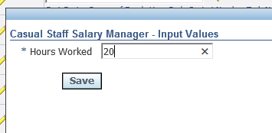

And click **Save**

Enter the LJMU Cost Allocation Flexfield if different from their normal costing

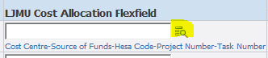

Enter the required costing information and click **Search**

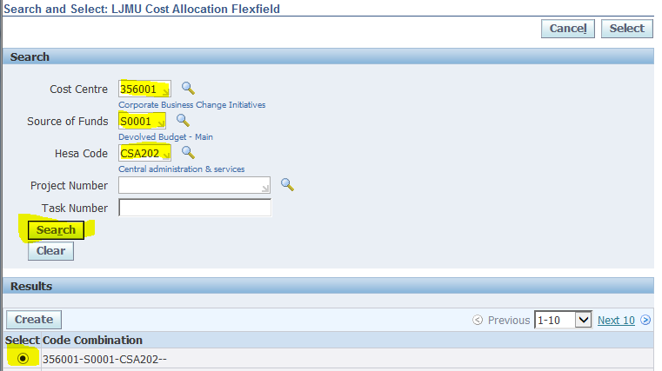

Click the radial button  by the correct costing string

And click  **Select** 

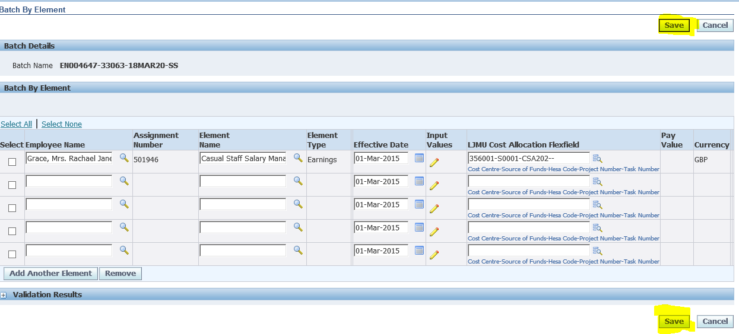

**Click Save**

This has saved the batch of data, this data now needs to be validated.

To do this click on Validate

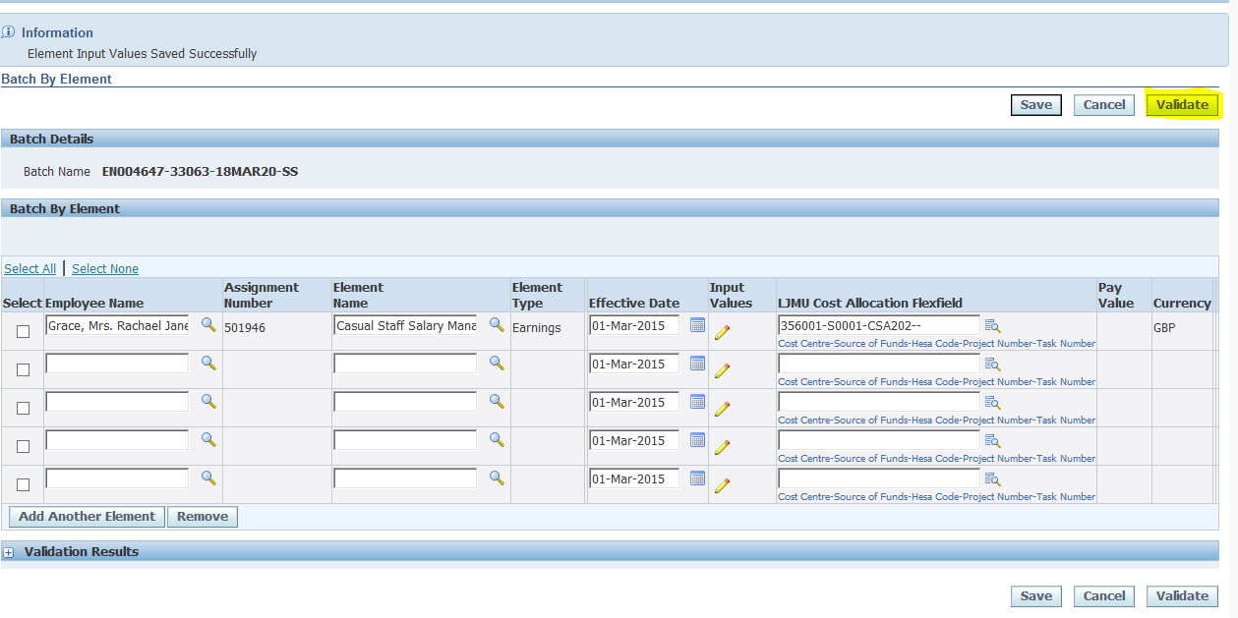

Then Click **OK**

(This allows the batch to be checked to see if it is valid)

Click on  **Go**

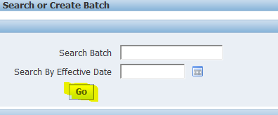

To find the status of the Batch validation

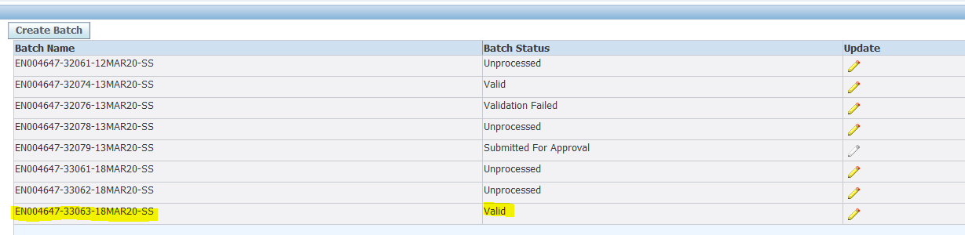

When the batch is shown to be valid – it can be sent to the line manager for approval.

To do this – click on the Yellow Pencil  alongside the valid batch

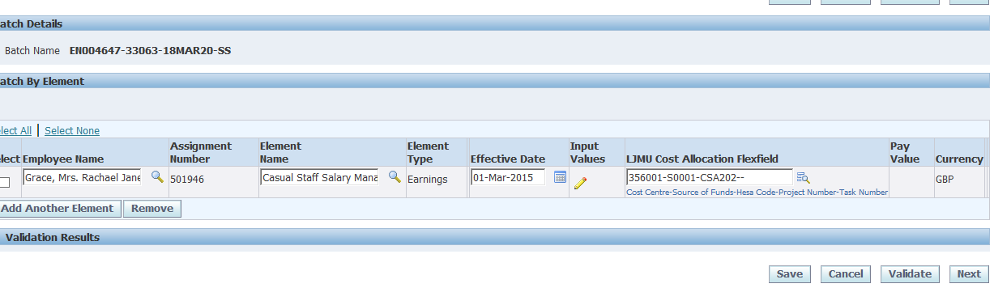

You’ll get this screen to confirm it’s the right batch that you want to send for approval

Then click Next

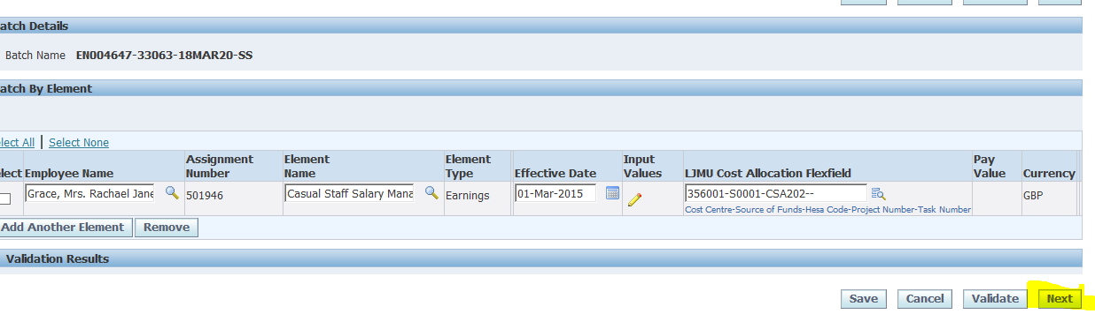

Check the details in the Review Screen

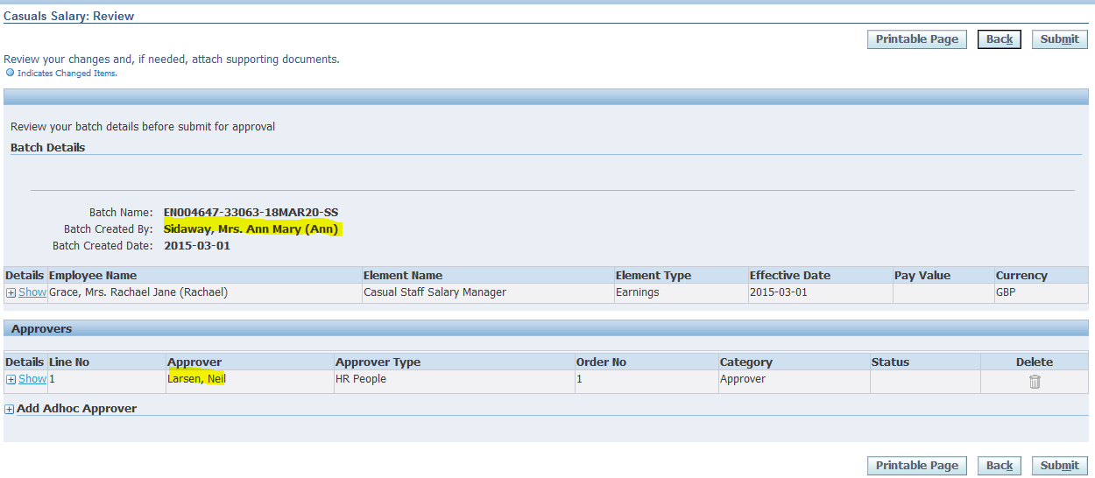

And click Submit



**Line Managers**

The line manger then gets an approval notification via workflow to accept the batch changes

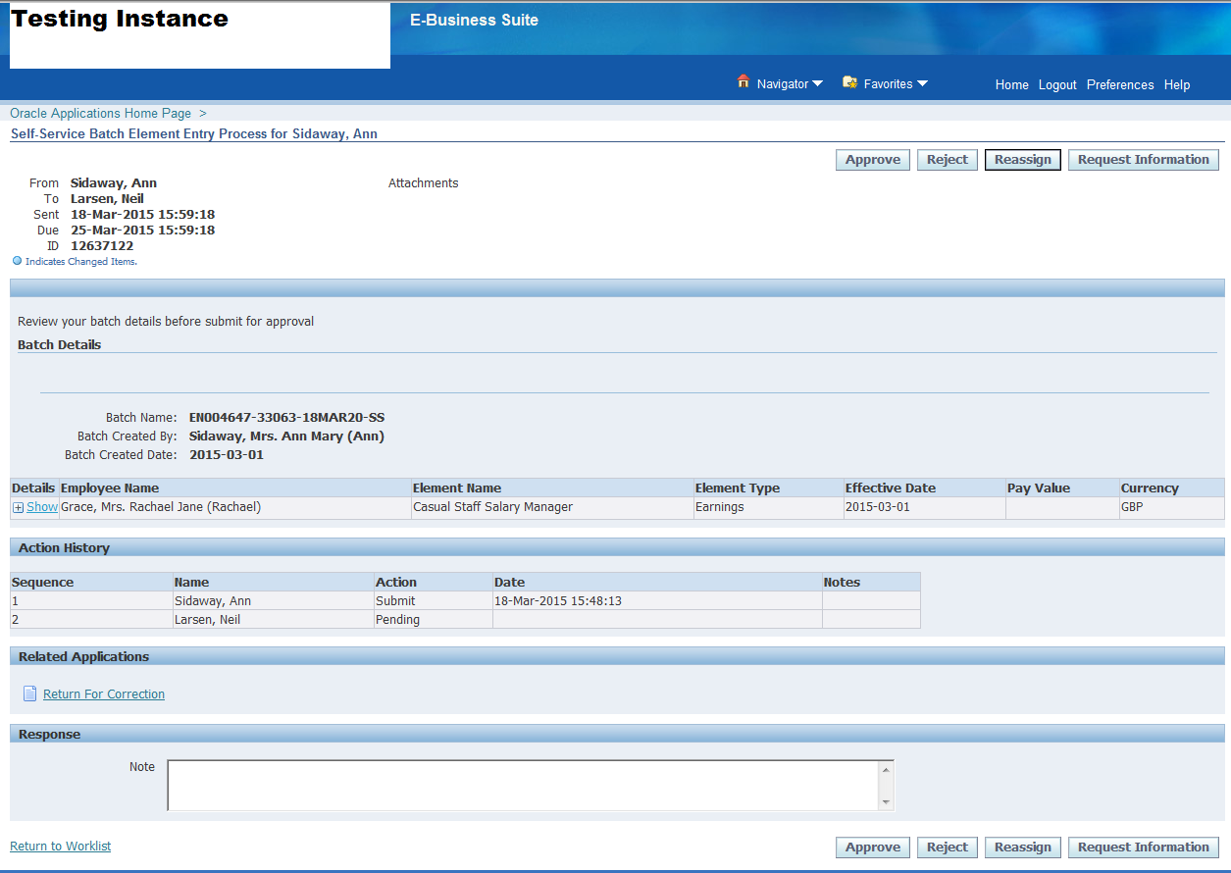

Once they are happy with the details, they click **Approve**

This then sends the data to payroll for them to “Approve” at a time that is convenient for them – i.e. they don’t accept it into the payroll in the middle of the payroll run